Clarkston Town Municipal and Civic Center Building
Request for Bid
Objective
Clarkston Town is in the process of converting our Civic Center into a Clarkston Town Municipality and Civic Center building. The current structure consists of a two-story building with assembly areas on the top and bottom floor. In the past, citizens have been allowed to rent these rooms for family and other social activities.
The existing structure will be expanded to the north nearly doubling the size of the current structure resulting in upper and lower floors. The top will become Clarkston’s Municipal building that will include a town hall, council chamber, clerk’s, mayor’s and future city manager offices, restrooms, small serving area, and storage area (see figure 1 below). The downstairs will be divided into two civic center rooms that will be available for citizens to utilize (see figure 2 below).
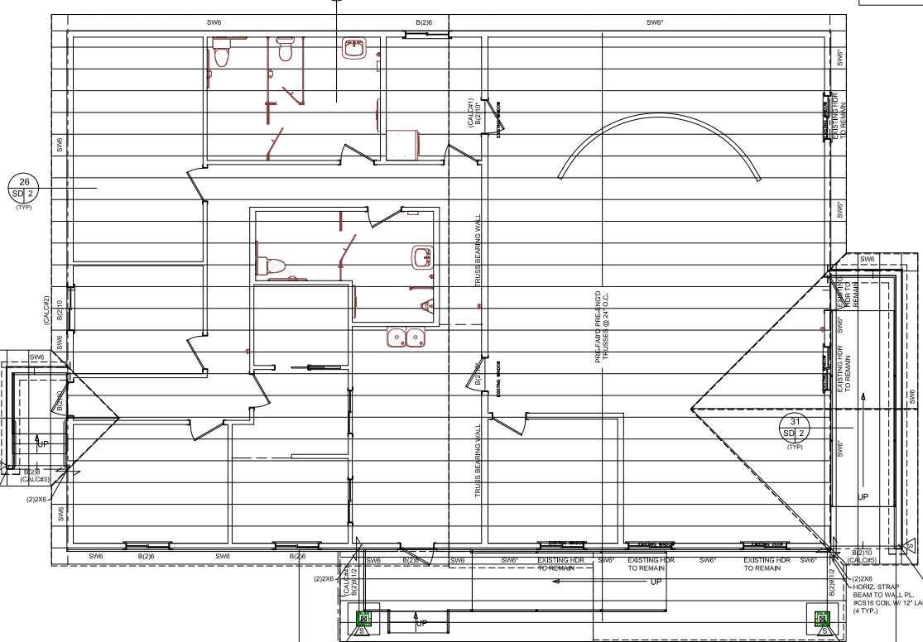
Figure 1
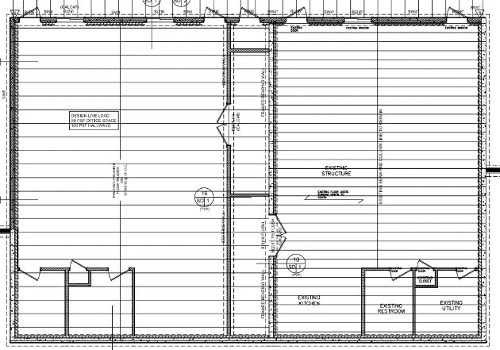
Figure 2
Statement of Work
The engineering drawings attached provide specific detail for the work to be performed. Each drawing has been reviewed and stamped by the required engineering disciplines. It is expected that upon completion the building and grounds will be complete and ready for occupancy. Including landscaping, asphalt, etc.
Request for Bid Criteria
- Building schedule: Plan start February/March 2023 and completed by October/ November 2023.
- All bids will be due by COB Friday, October 28, 2022.
- Contracts shall be a warded by competitive sealed bidding. Bids shall be opened publicly in the presence of one or more witnesses at the Clarkston Town Hall on November 1, 2022, during our regular public council meeting. The amount of each bid and any other relevant information, together with the name of each bidder, shall be recorded. The record and each bid shall be open to public inspection.
- Bids shall be opened to avoid disclosure of contents to competing offerors during the process of negotiation. A register of bids shall be prepared and shall be open for public inspection after contract award.
- Discussions may be conducted with responsible offerors who submit bids determined to be reasonably susceptible of being selected for award for the purpose of assuring full understanding of, and responsiveness to, solicitation requirements.
- Offerors shall be accorded fair and equal treatment with respect to any opportunity for discussion and revision of bids, and revisions may be permitted after submissions and prior to award for the purpose of obtaining best and final offers.
- There will be no disclosure of any information derived from bids submitted by competing offerors.
- Selection will be on the lowest responsive responsible bidder and the party to whom an award is given will be expected to enter into a contract with reasonable and customary terms.
- Cost-plus-a-percentage-of-cost contract is the type of contract Clarkston will pursue.
- Bid security in amount equal to at least 10% of the amount of the bid shall be required for all competitive sealed bidding for construction contracts. Bid security shall be a bond provided by a surety company authorized to do business in Utah, the equivalent in cash, or any other form satisfactory to the Town of Clarkston.
- Bonds necessary when contract is awarded — Waiver- Action — Attorneys' fees.
- When a construction contract is awarded, the contractor to whom the contract is awarded shall deliver the following bonds or security to the Town of Clarkston, which shall become binding on the parties upon the execution of the contract:
- Performance bond satisfactory to the Town of Clarkston that is in the amount equal to 100% of the price specified in the contract and is executed by a surety company authorized to do business in Utah or any other form satisfactory to the Town of Clarkston.
- Rules may provide for waiver of the requirement of a performance bond for circumstances in which the Town of Clarkston considers the bond to be unnecessary to protect the Town of Clarkston.
- Change orders which increases the contract amount shall be subject to prior written certification that the change order is within the determined project or contract budget. The certification shall be made by the mayor of the Town of Clarkston or another official, responsible for monitoring and reporting upon the status of the costs of the total project or contract budget. If the certification discloses a resulting increase in the total project or contract budget, the purchasing agent shall not execute or make the change order unless sufficient funds are available for the scope of the project or contract is adjusted to permit the degree of completion feasible within the total project or contract budget as it existed prior to the change order under consideration. However, with respect to the validity, as to the contractor, of any executed change order upon which the contractor has reasonably relied, it shall be presumed that there has been compliance with the provisions of this section.
Construction Criteria
- City will need to verify all color choices before ordering and where items are not specifically called out be granted an allowance that clearly states amount and what is being used.
- Rostrum will be high quality birch cabinetry with formica granite veneer finish. It will require an eight-inch step up to the platform or landing. Town will verify decorative details prior to ordering.
- Office areas will have built in cabinetry and cupboards supporting commercial use or modular cubicle type arrangements. Will require town’s approval before ordering.
- Mayor and city manager offices will be vacant but finished for occupancy.
- All areas, except bathrooms, will have commercial grade carpet and four-inch rubber baseboard that is clued on. Bathrooms will have vinyl floors with the same type of base.
- Public kitchen areas will have vinyl floors. Cabinetry should be low cost formica boxes with nice wood fronts. Cabinets will be verified for quality before ordering.
- Bathrooms: Plumbing fixtures need to be commercial grade quality. Provide in bid what fixtures will be used. Restrooms in the downstairs civic area are gender neutral and will need a urinal and toilet.
- Counter tops will be formica grade with a four inch back splash. Preference is granite veneer formica but is negotiable. Cabinets in the nonpublic areas could be a higher grade as they won't see the abuse level as the public areas.
- All exterior doors to be insulated steel doors with crash bars on the interior and anti-tamper on the exterior. Interior doors solid core birch wood stain grade with jam and casing to match. Open to negotiation.
- Windows need to be at least triple pane low-E glass with a solar heat gain coefficient of .28 or better. Please bid all new windows to be vinyl tempered glass Milgard brand.
- Roofing two options: 50-year shingles. Good standing seam metal roof (30 year or higher) with snow cleats installed over traffic areas. Discussion of cost and feasibility will determine which option.
- Exterior railings should be stainless steel or a comparable product that requires little or no upkeep.
Questions can be directed to the following individuals:
- Building/construction questions – Brent Godfrey 435-757-8841 (c) email: brent_godfrey@comcast.net
- Interior Design – Kristi Hidalgo or Holly Jones 435-563-9090
- Mayor Craig Hidalgo – 435-770-1229

For Bid Specifications and copies of Engineered Plans contact the Clarkston Town Hall 435-563-9090.

