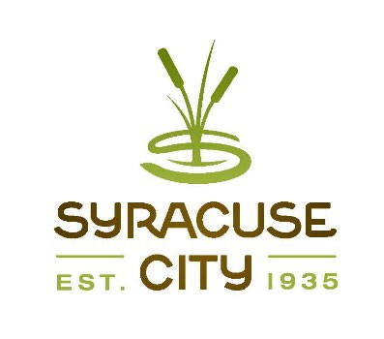Meeting called to order Adopt agenda
SYRACUSE CITY
Syracuse City Special Redevelopment Agency (RDA) Meeting September 13, 2022 – immediately following the City Council Business Meeting, which begins at 6:00 p.m.
In-Person Location: Syracuse City Hall, 1979 W. 1900 S. Electronic: Via Zoom Meeting
Connect via telephone: +1-301-715-8592 US, meeting ID: 812 6560 5947
Streamed on Syracuse City YouTube Channel

Proposed Resolution RDA R22-03 authorizing the execution of an agreement for tax increment financing (TIF) related to restaurant construction in the Syracuse Town Center Redevelopment Area. (5 min.)
- Adjourn.
~~~~~
In compliance with the Americans Disabilities Act, persons needing auxiliary communicative aids and services for this meeting should contact the City Offices at 801-825-1477 at least 48 hours in advance of the meeting.

CERTIFICATE OF POSTING
The undersigned, duly appointed City Recorder, does hereby certify that the above notice and agenda was posted within the Syracuse City limits on this 8th day of September, 2022 at Syracuse City Hall on the City Hall Notice Board and at http://www.syracuseut.com/. A copy was also provided to the Standard-Examiner on September 8, 2022.
CASSIE Z. BROWN, MMC SYRACUSE CITY RECORDER

