MINUTES OF A REGULAR CITY COUNCIL MEETING HELD AUGUST 18, 2022 AT THE HYRUM CITY COUNCIL CHAMBERS, 60 WEST MAIN, HYRUM, UTAH.

CONVENED: 6:30 P.M.

CONDUCTING: Mayor Stephanie Miller

ROLL CALL: Councilmembers Steve Adams, Paul James, Vicky McCombs, and Craig L. Rasmussen

CALL TO ORDER: There being four members present and four members representing a quorum, Mayor Stephanie Miller called the meeting to order.

EXCUSED: Councilmember Jared Clawson

OTHERS PRESENT: City Administrator Ron Salvesen, Lineman Quentin Voth, and two citizens. City Recorder Stephanie Fricke recorded the minutes.

WELCOME: Mayor Stephanie Miller welcomed everyone in attendance and invited audience participation.

PLEDGE OF ALLEGIANCE: Mayor Miller

INVOCATION: Councilmember Clawson

APPROVAL OF MINUTES:

The minutes of a regular meeting on August 4, 2022 were approved as written.

ACTION Councilmember James made a motion to approve the minutes of a regular meeting held on August 4, 2022 as written. Councilmember McCombs seconded the motion and Councilmembers Adams, James, McCombs, and Rasmussen voted aye. The motion passed.

AGENDA ADOPTION: A copy of the notice and agenda for this meeting was emailed to The Herald Journal, posted on the Utah Public Notice Website and Hyrum City’s Website, provided to each member of the governing body, and posted at the City Offices more than forty-eight hours before meeting time.

ACTION Councilmember James made a motion to approve the agenda for August 18, 2022 as written. Councilmember Rasmussen seconded the motion and Councilmembers Adams, James, McCombs, and Rasmussen voted aye. The motion passed.

9. INTRODUCTION AND APPROVAL OF RESOLUTIONS AND ORDINANCES
A. Resolution 22-13 - A resolution authorizing and approving an amended and restated capacity purchase agreement between the City and Utah Associated Municipal Power Systems, and related matters.
10. OTHER BUSINESS
A. Presentation of the Power Rate Study.
B. Mayor and City Council Reports.
11. ADJOURNMENT

PUBLIC COMMENT:

Mayor Miller said if a citizen has a question or would like to make a comment to please keep it under three minutes.

There being no public comment, Mayor Miller moved to the next agenda item.

INTRODUCTION AND APPROVAL OF RESOLUTIONS AND ORDINANCES:

Resolution 22-13 - A resolution authorizing AND APPROVING AN AMENDED AND RESTATED CAPACITY PURCHASE AGREEMENT BETWEEN THE cITY AND uTAH aSSOCIATED mUNICIPAL pOWER sySTEMS, AND RELATED MATTERS.

ACTION Councilmember James made a motion to approve Resolution 22-13 - A resolution authorizing and approving an amended and restated capacity purchase agreement between the City and Utah Associated Municipal Power Systems, and related matters. Councilmember McCombs seconded the motion and Councilmembers Adams, James, McCombs, and Rasmussen voted aye. The motion passed.

OTHER BUSINESS:

Presentation of the Power Rate Study.

Dave Berg with Dave Berg Consulting presented the final Power Rate Study of Hyrum City’s Electric Utility through a zoom call. The following information was presented by Dave Berg.

Dave Berg Consulting, LLC has undertaken a study of the retail rates Hyrum City (Hyrum) charges its customers for electric service. This report summarizes the analyses undertaken and the resulting recommendations for changes to the existing rates. The recommended rate adjustments have been made based on overall revenue and cash reserve needs of the utility and the results of a cost-of-service analysis. We recommend that an increase of 15% in FY 2023 with an additional increase of 10% in FY 2025. These increases are necessitated by increasing costs, including wholesale power costs and capital improvement needs, through the Study Period that negatively impact Hyrum’s financial results and level of cash reserves. Additional specific rate design issues have also been addressed in the rate recommendations.

The rates charged for electric service by Hyrum, combined with other operating and non- operating revenues, must be sufficient to meet the cost of providing services to Hyrum’s retail customers. This is necessary to ensure the long-term financial health of Hyrum. The cost of providing electric service consists of normal operating expenses such as purchased power, distribution functions, customer and administrative functions, system depreciation expenses, capital improvements, and other non-operating expenses.

An analysis of the operating results for Hyrum during the FY 2022-2026 Study Period has been performed assuming the current retail rates and charges remain in effect for the electric utility through the Study Period. This analysis has been done to determine the overall need, if any, for additional revenue through rates to meet projected revenue requirements. The analyses and assumptions utilized in these projections are explained below.

Estimated Revenues – Existing Rates

Retail Sales

Hyrum sells retail power and energy to residential, commercial and industrial customers. Hyrum retail sales grew 5.5% from 2021 to 2022. For 2023, sales are projected to increase 6.3%, primarily due to a large expansion at a large commercial customer. Total sales growth for the remainder of the Study Period is estimated to average approximately 2%.

Exhibit 2-A is a summarized listing of Hyrum’s historical and projected electric operating results at existing rates. The historical and projected revenues from retail sales of power and energy to different groups of customers are included at the beginning of the exhibit under Charges for Sales and Services. Operating revenues also include power factor penalties, connection fees and miscellaneous revenues.

Revenue Requirements

Purchased Power

Hyrum currently meets its wholesale power and energy requirements through its participation in Colorado River Storage Project hydro units and through its wholesale arrangement with UAMPS. Hyrum also has access, through UAMPS, to the real time wholesale market for both purchases and sales. Average wholesale power costs are assumed to increase 4% per year through the Study Period.
Hyrum’s actual retail sales and wholesale requirements for the FY 2021 Test Year are shown in Table 2-1.

Table 2-1 Retail Sales
And Wholesale Requirements
Item | 2021
Metered Retail Sales | 95,752,039 kWh
Wholesale Energy | 102,553,419 kWh
Wholesale Peak | 19,912 kW

Other Operating Expenses

Hyrum incurs other operating expenses associated with local electric system operations. Distribution operating and maintenance expenses are related to the substations, overhead and underground lines and customer facilities located in Hyrum. Hyrum also has customer account expenses related to serving retail electric customers. Administrative and general expenses are required for utility management, employee benefits, training and other administrative costs. Non-wholesale power related expenses are based on 2021 and 2022 values, the 2023 budget and are generally estimated to increase by 4.0% per year after 2023.

Depreciation

Hyrum has annual depreciation costs based on its system investments. Depreciation during the Study Period is based on budgeted Hyrum amounts and future capital improvements. Depreciation is a funded non-cash expense that generates monies available for annual capital improvements and reserves.

Non-operating Revenue (Expenses)

Hyrum’s non-operating revenue is primarily associated with investment income. Hyrum also receives impact fees from developers.

Capital Improvements

Hyrum makes annual normal capital investments in its electric system. Annual electric capital improvements for the Study Period, as budgeted by Hyrum, are shown in Table 2- 2 below.

Table 2-2
Capital Improvements

Capital Item | 2022 | 2023 | 2024 | 2025 | 2026
Revenue Financed | $1.421,311 | $3,223,700 | $1,000,000 | $1,000,000 | $1,000,000

Projected Operating Results – Existing Rates
Year | 2022 | 2023 | 2024 | 2025 | 2026
Operating Revenues | $9,627,223 | $9,397,469 | $9,685,282 | $9,982,918 | $10,308,642
Less Operating  Expenses | (10,140,273) | (11,162,166) | (11,227,632) | (11,826,908) | (12,474,613)
Plus Non -Operating Revenues (Expenses) | 12,352 | 13,200 | - | - | -
Plus Transfer In | 1,500,000 | - | - | - | -
Plus Impact Fees | 238,640 | 126,500 | 126,500 | 126,500 | 126,500
Change in Net Position | $1,237,942 | $(1,624,997) | $(1,415,850) | $(1,717,490) | $(2,039,472)
Net Position as Percent of Revenues | 12.9% | -17.3% | -14.6% | -17.2% | -19.8%
Based on the assumptions outlined above, the resulting projected operating results assuming continued application of the existing retail rates are summarized in Table 2-3 for the electric utility. A summary presentation of the operating results is shown in Exhibit 2-A.

Table 2-3
Projected Operating Results Existing Rates

Cash Reserves

A summary of the impact of the projected operating results on Hyrum’s cash reserves for the Study Period is shown at the end of Exhibit 2-A and in Table 2-4 below.
As shown below, under existing retail rates and estimated revenue requirements over the Study Period, the cash reserves for the electric utility are projected to decrease from approximately $3.4 million at the end of 2021 to approximately negative $6.8 million by the end of 2026. This is a decrease from 39% of revenues to negative 66% of revenues.

Table 2-4
Projected Cash Reserves Existing Rates

Year | 2022 | 2023 | 2024 | 2025 | 2026
Beginning Balance | $3,407,554 | $3,408,052 | $(853,265) | $(2,574,278) | $(4,563,598)
Plus Change in Net Position | 1,237,942 | (1,624,997) | (1,415,850) | (1,717,490) | (2,039,472)
Plus Depreciation | 540,000 | 587,380 | 694,837 | 728,170 | 761,504
Less Capital Improvements | (1,421,411) | (3,223,700) | (1,000,000) | (1,000,000) | (1,000,000)
Ending Balance | $3,408,052 | $(853,265) | $(2,574,278) | $(4,563,598) | $(6,841,566)
Reserves as % of Revenue | 35% | -9% | -27% | -46% | -66%

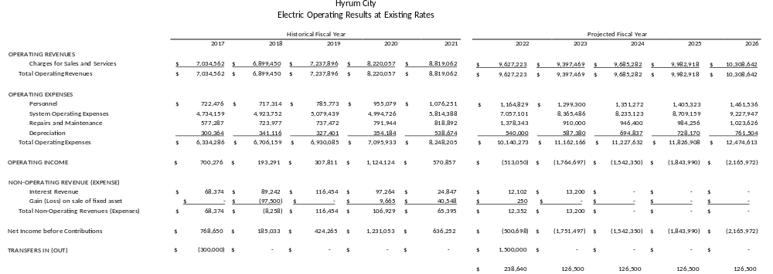

A cost-of-service analysis was performed to determine the allocated cost to serve each of Hyrum’s customer classes within the electric utility. Customer classes exist, in part, because the cost to serve different kinds of customers varies. The cost-of-service analysis has been performed on a FY 2021 ‘Test Year’ based on actual 2021 financials, operations and sales. The results of the cost-of-service study give an indication of the degree of revenue recovery warranted for each class of customers. A comparison of the allocated cost to serve a class of customers and the actual revenues received from that class is taken into consideration during rate design.

Functionalization of Costs
Hyrum’s Test Year electric revenue requirements have been divided into four functional categories. These categories are described below.

Power Supply – the power supply function is related to the cost of Hyrum’s purchases of wholesale power through UAMPS, CRSP and the wholesale market.

Distribution – expenses are related to the Hyrum owned system for delivering power and energy to Hyrum customers. They include local substation and distribution system costs.

Customer – the customer function includes fixed costs associated with the service facilities utilized to deliver electric power and energy directly to customers. They also include items such as meter reading, billing, collections and dealing with customers by customer service representatives.

Revenue – revenue related items include other operating and non-operating income and utility margin.
Table 3-1 below summarizes the functional electric costs for the 2021 Test Year. The detailed cost functions are shown in Exhibit 3-A.

Table 3-1
Functional Electric Costs
2021 Test Year
Component | Revenue  Requirement
Power Supply | $5,555,860
Distribution | 853,949
Customer | 308,066
Revenue | 548,840
Total | $7,266,715

Classification of Costs
Within each function, the revenue requirements have been divided into distinct cost classifications. These cost classifications are described below.

Demand Related – demand related costs are fixed costs that do not vary with hourly consumption. Demand related costs are required to meet the overall demand of the system as expressed in kW.
Energy Related – energy related costs vary based on hourly consumption in kWh
Customer Related – costs related to serving, metering and billing of individual customers.
Revenue Related – revenue related costs vary by the amount of revenue received by the utility.
Exhibits 3-B through 3-D show the detailed classification of revenue requirements within the functions.

Allocation of Costs
Based on an analysis of customer class service characteristics, the classified costs summarized above were allocated to the major Hyrum customer classes. Allocation of costs was performed on a fully-distributed, embedded cost allocation basis. Specific allocation factors were utilized in each of the cost classification categories as described below. Exhibit 3-E contains a summary of the development of the various allocation factors.

Demand Allocations
Customer class demands on a system can be reflected in various ways. Two primary demand allocation types were utilized in this analysis. A common industry allocator known as Coincident Peak Demand (CP) allocator is utilized to allocate demand related costs based on each class’ contribution to the system peak demand each month. A 12 CP demand allocator was utilized for power supply related demand costs. A Non-coincident Peak Demand (NCP) reflects a class maximum demand regardless of when it occurs. A 1 NCP method, an estimate of each class’ maximum annual demand on the system, was utilized for allocating local system demand related costs.

Energy Allocations
Each class’ share of energy requirements was used to allocate energy related costs. The predominant energy related costs are the energy portions of the purchased power expenses. These costs were allocated based on each classes’ estimated share of energy purchases.

Customer Allocations
Two separate customer allocators were utilized. The customer facilities allocator was used to allocate costs associated with the physical facilities required to serve individual customers. The customer service allocator is for allocation of costs associated with customer service – meter reading, billing, collections and customer inquiries. For both the customer meter and customer service allocators, a weighted customer allocation factor is developed. Weighting factors are developed to represent the difference in service configurations between customer classifications. For instance, a larger customer facility is required for a single large power customer than for a single residential customer, or a single large power customer requires more customer service than a single residential customer.

Revenue Allocations
Revenue related costs were allocated based on each class’ share of total demand, energy, customer facility, customer service and direct costs.

Cost of Service Results
Based on the classifications and allocations described above, the estimated cost to serve each major class of customers for the 2021 Test Year was determined. Exhibit 3-F presents this analysis in detail. Table 3-2 below summarizes the total allocated electric costs for each class compared to the total electric revenues received from the class during 2021.

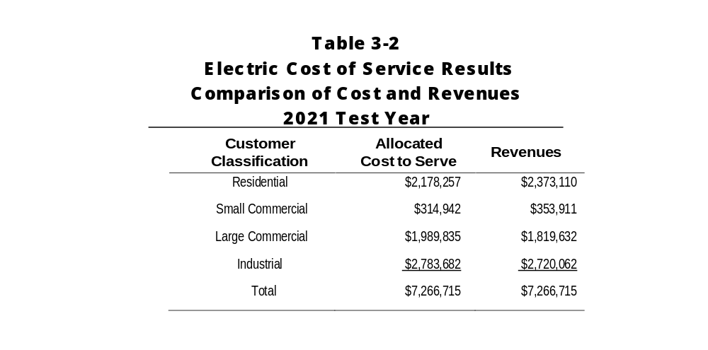
The revenue requirements and revenues as allocated to each class and summarized above are shown on a total dollars basis. Table 3-3 below makes the comparison based on percentages of total cost to serve and total revenues. The percentage increase/(decrease) in each class’ revenue shown below is the adjustment necessary to produce revenues from each class in accordance with the allocated cost to serve. The percentage adjustments do not represent the recommended change in each class’ rates. Table 3-4 makes the comparisons between allocated cost to serve and revenue on an average $/kWh basis. The cost-of-service results are one item for consideration in rate design. It is important to note also that the adjustments shown in the table below would not change the total revenue received by the utility and are not indicative of overall revenue needs of the utility going forward. Recommendations regarding rate design are included in Section 4 of this report.

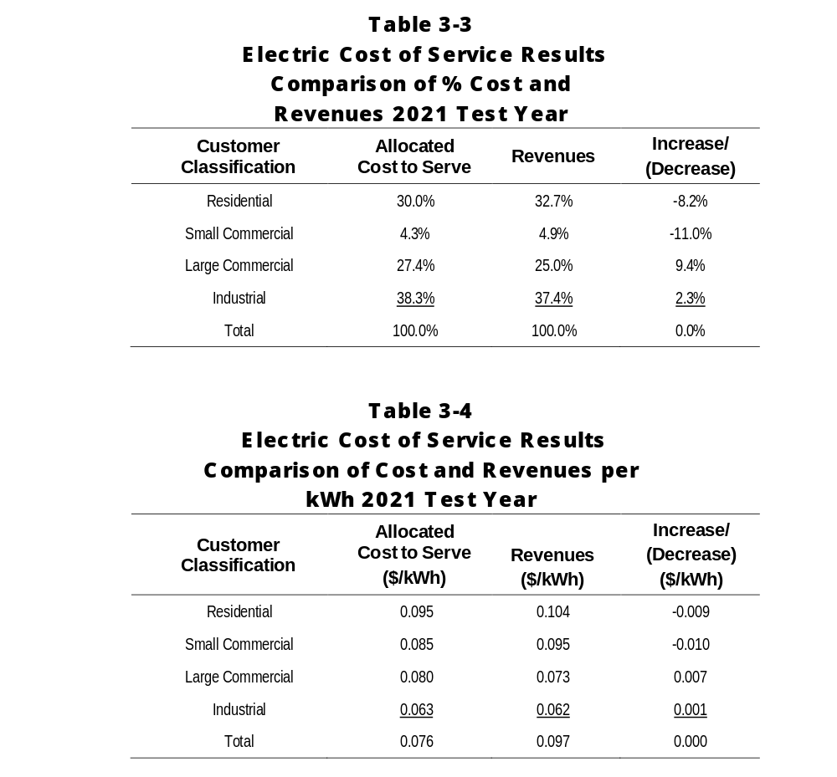

As indicated above, Hyrum’s existing class revenues do not exactly match the allocated cost to serve each class. Cost based rates are one of several goals in establishing rates. The relationship between allocated costs and revenues for each class should be considered, in addition to other rate related goals, in developing recommended rates.

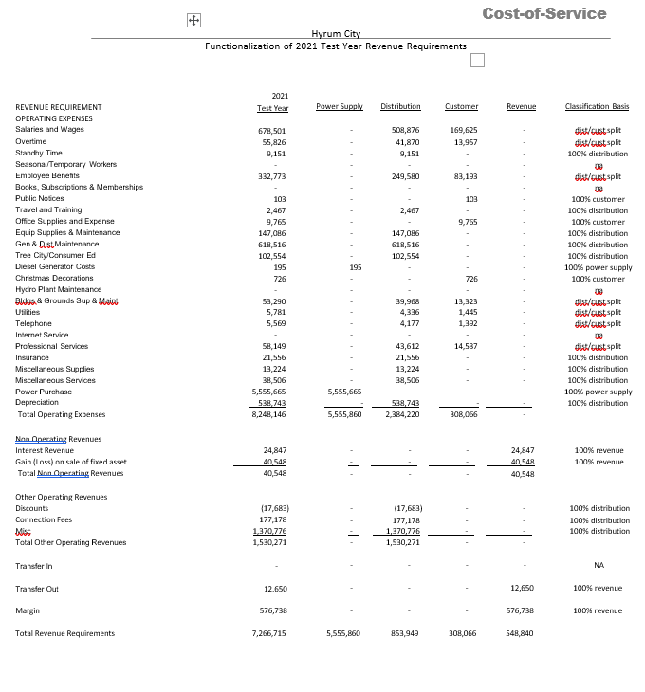

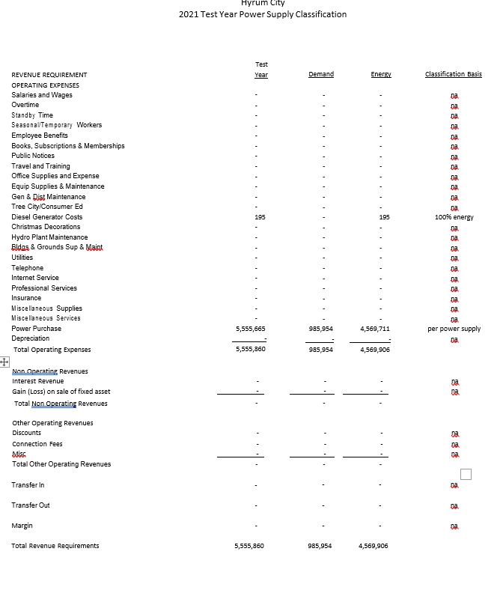

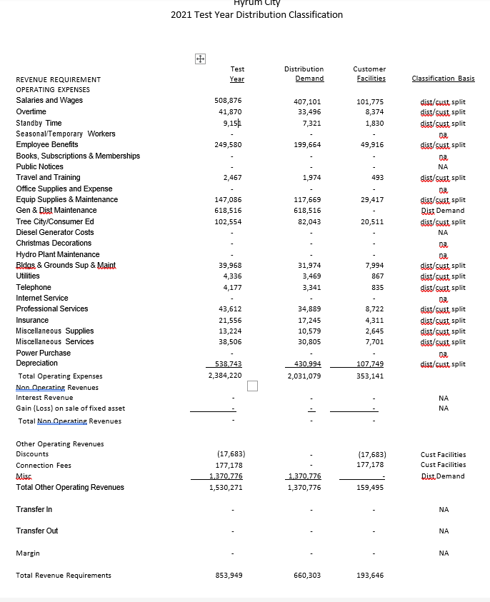

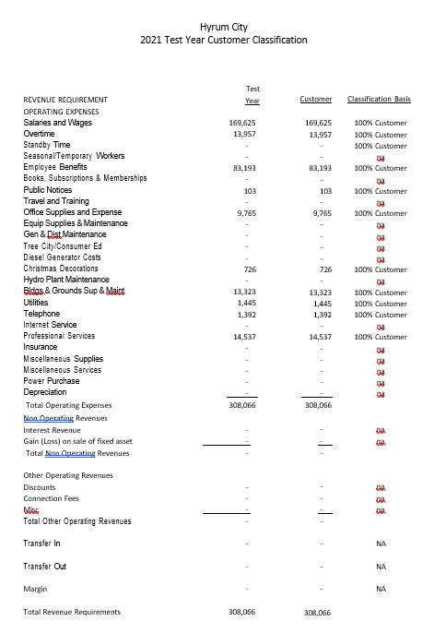

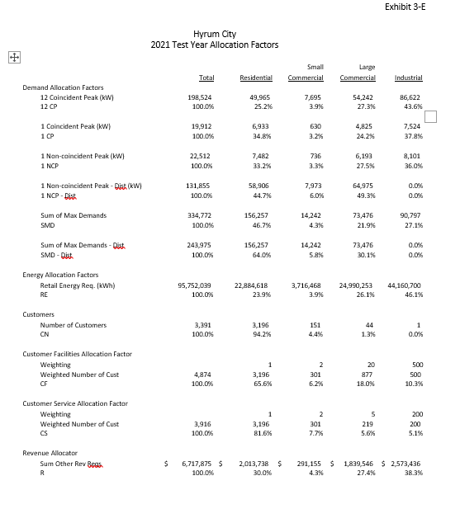

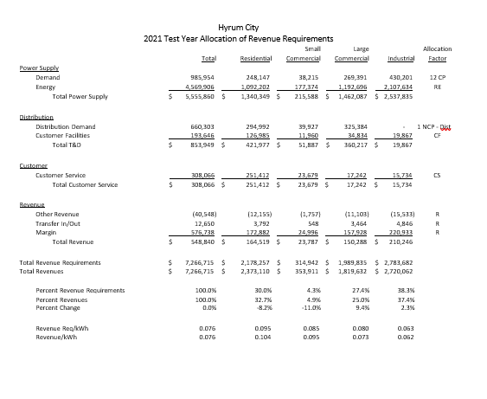
Changes to rates are generally based on the overall need for revenues and results of the cost-of-service analyses. The projected operating results at existing rates as presented in Section 2 of this report outlines the overall revenue needs of the electric utility. Section 3 summarizes the cost-of-service results. These factors have been considered in developing the proposed rates summarized in this section of the report.

Proposed Rates

Revenue Needs

In Section 2, it shows that Hyrum’s projected annual change in net position decreases from 12.9% of revenue in 2022 to minus 19.8% of revenue in 2026. Additionally, Hyrum’s projected total cash reserves at current rates is expected to decrease from $3.4 million to negative $6.8 million over the Study Period. This represents a significant decrease in total reserve levels and the reserves are projected to be negative 66% of operating revenue by the end of the Study Period. Based on the projected results, an overall rate increase of 15% for FY 2023 with an additional increase of 10% for FY 2025 is recommended at this time. Total increases through 2026 average 6.1% each year.

Rate Design Adjustments

The cost-of-service analysis summarized in Section 3 shows that the Residential and Small Commercial customers are providing subsidies to the Large Commercial customers. As such, higher increases are recommended for the Large Commercial customers with lower increases for the Residential and Small Commercial customers. The specific rate recommendations for all classes are described below and shown in Exhibit 4-A. The proposed rates in Exhibit 4-A are shown for each fiscal year. The FY 2023 rates are assumed to be effective in September 2022.

Residential rates: The current Residential rates include an inclining block structure. Under this structure, greater amounts of usage have an increasingly higher rate. This type of rate structure is partially designed to encourage conservation among users. The first 500 kWh each month are 8.46 cents/kWh the next 250 kWh are 11.03 cents per kWh and over 750 kWh are 13.76 cents/kWh for regular Residential rates. The Residential rates also include a monthly flat customer service charge of $6 per month. Blacksmith Fork residential customers pay the same energy rates but pay a higher monthly customer charge of $10. Rocky Mountain Power currently has a $10/month service charge for Residential customers. The current rate design is advantageous for small residential customers utilizing 500 kWh or less. An average Hyrum Residential customer uses approximately 620 kWh per month. Increases in both the monthly fixed charge and energy charges are recommended. The average increase for Residential customers in the first adjustment is 12% with an additional 10% increase in 2025.

Small Commercial rates: These rates have both energy and demand rates as well as a monthly customer charge. There is higher energy rate for the first 1500 kWh with a lower rate for energy over that amount. The demand rate is applicable to all demand exceeding 5 kW each month. This type of rate design is intended to have the demand charge become effective as the customer’s usage exceeds the 1500-kWh threshold. An average Small Commercial customer utilizes approximately 2100 kWh per month. The current structure is retained. The increases are applied to each of the rate components. The average increase for Small Commercial customers in the first adjustment is 12% with an additional 10% increase in 2025.

Large Commercial rates: The current structure of this rate is identical to the Small Commercial rates. However, the energy rates for this class are lower than for the Small Commercial class. The differing energy rates between Large and Small Commercial rates is the reason for the subsidization of Large Commercial customers as summarized in Section 3 of this report. An average Large Commercial customer utilizes approximately 47,500 kWh per month, substantially more than the average Small Commercial customer.

It is recommended that the structure of rates for this class be adjusted to bill all customers for all demand each month, not just the amount over 5 kW, and a single energy rate be applied to all energy each month. The demand and energy rates are set equal to the second block demand and energy rates in the Small Commercial class with a higher customer charge for the Large Commercial class. In this class the average increase is 19% in the first adjustment with an additional 10% increase in 2025.

Industrial rates: Hyrum has a unique rate for its single Industrial customer. This customer is very large and owns its own substation. The current rate is adjusted each month based on actual Hyrum wholesale power costs. The rate calculation includes two separate adjustments, one % adjustment and a second per kWh adjustment. It is recommended that the current formula rate for this customer be retained with increases in both adjustments are shown in Exhibit 4-A. For this single customer class, the increase is 15% in the first adjustment and an additional 10% increase in 2025.
The existing and proposed rates are summarized in Exhibit 4-A.

Rate Comparisons

Table 4-1 below shows comparative monthly bills for different kinds of customers based on Hyrum’s existing and 2023 proposed rates and Rocky Mountain Power (RMP) existing summer and winter rates. Three different Residential bills are shown (400 kWh, 1000 kWh and 2000 kWh). Three different Small Commercial customers, 500 kWh with a 2- kW demand, a 2000 kWh/5 kW bill and a 6,000 kWh/15 kW bill are shown. For Large Commercial the usage shown is 47,000 kWh with 130 kW of demand.

Table 4-1
Monthly Bill Comparisons
Customer Type and Usage | Hyrum Present | Hyrum 2023 Proposed | RMP  Winter | RMP  Summer
Residential 400 kWh | $39.82 | $46.20 | $43.93 | $48.34
Residential 1000 kWh | $110.27 | $123.00 | $110.00 | $123.00
Residential 2000 kWh | $247.91 | $267.00 | $220.13 | $247.45
Small Commercial 500 kWh/2 kW | $157 | $170 | $175 | $188
Small Commercial 2,000 kWh/5 kW | $183 | $200 | $210 | $227
Small Commercial 6,000 kWh/15 kW | $470 | $534 | $523 | $576
Large Commercial 47,000 kWh/130 kW | $3,332 | $4,067 | $3,941 | $4,375

Projected Operating Results – Proposed Rates

Table 4-2 below summarizes the revised projected operating results with the proposed rate increases. A more detailed presentation of operating results at proposed rates is included in Exhibit 4-B. The annual increases in rates result in the projected change in net position increasing each year. Table 4-3 below summarizes projected cash reserves assuming implementation of the recommended annual rate increases. The projected reserves at the end of 2026 are now $684,000 and equal to only 5% of operating revenue. This is still a low reserve level, Hyrum should continuously monitor its financial results and adjust rates as necessary to meet its goals.

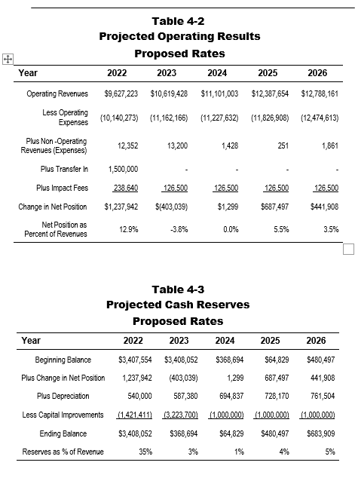

Purchased Power Adjustment Clause
The cost of wholesale power accounts for approximately two-thirds of Hyrum’s operating expenses. In the recent past, Hyrum has benefited from relatively stable wholesale power costs, this stability of wholesale costs has allowed Hyrum to maintain stable retail rates for its customers. The current projections for wholesale power costs include an assumption of 4% annual increases in average costs through 2026. The projected results shown in Tables 4-2 and 4-3 above assume those wholesale cost projections and the resulting rate adjustments are made in part to cover those costs. As wholesale costs become more volatile, it can become more difficult to make necessary adjustments to retail rates to match those wholesale changes. Many utilities employ a rate mechanism known as a Purchased Power Adjustment Clause (PPAC) to automatically adjust retail rates to reflect wholesale power costs. If wholesale costs are higher than expected, retail rates are automatically higher and if lower than expected retail rates are automatically lower. Rocky Mountain Power has a similar rate provision it calls the Energy Balancing Account that “accounts for differences between actual power costs and the level of power costs that were set in customer rates.” It is recommended that Hyrum implement a PPAC that automatically adjusts on an annual basis utilizing the following formula:
Proposed formula:


Where:
- PPA is the purchased power adjustment per kWh.
- WPC is the projected wholesale power cost in dollars for the projected year.
- Over/Under is the amount in dollars that the previous year’s estimated PPA over or under collected total wholesale costs in the previous year.
- PRE is the projected annual retail energy sales in kWh.
- 0.0687 is the base dollars per kWh.

The estimated average wholesale power cost per retail kWh in fiscal 2023 is 6.87 cents per kWh. That is the assumed power cost for 2023 and the estimated PPA for 2023 would be 0.00 per kWh. Exhibit 4-C presents proposed rates similar to Exhibit 4-A for each year through 2026. At the bottom of Exhibit 4-C is the estimated PPAC value for each year. That rate would be charged to all customers (not including Industrial) as an additional energy charge. If wholesale costs meet projections, the net rates in Exhibit 4-A and 4-C would be the same. The energy rates shown in Exhibit 4-C plus the PPAC value at the bottom of Exhibit 4-C equal the energy rates in Exhibit 4-A. A spreadsheet will be provided to Hyrum staff for calculation of the annual PPAC value. The PPAC would not be applied to the Industrial class, the Industrial rate is already adjusted monthly based on actual wholesale power costs.

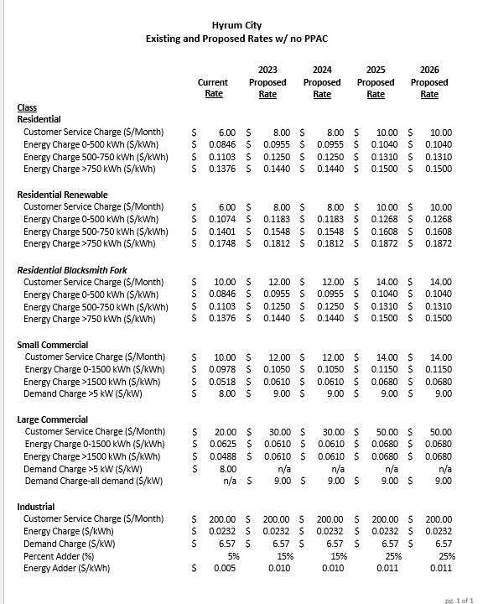

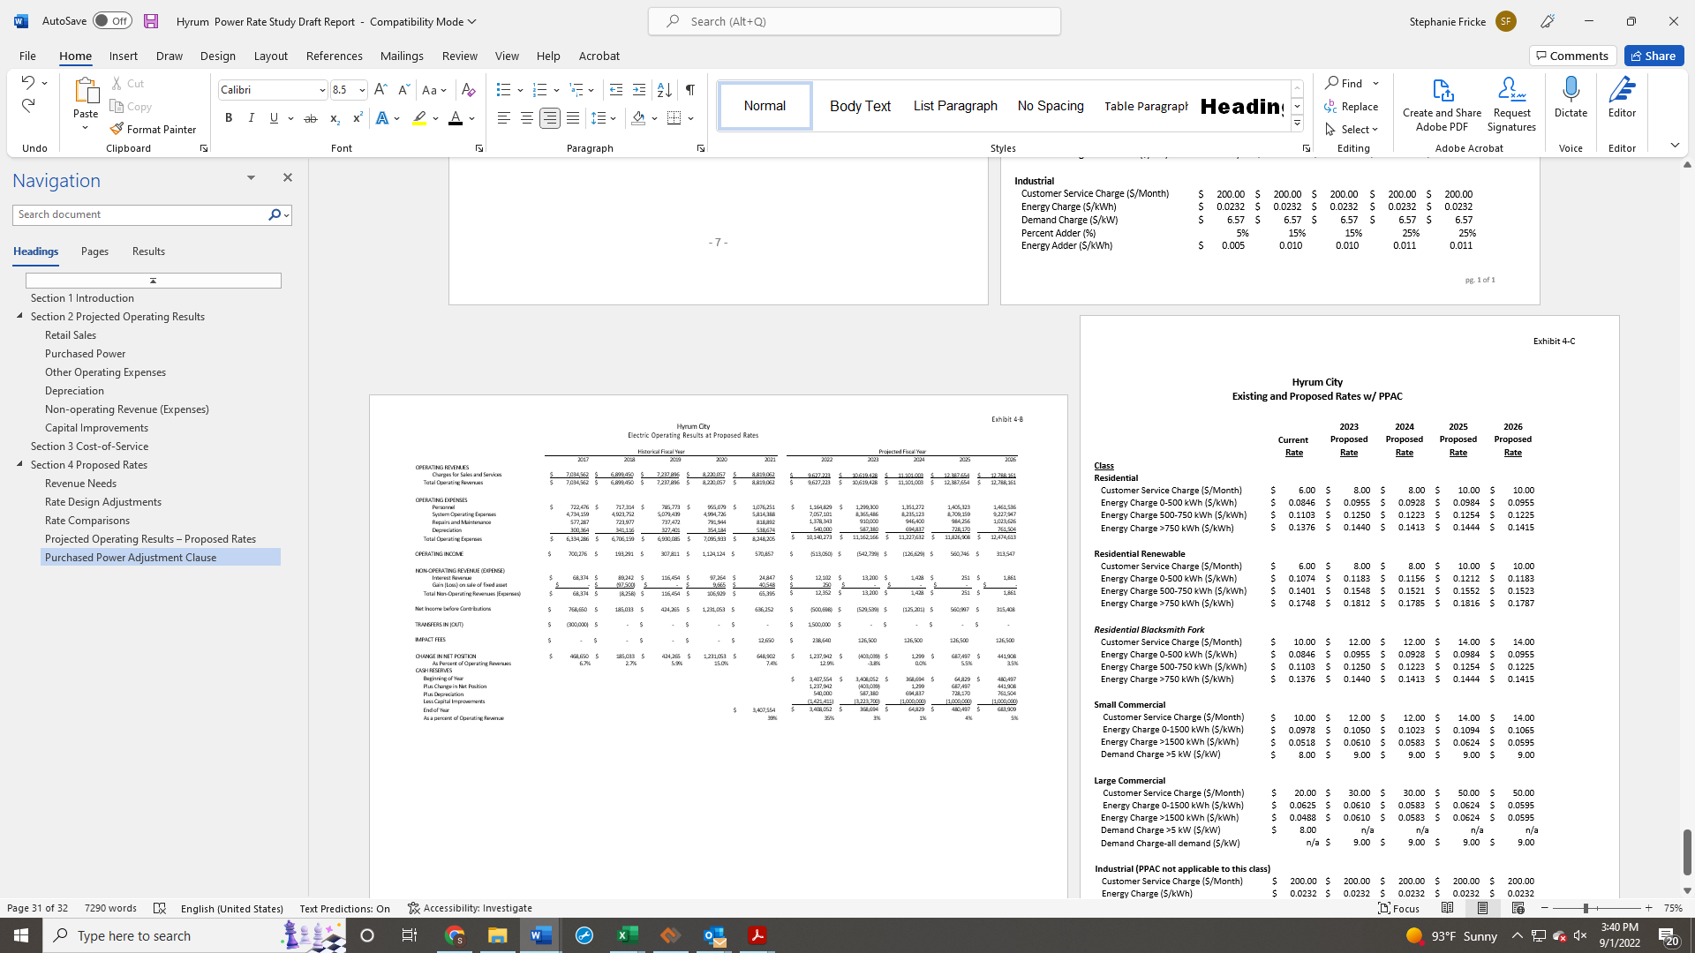
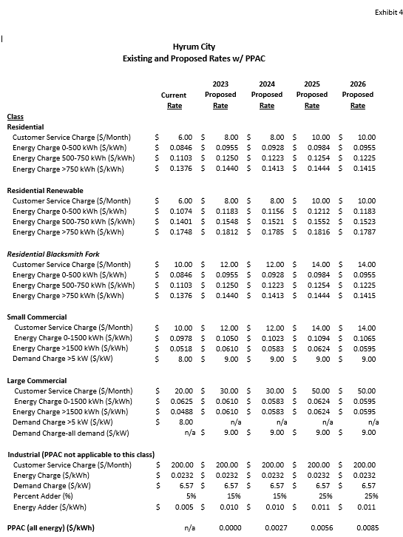

MAYOR AND CITY COUNCIL REPORTS.

Councilmember Rasmussen said the paint removal on the exterior of the Elite Hall is finished. The brick still needs to be repaired on the exterior of the building. Rain gutters need to be installed to help prevent future damage to the brick.

Councilmember James said he would arrange for Santa Claus to be at the Holiday Celebration on the City Square the day after Thanksgiving. The Hyrum Hornets won the Northern Region Tournament this year and with the number of people attending the games the City should invest in an announcement system for the ball diamonds.

Councilmember McCombs said there are some cracks in the cement at the Senior Center that need to be filled to help prevent tripping.

Mayor Miller said the Cache Garbage Coalition is accepting bids on the RFP for garbage service. Three cities in the north are opting out of the Coalition. Wastewater Treatment Plant Superintendent Kevin Maughan retires the end of September and the City has hired Angela Pritchett to replace him. City Administrator Ron Salvesen has announced he will retire on November 10.

ADJOURNMENT:

ACTION There being no further business before the City Council, the Council Meeting adjourned at 7:40 p.m.

_________________________________
Stephanie Miller
ATTEST: Mayor

______________________________
Stephanie Fricke
City Recorder

Approved: September 1, 2022__
As Written

