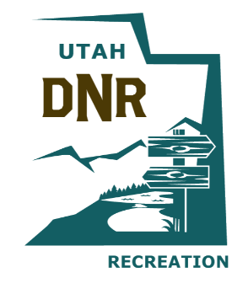
OHV Advisory Council Meeting 08/19/2022
DIVISION OF OUTDOOR RECREATION
OFF-HIGHWAY VEHICLE ADVISORY COUNCIL MEETING

AUDIO RECORDING LINK
https://youtu.be/2gwUmW7dVWQ

