MINUTES OF A REGULAR CITY COUNCIL MEETING HELD AUGUST 4, 2022 AT THE HYRUM CITY COUNCIL CHAMBERS, 60 WEST MAIN, HYRUM, UTAH.

CONVENED: 6:30 P.M.

CONDUCTING: Mayor Stephanie Miller

ROLL CALL: Councilmembers Steve Adams, Jared Clawson, Paul James, and Craig L. Rasmussen

CALL TO ORDER: There being four members present and four members representing a quorum, Mayor Stephanie Miller called the meeting to order.

EXCUSED: Councilmember Vicky McCombs

OTHERS PRESENT: City Administrator Ron Salvesen, and Zoning Administrator Matt Holmes, Power Superintendent Matt Draper, City Treasurer Todd Perkins, and nine citizens. City Recorder Stephanie Fricke recorded the minutes.

WELCOME: Mayor Stephanie Miller welcomed everyone in attendance and invited audience participation.

PLEDGE OF ALLEGIANCE: Councilmember Rasmussen

INVOCATION: Councilmember Adams

APPROVAL OF MINUTES:

The minutes of a regular meeting on July 21, 2022 were approved as written.

ACTION Councilmember James made a motion to approve the minutes of a regular meeting held on July 21, 2022 as written. Councilmember Rasmussen seconded the motion and Councilmembers Adams, Clawson, James, and Rasmussen voted aye. The motion passed.

AGENDA ADOPTION: A copy of the notice and agenda for this meeting was emailed to The Herald Journal, posted on the Utah Public Notice Website and Hyrum City’s Website, provided to each member of the governing body, and posted at the City Offices more than forty-eight hours before meeting time.

ACTION Councilmember Clawson made a motion to approve the agenda for August 4, 2022 as written. Councilmember James seconded the motion and Councilmembers Adams, Clawson, James, and Rasmussen voted aye. The motion passed.

10. SCHEDULED DELEGATIONS
A. Amber Wiedmeier - To request a Home Occupation Business License at 26 South 100 West for a preschool.
B. Roy Savage, Hidden Valley Estates PUD - To request Preliminary Plat approval for Hidden Valley Estates PUD located at approximately 900 West 85 South consisting of 13 single family lots on 34 acres.
C. David Madsen, Harvest Valley Court P.U.D. - To request Preliminary Plat approval for Harvest Valley Court P.U.D. located at approximately 43 North 300 East consisting of 28 patio home units on 3.75 acres.
D. Jeremy Broadhurst, Hyrum Self Storage - To request Site Plan approval for expansion of Hyrum Self Storage located at approximately 168 South 1720 East for shipping containers used for storage on .93 acres of real property.
10. INTRODUCTION AND APPROVAL OF RESOLUTIONS AND ORDINANCES
A. Resolution 22-11 - A resolution authorizing the Red Mesa Tapaha Solar Project amended and restated transaction schedule under the Power Supply Agreement with Utah Associated Municipal Power Systems, and related matters.
B. Resolution 22-12 - A Resolution declaring certain Hyrum City equipment (Conference Table) as surplus and ordering the sale or disposal thereof.
11. OTHER BUSINESS
A. Presentation of the Power Rate Study.
B. Mayor and City Council Reports.
12. ADJOURNMENT

PUBLIC COMMENT:

Mayor Miller said if a citizen has a question or would like to make a comment to please keep it under three minutes.

Joe Tenant said he moved to Hyrum in 2019 and attended a City Council meeting regarding the Hidden Valley PUD and was wondering why the City Council had different requirements for a PUD than a regular subdivision.

Councilmember Rasmussen said a Planned Unit Development has different requirements than a subdivision because it allows for a developer to create a unique development with more density in exchange for amenities; and it also requires keeping 50% of the land to be open space. If a developer meets all the conditions for a regular subdivision the City Council has to approve it, but the City Council can deny a PUD.

There being no further public comment, Mayor Miller moved to the next agenda item.

SCHEDULED DELEGATIONS:

Amber Wiedmeier - To request a Home Occupation Business License at 26 South 100 West for a preschool.

Amber Wiedmeier said she would like a Home Occupation Business License at 26 South 100 West for a preschool. It would be a Christian Preschool where she would teach them letters, numbers, and about Christ. There would be a maximum of 10 children per class.

ACTION Councilmember Clawson made a motion to approve Home Occupation Business License at 26 South 100 West for a preschool upon the condition that she receives a license from the State of Utah. Councilmember Adams seconded the motion and Councilmembers Adams, Clawson, James, and Rasmussen voted aye. The motion passed.

Roy Savage, Hidden Valley Estates PUD - To request Preliminary Plat approval for Hidden Valley Estates PUD located at approximately 900 West 85 South consisting of 13 single family lots on 34 acres.

Zoning Administrator Matt Holmes said the Planning Commission recommended approval of the Preliminary Plat for Hidden Valley Estates PUD located at approximately 900 West 85 South consisting of 13 single family lots on 34 acres with the following recommendations: 1. Drainage and stormwater be addressed; 2. Swales on lots 1, 2, 12, and 13 will not contribute to storage and may have erosion concerns that should be addressed per the comments on the plat; 3. Plat be updated with any existing land drains, high water limits (flood and dam failure), wetlands, etc. with a letter from the U.S. Army Corp is required; 4. Street lights be shown on plans; 5. Ribbon curb is approved by the Planning Commission; 6. Animal rights are to be kept for all lots in this subdivision; 7. The City Council accept the offer of ownership of the land between this subdivision and Hidden Valley with the boundaries to be shown on plat; and 8. Be allowed as a cul-de-sac and not provide connectivity to the north.

Roy Savage said he met with the City Council over four years ago on the concept plan for this PUD. The City Council was excited for unique larger lots and tentatively agreed upon the layout of the lots and that sewer did not have to be installed. He wants this property to remain rural and provide a development that Hyrum City doesn’t have anywhere. He is only asking for 13 single family lots rather on 34 acres which he could easily fit 65 lots on if he developed a regular subdivision.

Councilmember Rasmussen said he appreciates the Savage’s vision for this type of development, and he wants it to remain rural as presented. However, he is very concerned about there not being a road that connects adjacent property to the south. A road should be planned for future development. The properties south will not have access to the north if a road isn’t stubbed.

Roy Savage said if a road is required to be stubbed it will change the feel of the development and building a larger road will cost additional money. He would be forced to change the plan from a rural development to a regular subdivision.

ACTION Councilmember James made a motion to approve the Preliminary Plat for Hidden Valley Estates PUD located at approximately 900 West 85 South consisting of 13 single family lots on 34 acres with the following recommendations: 1. Drainage and stormwater be addressed; 2. Swales on lots 1, 2, 12, and 13 will not contribute to storage and may have erosion concerns that should be addressed per the comments on the plat; 3. Plat be updated with any existing land drains, high water limits (flood and dam failure), wetlands, etc. with a letter from the U.S. Army Corp is required; 4. Street lights be shown on plans; 5. Ribbon curb is approved by the Planning Commission; 6. Animal rights are to be kept for all lots in this subdivision; 7. The City Council accept the offer of ownership of the land between this subdivision and Hidden Valley with the boundaries to be shown on plat; and 8. Be allowed as a cul-de-sac and not provide connectivity to the north. Councilmember Adams seconded the motion and Councilmembers Adams, Clawson, and James voted aye; and Councilmember Rasmussen voted nay. The motion passed.

David Madsen, Harvest Valley Court P.U.D. - To request Preliminary Plat approval for Harvest Valley Court P.U.D. located at approximately 43 North 300 East consisting of 28 patio home units on 3.75 acres.

Zoning Administrator Matt Holmes said the Planning Commission recommended approval of the preliminary plat for Harvest Valley Court P.U.D. located at approximately 43 North 300 East consisting of 28 patio home units on 3.75 acres with the following conditions: 1. To include evergreens in the landscaping groups in the corners; 2. An arrangement or agreement be made to replace sidewalks along Main Street; and 3. Make any utility adjustments by advice of City Staff.

Councilmember Clawson said he would like the circle sidewalk on the south side of the property to be moved so that it is not on top of the irrigation company’s easement.

Councilmember Rasmussen said he is concerned about unit 18 having a 5 foot retention wall next to it. He asked what type of materials the retention wall would be made out of. Reviewing the plans it looks like there will be grade problems in several areas that the developer should be aware of and will have to make adjustments. He is highly concerned about the stormwater retention pond and the grade of it. The grade currently on the plans will not allow the water to drain. The southeast corner is 10 ½ feet from existing grade. Ground water is 9 1/2 feet deep in that area. There have been several property owners that have expressed their concerns about stormwater drainage and it flooding their homes. This area has a highwater table and the developer needs to be responsible for coming up with a plan to manage the drainage. At a previous City Council Meeting he told the developer that he would need to obtain an easement from one of the property owners for an overflow pipe to go through his/her property to help drain the pond if it gets too high. An overflow drain is necessary to help prevent flooding.

David Madsen with Harvest Valley Court P.U.D. said the round sidewalk will be adjusted so it is not in the irrigation company’s easement. He is not sure what type of material the retention wall will be made out of at this time. His engineer has drawn the plan to retain their properties water and there shouldn’t be a problem with flooding. If he has to get an easement through a neighbor’s property it could stop this entire project.

Councilmember Rasmussen asked if the property had been correctly surveyed because it looks like the development has encroached on the City’s road right-of-way. There are fencing discrepancies on the plan from materials to type. He would like to see the farm style 3 slat fence on the southside of the property. He has numerous comments on the plan that he would like the developer to address and will provide the developer a written copy of the items he sees are an issue. He would like the developer to address these issues

ACTION Councilmember James made a motion to table the Preliminary Plat approval for approve the Site Plan for Harvest Valley Court P.U.D. located at approximately 43 North 300 East consisting of 28 patio home units on 3.75 acres until the developer can provide a letter from City Engineer stating the stormwater pond meets the City’s standards or the developer has to come up with a solution to resolve the stormwater problem. Also for the developer to address the issues on fencing, property lines, grades, and other items that Councilmember Rasmussen has concerns with. Councilmember Adams seconded the motion and Councilmembers Adams, Clawson, James, and Rasmussen voted aye. The motion passed.

Jeremy Broadhurst, Hyrum Self Storage - To request Site Plan approval for expansion of Hyrum Self Storage located at approximately 168 South 1720 East for shipping containers used for storage on .93 acres of real property.

Zoning Administrator Matt Holmes said Jeremy Broadhurst with Hyrum Self Storage met with the Planning Commission on July 14 and it recommended Site Plan approval for expansion of Hyrum Self Storage located at approximately 168 South 1720 East for shipping containers used for storage on .93 acres of real property with the following recommendations: 1. A privacy fence be installed on the West of the property to the first row of 8 x 20 containers; 2. North side to be landscaped to meet twenty five percent screen within five years; and 3. The three-foot berm requirement be waived on the north side or the northerly driveway.

Jeremy Broadhurst said that he has two acres nearly full and is looking to include a third acre. The lot has a little curvature in it so the units will be placed to maximize the space available. The neighbor has 11 feet to the fence with just rock instead of landscaping. This project would like to have the same provisions. There will be asphalt put down before the containers are brought in.

Councilmember Clawson said the industrial park is being taken over with storage units. This property was zoned for industrial use to bring in new businesses. He is concerned about all of the storage units and would prefer this be the last of them in this area.

Councilmember Rasmussen said he would have a preferred a more detail plan rather than a simple pencil drawing that doesn’t reflect the actual look of the property or the placement of the containers.

A discussion took place on what type of fencing and in which areas of the lot, as well as how much landscaping to be considered.

ACTION Councilmember Adams made a motion to approve the Site Plan for expansion of Hyrum Self Storage located at approximately 168 South 1720 East for shipping containers used for storage on .93 acres of real property with the following recommendations: 1. A privacy fence be installed on the West of the property to the first row of 8 x 20 containers; 2. North side to be landscaped to meet twenty five percent screen within five years; 3. The three-foot berm requirement be waived on the north side or the northerly driveway; 4. Stop fence at corner east of the 8x20 unit; and 5. Additional landscaping instead of the 3’ mound. Councilmember Clawson seconded the motion and Councilmembers Adams, Clawson, James, and Rasmussen voted aye. The motion passed.

INTRODUCTION AND APPROVAL OF RESOLUTIONS AND ORDINANCES:

Resolution 22-11 - A resolution authorizing the Red Mesa Tapaha Solar Project amended and restated transaction schedule under the Power Supply Agreement with Utah Associated Municipal Power Systems, and related matters.

ACTION Councilmember James made a motion to approve Resolution 22-11 - A resolution authorizing the Red Mesa Tapaha Solar Project amended and restated transaction schedule under the Power Supply Agreement with Utah Associated Municipal Power Systems, and related matters. Councilmember Adams seconded the motion and Councilmembers Adams, Clawson, James, and Rasmussen voted aye. The motion passed.

Resolution 22-12 - A Resolution declaring certain Hyrum City equipment (Conference Table) as surplus and ordering the sale or disposal thereof.

Mayor Miller said the library is remodeling its conference room and needs to surplus the conference table.

ACTION Councilmember Clawson made a motion to approve Resolution 22-12 - A resolution declaring certain Hyrum City equipment (conference table) as surplus and ordering the sale or disposal thereof. Councilmember James seconded the motion and Councilmembers Adams, Clawson, James, and Rasmussen voted aye. The motion passed.

OTHER BUSINESS:

Presentation of the Power Rate Study.

Dave Berg with Dave Berg Consulting presented the Power Rate Study of Hyrum City’e Electric Utility through a telephone call. The following information was presented by Dave Berg.

The rates charged for electric service by Hyrum, combined with other operating and non- operating revenues, must be sufficient to meet the cost of providing services to Hyrum’s retail customers. This is necessary to ensure the long-term financial health of Hyrum. The cost of providing electric service consists of normal operating expenses such as purchased power, distribution functions, customer and administrative functions, system depreciation expenses, capital improvements, and other non-operating expenses.

An analysis of the operating results for Hyrum during the FY 2022-2026 Study Period has been performed assuming the current retail rates and charges remain in effect for the electric utility through the Study Period. This analysis has been done to determine the overall need, if any, for additional revenue through rates to meet projected revenue requirements. The analyses and assumptions utilized in these projections are explained below.

Estimated Revenues – Existing Rates

Retail Sales
Hyrum sells retail power and energy to residential, commercial and industrial customers. Hyrum retail sales grew 5.5% from 2021 to 2022. For 2023, sales are projected to increase 6.3%, primarily due to a large expansion at a large commercial customer. Total sales growth for the remainder of the Study Period is estimated to average approximately 2%.

Exhibit 2-A is a summarized listing of Hyrum’s historical and projected electric operating results at existing rates. The historical and projected revenues from retail sales of power and energy to different groups of customers are included at the beginning of the exhibit under Charges for Sales and Services. Operating revenues also include power factor penalties, connection fees and miscellaneous revenues.

Revenue Requirements

Purchased Power
Hyrum currently meets its wholesale power and energy requirements through its participation in Colorado River Storage Project hydro units and through its wholesale arrangement with UAMPS. Hyrum also has access, through UAMPS, to the real time wholesale market for both purchases and sales. Average wholesale power costs are assumed to increase 4% per year through the Study Period.
Hyrum’s actual retail sales and wholesale requirements for the FY 2021 Test Year are shown in Table 2-1.

Table 2-1 Retail Sales
And Wholesale Requirements
Item | 2021
Metered Retail Sales | 95,752,039 kWh
Wholesale Energy | 102,553,419 kWh
Wholesale Peak | 19,912 kW

Hyrum incurs other operating expenses associated with local electric system operations. Distribution operating and maintenance expenses are related to the substations, overhead and underground lines and customer facilities located in Hyrum. Hyrum also has customer account expenses related to serving retail electric customers. Administrative and general expenses are required for utility management, employee benefits, training and other administrative costs. Non-wholesale power related expenses are based on 2021 and 2022 values, the 2023 budget and are generally estimated to increase by 4.0% per year after 2023.

Depreciation
Hyrum has annual depreciation costs based on its system investments. Depreciation during the Study Period is based on budgeted Hyrum amounts and future capital improvements. Depreciation is a funded non-cash expense that generates monies available for annual capital improvements and reserves.

Non-operating Revenue (Expenses)
Hyrum’s non-operating revenue is primarily associated with investment income. Hyrum also receives impact fees from developers.

Capital Improvements
Hyrum makes annual normal capital investments in its electric system. Annual electric capital improvements for the Study Period, as budgeted by Hyrum, are shown in Table 2- 2 below.

Table 2-2
Capital Improvements

Capital Item | 2022 | 2023 | 2024 | 2025 | 2026
Revenue Financed | $1.421,311 | $3,223,700 | $1,000,000 | $1,000,000 | $1,000,000

Projected Operating Results – Existing RatesBased on the assumptions outlined above, the resulting projected operating results assuming continued application of the existing retail rates are summarized in Table 2-3 for the electric utility. A summary presentation of the operating results is shown in Exhibit 2-A.

Table 2-3
Projected Operating Results Existing Rates

Year | 2022 | 2023 | 2024 | 2025 | 2026
Operating Revenues | $9,627,223 | $9,397,469 | $9,685,282 | $9,982,918 | $10,308,642
Less Operating  Expenses | (10,140,273) | (11,162,166) | (11,227,632) | (11,826,908) | (12,474,613)
Plus Non -Operating Revenues (Expenses) | 12,352 | 13,200 | - | - | -
Plus Transfer In | 1,500,000 | - | - | - | -
Plus Impact Fees | 238,640 | 126,500 | 126,500 | 126,500 | 126,500
Change in Net Position | $1,237,942 | $(1,624,997) | $(1,415,850) | $(1,717,490) | $(2,039,472)
Net Position as Percent of Revenues | 12.9% | -17.3% | -14.6% | -17.2% | -19.8%

Cash Reserves
A summary of the impact of the projected operating results on Hyrum’s cash reserves for the Study Period is shown at the end of Exhibit 2-A and in Table 2-4 below. As shown below, under existing retail rates and estimated revenue requirements over the Study Period, the cash reserves for the electric utility are projected to decrease from approximately $3.4 million at the end of 2021 to approximately negative $6.8 million by the end of 2026. This is a decrease from 39% of revenues to negative 66% of revenues.
Table 2-4
Projected Cash Reserves Existing Rates

Year | 2022 | 2023 | 2024 | 2025 | 2026
Beginning Balance | $3,407,554 | $3,408,052 | $(853,265) | $(2,574,278) | $(4,563,598)
Plus Change in Net Position | 1,237,942 | (1,624,997) | (1,415,850) | (1,717,490) | (2,039,472)
Plus Depreciation | 540,000 | 587,380 | 694,837 | 728,170 | 761,504
Less Capital Improvements | (1,421,411) | (3,223,700) | (1,000,000) | (1,000,000) | (1,000,000)
Ending Balance | $3,408,052 | $(853,265) | $(2,574,278) | $(4,563,598) | $(6,841,566)
Reserves as % of Revenue | 35% | -9% | -27% | -46% | -66%

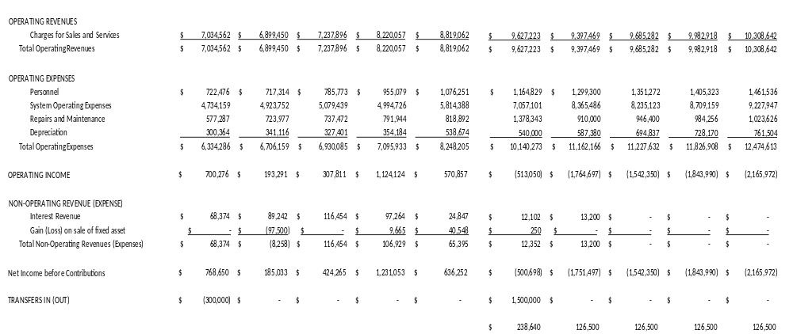

Section 3 Cost-of-Service
A cost-of-service analysis was performed to determine the allocated cost to serve each of Hyrum’s customer classes within the electric utility. Customer classes exist, in part, because the cost to serve different kinds of customers varies. The cost-of-service analysis has been performed on a FY 2021 ‘Test Year’ based on actual 2021 financials, operations and sales. The results of the cost-of-service study give an indication of the degree of revenue recovery warranted for each class of customers. A comparison of the allocated cost to serve a class of customers and the actual revenues received from that class is taken into consideration during rate design.

Functionalization of Costs
Hyrum’s Test Year electric revenue requirements have been divided into four functional categories. These categories are described below.
Power Supply – the power supply function is related to the cost of Hyrum’s purchases of wholesale power through UAMPS, CRSP and the wholesale market.
Distribution – expenses are related to the Hyrum owned system for delivering power and energy to Hyrum customers. They include local substation and distribution system costs.
Customer – the customer function includes fixed costs associated with the service facilities utilized to deliver electric power and energy directly to customers. They also include items such as meter reading, billing, collections and dealing with customers by customer service representatives.

Revenue – revenue related items include other operating and non-operating income and utility margin.
Table 3-1 below summarizes the functional electric costs for the 2021 Test Year. The detailed cost functions are shown in Exhibit 3-A.

Table 3-1
Functional Electric Costs
2021 Test Year
Component | Revenue  Requirement
Power Supply | $5,555,860
Distribution | 853,949
Customer | 308,066
Revenue | 548,840
Total | $7,266,715

Classification of Costs
Within each function, the revenue requirements have been divided into distinct cost classifications. These cost classifications are described below.
Demand Related – demand related costs are fixed costs that do not vary with hourly consumption. Demand related costs are required to meet the overall demand of the system as expressed in kW.
Energy Related – energy related costs vary based on hourly consumption in kWh
Customer Related – costs related to serving, metering and billing of individual customers.
Revenue Related – revenue related costs vary by the amount of revenue received by the utility.

Exhibits 3-B through 3-D show the detailed classification of revenue requirements within the functions.

Allocation of Costs
Based on an analysis of customer class service characteristics, the classified costs summarized above were allocated to the major Hyrum customer classes. Allocation of costs was performed on a fully-distributed, embedded cost allocation basis. Specific allocation factors were utilized in each of the cost classification categories as described below. Exhibit 3-E contains a summary of the development of the various allocation factors.

Demand Allocations

Customer class demands on a system can be reflected in various ways. Two primary demand allocation types were utilized in this analysis. A common industry allocator known as Coincident Peak Demand (CP) allocator is utilized to allocate demand related costs based on each class’ contribution to the system peak demand each month. A 12 CP demand allocator was utilized for power supply related demand costs. A Non-coincident Peak Demand (NCP) reflects a class maximum demand regardless of when it occurs. A 1 NCP method, an estimate of each class’ maximum annual demand on the system, was utilized for allocating local system demand related costs.

Energy Allocations
Each class’ share of energy requirements was used to allocate energy related costs. The predominant energy related costs are the energy portions of the purchased power expenses. These costs were allocated based on each classes’ estimated share of energy purchases.

Customer Allocations
Two separate customer allocators were utilized. The customer facilities allocator was used to allocate costs associated with the physical facilities required to serve individual customers. The customer service allocator is for allocation of costs associated with customer service – meter reading, billing, collections and customer inquiries. For both the customer meter and customer service allocators, a weighted customer allocation factor is developed. Weighting factors are developed to represent the difference in service configurations between customer classifications. For instance, a larger customer facility is required for a single large power customer than for a single residential customer, or a single large power customer requires more customer service than a single residential customer.

Revenue Allocations

Revenue related costs were allocated based on each class’ share of total demand, energy, customer facility, customer service and direct costs.

Cost of Service Results
Based on the classifications and allocations described above, the estimated cost to serve each major class of customers for the 2021 Test Year was determined. Exhibit 3-F presents this analysis in detail. Table 3-2 below summarizes the total allocated electric costs for each class compared to the total electric revenues received from the class during 2021.
Table 3-2
Electric Cost of Service Results
Comparison of Cost and Revenues
2021 Test Year

Customer Classification | Allocated Cost to Serve | Revenues
Residential | $2,178,257 | $2,373,110
Small Commercial | $314,942 | $353,911
Large Commercial | $1,989,835 | $1,819,632
Industrial | $2,783,682 | $2,720,062
Total | $7,266,715 | $7,266,715

The revenue requirements and revenues as allocated to each class and summarized above are shown on a total dollars basis. Table 3-3 below makes the comparison based on percentages of total cost to serve and total revenues. The percentage increase/(decrease) in each class’ revenue shown below is the adjustment necessary to produce revenues from each class in accordance with the allocated cost to serve. The percentage adjustments do not represent the recommended change in each class’ rates. Table 3-4 makes the comparisons between allocated cost to serve and revenue on an average $/kWh basis. The cost-of-service results are one item for consideration in rate design. It is important to note also that the adjustments shown in the table below would not change the total revenue received by the utility and are not indicative of overall revenue needs of the utility going forward. Recommendations regarding rate design are included in Section 4 of this report.

Table 3-3
Electric Cost of Service Results Comparison of % Cost and Revenues 2021 Test Year
Customer Classification | Allocated Cost to Serve | Revenues | Increase/ (Decrease)
Residential | 30.0% | 32.7% | -8.2%
Small Commercial | 4.3% | 4.9% | -11.0%
Large Commercial | 27.4% | 25.0% | 9.4%
Industrial | 38.3% | 37.4% | 2.3%
Total | 100.0% | 100.0% | 0.0%

Table 3-4
Electric Cost of Service Results Comparison of Cost and Revenues per kWh 2021 Test Year
Customer Classification | Allocated Cost to Serve  ($/kWh) | Revenues ($/kWh) | Increase/ (Decrease) ($/kWh)
Residential | 0.095 | 0.104 | -0.009
Small Commercial | 0.085 | 0.095 | -0.010
Large Commercial | 0.080 | 0.073 | 0.007
Industrial | 0.063 | 0.062 | 0.001
Total | 0.076 | 0.097 | 0.000

As indicated above, Hyrum’s existing class revenues do not exactly match the allocated cost to serve each class. Cost based rates are one of several goals in establishing rates. The relationship between allocated costs and revenues for each class should be considered, in addition to other rate related goals, in developing recommended rates.

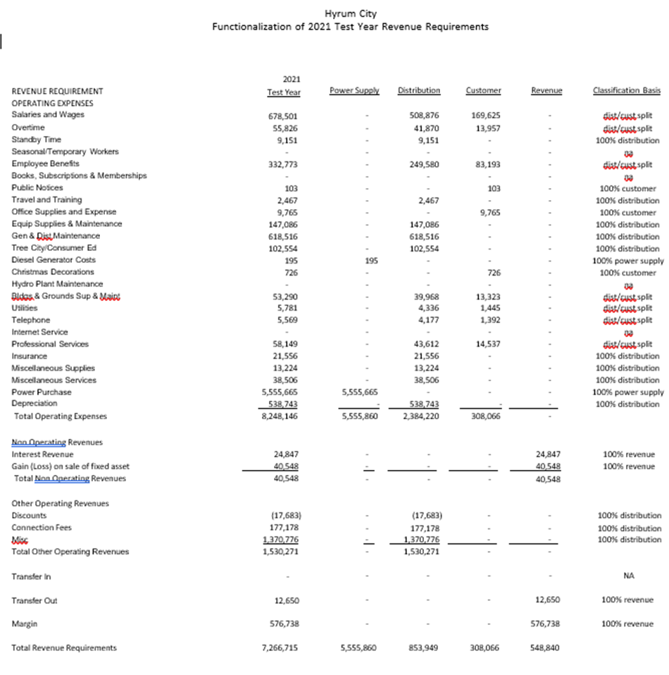

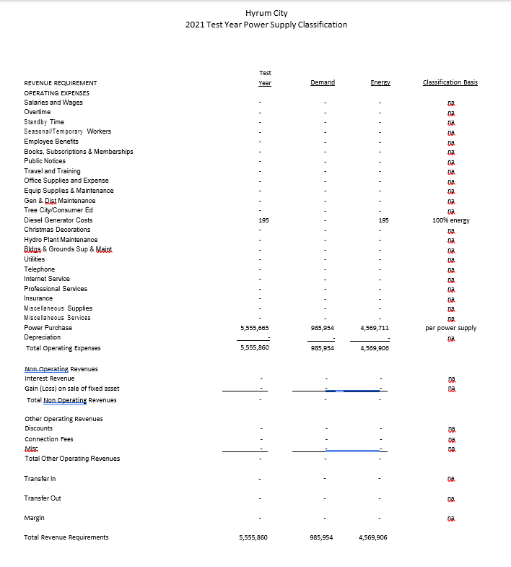

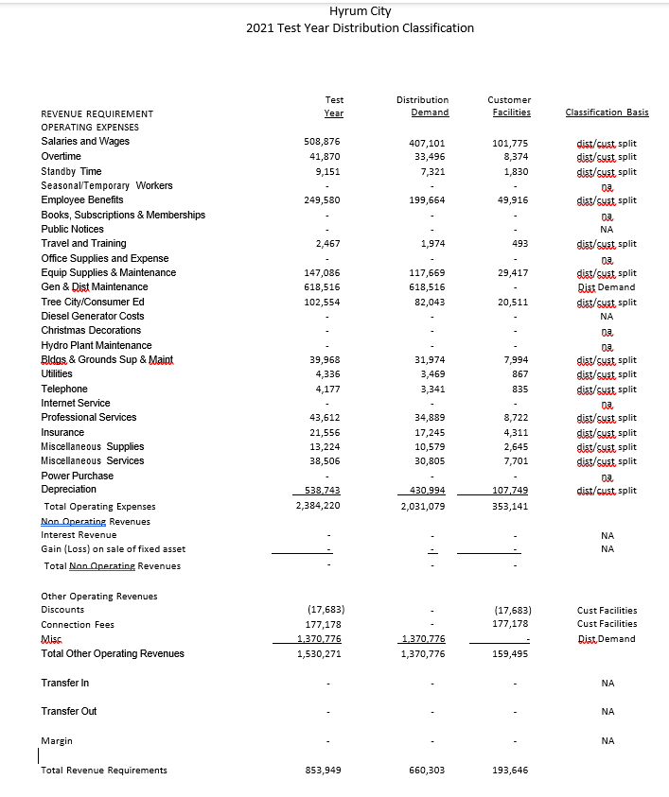

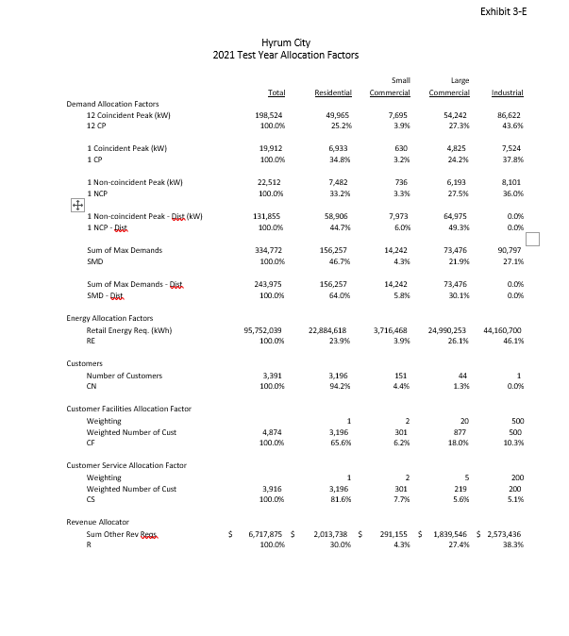

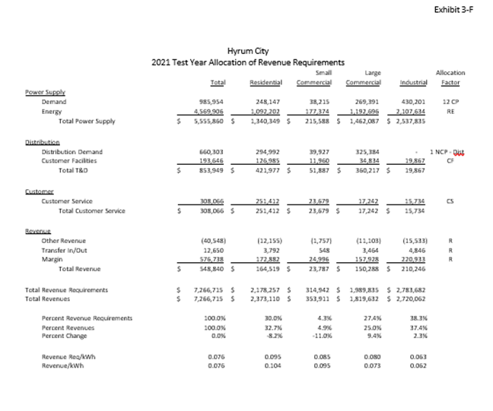

Dave Berg said there are additional items that he would like to include in the Power Rate Study. He will be working with City Staff and present a final power rate study at the next City Council Meeting.

MAYOR AND CITY COUNCIL REPORTS.

Mayor Miller said the Cache Garbage Coalition is accepting bids on the RFP for garbage service. The Emergency Preparedness Training will be held on November 9 and the City Council will need to certify in two SIMS classes before the training.

Councilmember Adams thanked the City Council for its help with National Night Out Against Crime.
Councilmember James said the Hyrum Hornets are having a winning season and are playing the hornets in the finals.

Councilmember Rasmussen said the removal of the exterior paint on the Elite Hall should be finished in the next couple of weeks. The City will need to have rain gutters installed on the north side of the building.

Councilmember Clawson said the irrigation season is more than half way over and it looks like there will be enough water to make it through October.

City Administrator Ron Salvesen said the City received a five million dollar grant for the installation of pressurized irrigation meters. The City will have to hire at least two additional employees in the irrigation department to complete the state mandated project.

ADJOURNMENT:

ACTION There being no further business before the City Council, the Council Meeting adjourned at 9:10 p.m.

_________________________________
Stephanie Miller
ATTEST: Mayor

______________________________
Stephanie Fricke
City Recorder

Approved: August 18, 2022__
As Written

