Kanosh Town Corporation held the public hearing Wednesday, July 13, 2022, electronically and in the town office at 7:00 p.m.

Members present:
Mayor Scott McDonald, Councilmembers: Brandon Stephenson, David Whitaker, Neil Shumway, and Hayden George, and, Kanosh Town Clerk: Cindy Turner.
Kanosh Town Treasurer DeniAnn Whitaker was unable to attend tonight's meeting.

Others in attendance: Town Employee Lorin Shumway, Planning and Zoning Chairman Geri Minton, David Hatton, Bart Whatcott, Ed Phillips, Stan Koyle, Star Cummings, Jim Weaver, and Mark Watterson. Josh Whitaker, Rodney Whatcott, Chad Whitaker, Kyle Stott, Brandon George, and via electronic Layne Jensen.

David Whitaker offered the opening ceremonies through an invocation.

Mayor MacDonald led everyone in attendance in the Pledge of allegiance.

Mayor McDonald opened the council meeting and welcomed all in attendance.

Minutes of the June 2022 meeting were read and approved through motion by Councilmember Neil Shumway, Councilmember David Whitaker provided a second to the motion, and all Council members voted in favor as noted below:
Mayor Scott McDonald: Aye
Council members
David Whitaker: Aye
Neil Shumway: Aye
Hayden George: Aye
Brandon Stephenson: Aye

Warrants for July 2022 were read discussed and approved to be paid through a motion by Councilmember David Whitaker Councilmember Hayden George seconded the motion, and all Council members voted in favor as noted below:
Mayor Scott McDonald: Aye
Council members
David Whitaker: Aye
Neil Shumway: Aye
Hayden George: Aye
Brandon Stephenson: Aye

CERT:
Nothing to report this month.

Fire Dept, Fire Chief Lorin Shumway:
*Chief Shumway reported that things are going pretty well, the department is keeping busy!

*Chief Shumway questioned how the council felt about Fireworks, particularly after the fire on the fourth. We have learned that the County did NOT ban fireworks therefore there were no consequences for the most recent county fire. Do we want to be more restrictive than the county? Kanosh Town has instructed our Town's people not to use fireworks within the town limits. There was a fire started by fireworks outside of the Kanosh Town limits, the individuals were responsible in reporting it, but that is when it was learned that the County did not impose a restriction on fireworks. The area of the fire is within our Kanosh Fire Department response area. The fire department is not "fun haters" but with the extremely dry conditions, do we want to be more restrictive than the county?

* No concrete decision was agreed upon at this time.

Planning and Zoning:
*Planning and Zoning member Geri Minton presented the building permit for Jesse Card. Mr. Card plans to build a garage first and then the house in a couple of months. The paperwork is all in order.
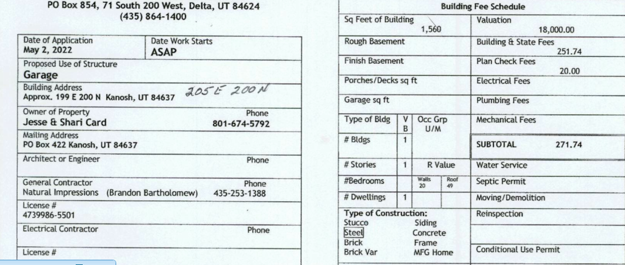

Councilmember Hayden George motioned to approve the building permit as presented for Jesse Card, Councilmember Neil Shumway provided a second to the motion all Council members voted in favor as noted below:
Mayor Scott McDonald: Aye
Council members
David Whitaker: Aye
Neil Shumway: Aye
Hayden George: Aye
Brandon Stephenson: Aye

*Planning and Zoning member Stan Koyle addressed the Council as a follow-up. Last month the Planning Commission was asked to look at the hook-up fee schedule for the water and the power that we are currently working with, with the rising costs associated with utility installations.

Currently, Water hook up fees are a flat $900.00 plus the impact fee. Currently, Fillmore City charges a flat fee of $1650.00 for a water hook-up fee.
It is the recommendation of the Planning and Zoning Commission that the Kanosh Town Water hook-up fees match Fillmore City's hook-up fee of $1650.00, plus the impact fee. The impact fee would remain what it is now. However, the impact fees should be reevaluated to include well and the other improvements to the water system.

Currently, the Electrical fee hook-up is $2600.00, if you want to encourage underground power we should include that in the fee. The Planning commission didn't feel they could set this fee due to the fluctuation in underground vs overhead power costs. Should the costs be evaluated by a three-year average? Councilmember Shumway has noticed that he has seen the costs for underground power be between 4 and 5 thousand dollars.
This topic of discussion, Utility hook-up fees, will serve as an agenda item for next month.

*The Planning and Zoning will continue to work on perfecting the forms needed in the building permit process.

*P&Z would like to have the council members revisit Ordinance No. 2000- 020900. Where it describes the job description of the planning and zoning. Some of the things outlined in the ordinance are not being done. The ordinance was created back in the year 2000, it is now 2022 and still, some things outlined in the original ordinance are not yet done. The Planning Commission is willing to meet with the council to "brainstorm" on what could be done.

See Ordinance 020900 below:

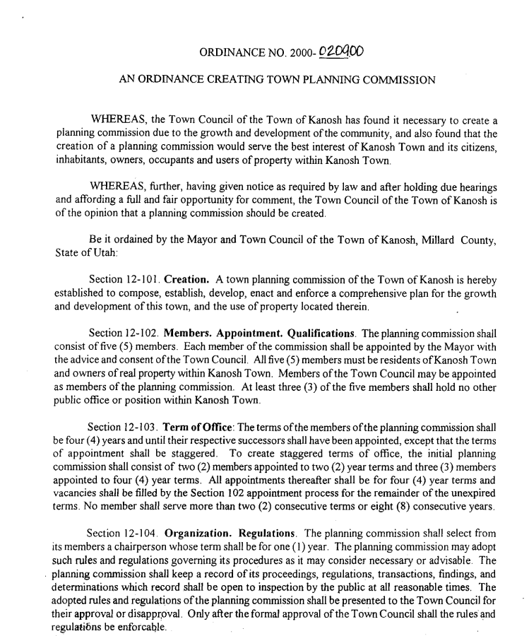
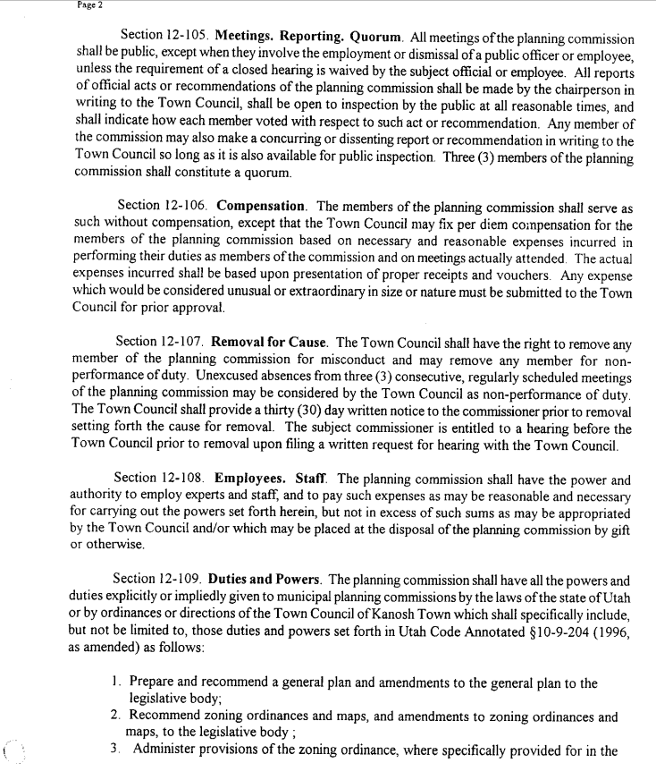
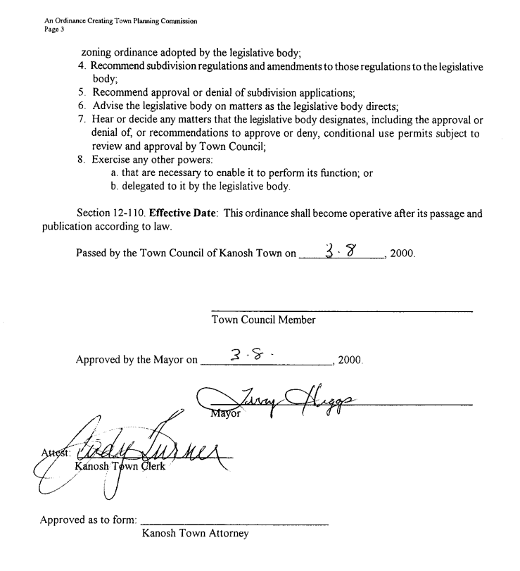

Brandon George & Chad Whitaker Corn Creek Irrigation:
Mr. Brandon George addressed the Council on behalf of Corn Creek Irrigation Company, At one time the irrigation asked Kanosh Town to sponsor the grant with the PL656 and the Town agreed to sponsor it, and take care of all of the billing. The Irrigation told the town that it would cost the Town nothing, that the grant would cover all the costs of the project. In the first part of the project, they do a 30% planning to get an idea of the project costs, problems, the system, etc. When it was started the irrigation company was after storage, they were hoping to get from 1000 to 2000 acre-feet of storage and then go to the pressurized system for the whole irrigation company. In addition to the increase in storage and pressurized system, they wanted to have a recreation/picnic area and then flood control, these were the main 4 things they were after. In the planning stage, this 30% the first thing they found out was that storage is not a possibility. Because of no storage, the pressurized system then was wiped out, then the recreation area got wiped out, pretty much leaving only the flood control. The conversation with the irrigation company resulted in them being ready to opt out of the project, due to the cost per share to them is not feasible and they felt like at this point it is not a project they wanted to continue with. At this point, they would recommend that if the Town would like to take it and go with the flood control, that would still be covered 100% of the cost, but what would get the irrigation company would be the most likely place to take the flood control water besides the Hatton ditch, would require easements and they feel like they would be doing this for the protection of the Town. If they opt out Kanosh could still proceed to build the new dam and build flood control. What the 30% designed so far is a 2000 CFS channel for flood control and that is a 100-year flood event. It is the Water Rights Division that will not allow the irrigation company to store water, through the Cox Decree and something else

CCI board members feel as though the dam should be the Town part, the town owns the property and the current dam and the irrigation will just do their irrigation part, whatever they decide.

The irrigation company has not voted to opt out of the project yet, but that is what it is looking like. The irrigation company would like to see the project go forward. The irrigation company will look into other grants and other avenues to get help with funding for the pipeline and the other things they want to be accomplished.
Existing ditches can handle an estimated 400 CFS, of the 1000-year event that is only 5%. NRCS could not justify 5% as flood control. In the 1000-year event you are not going to want that water in the ditches anyway. So the irrigation company would not be able to get help with those improvements under flood control. Now the hurdle they are up against is that the entire project benefits the Town and not the irrigation company. With that, the irrigation company is having a hard time justifying hiring an attorney, and getting easements from property owners for a flood channel, when it is benefitting the town and the dam is on the Town property. That is why the irrigation company wanted to see if the Town wants to take it over or if we want to just do with what we have.

Bottom line the dam still leaks to fix the dam. The funding is still there. The funding does not cover the money required to pay for easements.
Mr. Brandon George stated to clarify; that there are the 2000 CFS which the overflow would be designed to handle, the ditches would not be designed to handle that, which is believed to be the 100-year event. The structure of the dam will have an overflow to handle 10,000 CFS, but if anything over 10,000 CFS happens it is coming toward the Town, it will follow the contour of the land.
Layne Jensen tried to take part electronically, however, the connection could not be made.
Mr. Bart Whatcott commented that the bottom line is that the irrigation company would like to opt out of the project because it is in the Town's court, their dam, their property, and you cannot get the benefits that you were going after initially? The bottom line is that the dam still leaks. So the option is still there through you guys to get funding to fix the dam? Councilmember Hayden George responded, no the Town would just take over the project.
Mr. Brandon George stated anything to do with flood control would still be paid for, they are going to have the move the settling pond up above to the east. They have to go up there to get water pressure for the Indians. There will be a diversion up there to split the Town's water off, the Indian's water, and the irrigation so the pressurized system will get exactly the share of water that they are allotted. So anything that is for flood control is covered 100%. The irrigation company would still be working with it to do the irrigation part at the 70% cost share.
The main problem the irrigation company is having is with the easements, so if we continue on the high line ditch where it ends we would have to get easements all the way down or get legal advice to see where we could end the flood channel. If we have to take it across the freeway or if we can just turn it loose. The easements could end up costing quite a bit of money either for easements or for the attorney to write it. The grant doesn't cover anything on easements.
It would be beneficial to talk to Justin Wayment, our Kanosh Town attorney, look at the easements, etc. we need to find out where we can let go of the flood water and not be responsible for it. Since the dam has been identified as a failure would we be liable if the dam washes out? Justin will be invited to attend the next meeting to answer the questions we may have.
Councilmember Brandon Stephenson motioned to continue hosting the project, continue to gather information, and continue with the project until it starts costing money which is at the end of the design phase according to the engineer, and then reevaluate, before providing a second to the motion Council member Hayden George stated that he has a conflict of interest because he serves on both the CCI board and Kanosh Town board, and he then provided a second to the motion all Council members voted in favor as noted below:
Mayor Scott McDonald: Aye
Council members
David Whitaker: Aye
Neil Shumway: Aye
Hayden George: Aye
Brandon Stephenson: Aye

The consensus of the Council was if we have to choose between the dam and the well project we will use what money we have for the well project, making it our highest priority.
There is no cost until after the planning project.
Mr. Brandon George reemphasized that if the town takes the flood control part of the grant CCI would like to stay on for the 70% cost share.

COUNCIL REPORT ON DEPARTMENTS: i.e. park, cemetery, electrical, roads, & water
Park:
Councilmember Hayden George reported that we have had several trees start to die. A couple dozen of them are quite visually distressed. The town employees have been asked to water the trees with a hose. Mr. Bart Whatcott and Mrs. Geri Minton have been watering them by hand in an effort to revive them. The amount of watering that has been done is not enough to keep up with the need.

There has been Vandalism in the men’s restroom in the park. It was suggested that the restroom should be checked once a day.

Cemetery:
Due to the drought, we have ceased to water the cemetery.

Electrical Department:
Councilmember Neil Shumway is trying to get something figured out with the street lights, they do not last some only last a month. Council member Shumway is working on it.

Roads:
Process of getting the spray stuff figured out for the goat heads! There is still some work to do but Councilmember Stephenson and the Town Employee Lorin Shumway are devising a spray system.

Water:
Councilmember David Whitaker pointed out that the water tanks are down.
Last June the Council passed the below resolution for water conservation efforts which will be implemented immediately:

Kanosh Town Culinary Water Conservation Plan
Resolution #_____0609621B_________
Kanosh Town will have a 3 Level water restriction plan based on the water flow coming from our spring system into our water tanks and based on the water level in those tanks.

Water Conservation Level 1
Criteria to being Level 1 conservation
- No Overflow from tanks
Restrictions on Water Use
- Town Park, Ball field, and Cemetery Watering stopped
- All large bulk water sales (if any) stopped (fire-hydrants)

Water Conservation Level 2
Criteria to being Level 2 conservation
- No Overflow from tanks and:
- Spring Flow less than 300 GPM from springs for a change order. inches
Restrictions on Water Use
- Town Park, Ball field, and Cemetery Watering stopped
- Outdoor watering should be reduced and limited to evenings and early morning

Water Conservation Level 3
Criteria to being Level 3 conservation
- No Overflow from tanks and:
- Spring Flow less than 275 GPM from springs into tanks and/or
- Water Level in tanks down more than 3 feet
Restrictions on Water Use
- Town Park, Ball field, and Cemetery Watering stopped
- Outdoor watering prohibited
- All culinary water limited to indoor water use only- with the exception of watering pets and livestock

We have already stopped watering the ball fields, we just stopped watering the cemetery, after the 24th we may discontinue or cut back the watering in the town park. Townspeople are being asked to participate in conserving our water supply. Water levels are extremely low.
The water conservation plan will be posted throughout town, posted on our website, and our Facebook page.
General Government:
We may need an additional employee to help in the park, and the cemetery and to help spray weeds.

Well Project:
The well project came to a sort of halt, we are trying to do a change order or a point of diversion. So our water right is attached to the springs water source that we have right now. To do the well we have to do it with that water right, so we have applied for a point of diversion to put it to the well site. The problem is the way that it is defined right now, it is not legally good enough for the Division of Water Rights to do a change order.

Our water rights have never been quantified, there got better in 2013 but still did not define it enough for the Division of Water Rights. We are moving forward with the request to segregate our water right because there is still somehow a connection. We are moving to segregate our water right, our 2cfs when that is legally segregated and defined then we can again move forward with the process or point of diversion.

We have been working on this for a while. This is not the first route taken for the water rights, the previous routes we've gone down were dead ends for one reason or another. Now, this is the route that will get us forward. It takes time and is a process, we are looking at 2 to 3 years before the project will be complete. The funds that we have for the project are solidified to get us through the design process. We will likely come up short and will be seeking additional funding options.

Utility Delinquency Review:
Council members reviewed the monthly delinquency list. It was determined, again, to handle those accounts in arrears according to established Town policy

PUBLIC COMMENTS (Three Minute Limitation Each)
*David Hatton: read a publication from two documents the first was a publication of the Church of Jesus Christ of Latter-day Saints Doctrine and Covenants section 134 1&2
1 We believe that governments were instituted of God for the benefit of man; and that he holds men accountable for their acts in relation to them, both in making laws and administering them, for the good and safety of society.
2 We believe that no government can exist in ªpeace, except such laws are framed and held inviolate as will secure to each individual the free exercise of ^{c}onscience, the right and control of property, and the protection of life. and the second document: a publication by Karl Marx 1848 The Communist Manifesto plank 7: Extension of factories and instruments of production owned by the state; the bringing into cultivation of waste lands, and the improvement of the soil generally in accordance with a common plan.
Mr. Hatton stated these are the very words Planning and Zoning indicate, the government deciding how to use the property. I would petition the Town Council to do away with the Planning and Zoning Commission and return the right and control of the property to the individual. Thank you.
*Mark Waterson: commented on the IBC Code which is written by man, a special edition it is so convoluted and so confusing that there is actually additional comments to explain their rules and what they meant by that. Using the adoption of this code is written by man, adopted by cities and then the enforcement of it and the interpretation of it is by someone ... I am really confused who has the authority to do it, especially when it comes to displacing God given rights, like personal property rights, like Dave was just talking about. This here has a place, if you don't know how to build a structure you wanted, there is really good information in here it is good for making standards, but should never in my opinion trump personal property rights or personal liberty in any way. I don't think any government agency has got the right to do that. If you want to get a loan to build a house the bank requires a building permit and occupancy and if you want to voluntarily give that up because you want to borrow money, that is your right. I don't think the cities, counties or anybody else has the right to tell you what you can and cannot do with your personal property. You should be accountable for that, you should own that, you should be good neighbors and all of that stuff. So Man’s written law does not Trump Gods given rights of personal liberty. My opinion.
*Stan Koyle: in reference to the flood control, we are to or three years out, when is the 100 year flood going to come, will it come in the next three years? I think there is a lot we can do with the current system to clean it up and make an improvement. We talked about the debris basin that is one of them, there are things we can do with volunteer help that might work and get us by.

Follow up on Old Business:
24th of July: Everyone has their assignments but we will require help getting the meat ready the night before, getting the fire ready etc.
The Town Council has opted out of riding in the parade as a council. The majority of the council members have other responsibilities in the parade.
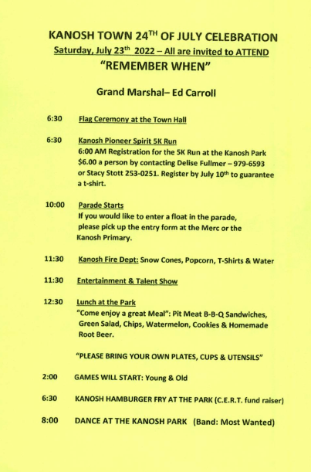

There being no further business to come before the board, the meeting adjourned.

Scott McDonald Cindy Turner,
Kanosh Town Mayor Kanosh Town Clerk

****Agenda
review utility fees

