MINUTES OF A REGULAR CITY COUNCIL MEETING HELD JULY 21, 2022 AT THE HYRUM CITY COUNCIL CHAMBERS, 60 WEST MAIN, HYRUM, UTAH.

CONVENED: 6:30 P.M.

CONDUCTING: Mayor Stephanie Miller

ROLL CALL: Councilmembers Jared Clawson, Paul James, Vicky McCombs, and Craig L. Rasmussen

CALL TO ORDER: There being four members present and four members representing a quorum, Mayor Stephanie Miller called the meeting to order.

EXCUSED: Councilmember Steve Adams

OTHERS PRESENT: City Administrator Ron Salvesen, and Zoning Administrator Matt Holmes, Hyrum Lineman Quentin Voth, and one citizen. City Recorder Stephanie Fricke recorded the minutes.

WELCOME: Mayor Stephanie Miller welcomed everyone in attendance and invited audience participation.

PLEDGE OF ALLEGIANCE: Mayor Miller

INVOCATION: City Administrator Ron Salvesen

APPROVAL OF MINUTES:

The minutes of a regular meeting on June 16, 2022 were approved as written.

ACTION Councilmember Clawson made a motion to approve the minutes of a regular meeting held on June 16, 2022 as written. Councilmember McCombs seconded the motion and Councilmembers Clawson, James, McCombs, and Rasmussen voted aye. The motion passed.

AGENDA ADOPTION: A copy of the notice and agenda for this meeting was emailed to The Herald Journal, posted on the Utah Public Notice Website and Hyrum City’s Website, provided to each member of the governing body, and posted at the City Offices more than forty-eight hours before meeting time.

ACTION Councilmember James made a motion to approve the agenda for July 21, 2022 as written. Councilmember Clawson seconded the motion and Councilmembers Clawson, James, McCombs, and Rasmussen voted aye. The motion passed.

10. SCHEDULED DELEGATIONS
A. Roy Savage, Hidden Valley Estates PUD - To request Preliminary Plat approval for Hidden Valley Estates PUD located at approximately 900 West 85 South consisting of 13 single family lots on 34 acres.
11. INTRODUCTION AND APPROVAL OF RESOLUTIONS AND ORDINANCES
A. Resolution 22-10 - A resolution authorizing the Steel Solar 1A Project amended and restated transaction schedule under the Master Firm Power Supply Agreement with Utah Associated Municipal Power Systems; and related matters.
12. OTHER BUSINESS
A. Presentation of the Power Rate Study.
B. Appointment to the Hyrum Library Board.
C. Consideration and approval of the Hyrum City Municipal Wastewater Planning Program (MWPP) Annual Report for year ending 2021.
D. Mayor and City Council reports.
13. ADJOURNMENT

PUBLIC COMMENT:

Mayor Miller said if a citizen has a question or would like to make a comment to please keep it under three minutes.

There being no further public comment, Mayor Miller moved to the next agenda item.

SCHEDULED DELEGATIONS:

Roy Savage, Hidden Valley Estates PUD - To request Preliminary Plat approval for Hidden Valley Estates PUD located at approximately 900 West 85 South consisting of 13 single family lots on 34 acres.

Roy Savage was not in attendance.

Zoning Administrator Matt Holmes said the Planning Commission recommended approval of the Preliminary Plat for Hidden Valley Estates PUD located at approximately 900 West 85 South consisting of 13 single family lots on 34 acres with the following recommendations: 1. Drainage and stormwater be addressed; 2. Swales on lots 1, 2, 12, and 13 will not contribute to storage and may have erosion concerns that should be addressed per the comments on the plat; 3. Plat be updated with any existing land drains, high water limits (flood and dam failure), wetlands, etc. with a letter from the U.S. Army Corp is required; 4. Street lights be shown on plans; 5. Ribbon curb is approved by the Planning Commission; 6. Animal rights are to be kept for all lots in this subdivision; 7. The City Council accept the offer of ownership of the land between this subdivision and Hidden Valley with the boundaries to be shown on plat; and 8. Be allowed as a cul-de-sac and not provide connectivity to the north.

Councilmember Rasmussen said he has concerns with road connectivity issues and only one road coming into the development. The utilities are not looped either.

ACTION Councilmember Rasmussen made a motion to continue the discussion on Preliminary Plat approval for Hidden Valley Estates PUD located at approximately 900 West 85 South consisting of 13 single family lots on 34 acres until a future City Council Meeting when Roy Savage was in attendance. Councilmember McCombs seconded the motion and Councilmembers Clawson, James, McCombs, and Rasmussen voted aye. The motion passed.

INTRODUCTION AND APPROVAL OF RESOLUTIONS AND ORDINANCES:

Resolution 22-10 - A resolution authorizing the Steel Solar 1A Project amended and restated transaction schedule under the Master Firm Power Supply Agreement with Utah Associated Municipal Power Systems; and related matters.

Mayor Miller said Resolution 22-10 authorizes the Steel Solar 1A Project amended and restated transaction schedule under the Master Firm Power Supply Agreement with Utah Associated Municipal Power Systems; and related matters.

ACTION Councilmember James made a motion to approve Resolution 22-10 - a resolution authorizing the Steel Solar 1A Project amended and restated transaction schedule under the Master Firm Power Supply Agreement with Utah Associated Municipal Power Systems; and related matters. Councilmember Clawson seconded the motion and Councilmembers Clawson, James, McCombs, and Rasmussen voted aye. The motion passed.
OTHER BUSINESS:

Presentation of the Power Rate Study.

Dave Bert with Dave Berg Consulting presented the Power Rate Study of Hyrum City’e Electric Utility through a Zoom Meeting. The following are slides are from his presentation.
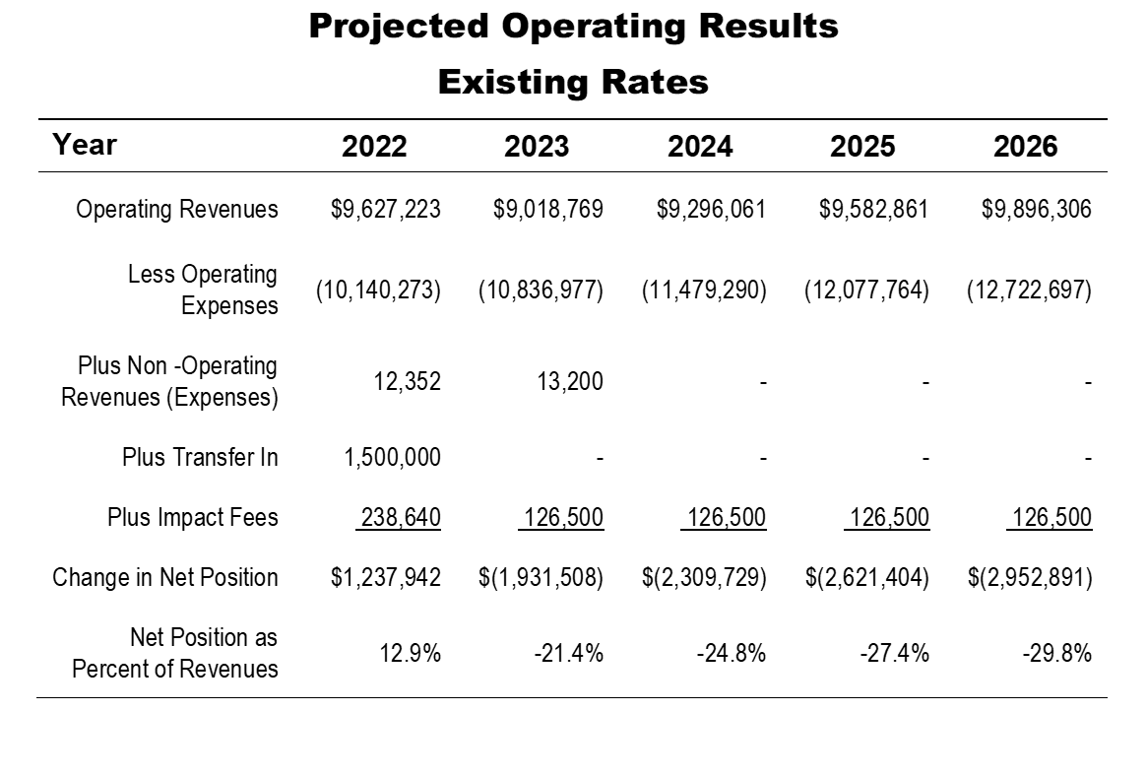

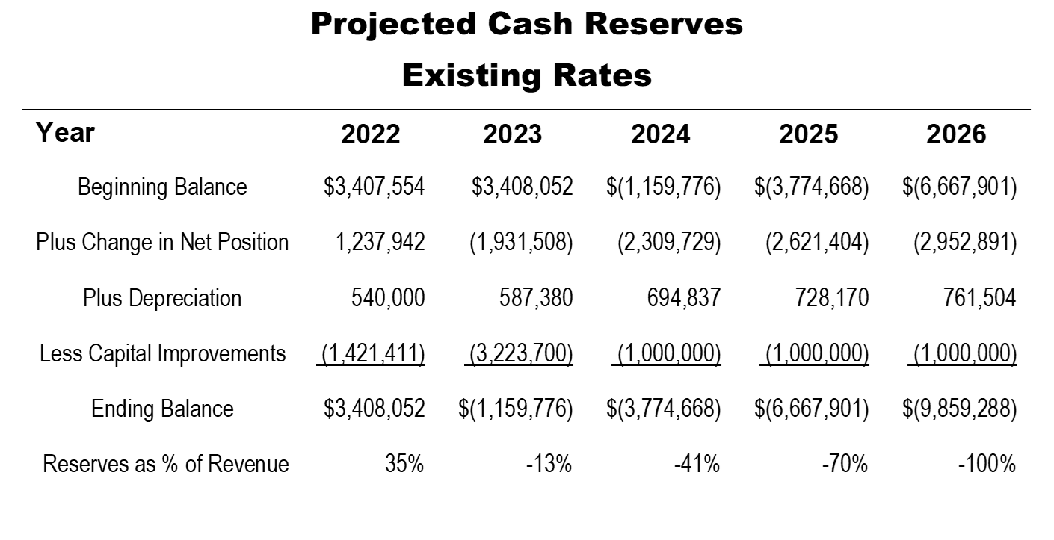

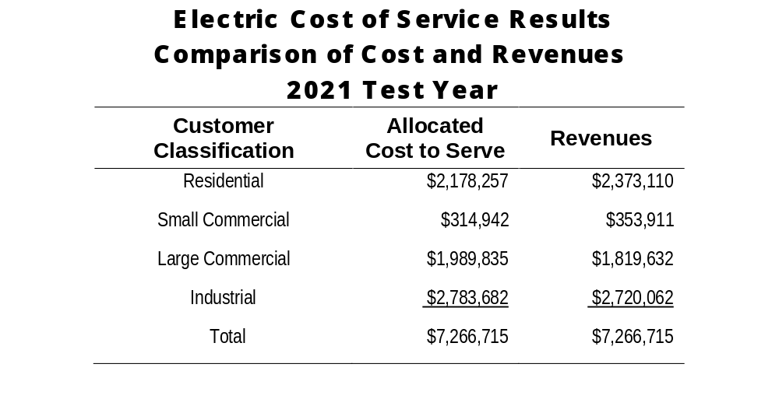
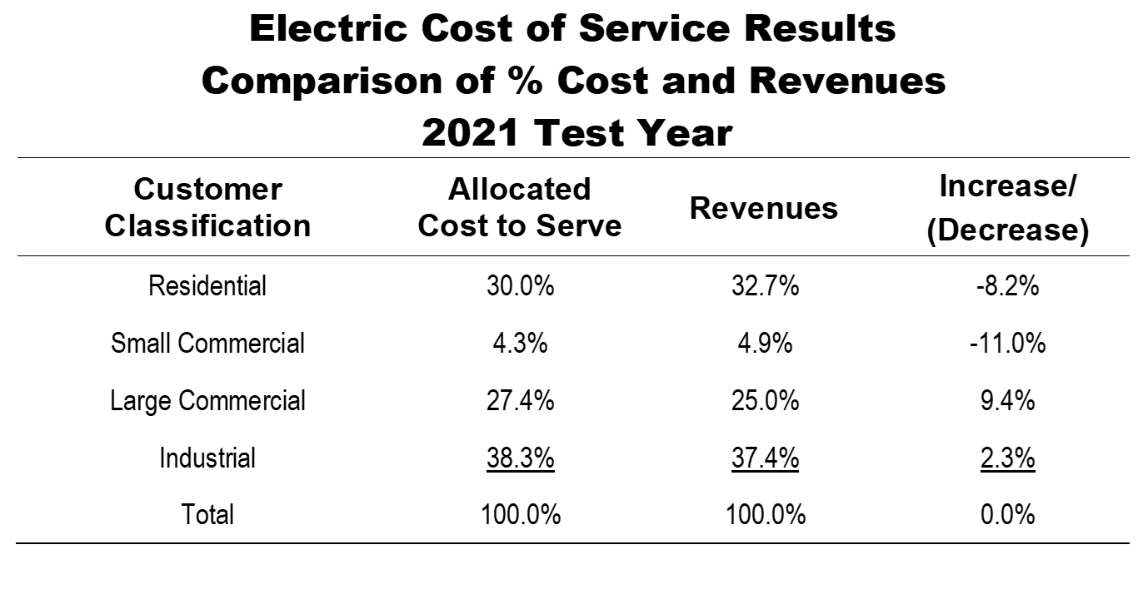

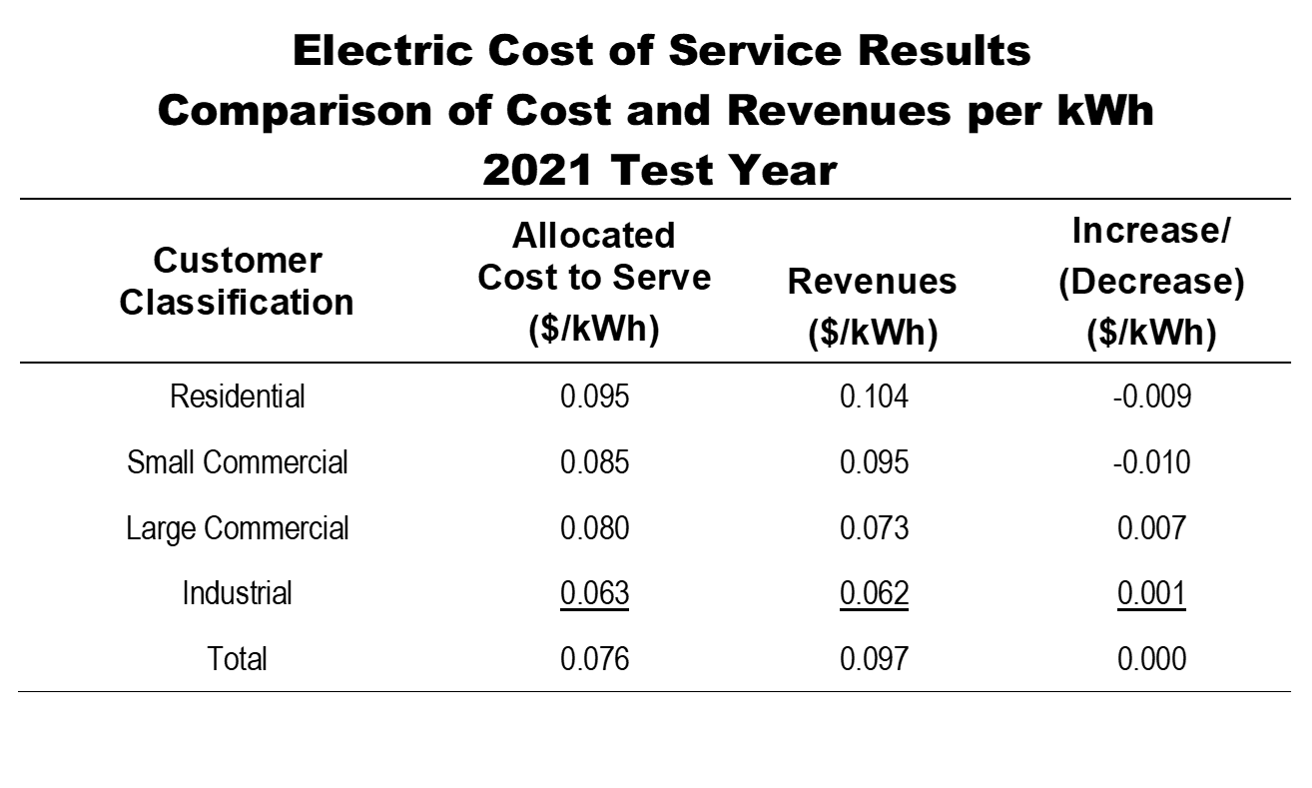

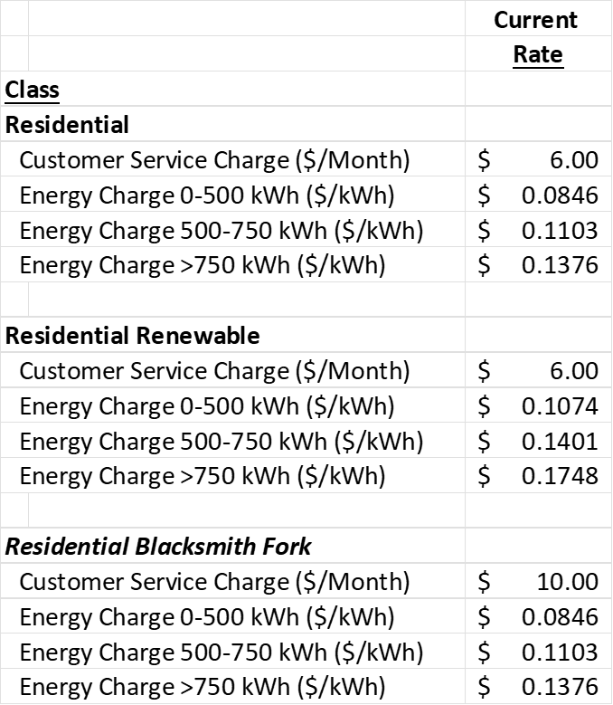

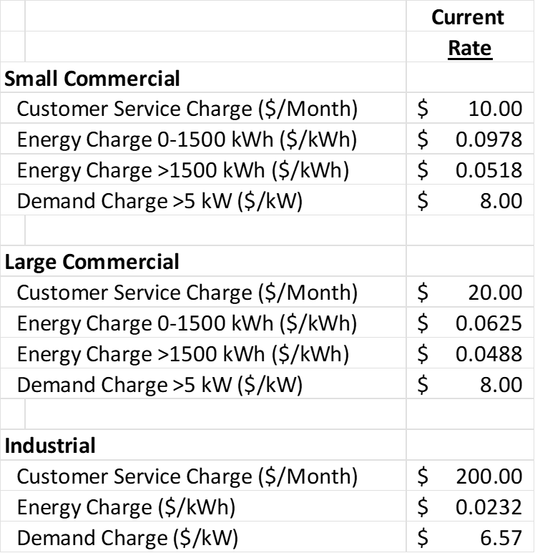

RATE DESIGN CURRENT RATES
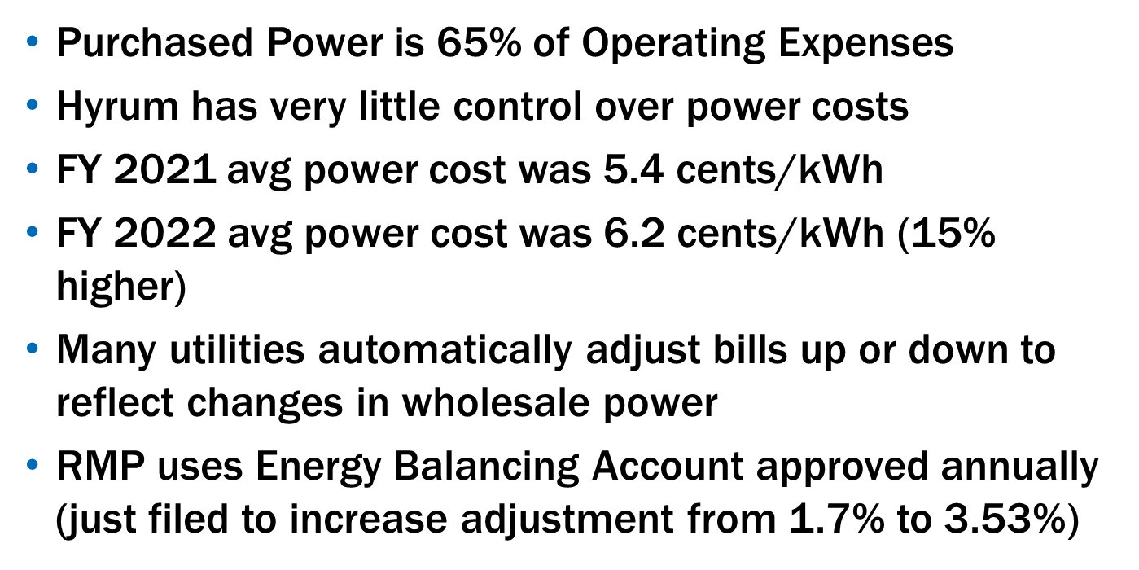

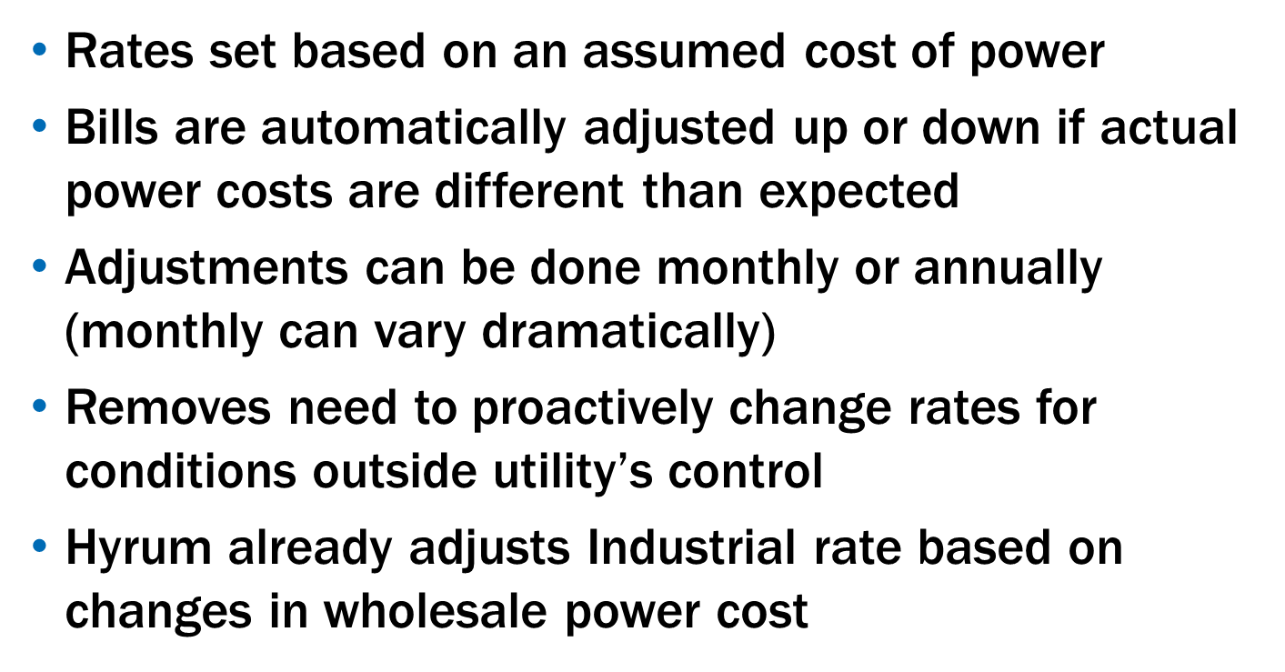

RATE DESIGN GUIDANCE:

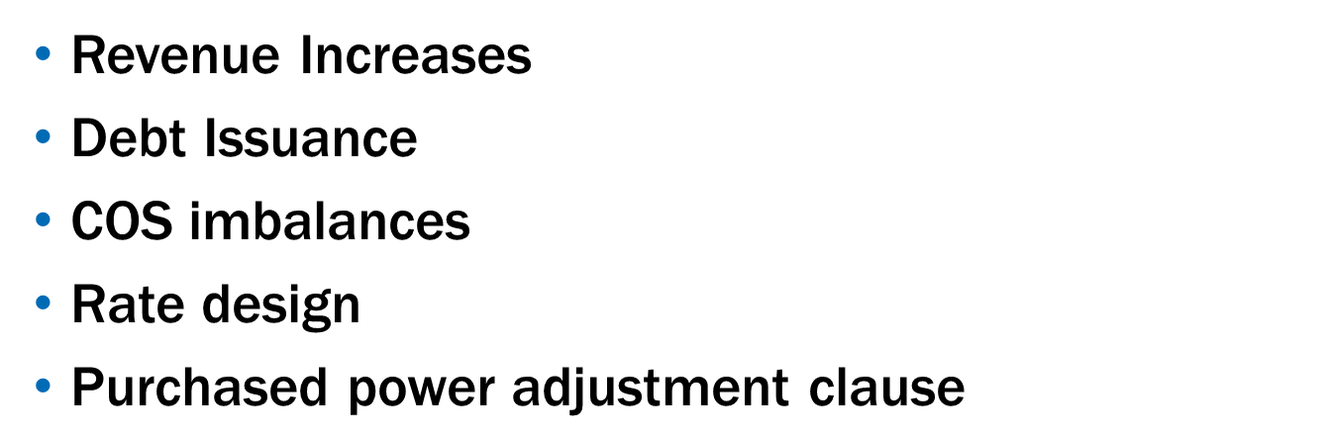

Dave Berg said there are additional items that he would like to include in the Power Rate Study to get definite numbers and there were things that were included in this analysis that need to be changed. He will be working with City Staff and present a final power rate study at the next City Council Meeting. He wanted to discuss with the City Council his initial findings because power rates are going to have to increase in some categories by 30%.

Appointment to the Hyrum Library Board.

ACTION Councilmember Clawson made a motion to appoint Kelsey Bladen to the Hyrum Library Board. Councilmember James seconded the motion and Councilmembers Clawson, James, McCombs, and Rasmussen voted aye. The motion passed.

Consideration and approval of the Hyrum City Municipal Wastewater Planning Program (MWPP) Annual Report for year ending 2021.

Mayor Miller said the City Council needs to acknowledge receipt of the Hyrum City Municipal Wastewater Planning Program (MWPP) Annual report for the year ending 2021 and approve it for submittal to the State.

ACTION Councilmember James made a motion to approve the Hyrum City Municipal Wastewater Planning Program (MWPP) Annual report for the year ending 2021. Councilmember McCombs seconded the motion and Councilmembers Clawson, James, McCombs, and Rasmussen voted aye. The motion passed.

MAYOR AND CITY COUNCIL REPORTS.

Mayor Miller said Cache County Sheriffs Office has recommended Hyrum City adopt an ordinance to not allow chairs or blankets to be put on City Property during special events. By having an ordinance in place tickets could be issued to those people who put out chairs and blankets along the parade route before the allowed time. Hyrum City’s Emergency Management Coordinator Blake Christiansen would like to hold a disaster training event with City Council and City Staff on November 9 from 8:00 a.m. to 4:00 p.m. Hyrum City’s Wastewater Superintendent Kevin Maughan is retiring September 30 and the City has hired Angela Pritchett from JBS Swift to replace him. She will start July 26, 2022. The City is also starting the process to replace Kevin Maughan as Fire Chief. National Night Out Against Crime is Tuesday, August 2. Councilmember Adams has asked the City Council to be there at 5:00 p.m. to help him prepare for the event.

Councilmember James expressed his appreciation to the City Council for its help with the 4th of July. Hyrum’s fireworks were spectacular, and he received many compliments.

Councilmember McCombs said the drain at the Senior Center has been fixed.

Councilmember Clawson said irrigation water is holding out and with July almost over there should be enough water to get the City through the irrigation season.

Councilmember Rasmussen said the Museum is working on a historic project researching and finding all the original settlers of Hyrum who are buried in the cemetery. There will be a tour of the cemetery when it is finished. On the 4th of July there were over 400 people who attended the Flag Display in the Elite Hall. The paint removal on the exterior of the Elite Hall is almost finished. There is a minimum of $120,000 more brick damage than anticipated on the North side of the building. The brick has to be repaired or it will only continue to damage the structure.

The City Council discussed why the paint on the east side of the building where Hawn’s building was still there. Rather than waiting for the annex to be built the City Council requested Councilmember Rasmussen get a quote to remove the remainder of the paint.

ADJOURNMENT:

ACTION There being no further business before the City Council, the Council Meeting adjourned at 8:05 p.m.

_________________________________
Stephanie Miller
ATTEST: Mayor

______________________________
Stephanie Fricke
City Recorder

Approved: August 4, 2022__
As Written

