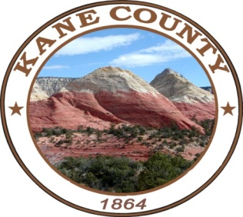
PUBLIC NOTICE OF TOWN HALL MEETING
ON AUGUST 11, 2022
***************************************

PUBLIC NOTICE IS HEREBY GIVEN that the Commissioners of Kane County, State of Utah, will hold a TOWN HALL Meeting at the Kanab Center, 20 N. 100 E. Kanab, Utah on Thursday, August 11, 2022 at the hour of 7:00 p.m.

The Kane County Commissioners will be holding a town hall meeting at 7:00 pm on Thursday, August 11, 2022 in the Kanab Center Ballroom C. This meeting will include Q&A from the Commissioners as well as discussions on expansion of boundaries for special service districts regarding fire protection services, and discussions on new growth within Kane County. All members of the public are welcome and encouraged to attend.

NOTICE OF SPECIAL ACCOMMODATION DURING PUBLIC MEETINGS:
In compliance with the Americans with Disabilities Act, individuals needing special accommodations (including auxiliary communicative aids and services) during this meeting should notify Karla Johnson at (435) 644-2458. Agenda items may be accelerated or taken out of order without notice as the Administration deems appropriate. All items to be placed on the agenda must be submitted to the Clerk’s office by noon Thursday, prior to the meeting.

