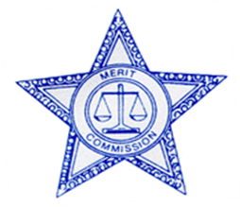

PLEASE POST

PEACE OFFICER MERIT COMMISSION
NOTICE

DATE OF ISSUE: 08/01/2022 EXPIRATION DATE: 08/04/2022

SHERIFF’S OFFICE PEACE OFFICER MERIT COMMISSION

PUBLIC MEETING

Date: 08/04/2022

Time: 4:30 p.m.

Site: SL County Government Center
2001 South State Street, Room S2-830
Salt Lake City, Utah 84190
WebEx also available (see link below)

AGENDA

- 2022 Captain Promotional Examination Plan – Carita Lucey

- Deputy Entry-Level Examination Plan – Carita Lucey and Sgt. Christian Luke

Reasonable accommodations (including auxiliary communicative aids and services) for individuals with disabilities may be provided upon receipt of a request. For assistance, please call 385.468.9885. Members of the Commission may attend electronically. The public may attend. Public comments are limited to 3 minutes unless otherwise approved.

When it's time, join your Webex meeting here.

Join meeting

More ways to join:
Join from the meeting link
https://slco.webex.com/slco/j.php?MTID=m8a52b92d37e0e656bda4f8db99a74395

Join by meeting number
Meeting number (access code): 2487 796 6868
Meeting password: R36fif6AJxM
Tap to join from a mobile device (attendees only)
+1-213-306-3065,,24877966868## United States Toll (Los Angeles)
+1-602-666-0783,,24877966868## United States Toll (Phoenix)
Join by phone
+1-213-306-3065 United States Toll (Los Angeles)
+1-602-666-0783 United States Toll (Phoenix)
Global call-in numbers
Join from a video system or application
Dial 24877966868@slco.webex.com
You can also dial 173.243.2.68 and enter your meeting number.

