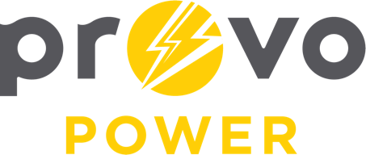
AGENDA
ENERGY BOARD MEETING PROVO POWER
Monday, August 8, 2022
4:00 P.M.

- Welcome & Introductions - Chairman Ned Hill
- Review & Approval of Minutes – April 4, 2022
- Financial Report – Charlie Fuller
- KPI Report – Charlie Fuller
- APPA National Conference Reports
  - Travis Ball & Julie Rash
- Manager Report – Travis Ball
- Calendar & Scheduling
  - Next board meeting: TBD

A copy of the agenda was posted in the Civic Center, and the Provo City Library, on August 2, 2022, and also delivered to the Mayor,
City Council Members, required news media, and adjacent cities in
compliance with the Utah Code 52-4-202

