SYRACUSE CITY
Syracuse City Council Work Session Agenda July 26, 2022 – 6:00 p.m.
In-Person Location: Syracuse City Hall, 1979 W. 1900 S. Electronic Via Zoom
Connect via telephone: +1-301-715-8592 US, meeting ID: 861 4298 7979
Streamed on Syracuse City YouTube Channel

a. Meeting called to order
a. Public Comment: This is an opportunity to address the Council regarding your concerns or ideas. Please limit your comments to three minutes. (Individuals wishing to provide public comment may do so via email to City Recorder Cassie Brown, cassieb@syracuseut.gov, by 4:00 p.m. on July 26, 2022. Comments submitted by the deadline will be read for the record of the meeting.)
- Review draft Rocky Mountain Power franchise agreement. (10 minutes)
- Planning items:
  - Review/discussion regarding existing procedure for considering architectural style of a development project. (10 min.)
  - Discussion regarding building permit fees for Accessory Dwelling Units (ADUs). (10 min.)
- Discussion regarding open space requirements in Cluster Zone. (15 min.)
- Discussion of possible amendment of City Code Section 3.10.080 pertaining to the scope of the Planning Commission. (10 min.)
- Continued discussion regarding Syracuse City Youth Council. (15 min.)
- General budget discussion and preparation for Truth in Taxation process. (10 min.)
- Adjourn.
~~~~~
In compliance with the Americans Disabilities Act, persons needing auxiliary communicative aids and services for this meeting should contact the City Offices at 801-825-1477 at least 48 hours in advance of the meeting.
CERTIFICATE OF POSTING
The undersigned, duly appointed City Recorder, does hereby certify that the above notice and agenda was posted within the Syracuse City limits on this 21st day of July, 2022 at Syracuse City Hall on the City Hall Notice Board and at http://www.syracuseut.gov/. A copy was also provided to the Standard- Examiner on July 21, 2022.
CASSIE Z. BROWN, MMC SYRACUSE CITY RECORDER

COUNCIL AGENDA

July 26, 2022

Agenda Item “b” Review Draft Rocky Mountain Power Franchise
Agreement

- Any question regarding this agenda item may be directed at City Manager Brody Bovero or City Attorney Paul Roberts

- The franchise agreement with Rocky Mountain Power is made to allow RMP to provide electricity to citizens and businesses via the City’s public rights of way. It is essentially a blanket permission for all roadways in the city, with certain requirements and restrictions attached.

- The current franchise agreement dates back to 2013 and has a term of 10 years. With the expiration approaching, it is time to review it and adopt a new agreement with a new term.

General Overview of the Agreement
- Grant of Franchise and General Utility Easement: The city allows RMP to use public rights of way for purposes of supplying and transmitting electric power.

- Term: The proposed term is not set. The suggested term is 10 years.

- Indemnification: The City is in no way liable for any damage, loss, injury, or death caused by the construction, operation, or maintenance of RMP facilities.

- Annexation: When areas are annexed, this agreement automatically applies to the newly annexed area.

- Construction and Installation of RMP Facilities: RMP facilities must comply with the City’s engineering standards and comply with City rules and regulations. Except in cases of emergency, RMP is required to obtain permits from the City prior to construction.

- City Use of Poles: The City may utilize RMP poles, without cost, for public safety communications or signals.

- Relocation of Electric Facilities: The City has the right to require RMP to relocate electric facilities for purpose of public convenience, necessity, health, safety, or welfare at no cost to the City. RMP shall not be obligated to pay the cost of relocation that is required as part of a private development.

- Vegetation Management: RMP may prune any trees that overhang the public right of way and interfere with RMP facilities. With approval of the owner, any such tree may be cut down and removed by RMP.

Changes from Current Agreement
- Section 1: Clarifies that parks and other public properties are not part of the agreement.

- Section 4: Broadens the non-exclusive use of public ways by the City to allow all other services, not just water and sewer.

- Section 18: Adds a waiver of jury trial clause, where both parties waive the right to a jury trial associated with the agreement.

Goals of Discussion
- Review and discuss the draft franchise agreement with Rocky Mountain Power.

- Provide direction to the Administration on placing this item on a future agenda for adoption by the Council.

AN ORDINANCE GRANTING AN ELECTRIC UTILITY FRANCHISE AND GENERAL UTILITY EASEMENT
TO
ROCKY MOUNTAIN POWER

WHEREAS, Rocky Mountain Power, is a regulated public utility that provides electric power

and energy to the citizens of
City (the “City”) and other surrounding areas;

WHEREAS, providing electrical power and energy requires the installation, operation and maintenance of power poles and other related facilities to be located within the public ways of the City;

WHEREAS, the City, pursuant to the provisions of Utah Code Ann. § 10-8-21 has the authority to regulate power line facilities within public ways and to grant to Rocky Mountain Power a general utility easement for the use thereof;

WHEREAS, the City desires to set forth the terms and conditions by which Rocky Mountain Power shall use the public ways of the City;

NOW, THEREFORE, be it ordained by the City:

SECTION 1. Grant of Franchise and General Utility Easement. The City hereby grants to Rocky Mountain Power the right, privilege and authority to construct, maintain, operate, upgrade, and relocate its electrical distribution and transmission lines and related appurtenances, including underground conduits and structures, poles, towers, wires, guy anchors, vaults, transformers, transmission lines, and communication lines (collectively referred to herein as “Electric Facilities”) in, under, along, over and across the present and future streets, alleys, and rights-of-way, not including City parks, buildings or other spaces not associated with City-owned rights-of-way (collectively referred to herein as “Public Ways”) within the City, for the purpose of supplying and transmitting electric power and energy to the inhabitants of the City and persons and corporations beyond the limits thereof.

SECTION 2. Term. The term of this Franchise and General Utility Easement is for ( )
years commencing on the date of acceptance by the Company as set forth in Section 3 below.

SECTION 3. Acceptance by Company. Within sixty (60) days after the passage of this ordinance by the City, Rocky Mountain Power shall file an unqualified written acceptance thereof, with the City Recorder otherwise the ordinance and the rights granted herein shall be null and void.

SECTION 4. Non-Exclusive Franchise. The right to use and occupy the Public Ways of the City shall be nonexclusive and the City reserves the right to use the Public Ways for itself or any other entity that provides service to City residences; provided, however, that such use shall not

unreasonably interfere with Rocky Mountain Power’s Electric Facilities or Rocky Mountain Power’s rights as granted herein.

SECTION 5. City Regulatory Authority. In addition to the provision herein contained, the City reserves the right to adopt such additional ordinances and regulations as may be deemed necessary in the exercise of its police power for the protection of the health, safety and welfare of its citizens and their properties or exercise any other rights, powers, or duties required or authorized, under the Constitution of the State of Utah, the laws of Utah or City Ordinance.

SECTION 6. Indemnification. The City shall in no way be liable or responsible for any loss or damage to property or any injury to, or death, of any person that may occur in the construction, operation or maintenance by Rocky Mountain Power of its Electric Facilities. Rocky Mountain Power shall indemnify, defend and hold the City harmless from and against claims, demands, liens and all liability or damage of whatsoever kind on account of Rocky Mountain Power’s use of the Public Ways within the City, and shall pay the costs of defense plus reasonable attorneys' fees for any claim, demand or lien brought thereunder. The City shall: (a) give prompt written notice to Rocky Mountain Power of any claim, demand or lien with respect to which the City seeks indemnification hereunder; and (b) permit Rocky Mountain Power to assume the defense of such claim, demand, or lien. If such defense is not assumed by Rocky Mountain Power, Rocky Mountain Power shall not be subject to liability for any settlement made without its consent. Notwithstanding any provision hereof to the contrary, Rocky Mountain Power shall not be obligated to indemnify, defend or hold the City harmless to the extent any claim, demand or lien arises out of or in connection with any negligent or willful act or failure to act of the City or any of its officers or employees.

SECTION 7. Annexation.

  - Extension of City Limits. Upon the annexation of any territory to the City, the rights granted herein shall extend to the annexed territory to the extent the City has such authority. All Electrical Facilities owned, maintained, or operated by Rocky Mountain Power located within any public ways of the annexed territory shall thereafter be subject to all of the terms hereof.

  - Notice of Annexation. When any territory is approved for annexation to the City, the City shall, not later than ten (10) working days after passage of an ordinance approving the proposed annexation, provide by certified mail to Rocky Mountain Power: (a) each site address to be annexed as recorded on county assessment and tax rolls; (b) a legal description of the proposed boundary change; and (c) a copy of the City’s ordinance approving the proposed annexation. The notice shall be mailed to:

Rocky Mountain Power Customer Contact Center Attn: Annexations
P.O. Box 400
Portland, Oregon 97207-0400

With a copy to:

Rocky Mountain Power
Attn: Office of the General Counsel 1407 West North Temple, Room 320 Salt Lake City, UT 84116

SECTION 8. Plan, Design, Construction and Installation of Company Facilities.

  - All Electrical Facilities installed or used under authority of this Franchise shall be used, constructed and maintained in accordance with applicable federal, state and city laws, codes and regulations.

  - Except in the case of an emergency, Rocky Mountain Power shall, prior to commencing new construction or major reconstruction work in the Public Ways, apply for any permit from the City as may be required by the City’s ordinances, which permit shall not be unreasonably withheld, conditioned, or delayed. Rocky Mountain Power will abide by all applicable ordinances and all reasonable rules, regulations and requirements of the City, and the City may inspect the manner of such work and require remedies as may be reasonably necessary to assure compliance. Notwithstanding the foregoing, Rocky Mountain Power shall not be obligated to obtain a permit to perform emergency repairs.

  - All Electric Facilities shall be located so as to cause minimum interference with the Public Ways of the City and shall be constructed, installed, maintained, cleared of vegetation, renovated or replaced in accordance with applicable rules, ordinances and regulations of the City.

  - If, during the course of work on its Electrical Facilities, Rocky Mountain Power causes damage to or alters the Public Way or public property, Rocky Mountain Power shall (at its own cost and expense and in a manner reasonably approved by the City) replace and restore it in as good a condition as existed before the work commenced.

  - In addition to the installation of underground electric distribution lines as provided by applicable state law and regulations, Rocky Mountain Power shall, upon payment of all charges provided in its tariffs or their equivalent, place newly constructed electric distribution lines underground as may be required by City ordinance.

  - The City shall have the right without cost to use all poles and suitable overhead structures owned by Rocky Mountain Power within Public Ways for City wires used in connection with its fire alarms, police signal systems, or other public safety communication lines used for governmental purposes; provided, however, any such uses shall be for activities owned, operated or used by the City for a public purpose and shall not include the provision of CATV, internet, or similar services to the public. Provided further, that Rocky Mountain Power shall assume no liability nor shall it incur, directly or indirectly, any additional expense in connection therewith, and the use of said poles and structures by the City shall be in such a manner as to prevent safety hazards or interferences with Rocky Mountain Power’s use of same. Nothing herein shall be construed to require Rocky Mountain Power to increase pole size, or alter the

manner in which Rocky Mountain Power attaches its equipment to poles, or alter the manner in which it operates and maintains its Electric Facilities. City attachments shall be installed and maintained in accordance with the reasonable requirements of Rocky Mountain Power and the current edition of the National Electrical Safety Code pertaining to such construction. Further, City attachments shall be attached or installed only after written approval by Rocky Mountain Power in conjunction with Rocky Mountain Power’s standard pole attachment application process. Rocky Mountain Power shall have the right to inspect, at the City’s expense, such attachments to ensure compliance with this Section 8.6 and to require the City to remedy any defective attachments.

  - Rocky Mountain Power shall have the right to excavate the Public Rights of Ways subject to reasonable conditions and requirements of the City. Before installing new underground conduits or replacing existing underground conduits, Rocky Mountain Power shall first notify the City of such work by written notice and shall allow the City, at its own expense, (to include a pro rata share of the trenching costs), to share the trench of Rocky Mountain Power to lay its own conduit therein, provided that such action by the City will not unreasonably interfere with Rocky Mountain Power’s Electrical Facilities or delay project completion.

  - Before commencing any street improvements or other work within a Public Way that may affect Rocky Mountain Power’s Electric Facilities, the City shall give written notice to Rocky Mountain Power.

SECTION 9. Relocations of Electric Facilities.

  - The City reserves the right to require Rocky Mountain Power to relocate its Electric Facilities within the Public Ways in the interest of public convenience, necessity, health, safety or welfare at no cost to the City. Within a reasonable period of time after written notice, Rocky Mountain Power shall promptly commence the relocation of its Electrical Facilities. Before requiring a relocation of Electric Facilities, the City shall, with the assistance and consent of Rocky Mountain Power, identify a reasonable alignment for the relocated Electric Facilities within the Public Ways of the City.
The City shall assign or otherwise transfer to Company all right it may have to recover the cost for the relocation work and shall support the efforts of Rocky Mountain Power to obtain reimbursement.

  - Rocky Mountain Power shall not be obligated to pay the cost of any relocation that is required or made a condition of a private development. If the removal or relocation of facilities is caused directly or otherwise by an identifiable development of property in the area, or is made for the convenience of a customer, Rocky Mountain Power may charge the expense of removal or relocation to the developer or customer. For example, Rocky Mountain Power shall not be required to pay relocation costs in connection with a road widening or realignment where the road project is made a condition of or caused by a private development.

SECTION 10. Subdivision Plat Notification. Before the City approves any new subdivision and before recordation of the plat, the City shall obtain Rocky Mountain Power’s approval of Electrical Facilities, including underground facilities to be installed by the developer, and

associated rights of way depicted on the plat. A copy of the plat shall be mailed for approval to Rocky Mountain Power:

Rocky Mountain Power Attn: Estimating Department Local Address
Local Address

SECTION 11. Vegetation Management. Rocky Mountain Power or its contractor may prune all trees and vegetation which overhang the Public Ways, whether such trees or vegetation originate within or outside the Public Ways to prevent the branches or limbs or other part of such trees or vegetation from interfering with Rocky Mountain Power’s Electrical Facilities. Such pruning shall comply with the American National Standard for Tree Care Operation (ANSI A300) and be conducted under the direction of an arborist certified with the International Society of Arboriculture. A growth inhibitor treatment may be used for trees and vegetation species that are fast-growing and problematic. Nothing contained in this Section shall prevent Rocky Mountain Power, when necessary and with the approval of the owner of the property on which they may be located, from cutting down and removing any trees which overhang streets.

SECTION 12. Renewal. At least 120 days prior to the expiration of this Franchise, Rocky Mountain Power and the City either shall agree to extend the term of this Franchise for a mutually acceptable period of time or the parties shall use best faith efforts to renegotiate a replacement Franchise. Rocky Mountain Power shall have the continued right to use the Public Ways of the City as set forth herein in the event an extension or replacement Franchise is not entered into upon expiration of this Franchise.

SECTION 13. No Waiver. Neither the City nor Rocky Mountain Power shall be excused from complying with any of the terms and conditions of this Franchise by any failure of the other, or any of its officers, employees, or agents, upon any one or more occasions to insist upon or to seek compliance with any such terms and conditions.

SECTION 14. Transfer of Franchise. Rocky Mountain Power shall not transfer or assign any rights under this Franchise to another entity, except transfers and assignments by operation of law, or to affiliates, parents or subsidiaries of Rocky Mountain Power which assume all of Rocky Mountain Power’s obligations hereunder, unless the City shall first give its approval in writing, which approval shall not be unreasonably withheld, conditioned or delayed; provided, however, Rocky Mountain Power may assign, mortgage. pledge, hypothecate or otherwise transfer without consent its interest in this Franchise to any financing entity, or agent on behalf of any financing entity to whom Rocky Mountain Power (1) has obligations for borrowed money or in respect of guaranties thereof, (ii) has obligations evidenced by bonds, debentures, notes or similar instruments, or (iii) has obligations under or with respect to letters of credit, bankers acceptances and similar facilities or in respect of guaranties thereof.

SECTION 15. Amendment. At any time during the term of this Franchise, the City through its City Council, or Rocky Mountain Power may propose amendments to this Franchise by giving thirty (30) days written notice to the other party of the proposed amendment(s) desired,

and both parties thereafter, through their designated representatives, will, within a reasonable time, negotiate in good faith in an effort to agree upon mutually satisfactory amendment(s). No amendment or amendments to this Franchise shall be effective until mutually agreed upon by the City and Rocky Mountain Power and formally adopted as an ordinance amendment, which is accepted in writing by Rocky Mountain Power.

SECTION 16. Notices. Unless otherwise specified herein, all notices from Rocky Mountain Power to the City pursuant to or concerning this Franchise shall be delivered to the City Recorder's Office. Unless otherwise specified herein, all notices from the City to Rocky Mountain Power pursuant to or concerning this Franchise shall be delivered to the Regional Business Management Director, Rocky Mountain Power, 1438 West 2550 South, Ogden, Utah, 84401, and such other office as Rocky Mountain Power may advise the City of by written notice.

SECTION 17. Severability. If any section, sentence, paragraph, term or provision hereof is for any reason determined to be illegal, invalid, or superseded by other lawful authority including any state or federal regulatory authority having jurisdiction thereof or unconstitutional, illegal or invalid by any court of common jurisdiction, such portion shall be deemed a separate, distinct, and independent provision and such determination shall have no effect on the validity of any other section, sentence, paragraph, term or provision hereof, all of which will remain in full force and effect for the term of the Franchise or any renewal or renewals thereof.

SECTION 18. Waiver of Jury Trial. To the fullest extent permitted by law, each of the parties hereto waives any right it may have to a trial by jury in respect of litigation directly or indirectly arising out of, under or in connection with this agreement. Each party further waives any right to consolidate any action in which a jury trial has been waived with any other action in which a jury trial cannot be or has not been waived.

PASSED by the City Council of the City of , Utah this day of
, 2021.

MAYOR

ATTEST:

CITY RECORDER



Agenda Item "c.1"

COUNCIL AGENDA

July 26, 2022

Architectural Review Committee (ARC)

Factual Summation
Before a new commercial, industrial, professional office, MXD or public facilities building is built in
the city, it is required to go through the site plan approval process. Planning Commission is the land use authority for site plans. Before the Planning Commission reviews a site plan, it must first go through staff review and a meeting with the Architectural Review Committee (ARC). The ARC acts as a recommending body to Planning Commission. The ARC consists of various community members, Staff, Planning Commissioners, and a City Council liaison (Lisa Bingham). The committee reviews architectural elevations and site plan documents for compliance with the design standards adopted in Chapter 10.28. The design standards are not overly specific to any one architectural style or color but rather focus on general form to ensure high quality design. See attached for Chapter 10.28.

Goal of Discussion
Familiarize yourself with the ARC ordinance and decide if there needs to be any amendments to the text to 'dial in' the language to require a more specific architectural style.

7/19/22, 1:39 PM Chapter 10.28 ARCHITECTURAL REVIEW COMMITTEE AND DESIGN STANDARDS

Chapter 10.28
ARCHITECTURAL REVIEW COMMITTEE AND DESIGN STANDARDS

Sections:
10.28.010 Purpose.

10.28.020 Architectural Review Committee (ARC).

10.28.100 Commercial, professional office, and public facility developments.

10.28.110 Building design.

10.28.120 Site design.

10.28.200 Industrial developments.

10.28.210 Industrial site planning.

10.28.220 Industrial architecture.

10.28.230 Industrial landscape design.

10.28.010 Purpose.
- The purpose of the design standards outlined in this chapter is to facilitate exceptional design in the built environment and preserve the quality of life within Syracuse City. This chapter is based on the following principles:

  - Higher quality designs will bring value to the commercial community of Syracuse and attract businesses which positively contribute to the overall quality of life and well-being of Syracuse residents.

  - Syracuse welcomes a variety of businesses and recognizes that brand recognition has become an important aspect of developing a successful and competitive business. The design standards enumerated in this chapter are intended to help and encourage development of imaginative and unique design solutions which meet business needs, while at the same time preserving Syracuse’s unique history and community identity.

  - This chapter supplements the objectives of other chapters in this title which also impose certain design standards or requirements that are zone specific.

7/19/22, 1:39 PM Chapter 10.28 ARCHITECTURAL REVIEW COMMITTEE AND DESIGN STANDARDS

- This chapter references design standards and design guidelines. They are intended to improve the quality and compatibility of development, particularly with regard to b uilding design and site design.

  - Design Standards. Design standards are required in addition to other standards set forth in this title. Design standards are intended to ensure quality development and permanence in design. The implementation of these standards ensures that the goals and values of the community are reflected in each commercial development and contribute positively to the overall built environment.

  - Design Guidelines. Design guidelines offer examples to clarify and explain design standards. They are made available for public use and distribution within a separate manual that can be found on record in the Community Development Department. The purpose of the Syracuse City Commercial Design Standards and Guidelines Manual is to better clarify the relationship between design standards and guidelines. The design guidelines serve to graphically represent the design standards and are used as a reference tool in order to better illustrate the application of the design standards. [Ord. 13-11 § 1.]

10.28.020 Architectural Review Committee (ARC).
The ARC is established to review all applicable development plans for compliance with the design

standards in this chapter. This committee functions as a subcommittee of the P
lanning Commission

and consists of seven members appointed by the Mayor with the advice and consent of the City
Council in accordance with the Syracuse Municipal Code. Members consist of community residents,

Planning Commissioners (maximum two), and City staff. The P recommend candidates for the Mayor’s consideration.
lanning Commission Chair may

The ARC is responsible to review the plan, elevations, architectural details, and development design pattern book and make recommendations to the Planning Commission consistent with this chapter.

The P
§ 1.]
lanning Commission will, in turn, submit their recommendations to the C
ity Council. [Ord. 13-11

10.28.100 Commercial, professional office, and public facility developments.
- Applicability. The design standards set forth in SCC 1 0.28.110 and 10.28.120 apply to:

  - All new commercial, professional office or public facilities buildings and u ses except where the requirements of this chapter are superseded by another provision of this title.

  - Existing commercial, professional office, or public buildings and uses when a change occurs that involves a design standard set forth in this chapter and either:

7/19/22, 1:39 PM Chapter 10.28 ARCHITECTURAL REVIEW COMMITTEE AND DESIGN STANDARDS

    - Requires a building or other permit issued by the City;

    - Alters the occupancy designation of a building under the current building codes adopted by the City;

    - Increases required parking; or

    - Increases the amount of outside storage.

- Imposition of Conditions. When reviewing a development plan, the Architectural Review Committee (ARC) may recommend that the Planning Commission impose conditions consistent with design standards in this chapter.

- Other Code Requirements. The requirements of this chapter apply in addition to other applicable requirements of this title. [Ord. 13-11 § 1.]

10.28.110 Building design.
- Context. All building designs are required to be drafted with sensitivity to the design of nearby
buildings and developments. This sensitivity includes considering whether:

  - Buildings contribute to the overall character of Syracuse and the neighborhood;

  - Buildings reflect the character of surrounding development through use of some similar features;

  - Buildings demonstrate imaginative design; and

  - Buildings vary colors, materials, or architectural elements where proposed building designs closely copy or mirror surrounding developments.

- Entrances. All building entrances are required to be clearly articulated to indicate a transition from the exterior to the interior of the building. Every main entrance is required to have a special emphasis when compared to the other portions of the building. This is accomplished through the use of at least three of the following near entrances:

  - A prominent architectural feature that is unique to the overall building design;

  - Complimentary yet differing building materials or colors;

  - Increased use of windows or glass;

7/19/22, 1:39 PM Chapter 10.28 ARCHITECTURAL REVIEW COMMITTEE AND DESIGN STANDARDS

  - Pedestrian amenities that may include patios, porches, special paving treatments, seating
areas, or awnings; or

  - Increased landscaping.

- Facade Articulation. Buildings designed with completely flat facades and monotone color schemes are not permitted. All buildings are required to have articulation of all facades.

  - Horizontal or vertical facade variations must occur at least every 30 feet or along a minimum of 60 percent of the horizontal length of buildings with facades 100 feet or greater. This is accomplished by using methods such as:

    - Variation in the surface plane that may include pop-outs, bays, and recesses;

    - Variation in the surface pattern such as arches, banding, and paneling; or

    - Distinguished treatment of windows, doors, and eaves that may include molding or framing.

  - Buildings with facades 100 feet or greater in total length must have at least one significant facade variation from the primary wall plane whose depth is at least five percent of the total facade length and whose width is at least 20 percent of the total facade length. Uninterrupted facades 100 feet or greater in length are prohibited.

- Height and Roofline. All building roof heights will be compatible with the building’s location, and varied roofline elevations or parapets are required in order to add architectural interest and avoid the appearance or sense of monotonous roofline expanses. All buildings are required to:

  - Have appropriate roof height for the location based on zoning regulations and the height of
buildings within the immediate area;

  - Have roofline and parapet variations where there are long, continuous, and undisturbed rooflines 50 feet in length or greater;

  - Use similar materials and colors on the back of false fronts, parapets, cornices, or other parts of the building which extend beyond the roofline or main building so that the building appears cohesive from all views; and

  - Have screening of mechanical equipment and systems that will be mounted on the roof. Any portion of these pieces of equipment that is not fully shielded is required to be painted a color

7/19/22, 1:39 PM Chapter 10.28 ARCHITECTURAL REVIEW COMMITTEE AND DESIGN STANDARDS

which is compatible with the roofing or parapet materials.

- Massing. Proper massing reduces the impact of the massive bulk created by large buildings that may not otherwise relate in scale to surrounding development. Vertical articulation, horizontal articulation, and multi-planed roof or awnings must be used in designs to mitigate the impact on surrounding development and the overall landscape.

- Materials. Quality long-lasting materials are required for all buildings in order to contribute to the aesthetics of the community over the long term.

  - A minimum of three colors per elevation is required.

  - Color utilization should be sensitive to existing development within the vicinity and the natural landscape in which the project is situated.

  - Primary Materials. Sixty-five percent of all surface materials, not including glass or roofing materials, are required to include a combination of brick, stone, ceramic tile, masonry materials, insulated metal panels, or wood fiber/composite siding. Exposed cinder block is not permitted, except for minimal foundation exposure. Concrete masonry unit, exposed concrete, stucco, vinyl, wood siding, or metal components may be used as accent or secondary materials only.

  - Exposed tilt-up concrete or insulated metal panels may be used as a primary material on
buildings located in the business park zone. Some variation in materials along the base and near the entrances of concrete tilt-ups is required.

  - All projects are required to submit a sample board containing physical samples of all exterior surface materials, including roofing materials, in all the colors they will be used. Photos alone are not sufficient.

- Development Design Pattern Book. The developer is required to provide a development design pattern book to be reviewed by the ARC and then the Planning Commission in conjunction with a subdivision plan and/or site plan application. Where there is a development agreement, the design pattern book will become a part of the agreement. Design pattern books are subject to the following:

  - Written descriptions with graphic illustrations explaining how the development complements the physical form of the property and how the theme and standards found in this chapter are to be integrated into the design of the development;

7/19/22, 1:39 PM Chapter 10.28 ARCHITECTURAL REVIEW COMMITTEE AND DESIGN STANDARDS

  - Written descriptions with graphic illustrations explaining the proposed conceptual architectural design, building elevations, and other such related design schemes; and

  - Written descriptions with graphic illustrations that clearly describe proposed open spaces,
landscaping ideas, pedestrian pathways, furnishings, lighting and related entryway features and/or amenities.

- Pedestrians. All buildings will be designed with an integral focus on encouraging pedestrian activity and social interaction. Additionally, buildings that contain more than one story or that are above 20 feet in height are required to provide a clearly articulated and more detailed base that relates to pedestrians.

- Signs. Signs located on any building facade are required to be compatible with the building’s overall design. As an integral design element, signs are required to be compatible with the style of the
buildings in terms of location, scale, color, and lettering.

  - The locations for signs on a building’s facade will be planned for as part of the building’s overall design.

  - Signs located on facades should integrate similar or complementary materials as the building.

- Windows. Windows are key to the overall design of a building and the relationship between the exterior and interior. The majority of windows are required to relate to the scale of a person.

  - Windows should be at eye level.

  - Where buildings are adjacent to pedestrian walkways, transparent windows must relate the scale of the building and the building’s interior to pedestrians. Where transparent windows may not be desirable, tinted windows, false windows, or glass block are allowed.

  - Window awnings are an effective way to add detail and variation to a building, emphasize pedestrian scale windows, and create an exciting and inviting environment. When placing awnings:

    - Use quality materials which are durable and are able to withstand extremes in the weather;

    - Colors should be complementary to the color of the building on which the awning is located; and

7/19/22, 1:39 PM Chapter 10.28 ARCHITECTURAL REVIEW COMMITTEE AND DESIGN STANDARDS

    - Styles should be compatible with the architectural features and overall architecture of the
building on which the awning is located. [Ord. 13-11 § 1.]

10.28.120 Site design.
- Building Placement. Building placement is integral to the site design and the overall effect any development has on surrounding properties. Building placement is required to comply with the following:

  - All buildings must be oriented with the main or similar facade facing a principal street to which it has frontage.

  - Buildings located on corner lots are required to orient main facades to each street and give equal treatment to each.

  - Buildings located on corner lots should include a prominent architectural feature of greater height than the rest of the roof, or emphasis at the corner where the two public streets meet.

- Context. New developments are required to match or complement surrounding developments in order to create a site which relates to its surroundings and adds positively to the overall built environment in the site area.

- Miscellaneous. The small details that sometimes become afterthoughts of site planning and design are important factors for making aesthetically attractive sites. The following are required during initial site planning, along with any other requirements within this code:

  - Landscaped areas and walls will be designed to decrease noise levels and separate loading and service bays from customer parking. Service and loading bays (automotive, service, tire, etc.) should be oriented away from neighboring residential areas. Further, they cannot have direct access to major public streets; access shall be provided via internal site plan circulation. The general public should be restricted from accessing such areas.

  - Approved outdoor storage areas are required to be fully screened from view using the same materials as the building or approved masonry fencing. Enclosures are also required to be surrounded by landscaping to further soften their visual impact. Public access to these areas should be restricted.

  - Outdoor refuse and garbage collection containers are required to be fully screened from view using the same materials as the building or approved masonry fencing. Enclosures are required

7/19/22, 1:39 PM Chapter 10.28 ARCHITECTURAL REVIEW COMMITTEE AND DESIGN STANDARDS

to be surrounded by landscaping to further soften their visual impact. Public access to these
areas should be restricted.

  - Shopping cart corrals are highly visible and needed to keep development sites safe and orderly. Corrals are required to be in fixed position.

  - Generators are required for businesses that the ARC determines will provide essential services to the public during inclement weather or natural disasters. Generators and other large auxiliary equipment are required to be placed at locations where they will be least intrusive in terms of noise, appearance, and odors, particularly for occupants of neighboring properties. Site plans will include public utilities equipment placement. Generators and other large auxiliary equipment:

    - Should be kept low to the ground;

    - If they include exhaust systems may not have exhaust systems protrude above the equipment; and

    - Are required to be surrounded by walls, landscaping, and other screening.

  - Site plans will be designed to conform to all requirements of the Americans with Disabilities Act (ADA). The ARC shall review the site plan for adequate handicap parking and access to
buildings.

- Landscaping. Landscaping is required as a tool to enhance and beautify the site, and the
building’s architecture and design. To aid in the design process, designers are encouraged to refer to the Syracuse City Commercial Design Standards and Guidelines Manual.

  - The portion of a development site devoted to landscaping exclusive of parkstrips and walkways will be calculated by the zone requirements for the parcel. Additional landscaping should be provided to achieve compatibility between differing, adjacent land uses such as residential and commercial, as required in the buffering table.

  - Landscaping is required to be integrated into the design, placement, and enhancement of pedestrian plazas, sitting areas, walkways, flag poles, and signs and will comply with zoning requirements.

  - Vegetative ground cover must be utilized for at least 80 percent of a development site’s
frontage along any public right-of-way and in required landscape areas between a building and

7/19/22, 1:39 PM Chapter 10.28 ARCHITECTURAL REVIEW COMMITTEE AND DESIGN STANDARDS

the parkstrip not including sidewalks, trails, and entry points.

  - Drought resistant shrubs and trees will be used in conjunction with efficient low water use irrigation systems. A list of low water use plants is available from the Community Development Department.

- Lighting. Carefully planned lighting schemes can create safe environments for pedestrians and motorists. Lighting is an integral design element which adds to the overall site plan and building design. Lighting must be designed in compliance with Chapter 10.45 SCC (Sign and Lighting Regulations).

  - Lighting schemes will include coordinating parking, wall, and pedestrian scaled fixtures which compliment building architecture and site features.

  - Parking and Circulation. Lifestyle, separated land uses, and lack of sufficient public transit have created the need for parking and access for automobiles onto most commercial sites. Lighting in required parking areas must be designed to have a minimal impact on the surrounding environment.

- Traffic. Developments which generate significant increases in traffic will include an analysis of the proposed development’s impact on the current and future transportation system, and methods to control traffic.

  - Major internal circulation roadways that provide access from the public right-of-way or between buildings on the same site must be separated from parking areas using curb and gutter and a combination of any of the following methods:

    - Landscaping;

    - Pedestrian walkways; or

    - Lighting.

  - Concrete “deadmen” wheel stoppers are required for parking spaces adjacent to a pedestrian walkway or amenity.

  - Cross access for automobiles and pedestrians to future and existing commercial developments is required during initial site planning and construction.

7/19/22, 1:39 PM Chapter 10.28 ARCHITECTURAL REVIEW COMMITTEE AND DESIGN STANDARDS

  - The design and location of loading areas and dock facilities must minimize the interaction between trucks and visitors’ automobiles. Access to loading and delivery areas must be separated from parking areas.

  - The design and location of loading facilities must take into consideration the specific dimensions required for the maneuvering of large trucks and trailers into and out of loading position at docks or in stalls and driveways.

- Pedestrians. Site layout and design must equally address the needs of pedestrians and automobiles. Pedestrian access and safety on the site should be ensured.

  - Pedestrian access from the public right-of-way through the site to main entrances is required. These walkways are required to be constructed of dissimilar materials to the roadway or parking
area, and provide for clearly defined crossings where there are points of conflict with automobiles.

  - Dissimilar roadway materials within parking lots are required to be used directly in front of entrances to slow motorists and create a safer environment for pedestrians.

  - Pedestrian drop-off locations, when incorporated within overall circulation patterns, are required to be convenient and safe for pedestrians.

- Security. Security of the site is required to be addressed in site design. The developer is required to submit documents that demonstrate the security measures of the site design in relation to private, semi-public and public areas, by utilizing natural surveillance, access control and proper maintenance. [Ord. 13-11 § 1.]

10.28.200 Industrial developments.
The design guidelines in SCC 10.28.210 through 10.28.230 are applicable to all new industrial and warehouse developments in the City as well as additions to and exterior remodeling of existing
buildings where the improvements are visible from a public right-of-way. [Ord. 13-11 § 1.]

10.28.210 Industrial site planning.
Site planning considers how the various components of a development (e.g., buildings, circulation, parking, open space, etc.) relate to adjacent streets and existing development, and how the various components relate to each other within the development site.

- Building and Facilities Location. The main elements of a well-designed industrial site include:

7/19/22, 1:39 PM Chapter 10.28 ARCHITECTURAL REVIEW COMMITTEE AND DESIGN STANDARDS

  - Controlled site access with appropriate maneuvering areas for trucks separated from general vehicle circulation (1 in figure below).

  - Employee parking areas located apart from loading and service areas (2 in figure below).

  - Convenient public access and short-term visitor parking at the front of the building (3 in figure below).

  - Screening of storage, work areas, and mechanical equipment and buffering of adjacent land
uses (4 in figure below).

  - Emphasis on a well-designed main building entry and landscaping (5 in figure below).

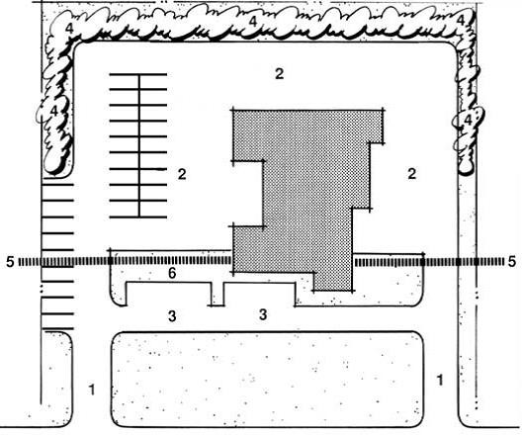

Example of appropriate industrial site layout

  - Site elements, such as buildings, parking, driveways, and outdoor activities, should be arranged to emphasize the more aesthetically pleasing components of the site (e.g., landscaping and superior architectural features) and disguise less attractive elements (e.g., service facilities, outside storage, equipment areas, and refuse enclosures) through proper placement and design of buildings, screen walls, and landscaping.

7/19/22, 1:39 PM Chapter 10.28 ARCHITECTURAL REVIEW COMMITTEE AND DESIGN STANDARDS

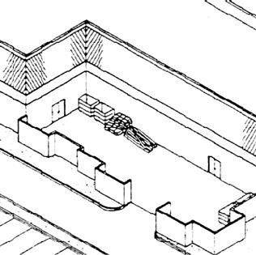

  - Industrial and warehouse development must be screened and buffered from any adjacent
uses that are less intensive in compliance with the code. Intensified landscaping, increased
setbacks, and appropriate building location will be utilized as a means of providing adequate separation between land uses of varied intensity.

Outdoor storage areas – screened from view

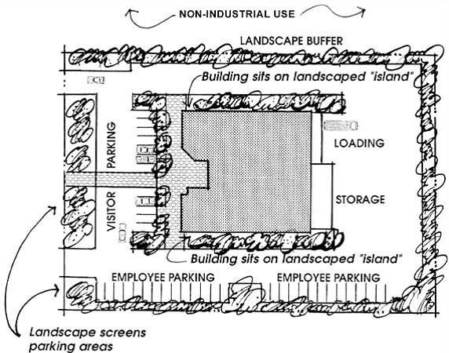

7/19/22, 1:39 PM Chapter 10.28 ARCHITECTURAL REVIEW COMMITTEE AND DESIGN STANDARDS

  - Noise generating functions must be located in a way that minimizes any impact on adjacent nonindustrial properties. Sound attenuation walls should be used where appropriate to mitigate/reduce noise.

  - The number of site access points are to be located at distances from street intersections that will minimize points of potential vehicle conflict, especially between automobiles and trucks.

  - Primary entry drives for automobiles, especially visitors, must be enhanced with: ornamental
landscaping, low-level decorative walls, monument-type signs, or decorative paving to emphasize site access locations.

- Vehicular Circulation.

  - Site access and internal circulation must promote safety, efficiency, convenience, and minimize conflict between trucks and other vehicles. Appropriate maneuvering and stacking
areas for trucks should be a primary consideration in the overall design of the circulation system.

  - Uses where trucks are anticipated, such as distribution centers, should be planned to accommodate safety and maximize visibility for both truck maneuvering and other traffic.

  - The design and location of loading areas and dock facilities must minimize the interaction between trucks and other automobiles. Access to loading and delivery areas must be separated from parking areas.

  - The design and location of loading facilities must take into consideration the specific dimensions required for the maneuvering of large trucks and trailers into and out of loading position at docks or in stalls and driveways.

- Parking Location.

  - Parking lots are not to be the dominant visual element at the front of the site. Expansive paved areas located between the street and the building are prohibited.

  - Large parking areas (over 100 spaces) must be divided into smaller multiple lots and provided with trees located throughout the parking area to reduce the visual impact.

  - Visitor parking spaces should be located to produce the shortest route of travel to a building entrance.

7/19/22, 1:39 PM Chapter 10.28 ARCHITECTURAL REVIEW COMMITTEE AND DESIGN STANDARDS

  - Pedestrian walkways must provide safe, convenient, and well-defined access between parking areas and the public sidewalk and the main public access to the building.

  - Pedestrian circulation should be clearly delineated and separate from vehicle circulation. The
use of landscaping, walkways, or decorative paving to delineate pedestrian circulation must be used. [Ord. 13-11 § 1.]

10.28.220 Industrial architecture.
The architectural design of a structure must consider many variables, from the functional use of the
building, to its aesthetic design, to its “fit” within the context of existing development. The following standards help buildings achieve the appropriate level of design detail on all facades, avoid blank/uninteresting facades, and provide for the proper screening of equipment and refuse areas:

- Architectural Form and Detail.

  - If adjacent to a residential zoning district, in addition to the buffer requirements of this code, additional building setbacks of 10 feet must be provided adjacent to the residential use to reduce the visual impact of large-scale industrial buildings.

  - The mass and scale of large, box-like industrial buildings are to be reduced through the incorporation of varying building heights and setbacks along the front and street sides of building facades.

  - Front and street sides of facades of large buildings visible from a public street must include: architectural features such as reveals, windows and openings, changes in color, texture, or material to add interest to the building elevation and reduce its visual mass.

  - Primary building entries must be readily identifiable and well defined through the use of projections, recesses, columns, roof structures, or other design elements.

- Color and Materials.

  - A comprehensive material and color scheme must be developed for each site. Material and color variations in multi-building complexes must be complementary and compatible among
buildings.

  - Primary Materials. Fifteen percent of the front exterior walls and 10 percent of street facing exterior walls must be finished with brick, concrete formliner, architectural block, stone, or glass.

7/19/22, 1:39 PM Chapter 10.28 ARCHITECTURAL REVIEW COMMITTEE AND DESIGN STANDARDS

Unfinished gray concrete block is not permitted. The use of noninsulated metal siding exclusively on any wall is prohibited. All finish material shall be durable to the effects of weather and soiling.

  - All projects are required to submit a sample board containing physical samples of all exterior surface materials, including roofing materials, in all the colors they will be used. Photos alone are not sufficient.

  - Large expanses of precast concrete (including cast in place concrete tilt-up panels), metal wall panels, or other uniform material must be broken up with pop outs, recesses, awnings, staggered facades, metal structures, trellis, change in color and texture, or the addition of other designed three dimensional architectural features, every 100 feet.

  - Bright, contrasting colors should be used for small areas of building accents only.

  - Design and colors of wall signs must be compatible with the main buildings on the site.

  - Materials, design, and colors of monument signs must be compatible with the main buildings on the site.

- Accessory Buildings.

  - The design of accessory buildings (e.g., security kiosks, maintenance buildings, and outdoor equipment enclosures) must be incorporated into and be compatible with the overall design of the project and the main buildings on the site.

  - Temporary buildings are not to be located where they will be visible from adjoining public
streets.

  - Modular buildings must be skirted with material and color that is compatible with the modular unit and the main buildings on the site. [Ord. 16-28 § 1 (Exh. A); Ord. 15-27 § 1 (Exh. A); Ord. 13-11 § 1.]

10.28.230 Industrial landscape design.
Landscaping has a variety of functions, including softening the hard edges of development, screening unattractive views, buffering less intensive uses, providing shade, and increasing the overall aesthetic appeal of a project.

- Landscape Design.

  - Landscape design must follow an overall concept and link various site components together.

7/19/22, 1:39 PM Chapter 10.28 ARCHITECTURAL REVIEW COMMITTEE AND DESIGN STANDARDS

  - Landscaped areas incorporate a three-tiered planting system: (a) grasses, ground covers, or flowers; (b) shrubs or vines; and (c) trees.

  - The use of a variety of trees, especially in parking areas and pedestrian open space areas, is required.

  - More intense landscaping and special landscape features are to be provided at major focal points, such as entries and pedestrian gathering areas.

  - The front, public portions of buildings must be separated from parking areas by landscaping and pedestrian walkways.

- Walls and Fences.

  - The colors, materials, and appearance of walls and fences, including walls for screening purposes, must be compatible with the overall design character/style of the development.

  - Landscaping must be used in combination with walls and fences to visually soften blank surfaces.

  - When security fencing is required adjacent to streets, it must consist of wrought iron, tubular steel, or similar material supported by masonry piers.

- Outdoor Lighting.

  - The design and location of outdoor lighting fixtures must preclude direct glare onto adjoining property and streets in compliance with the development code. Illumination devices must be installed, directed, and shielded to confine light rays within the property.

  - Outdoor lighting (e.g., location, height, and number) must be designed to foster security. Site and building entries must have enhanced illumination to increase visibility and safety.

- Refuse Storage and Utility Equipment.

  - Refuse storage areas should be located at the rear of the development and screened from public view in compliance with the development code.

  - If refuse storage areas, fuel tanks, generators, and fire check safety valves cannot be located out of public view, the design of refuse storage areas should incorporate architectural screening

7/19/22, 1:39 PM Chapter 10.28 ARCHITECTURAL REVIEW COMMITTEE AND DESIGN STANDARDS

elements and landscaping compatible with the design of buildings and landscaping on the site. [Ord. 13-11 § 1.]

The Syracuse City Code is current through Ordinance 22-08, passed May 10, 2022.

Disclaimer: The city clerk’s office has the official version of the Syracuse City Code. Users should contact the city clerk’s office for ordinances passed subsequent to the ordinance cited above.

City Website: https://syracuseut.gov/ City Telephone: (801) 614-9633

Code Publishing Company

Agenda Item "c.2"

COUNCIL AGENDA

July 26, 2022

Accessory Dwelling Unit (ADU) Impact Fees

Factual Summation
This discussion item was requested by a resident interested in building an ADU in his backyard but was surprised by the high dollar amount of impacts fees that would be charged to build the structure. Fees related to building permits are found in the consolidated fee schedule. When somebody builds a detatched ADU behind their house, more people will move in and thus increase impacts to the city's parks, transportation, and public safety. Impact fees are charged with the original home building permit and then again with the ADU. The legislature passed a law that says for basement apartments (internal ADU) cities can't charge the impact fees. However, cities can still legally charge impact fees with a detatched ADU. If the city waives the fee for detatched ADU's, that can count as an approved strategy in the city's moderate income housing plan.

Goal of Discussion
Decide if the city should persue a fee waiver for this resident or a change in the fee structure for ADU's.

Building All Fees Are Effective July 1, 2022 Except As Noted (All fees paid with credit card are subject to 1% fee)

Proposed

Fee Description Bond Fees

Current Base Fee Additional Fee
Proposed Base Fee
Additional Fee
Base Fee
Increase Additional Fee Increase

Performance Bond $100.00 per Permit NA NA

Plan Check Fees
Residential All Permitted Structures 40% Permit Fee NA NA Residential - Duplicate multi-family structure 50% of original plan check fee
NOTE: Applicable within 1 year of first permit issuance and within the same ICC code period

Commercial All Permitted Structures  Building Investigation Fee All Permitted Structures  Fire Sprinkler/Safety Plans All Permitted Structures Additional Plan Review Due to Revisions |  | 65% Permit Fee 100% % Permit Fee  $75.00 Per Hour  $60.00 Per Hour (1/2 hr min.) | NA NA NA NA NA NA NA NA
General Building Valuation  Building Value from $1-1,000.00 |  | $60.00 ea. Unit | NA NA
Building Value from $1,001-2,000 Building Value from $2,001-25,000 Building Value from $25,001-50,000 Building Value from $50,001-100,000 Building Value from $100,001-500,000 Building Value from $501,000-1,000,000  Building Value from $1,000,000.00+ |  | $60.00 ea. Unit  $87.00 ea. Unit  $473.00 ea. Unit  $776.00 ea. Unit  $1,196.00 ea. Unit  $3,884.00 ea. Unit  $6,734.00 ea. Unit | $2.70 ea. addl. $100 or fraction therof  $16.80 ea. addl. $1000 or fraction therof  $12.11 ea. addl. $1000 or fraction therof  $8.40 ea. addl. $1000 or fraction therof  $6.72 ea. addl. $1000 or fraction therof  $5.70 ea. addl. $1000 or fraction therof  $4.65 ea. addl. $1000 or fraction therof
Pools, Tubs & Spas
Public Pool |  | Bid Price ea. Unit | NA NA
Private Pool - In Ground  Private Pool - Above Ground Temporary Private Pool - Above Ground Permenant |  | Bid Price ea. Unit  $60.00 ea. Unit Bid Price ea. Unit | NA NA  NA NA
Accessory Structures State Fee (Surcharge) |  | Construction Value ea. Unit  1% of Permit Fee | NA NA NA NA
Expired Permit  Less Than to 180 days |  | 65% Building Value | NA NA
Greater than 180 Days but Lesss Than 1 Year Greater Than 1 Year |  | 65% of Original Permit Cost 100% of Original Permit Cost | NA NA NA NA
Impact Fees
Parks, Trails, and Recreation Residential Transportation | Single Family Residence | $2,750.00 Per Household  $1,020.00 Per Unit | NA NA
Residential Transportation | Multi Family >= 4 units | $632.00 Per Unit | NA NA
Residential Transportation | Apartment > 4 units | $530.00 Per Unit
Residential Transportation | Mobile Home, RV Park | $601.00 Per Unit
Commercial Transportation (Please review the transportation IFA plan on our website for a complete list of commercial impact fees)
General Commercial |  | $2,498.00 Per 1,000 sf of GFA | NA NA
Office/Institutional |  | $1,520.00 Per 1,000 sf of GFA | NA NA
Assisted Living |  | $224.00 Per Bed | NA NA
Hotel |  | $612.00 Per Room | NA NA
Industrial  Institutional | Church | $867.00 Per 1,000 sf of GFA  $561.00 Per 1,000 sf of GFA | NA NA  NA NA
Culinary Water
¾” Line |  | $1,204.00 ea. Unit | NA NA
1” Line |  | $2,008.00 ea. Unit | NA NA
1½” Line |  | $4,016.00 ea. Unit | NA NA
2” Line |  | $6,426.00 ea. Unit | NA NA
3” Line |  | $12,852.00 ea. Unit | NA NA
4” Line |  | $20,081.00 ea. Unit | NA NA
6” Line |  | $40,163.00 ea. Unit | NA NA
8” Line |  | $64,262.00 ea. Unit | NA NA
Secondary Water - Residential 4,000-7,000sf lot |  | $1,011.00 ea. Unit | NA NA
7,001-8,000sf lot 8,001-9,000sf lot 9,001-10,000sf lot  10,001-11,000sf lot |  | $1,470.00 ea. Unit  $1,707.00 ea. Unit  $1,949.00 ea. Unit  $2,196.00 ea. Unit | NA NA NA NA NA NA NA NA

Building All Fees Are Effective July 1, 2022 Except As Noted (All fees paid with credit card are subject to 1% fee)

11,001-13,000sf lot  13,001-15,000sf lot  15,001-17,000sf lot  17,001-19,000sf lot  19,001-21,000sf lot  21,001-23,000sf lot  23,001-25,000sf lot  25,001-27,000sf lot  27,001-30,000sf lot  30,001-33,000sf lot  33,001-36,000sf lot  36,001-39,000sf lot  39,001-42,000sf lot  42,001-45,000sf lot  45,001-48,000sf lot  48,001-51,000sf lot  51,001-54,000sf lot  54,001-57,000sf lot  57,001-60,000sf lot  Secondary Water - Open Land in a Commercial Subdivision Sewer - North Davis Sewer District (Fee)  Storm Water - Residential & Commercial | $2,572.00 ea. Unit  $3,085.00 ea. Unit  $3,609.00 ea. Unit  $4,143.00 ea. Unit  $4,686.00 ea. Unit  $5,236.00 ea. Unit  $5,794.00 ea. Unit  $6,358.00 ea. Unit  $7,072.00 ea. Unit  $7,939.00 ea. Unit  $8,818.00 ea. Unit  $9,707.00 ea. Unit  $10,606.00 ea. Unit  $11,512.00 ea. Unit  $12,429.00 ea. Unit  $13,350.00 ea. Unit  $14,281.00 ea. Unit  $15,216.00 ea. Unit  $16,161.00 ea. Unit  $0.33 sf of pervious area  $3,256.00 per Connection  $9,217.00 per acre or 0.212 per sf | NA NA NA NA NA NA NA NA NA NA NA NA NA NA NA NA NA NA NA NA NA NA NA NA NA NA NA NA NA NA NA NA NA NA NA NA NA NA NA NA NA NA NA NA
Public Safety  Residential | $874.00 per application | NA
Commercial | $0.75 Per sf of building | NA
Connection Fees
Culinary Water

3/4” Meter | $485.00 ea. Unit | NA NA
1” Meter | $645.00 ea. Unit | NA NA
1 ½” Meter | $840.00 ea. Unit | NA NA
2” Meter | $1,143.00 ea. Unit | NA NA
3” Meter | $1,860.00 ea. Unit | NA NA
4” Meter | $3,165.00 ea. Unit | NA NA
6” Meter | $4,942.00 ea. Unit | NA NA
8” Meter | $7,303.00 ea. Unit | NA NA
Secondary Water
1” Line | $645.00 ea. Unit | NA NA
1½” Line | $5,288.00 ea. Unit | NA NA
2” Line | $5,873.00 ea. Unit | NA NA
3” Line | $6,435.00 ea. Unit | NA NA
4” Line | $6,441.00 ea. Unit | NA NA
6” Line | $6,871.00 ea. Unit | NA NA
8” Line | $7,860.00 ea. Unit | NA NA
Sewer - North Davis Sewer District (Connection) Sewer - City Connection  Review for 8" Main Line | $240.00 per Connection  $300.00 ea. Unit  $250.00 | NA NA NA NA
Inspection Fees
Outside of normal business hours $114.00 Per Inspection NA NA
Re-Inspections $60.00 Per Inspection NA NA
Plan Changes 2 x Plan Fee NA NA
Inspection with no fee indicated $60.00 Per Inspection NA NA
Additional Plan Reviews Due to Revisions $60.00 Per Inspection
Miscellaneous/Requested Inspections $60.00 Per Inspection NA NA
Final Off-Site Inspection $350.00 Per Lot NA NA Warranty Inspections
First Final Warranty $50.00 per Project NA NA Final Warranty Re-inspection (if punch list is complete) $50.00 per Project NA NA Third Final Warranty $75.00 per Project NA NA
Fourth Final Warranty $100.00 per Project NA NA 3rd Party Project or Plan Review Fee Variable Fee assessed to the project applicant
Sign Permit Fees
Sign - Building Permit $318.00 Per Permit NA NA

Community Development All Fees Are Effective July 1, 2022 Except As Noted (All fees paid with credit card are subject to 1% fee)

Proposed

Fee Description
Development Application Fees
Site Plan*

Current Base Fee Additional Fee
Proposed Base Fee
Additional Fee
Base Fee Increase
Additional Fee Increase

0-5 Acres | $575.00 per Plan set | $55.00 per Acre
5.01-10 acres | $1,585.00 per Plan set | $173.00 per Acre
10.01-15 acres | $2,450.00 per Plan set | $144.00 per Acre
15.1-20 acres | $3,170.00 per Plan set | $115.00 per Acre
> 20.1 acres | $3,745.00 per Plan set | $100.00 per Acre
Each Revised Plan* | $250.00 per Plan set | $50.00 per Lot
Site Plan Amendment (minor) | $100.00 per Plan set | NA NA
Site Plan Including Conditional use | $650.00 per Plan set | $55.00 per acre
Residential Development Plat*
Concept Plan Review | $225.00 per Plan set
Revised Concept Plan | $75.00 per Plan set
Preliminary Plan | $575.00 per Plan set | $50.00 per Lot
Each Revised Preliminary Plan | $150.00 per Plan set | $15.00 per Lot
Final Plan | $575.00 per Plan set | $75.00 per Lot
Each Revised Final Plan | $250.00 per Plan set | $50.00 per Lot
* Site Plan Review includes one (1) additional corrections review after first submittal

Staff Review Fees

Amended Subdivision Residential Multi-Family  All Addtitional Reviews Required by Plan Changes Geologic Hazards Report Review | $550.00 per Plan set  $750.00 per Plan set  $60.00 per Hour (1/2 hour min.) Bid Price Per Hour | $50.00 per Lot  1.00% Bond Amount  $0.00 NA
Administrative Fees  Appeal to Board of Adjustments  Plat Recording Fee (Per County Recorders Fee Schedule) Payback or Reimbursement Agreement  Zoning Verification / Rebuild Letter | $350.00 per appeal  $37.00 per Plat  $500.00 per agreement  $50.00 Per Letter | NA NA  $1/lot + $1/signature over 2 + $1/each common space NA NA
Application Fees
General Plan Amendment Re-Zone  Text Amendment to Land Use Ordinance Conditional Use (Major)  Conditional Use (Minor)  Conditional Use Extension or Modification (Major) Agricultural Protection Area Designation Annexation Petition and Review  0-2 acres  2.1-5 acres  5.1-10 acres  > 10 acres Easement Vacation Fee Car Restoration Permit Public Noticing Fees Public Notice Signs  Planning & Zoning Noticing Fees Major Conditional Use Noticing Fees | $450.00 per Application  $425.00 per Application  $200.00 per Application  $100.00 per Application  $100.00 per Application  $50.00 per Application  $250.00 per Application  $230.00 per Application  $575.00 per Application  $1,007.00 per Application  $1,582.00 per Application  $200.00 Per Application  $25.00 per car  $20.00 Per Sign  $100.00 Per Application  $50.00 Per Application | NA NA NA NA NA NA  NA NA  $25.00 NA  $173.00 per Acre  $144.00 per Acre  $115.00 per Acre  $87.00 per Acre NA NA  $15.00 renewal
Business License Fees  Business License Amendment Duplicate Business License Business License Directory Commercial Fire Inspection Commercial Building Inspection Home Occupation | $5.00 per Amendment  $5.00 per Application  $5.00 per printed copy  $100.00 per inspection  $100.00 per inspection  $100.00 per Application | NA NA NA NA NA NA  NA NA

Community Development All Fees Are Effective July 1, 2022 Except As Noted (All fees paid with credit card are subject to 1% fee)
Home Occupation Fire Inspection $50.00 per Application
Home Building Fire Inspection $50.00 per Application
Food Truck License - Originated in Syracuse $100.00 per Application
Reciprocal Food Truck License $50.00 per Application
Temporary Commercial Business (6 months Max.) $125.00 per Application NA NA Clean Up Deposit (Refundable) $300.00 per deposit
Commercial Business
< 5,000 sf $100.00 per Application NA NA
5,001-10,000 sf $150.00 per Application NA NA
> 10,001 sf $350.00 per Application NA NA
Solicitor Business License $150.00 per Application NA NA Sexually Oriented Business (SOB)
Sexually Oriented Business (SOB) $950.00 per Application NA NA
Escort Services $950.00 per Application NA NA
Nude Entertainment Business $950.00 per Application NA NA
Nude Entertainment Employee $250.00 per Application NA NA
Semi-Nude Entertainment Business $950.00 per Application NA NA
Semi-nude Entertainment Employee $250.00 per Application NA NA Nude Entertainment Employee (Outcall, on-site and non-performing

nude entertainment/dancing agency employees)
$250.00 per Application NA NA

Nude Dancing Agency $950.00 per Application NA NA
Semi-Nude Dancing Agency $950.00 per Application NA NA
Outcall Agency $950.00 per Application NA NA
Outcall Agency Employee (Off-site services) $250.00 per Application NA NA
Disclosure Application investigation $50.00 per Application NA NA
Outcall Agency Employee (Off-site services) $252.00 per Application NA NA
Application for 2+ Licenses at one time $20.00 per Application Higher of applicable fees
Outcall Agency Employee (Off-site services) $254.00 per Application NA NA Alcoholic Beverages
Class "A" $250.00 per Application NA NA
Class "B" $350.00 per Application NA NA
Pawn Shops $450.00 per Application NA NA
Late Payment Fees
Paid after Jan 15th 50.00% of renewal fee
Paid after Feb. 15th 75.00% of renewal fee
Paid after Mar 15th 100.00% of renewal fee

Fines
Operating a Business Without a Certificate of Occupancy $1,000.00 Per Day
Occupying a Residential Unit Without a Certificate of Occupancy $250.00 Per Day
Utility Excavation without a Permit $250.00 per Incident NA NA
Storm Water Pollution - Illicit Discharge $200.00 Per Incident
Storm Water Pollution - construction stabilization control & track-out $1,000.00 Per Incident Storm Water - Post contsruction BMP removal $100.00 Per BMP
Construction Activity Without a Permit when required $100.00 per Incident NA NA
Operating without a business license $150.00 per incident Certified mailing costs
Late Payment Fees $20.00 per month
Sign Reclamation fee (Illegal sign) $10.00 per Sign NA NA
Sign Reclamation fee (Repeat offenses) $40.00 per Sign NA NA Weed Mowing (Code Enforcement)
Class B - A parcel of 1/4 acre or less with weeds and/or a heavy amount of trash (i.e. tires, building materials, stumps, etc.) $170.00
Class C - A parcel greater than 1/4 acre, but less than 1/2 acre with weeds and/or a small amount of trash $180.00 Class D - A parcel greater than 1/4 acre, but less than 1/2 acre with weeds and/or a heavy amount of trash (i.e. tires, building materials, stumps, etc.) $205.00 Class E - A parcel greater than 1/2 acre, but less than 3/4 acre with weeds and/or a small amount of trash $225.00 Class F - A parcel greater than 1/2 acre, but less than 3/4 acre with weeds and/or a heavy amount of trash (i.e. tires, building materials, stumps, etc.) $255.00 Class G - A parcel greater than 3/4 acre, but less than 1 acre with weeds and/or a small amount of trash $262.50 Class H - A parcel greater than 3/4 acre, but less than 1 acre with weeds and or a heavy amount of trash (i.e. tires, building materials, stumps, etc.) $352.50 Class I - A parcel greater than 1 acre, but less than 2 acres with weeds and/or a small amount of trash $375.00 Class J - A parcel greater than 1 acre, but less than 2 acres with weeds and/or a heavy amount of trash (i.e. tires, building materials, stumps, etc.) $412.50

Community Development All Fees Are Effective July 1, 2022 Except As Noted (All fees paid with credit card are subject to 1% fee)
Class K - A parcel greater than 2 acres, but less than 3 acres with weeds and/or a small amount of trash $457.50 Class L - A parcel greater than 2 acres, but less than 3 acres with weeds and/or a heavy amount of trash (i.e. tires, building materials, stumps, etc.) $615.00
Special Class - Special nuisances not easily classified requiring hourly fees for drivers, trucks, tractors, and hand work. bids will be obtained from contractors.
1/4 acre = 10,890 square feet 1/2 acre = 21,780 square feet 3/4 acre = 32,674 square feet 1 acre = 43,560 square feet
**All rates include dump fees
Administration Fee for each subsequent weed mowing incident $50.00 per incident NA NA Hourly Rates
Weedeater | $33.00
Edger | $33.00
Leaf Blower | $33.00
Push Mower | $36.00
Small Riding Mower | $43.50
Large Riding Mower | $52.50
Tractor | $75.00
Truck/Trailer | $82.50
Tractor/Mower | $78.00
**Hourly rates include operator, equipment, and all incidentals required to complete the work.

Excavation Permit Fees
NOTE: Trench Repair Fees for Excavations between October 15th and April 15th are double fee shown Administrative Fee $50.00 per Application
Inspection Fee $50.00 per Inspection
Reinspection Fee $100.00 per Occurence
Trench Management Fee (Boring using keyhole method will not be charged a trench maintenance fee) Perpendicular Asphalt Cuts
Up to and less than centerline $250.00 Per Cut
Beyond centerline $500.00 Per Cut
Parallel Asphalt Cuts
Outside travel lane $10.00 Per Linear Foot
Inside travel lane $20.00 Per Linear Foot
Excavation pits in asphalt (Bore pits, pipe bursting pits, etc) $2.50 Per Square Foot Bond (Refundable)
Minimum bond for work in City right-of-way Perpendicular asphalt cuts  Parallel Asphalt Cuts (maximum bond of $15,000) Noncompliance of excavation permit | $1,000.00 Per Application  $1,000.00 Per Application  $1,000.00 Per Application  $500.00 Per day |  | $20.00 Per Linear Foot over 35 feet
Storm Water Activity Permit Fees  Storm Water Permit Fees | $50.00 | Per Lot | $20.00 Per Linear Foot over 35 feet
Deposit - Storm Water Activity Permit | $1,000.00 | Per application | $20.00 Per Linear Foot over 35 feet
Utility Bill Advertising Fees
NOTE: See Resolution R11- for policies governing advertising on the Utility Bill
 | Per Issue Rate
Full page color ad (8.5" x 11") | $1,200.00 | per ad
Full page black and white ad (8.5" x 11") | $600.00 | per ad
Half page color ad | $600.00 | per ad
Half page black and white ad | $300.00 | per ad

Utilities All Fees Are Effective July 1, 2022 Except As Noted (All fees paid with credit card are subject to 1% fee)

Proposed

Fee Description Utility Rates
Garbage Service

Current Base Fee Additional Fee
Proposed Base Fee
Additional Fee
Base Fee Increase
Additional Fee Increase

Service $12.55 per month N/A NA
New Garbage Can Set-up $150.00 ea. Unit NA NA
Extra Garbage Can (Limit 3) $9.63 per month NA NA
Green Waste Can $7.43 per month N/A N/A
Replacement Cost $90.00 per can NA NA
Early Return of Extra Can(s) - less than six (6) months $35.00 per can NA NA Street Lighting (Effective May 1st, 2009)
Street Ligting Power Fee $1.00 per month NA NA
Purchase of New Street Lights $0.32 per month NA NA
Parks Maintenance Fee $4.25 per month NA NA
Temporary Meter (New Construction) $30.00 per application NA NA
New Service (Does not include impact fee) $25.00 per application NA NA
Utility Account Transfer (within City limits) $15.00 per request NA NA
Utility Doorhanger Notice Fee $5.00 per incident
Late Fee on Delinquent Accounts $20.00 per incident NA NA Request for Re-establishment of Service after Delinquency
First Occurrence $35.00 per request NA NA
Subsequent Occurrences (Same Year) $50.00 per request NA NA
After Hours Re-connection of Service $35.00 per request NA NA Deposit for Water Service
Residential $100.00 per application NA NA

Commercial/Industrial/Multi-Family Culinary Water Service | $100.00 per application | NA NA
Commercial Service  < 5,000 Gallons | $21.41 per month | N/A N/A
5,001-10,000 gallons  10,001-15,000 gallons  15,001-20,000 gallons  20,001-25,000 gallons  25,001-30,000 gallons  30,001-35,000 gallons  35,001-40,000 gallons  > 40,000 gallons | $21.41 per month  $31.41 per month  $43.91 per month  $58.91 per month  $76.41 per month  $94.41 per month  $118.91 per month  $143.91 per month | $2.00 per 1,000 gallons  $2.50 per 1,000 gallons  $3.00 per 1,000 gallons  $3.50 per 1,000 gallons  $4.00 per 1,000 gallons  $4.50 per 1,000 gallons  $5.00 per 1,000 gallons  $5.50 per 1,000 gallons
Residential Service (with secondary water)
< 3,000 Gallons  3,001 - 6,000 gallons  6,001 - 9,000 gallons  9,001 -12,000 gallons  12,001 -15,000 gallons  15,001 -18,000 gallons  18,001 -21,000 gallons  21,001 -24,000 gallons  24,001 -27,000 gallons  27,001 -30,000 gallons  > 30,000 gallons | $21.41 per month  $22.80 per month  $26.04 per month  $26.04 per month  $40.02 per month  $56.10 per month  $74.58 per month  $99.00 per month  $127.08 per month  $159.39 per month  $196.53 per month | N/A N/A N/A N/A N/A N/A  $4.66 per 1,000 gallons  $5.36 per 1,000 gallons  $6.16 per 1,000 gallons  $8.14 per 1,000 gallons  $9.36 per 1,000 gallons  $10.77 per 1,000 gallons  $12.38 per 1,000 gallons  $14.24 per 1,000 gallons
Residential Service (without secondary water)  < 3,000 Gallons  3,001 - 6,000 gallons  6,001 - 9,000 gallons  9,001 -12,000 gallons | $21.41 per month  $22.80 per month  $26.36 per month  $26.36 per month | N/A N/A N/A N/A N/A N/A  $5.13 per 1,000 gallons

Utilities All Fees Are Effective July 1, 2022 Except As Noted (All fees paid with credit card are subject to 1% fee)

12,001 -15,000 gallons  15,001 -18,000 gallons  18,001 -21,000 gallons  21,001 -24,000 gallons  24,001 -27,000 gallons  27,001 -30,000 gallons  > 30,000 gallons | $41.75 per month  $59.45 per month  $79.79 per month  $106.64 per month  $137.54 per month  $173.09 per month  $213.95 per month | $5.90 per 1,000 gallons  $6.78 per 1,000 gallons  $8.95 per 1,000 gallons  $10.30 per 1,000 gallons  $11.85 per 1,000 gallons  $13.62 per 1,000 gallons  $15.66 per 1,000 gallons
Secondary Water Service (rate based on 3/4" line size flow for any service larger than 1")
3/4" line 1" line  1 1/2" line  2" line  3" line  4" line  6" line  8" line Bulk Water  Administrative Fee Water Fill  Hydrant Meter Deposit  Hydrant Meter Rental (rental fee paid monthly) Late Fee  Hydrant Flushing  North Davis Sewer District - Sewer Disposal Service (Waste) Residential  Commercial | $22.19 per month  $28.19 per month  $64.69 per month  $109.80 per month  $191.19 per month  $421.13 per month  $934.69 per month  $1,656.49 per month  $30.00 per application  $5.92 per 1,000 gallons  $1,700.00 per application  $30.00 per month  $100.00 per month  $250.00 per Flushing  $21.50 per month  $21.50 per month | NA NA NA NA NA NA NA NA NA NA NA NA NA NA NA NA  NA NA NA NA NA NA  NA NA  $2.18 per 1,000 gallons  NA NA  $2.15 Per 1000 gallons over 5,500 gallons of water
Syracuse City - Sewer Maintenance Service (Waste) Residential  Commercial | $7.06 per month  $7.06 per month | NA NA NA NA
Sewer Service (Storm) Residential Commercial  0 - 1 acre  1.1 - 2 acres  2.1 - 2 acres  3.1 - 4 acres  4.1 - 5 acres  5.1 - 6 acres  6.1 - 7 acres  7.1 - 8 acres  8.1 - 9 acres  Each additional acre  Secondary Water - Open Land in a Residential Subdivision Public Works  Sidewalk & Driveway Approach Replacement Street Sweeping (Contractor failure to clean) | $6.32 per month  $8.63 per month  $16.86 per month  $25.03 per month  $33.19 per month  $41.36 per month  $49.58 per month  $57.75 per month  $65.91 per month  $74.08 per month  $8.63 per month  $0.19 sf of pervious area  $45.00 per inspection  $515.00 per incident | NA NA  NA NA NA NA NA NA NA NA NA NA NA NA NA NA NA NA NA NA NA NA NA NA  NA NA  Time & Material for City Personnel
Fines  Fines - Water Meter Tampering  Cross Connection of Culinary & Secondary Lines | $100.00 1st incident  $1,000.00 per incident | $500.00 2nd incident reimbursement of city costs to remediate
(No water contamination of city water supply)

Parks & RecreatioAnll Fees Are Effective July 1, 2022 Except As Noted (All fees paid with credit card are subject to 1% fee)

Proposed

Fee Description Community Center Fees

Current Base Fee Additional Fee
Proposed Base Fee
Additional Fee
Base Fee
Increase Additional Fee Increase

Rental - after hours fee for all activities $15.00 per hour per staff member Rental - Gymnasium
Resident $125.00 per hour per gym $900.00 per 8 hours per gym
Non-resident $200.00 per hour per gym $1,500.00 per 8 hours per gym Rental - Classroom/Craft Room
Resident | $30.00 per hour per room | $200.00 per 8 hours per room
Non-resident | $45.00 per hour per room | $300.00 per 8 hours per room
Memberships

Children (Ages 5-13) Resident  Non-Resident | $1.00 per day  $1.00 per day | $9.00 per month or $50 per year  $11.00 per month or $76 per year
Youth (Ages 14-17) Resident | $2.00 per day | $18.00 per month or $110 per year
Non-Resident | $2.00 per day | $27.00 per month or $193 per year
Adults (Ages 18-59) Resident | $2.00 per day | $18.00 per month or $110 per year
Non-Resident | $2.00 per day | $27.00 per month or $193 per year
Seniors (Ages 60+) Resident | $0.50 per day | $7.00 per month or $42 per year
Non-Resident | $0.50 per day | $11.00 per month or $76 per year
Seniors Couples Resident | n/a per day | $11.00 per month or $70 per year
Non-Resident | n/a per day | $20.00 per month or $130 per year
Adult Couples  Resident | n/a per day | $30.00 per month or $187 per year
Non-Resident | n/a per day | $49.00 per month or $312 per year
Familes  Resident  Non-Resident | n/a per day n/a per day | $54.00 per month or $259 per year  $78.00 per month or $405 per year
Park Rental Fees
Park Land Rental (Concessionaire) $250.00 per month NA NA Athletic Fields
Non-Recreational Play

Resident |  | $15.00 per field per hour | NA NA
Non-Resident Recreational Play Field Lighting | Multi-day | $25.00 per field per hour Fee negotiated per Contract  $15.00 per hour per field | NA NA NA NA NA NA
Boweries (except for Jensen and Legacy Parks) Parties of 150 or Less
Resident  Non-Resident | $25.00 per (4) hour period  $50.00 per (4) hour period | $5.00 per hour for 5+ hours  $10.00 per hour for 5+ hours
Parties of 150 or More (Special Event)
Resident  Non-Resident  Ice Rink Rental (Skate Rentals not included) | $75.00 per (4) hour period  $125.00 per (4) hour period  $50.00 per 2 hour session | $10.00 per hour for 5+ hours  $20.00 per hour for 5+ hours
Ice Skate Rentals
Adults (ages 13 and up) Children | $4.00 per hour  $3.00 per hour | NA NA NA NA
Jensen Nature Park (Bowery)
Resident  Non-Resident | $50.00 per (4) hour period  $75.00 per (4) hour period | NA NA NA NA
Jensen Park Nature Center
Resident - 1/2 Day | $150.00 per rental | NA NA
Resident - Whole Day | $275.00 per rental | NA NA

Parks & RecreatioAnll Fees Are Effective July 1, 2022 Except As Noted (All fees paid with credit card are subject to 1% fee)

Non-resident - 1/2 Day | $200.00 per rental | NA NA
Non-resident - Whole Day | $375.00 per rental | NA NA
Legacy Park
Resident  Non-Resident Cancellation Fee | $50.00 per (4) hour period  $75.00 per (4) hour period  $5.00 per cancellation | NA NA NA NA  50% within 7 days, no refund under 3 days
Heritage Days
10 x 10 Booth $80.00 per booth NA NA
10 x 20 Booth $160.00 per booth NA NA
Power for Booth $12.00 per booth NA NA Roving Vendor Permit
Without a booth rental $50.00 per permit NA NA
With a booth rental $25.00 per permit NA NA
Parade Entry $15.00 per vehicle
Late Fee $20.00 per application NA NA

Recreation Programs
Late Sign-up Fee $5.00 per person NA NA Merit Badge Classes Actual cost of materials (varies based on merit badge)
Camp Syracuse $45.00 per person $15.00 Additional non-resident fee Golf
Tennis $55.00 per person $15.00 Additional non-resident fee
Pickleball $25.00 per person $5.00 Additional non-resident fee
Dodgeball $25.00 per person $300.00 per team
Football (Tackle) - Jr. Mite $160.00 per person NA NA
Football (Tackle) - Mitey Mite through Bantam $170.00 per person NA NA
Football (Flag) $55.00 per person
Adult Basketball $351.00 per team NA NA Soccer (Fall/Spring)
Little Kicks/Pre K $50.00 per person $15.00 Additional non-resident fee
Kindergarten-2nd grade $55.00 per person $15.00 Additional non-resident fee
3rd grade-9th grade $60.00 per person $15.00 Additional non-resident fee Baseball/Softball
T-ball / Coach Pitch | $50.00 per person | $15.00 | Additional non-resident fee
Single A Baseball | $50.00 per person | $15.00 | Additional non-resident fee
Double A Baseball | $60.00 per person | $15.00 | Additional non-resident fee
Triple A Baseball | $60.00 per person | $15.00 | Additional non-resident fee
Major Baseball | $60.00 per person | $15.00 | Additional non-resident fee
3rd/4th Girls Softball | $60.00 per person | $15.00 | Additional non-resident fee
Major Softball | $60.00 per person | $15.00 | Additional non-resident fee
Junior High Baseball | $70.00 per person | $15.00 | Additional non-resident fee
Junior High Softball | $70.00 per person | $15.00 | Additional non-resident fee
Basketball
Itty Bitty | $45.00 per person | $15.00 | Additional non-resident fee
1st/2nd grade | $45.00 per person | $15.00 | Additional non-resident fee
3rd-6th grades (Jr Jazz) | $55.00 per person | $15.00 | Additional non-resident fee
7th-12th grades (Jr Jazz) | $75.00 per person | $15.00 | Additional non-resident fee
Equipment Rental
Performance Stage $900.00 per day

Cemetery All Fees Are Effective July 1, 2022 Except As Noted (All fees paid with credit card are subject to 1% fee)

Proposed

Fee Description Basic Fees
Plot Purchase

Current Base Fee Additional Fee
Proposed Base Fee
Additional Fee
Base Fee Increase
Additional Fee Increase

Resident $500.00
Non-Resident $1,000.00
Plot Purchase - half/infant/urn

Resident | $250.00
Non-Resident | $500.00
Interment - Adult Resident | $300.00
Non-Resident | $700.00
Interment - Child Resident | $175.00
Non-Resident | $400.00
Interment - Urn or Infant
Resident $100.00
Non-Resident $200.00
Interment - Weekend or Holiday

Resident | $200.00
Non-Resident | $200.00
Disinterment
Resident | $400.00
Non-Resident | $400.00
Monument Move (Flat Monument)
Resident $50.00
Non-Resident $50.00
Monument Move (Upright Monument)

Resident | $250.00
Non-Resident Position Transfer Fee  Resident | $250.00  $35.00
Non-Resident | $35.00
After Hours fee (3:00 p.m.)
Resident | $100.00
Non-Resident | $100.00
Cemetery Certificate Replacement | $10.00 | Per Additional Certificate

Public Safety & Public Works All Fees Are Effective July 1, 2022 Except As Noted (All fees paid with credit card are subject to 1% fee)

Fee Description | Current Base Fee | Proposed Base  Additional Fee Fee | Proposed Additional Fee | Base Fee Increase | Additional Fee Increase
Fire Department
Two EMT Ambulance | $100.00 per hour | plus cost of materials
EMT or Firefighter with basic equipment (no ambulance) | $50.00 per hour | plus cost of materials
Four Firefighter Engine Company | $250.00 per hour | plus cost of materials
Two Firefighter Brush Truck | $150.00 per hour | plus cost of materials
CERT Special Class fee for additional classes requested by organizations outslide of regulary scheduled classes | $200.00 per class
Equipment issued during CERT Class | $45.00
Fireor EMS Report | $10.00 | $15.00 per hour of research (31+ minutes)
Fire or EMS Report with pictures | $50.00 | $15.00 per hour of research (31+ minutes)
CPR/ First Aid Course
Resident | $30.00
Non-Resident | $40.00
Skills Pass-off (blended learning option) | $15.00
Off-site CPR, First Aid, or AED Training course | $200.00 per class | plus cost of cards
Children's Bike Helmets | $10.00
Fireworks Sales Permit (in addition to business license) | $300.00
Miscellaneous Inspections | $75.00
Additional Inspections (after first follup-up / no show | $75.00
False Alarm Fees - Commercial
3rd false alarm per quarter | $250.00
4th false alarm per quarter | $350.00
5th false alarm per quarter | $450.00 | $100.00 per occurance after 5th
Police Department
Fingerprinting
Resident | $10.00 per card
Non-Resident | $15.00 per card
Criminal History Background Check | $10.00 per background check
Police contract services (i.e. special events, interagency, etc)
Admin Fee - staffing costs | $20.00 per event
Each officer | $60.00 per hour | 2 hour minimum
Parking Violation Penalty Fee **
Paid within 14 days of issuance $30.00 per ticket
Paid within 15 to 30 days of issuance $50.00 per ticket
Paid after 30 days of issuance $70.00 per ticket plus cost of collections, if applicable
Parking Violation Appeal Hearing Fee $25.00 per appeal Police GRAMA requests

Police Report
$10.00 per report $15.00 per hour of research (31+ minutes)

Police Report with any pictures or video on CD or DVD $50.00 per report $15.00 per hour of research (31+ minutes) Good Conduct Letter Request $5.00 per letter
Annual sex offender / child abuse registration fee $25.00 Per Registration

Emergency Services
Base Fee and Mileage Rate As per State approved Utah Health Department Rates Surcharges (Emergency, night service, off-road)
Special Provisions (wait time, non-transport) Medical Supplies
Hardship Waivers for Emergency Services As per City Council Resolution R19-06

Public Works Department
Public Works contract services (i.e. staffing, capital projects, interagency, etc)

Staffing costs  Heavy equipment costs | $75.00 minimum up to 1st hour  $100.00 minimum up to 1st hour | $75.00 per hour after 1st hour  $100.00 per hour after 1st hour
**Rate billed by the City includes time for mobilization and demobilization.
Street Light Installation Charge - Charged to new development | $150.00 per light | Plus Actual Cost of Materials and Installation
Street Sign Installation Charge - Charged to new development Traffic Evaluation Request * | $1,000.00 Per Street Intersection  $300.00 Per application

*Reimbursement may be provided if the specified area is found to be in need of correction.
**1st time offense is eligible for a $20.00 reduction in fee with a mandatory appearance at city hall and receipt of parking information.

Miscellaneous All Fees Are Effective July 1, 2022 Except As Noted (All fees paid with credit card are subject to 1% fee)

Fee Description Faxes

Current Base Fee Additional Fee
Proposed Base Fee
Proposed Additional Fee
Base Fee Increase
Additional Fee Increase

Local $1.00 Per Call NA NA
Long Distance $3.00 Per Call NA NA

Copies
8 1/2 " x 11" - single sheet B&W $0.25 per sheet NA NA
8 1/2 " x 11" - single sheet Color $0.50 per sheet NA NA
11 " x 17" - single sheet B&W $0.50
11 " x 17" - single sheet Color $1.00
24" x 36" $2.00 per sheet NA NA
Off-site Printing Actual Cost NA NA

Post Office Supplies
Stamps, Packages, Boxes, etc. As per approved USPS prices Bubble Wrap $3.99
Packing Tape Dispensers $3.99
Mailing Carton 12" x 10" x 8" $2.19
Mailing Carton 15"x12"x10" $4.99
Mailing Carton 8" x 8" x 8" $3.29
Photo/Doc Mlr 9.75" x 12.25" (Chipboard) $1.89
Photo/Doc Mailer 6" x 10" (Chipboard) $1.79
Photo/Doc Mlr 6.5" x 9.5" Corr-Ins peel adh $2.09
Photo/Doc Mlr 9.5" x 12.5" Corr-Ins peel adh $2.69
Bubble Mailer 6" x 10" $1.79
Bubble Mailer 10.5" x 16" $2.69
Bubble Mailer 8.5" x 12" $2.19
Bubble Mailer 12.5" x 19" $2.59
Envelope 6" x 9" $0.49
Utility Mailer 10.5" x 16" $1.49

Administrative Reports, Documents, and Fees
Financial Report
First Copy No Charge per report NA NA
Additional $5.00 per report NA NA
Budget Document
First Copy No Charge per report NA NA
Additional $5.00 per report NA NA
Audio Recordings on CD $10.00 per CD NA NA
Certification of Copies $2.00 per copy NA NA
Administration Processing Fee $50.00 Per hour
GRAMA Records Request
Records Request $0.25 per page
Research, compilation, editing, redaction, etc. $0.00 per minute (first 30 min) $15.00 per hour (31+ minutes)
Passport Photos** $10.00 per photo NA NA
Passport Acceptance Fee** $35.00 per application NA NA
Passport Express Mail Fee (1-2 day delivery)** $30.00 per application NA NA
Notarization $10.00 per stamp NA NA
Subdivision Ordinance Book
Entire Book $15.00 per book NA NA
Per Chapter $1.50 per chapter NA NA
General Plan Book $15.00 per book NA NA

Maps (includes Zoning, General Plan, Garbage Pick-up, Master Transportation etc.)
8 1/2 " x 11" Size A $3.00 per map NA NA
11" x 17" Size B $5.00 per map NA NA
22" x 34" Size D $15.00 per map NA NA
Map Research & Compilation $50.00 per hour
Maps on disk $10.00 per disk NA NA

Collections
Returned Check Fee $20.00 per check NA NA
Warrant Collection Fee 2.75% of outstanding warrant balance
Outside Collection Agency Fee 25.00% of balance owed to City

Candidate Filing Fee for Public Office $25.00 per application NA NA

City Hall Lobby Rental *
Small Events (< 25 persons - no food present)

subject to 1% fee)
Miscellaneous All Fees Are Effective July 1, 2022 Except As Noted (All fees  Resident $100.00 per rental * |  | paid with credit card are  $35.00 per hour for staffing
Non-resident | $150.00 per rental * | $40.00 per hour for staffing
Small Events (< 25 persons - with food present) Resident  Non-resident | $200.00 per rental *  $300.00 per rental * | $40.00 per hour for staffing  $45.00 per hour for staffing
Large Events (> 25 persons - no food present) Resident  Non-resident | $600.00 per rental *  $900.00 per rental * | $45.00 per hour for staffing  $50.00 per hour for staffing
Large Events (> 25 persons - with food present) Resident  Non-resident | $600.00 per rental *  $900.00 per rental * | $50.00 per hour for staffing  $55.00 per hour for staffing
City Hall Chambers Rental *
Small Events (< 25 persons - no food present) Resident  Non-resident | $200.00 per rental *  $300.00 per rental * | $35.00 per hour for staffing  $40.00 per hour for staffing
Large Events (< 25 persons - no food present) Resident  Non-resident | $600.00 per rental *  $900.00 per rental * | $40.00 per hour for staffing  $45.00 per hour for staffing

City Hall Lobby and Chambers Rental *
Small Events (< 25 persons - no food present)

Resident | $300.00 per rental * | $35.00 per hour for staffing
Non-resident | $400.00 per rental * | $40.00 per hour for staffing
Small Events (< 25 persons - with food present)

Resident | $400.00 per rental * | $40.00 per hour for staffing
Non-resident | $500.00 per rental * | $45.00 per hour for staffing
Large Events (> 25 persons - no food present)

Resident  Non-resident | $700.00 per rental *  $800.00 per rental * | $50.00 per hour for staffing  $55.00 per hour for staffing
Large Events (> 25 persons - with food present) Resident  Non-resident | $900.00 per rental *  $1,000.00 per rental * | $55.00 per hour for staffing  $60.00 per hour for staffing
Miscellaneous
Sale of Mulch | $25.00 per cubic yard
Sale of Dirt
Resident | $20.00 per cubic yard | $30.00 Delivery Fee
Non-resident | $25.00 per cubic yard | $40.00 Delivery Fee
- 50% of rental fee will be refunded upon satisfactory cleanup of facility and no damages.
** The Department of State also charges passport processing fees, expedited fees, and file search fees in addition to our Syracuse City processing fees. These fees are sent directly to the Department of State with the passport applications. See our website for additional information and required fees.

COUNCIL AGENDA

July 26, 2022

Agenda Item “d” Discussion of Open Space Requirements in Cluster Zone

Factual Summation
  - Any question regarding this agenda item may be directed at Brody Bovero, Paul Roberts, Noah Steele and Kresta Robinson

  - Developments in the Cluster zone are required to provide 50% or more of the ground for open space, which may be retained by the residents or dedicated to the City.

  - Restrictions associated with open space in the Cluster Zone include:

    - It may not include streets, driveways or parking areas
    - It may only be used for agriculture, recreation, or wetland preservation
    - Open space that is use for recreation is anticipated to be fully landscaped and developed with amenities for the full use of all residents and the public
    - No fencing is permitted

  - These restrictions were established by the City in order to preserve the open space aspects of the zone – the higher densities of the clustered homes are enhanced by the views and openness they enjoy from the clustered open space.

  - The question has arisen whether structures used for recreational purposes could be established in the open space. If the amenity had no parking areas or fencing, then it seems to fit within the stated purposes of the open space/common space designation. For instance, a soccer field could be established there if the soccer pitch relied upon on-street parking for its use.

  - If parking areas, driveways to the parking areas, and fencing are contemplated as part of these recreational amenities, then the code would need to be changed prior to its establishment.

  - If amended, then the text would apply to any other future Cluster zones. Potentially, a developer could build parking areas for a recreational amenity that also serves as overflow parking for the development. This effect could be limited by language that restricts the establishment of parking areas to those areas connected to a recreational amenity, and an indication that parking provided there does not count toward the parking requirements for the remainder of the subdivision.

  - If fencing is permitted in recreational areas, then a developer could also establish a fence in future open spaces. This could serve as a perceived barrier against public use of the open space and would also result in a less open feeling for users of the property.

  - The Council should also consider the impact this might have on residents who have settled into the homes built in the Fields with an expectation that the field to their south would remain a field. The Council should also consider whether preserving this as cropland will aid farmland conservation efforts.
Discussion Goals
The following items outline the goals of this discussion:
- Whether to pursue a text amendment with an eye of establishing an exception for recreational amenities with parking and fencing components
- If so, then the next step will be for the CED department to provide a proposed text amendment to Chapter 10.80 of the Zoning Code.

Current text of 10.80.020(H):

- Open Space and Common Space.

  - The development shall provide 50 percent open space. A minimum of 10 percent of the open space shall be common space.

  - Open space and common space shall not include streets, driveways, or parking areas.

  - Open space may include agricultural areas, recreation areas, and wetland preserve.

  - Open space not used for agriculture and wetland preserve shall be fully landscaped and developed with amenities as identified in the City’s parks master plan for the enjoyment and full use of all residents of the development and/or the public.

  - Open space that is designated for agricultural use shall have a recorded perpetual conservation easement.

  - Open space shall not be enclosed with fencing, except as required per buffer table of this title.

  - Common space shall be fully landscaped and developed with approved amenities for the enjoyment and full use of all residents of the development and/or the public.

  - Common space shall be preserved, maintained and owned through
the homeowners’ association from the onset, or may be deeded to Syracuse City, if the developer makes the request and the City Council grants the request, at
the City Council’s sole discretion.

COUNCIL AGENDA

July 26, 2022

Agenda Item “e” Possible Amendment of Section 3.10.080 of the
City Code pertaining to Planning Commission review of all land sales and acquisitions

Factual Summation
- Any question regarding this agenda item may be directed at Brody Bovero or Mayor Maughan

- Section 3.10.080 of the Syracuse Municipal Code currently includes the following as within the scope of the Planning Commission (emphasis added):

All matters pertaining to:

    - The physical development of the City, except as concerned with the International Building Code as adopted by the State of Utah;

    - The use and zoning of land for private or public purposes;

    - Location, widening, narrowing, abandonment, extension or relocation of proposed or existing streets; also the acquisitions of land for new streets, for the acceptance of private streets for public use, and the sale of or lease of municipally owned streets;

(D) The acquisition or acceptance of land for any public property, public way, ground, place, or structure; also the sale or lease of municipally owned property, and the location of public buildings, parks or other open spaces;

- The location and extent of public or private utilities; and

- The subdivision of land;

shall be submitted to the Planning Commission for consideration and recommendation before action is taken thereon by the City Council or other City official.

- State law does not require the Planning Commission’s input on the acquisition or sale of land. For a list of Planning Commission powers and duties, see Utah Code Ann. § 10-9a-302(1).

- When it comes to selling “significant parcels,” the city is required to conduct a hearing with 14-day notice. Utah Code Ann. § 10-8-2(4). The Code does not specify where the hearing is conducted, so we have been conducting them in the Planning Commission.

- The City is not required by state law to conduct a public hearing for land acquisitions, unless it is acquiring the land from outside of its boundaries for infrastructure or other facilities.

- The City is not required by state law to conduct a hearing for parcel sales that are not considered “significant.”

o Reminder: The City Council defined whether a parcel is “insignificant” in a resolution it adopted in 2019: (i) the conveyance is not anticipated to result in a change of zoning on the property, (ii) the conveyance does not conflict with a specific reference in the general plan, and (iii) the parcel is not of the size, configuration and zoning that would permit the construction of a primary structure on the property.

- Requiring all land acquisitions and sale to go through the Planning Commission usually adds between 2-6 weeks to the overall process, depending on calendaring, notice deadlines and the cycle between work and business sessions for Council meetings. It can also draw the Planning Commission into matters of policy beyond planning – such as whether the transaction is a good deal or the details of the transaction.

Discussion Goals
The following items outline the goals of this discussion:

- Consider whether to remove the Planning Commission’s purview over all land sales and purchases.

- If the Council wishes to do so, then direct staff to prepare an amendment to the ordinance for consideration at the next business meeting.

COUNCIL AGENDA

July 26, 2022

Agenda Item “f” Discussion of Youth Council Structure

- Any question regarding this agenda item may be directed at City Manager Brody Bovero

Overview of Organization of the Youth Council
- Number of Adult Mentors: The Council previously discussed appointing one or two adult mentors to run the program.

- Term of Service for Students: The Council previously discussed adjusting the calendar of the Youth Council so students serve beginning in the fall, and serving through the end of the school year into the summer.

- Youth Council Activities and Service: The Youth Council would do the following:

  - Attend one business session and one work session of the City Council
  - Assist in planning and helping with 5-6 public events, which could be city events or other public events.
  - Periodic meetings, monthly or quarterly, to plan and coordinate activities.

- Age Groups: There needs to be a consensus on the student grades that are eligible. 9th through 12th grade, or 9th through 11th grade are suggested.

- Report Card Grade Standards: Should the City require a report card grade and citizenship grade standard in order to participate?

- Methods of Advertisement: Which methods should be used to recruit participants? Suggested methods include the city magazine, social media, school district Peach Jar newsletter.

Actions Required to Move Forward
Prior to starting up the newly organized Youth Council, the following items will need to occur:
- Find consensus amongst councilmembers on the items listed above

- Amend the City ordinance pertaining to Youth Council, as needed

- Advertise and select volunteer adult mentors

- Recruit student participants

Goals of Discussion
1. Review, discuss, and find consensus on the items for organization of the Youth Council.

COUNCIL AGENDA

July 26, 2022

Agenda Item “g" General Budget Discussion and Preparation for
August Truth in Taxation hearing

- Any question regarding this agenda item may be directed at City Manager Brody Bovero or Administrative Services Director Steve Marshall

- This discussion item is meant to allow any item related to the upcoming FY23 budget amendment pursuant to the August 9th Truth in Taxation hearing. The Council is welcome to address any items that they feel necessary to discuss related to the budget.

Truth in Taxation Presentation
- In addition to the budget hearing on August 9th, a presentation will be given to explain to the public the consideration of the potential property tax increase. The presentation is attached for the Council’s review.

- If there are any other major points to consider in the presentation, the Council can provide that direction to staff at the meeting.

Goals of Discussion
- Discuss any budgetary items related to the upcoming budget amendment on August 9th pursuant to the truth in taxation hearing.

- Review and discuss edits, additions, or other matters related to the truth in taxation presentation.



TRUTH IN TAXATION INFORMATIONAL PRESENTATION
City Manager Brody Bovero August 9, 2022

Main Points: Welcome and explanation of Truth in Taxation process


MISSION STATEMENT

Main Points:
- Everything the City does aims to accomplish this mission statement
- Focus tonight on “quality” and “affordable” services



12 years straight
CITY FINANCES

Main Points:
- The City has a long history of financial transparency and excellence
- All financial information for the city is available on the website syracuseut.gov

Category | Amount
Charge for Services | $6,034,069
Sales Tax | $5,914,756
Investment Earnings | $52,361
Grants & Contributions | $4,562,361
Property Tax | $3,242,695
Franchise Tax | $1,474,405
Other Revenues | $269,259

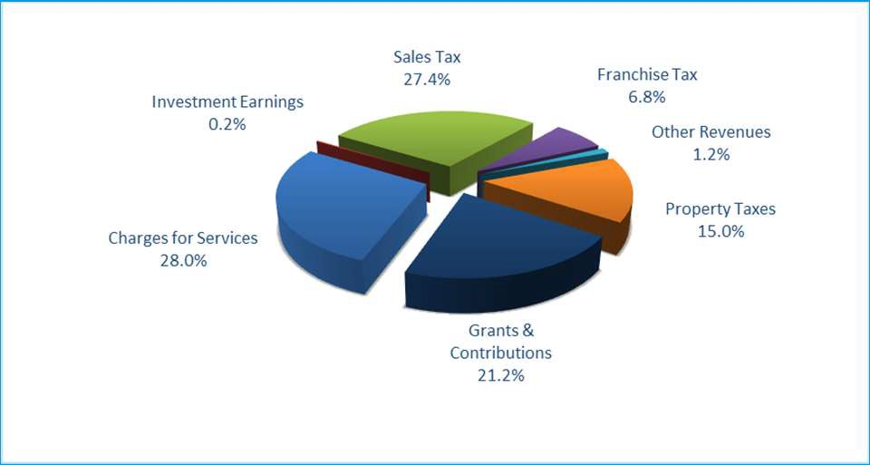Main Points:
REVENUES BY SOURCE – 2021 GENERAL FUND
- Provide understanding of all revenue sources, Property tax is only one of several
- The Truth in Taxation advertisement indicates 33.54%, but that is referring to a percentage of only one slice of the pie (property tax)
- In terms of total government spending, the potential rate increase tonight represents about 5% of the city’s general fund budget.

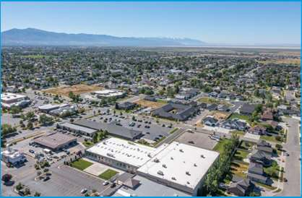
Regardless of change in property values
the tax revenue remains the same

Base Tax Revenue: $3 Million
=
$3 Million
=
$3 Million
City-Wide Property Values

Main Points:
- Provide basic education on how tax rates automatically go up or down without action by the City Council, based on property values

INFLATION AND PROPERTY TAX REVENUE
Inflation makes it so that the City has fewer resources (purchasing power) to
provide services to existing citizens City
Services
2012 2022
New growth requires the City to cover
additional services required by the new property. It is not intended to offset inflation

$786
Source: Bureau of Labor Statistics CPI Inflation Calculator http://www.bls.gov/data/inflation_calculator.htm

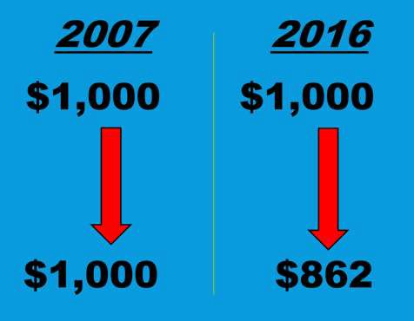Source: Bureau of Labor Statistics CPI Inflation Calculator http://www.bls.gov/data/inflation_calculator.htm
Main Points:
- Provide basic education on how inflation erodes the city’s ability to provide services to existing citizens
- Provide understanding that new growth provides new revenue, but it also demands additional services
- New growth is meant to pay for new growth, existing homes/businesses require same demands but the city has fewer resources to provide services due to inflation

ESTIMATED TOTAL PROPERTY TAX BILL – BREAKDOWN BY TAXING ENTITY
Taxes based on a $535,000 home, which is the average value home in Syracuse.

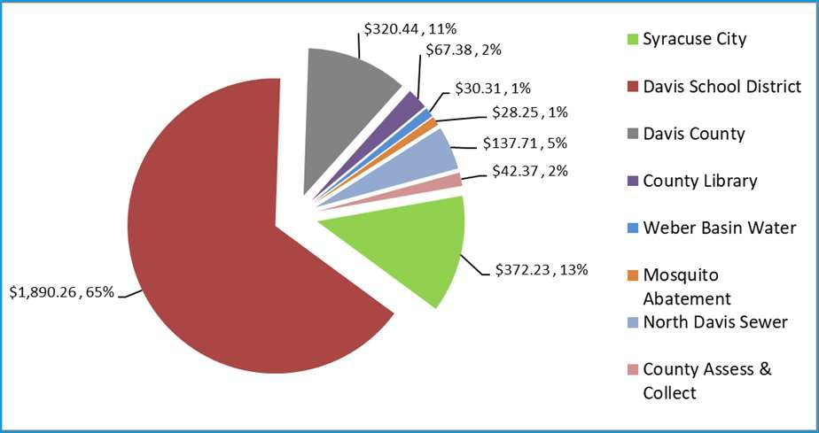Main Points:
- Explain that the city is a minor portion of the entire property tax bill
- Ensure that people understand that a tax increase tonight is not on the total bill, but only on the city portion

BY WAY OF COMPARISON
Avg Annual City Avg Annual Cell Phone Bill
Tax $1,368
$372

Avg Annual Household Streaming Services
$660

Avg Annual Cable/Internet Bill
$1,141

Sources: https://www.moneysavingpro.com/plans/average-phone-bill-per-month/ , https://www.jdpower.com/business/resources/despite-return-normal-people-spending-more-time-and- money-streaming-services-now , https://www.businesswire.com/news/home/20210518005827/en/United-States-of-Bill-Pay-The-Average-U.S.-Household-Spends-1141-Per-Year-on-Cable- Internet-Bills

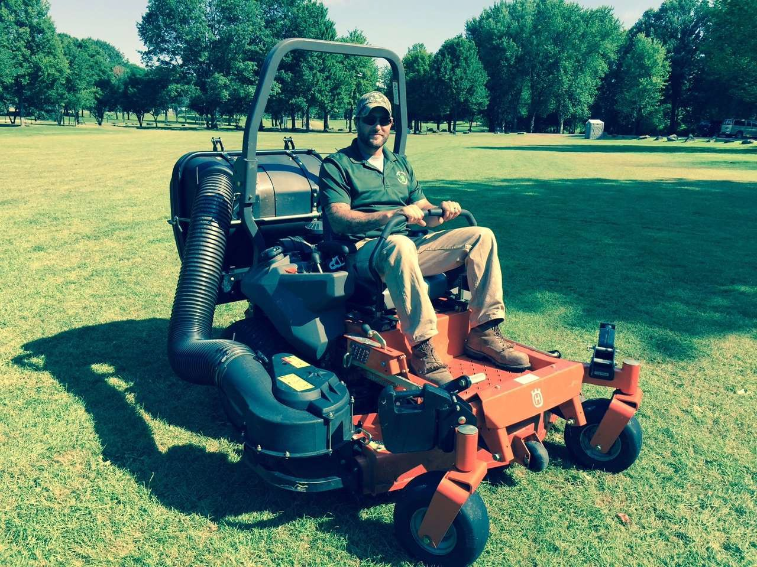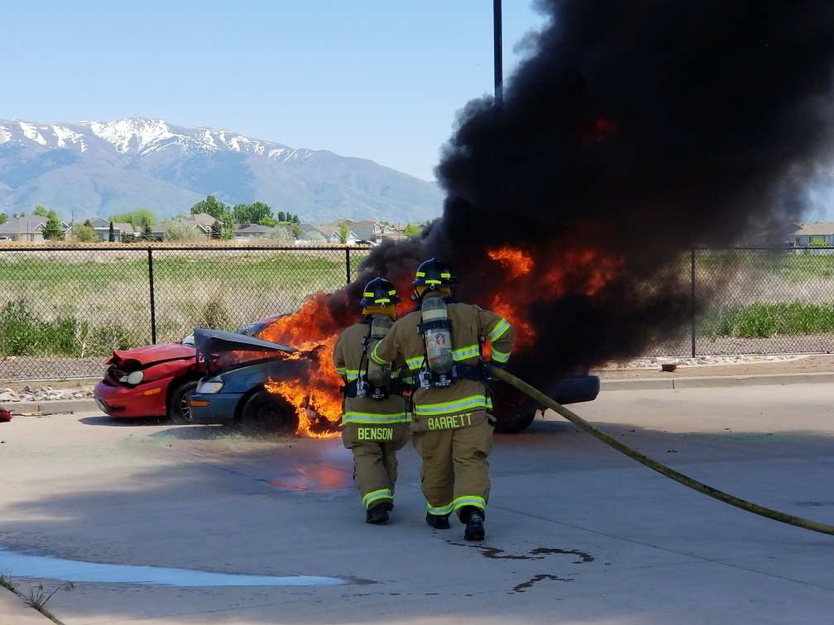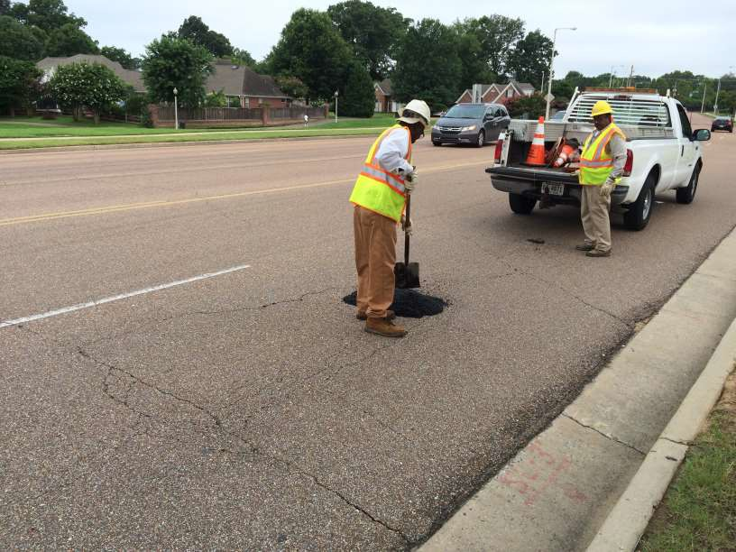Main Points:
- To gain perspective, understand the magnitude of city property tax in comparison to other ubiquitous consumer services

BB15
TRUTH IN TAXATION PROPOSAL
- Property Tax Rate Adjustment
  - Without action, the tax rate would drop from 0.001653 to 0.001265
  - Proposal is to adjust the tax rate from 0.001653 to 0.001689
  - Approx. $1,193,000 in additional revenue
  - $124.76/year or ~$10.40/month for the average residence ($535,000
home value)

Main Points:
- Simplify the proposed tax rate adjustment so it is easily understood

Slide 9

BB15 Animate first and second sections seperatley on a click
Brody Bovero, 7/27/2017

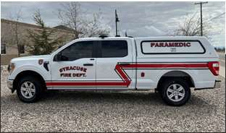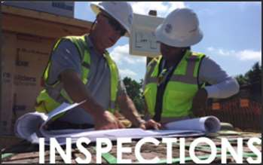

TRUTH IN TAXATION PROPOSAL
- Priority Direction of Additional Revenue
  - $450,000 for paramedic transition from Davis County (2nd/final installment).
  - $132,000 for 2 Park Maintenance Workers
  - $128,500 for 1 Police Officer III (Experienced)
  - $98,250 for a public information specialist
  - $86,000 for an HR Specialist
  - $80,000 for a Facility Maintenance Tech
  - $18,500 for a Public Works Inspector
  - ~$120,000 for vehicles, equipment

Main Points:
- Walk through the priority direction on where the additional tax revenue will be spent so people know where the money will go

TRUTH IN TAXATION PROPOSAL (MONTHLY)
- Portion of Additional Tax Revenue (monthly)
  - $3.92/mo for paramedic transition from Davis County (2nd/final installment).
  - $1.15/mo for 2 Park Maintenance Workers
  - $1.12/mo for 1 Police Officer III (Experienced)
  - $0.86/mo for a public information specialist
  - $0.75/mo for an HR Specialist
  - $0.70/mo for a Facility Maintenance Tech
  - $0.16/mo for a Public Works Inspector
  - ~$1.05/mo for vehicles, equipment

Main Points:
- Boil down the items from the previous slide to a monthly cost so it is more readily understood on the average household budget

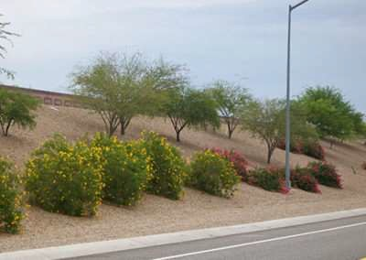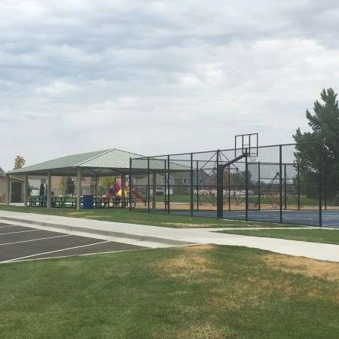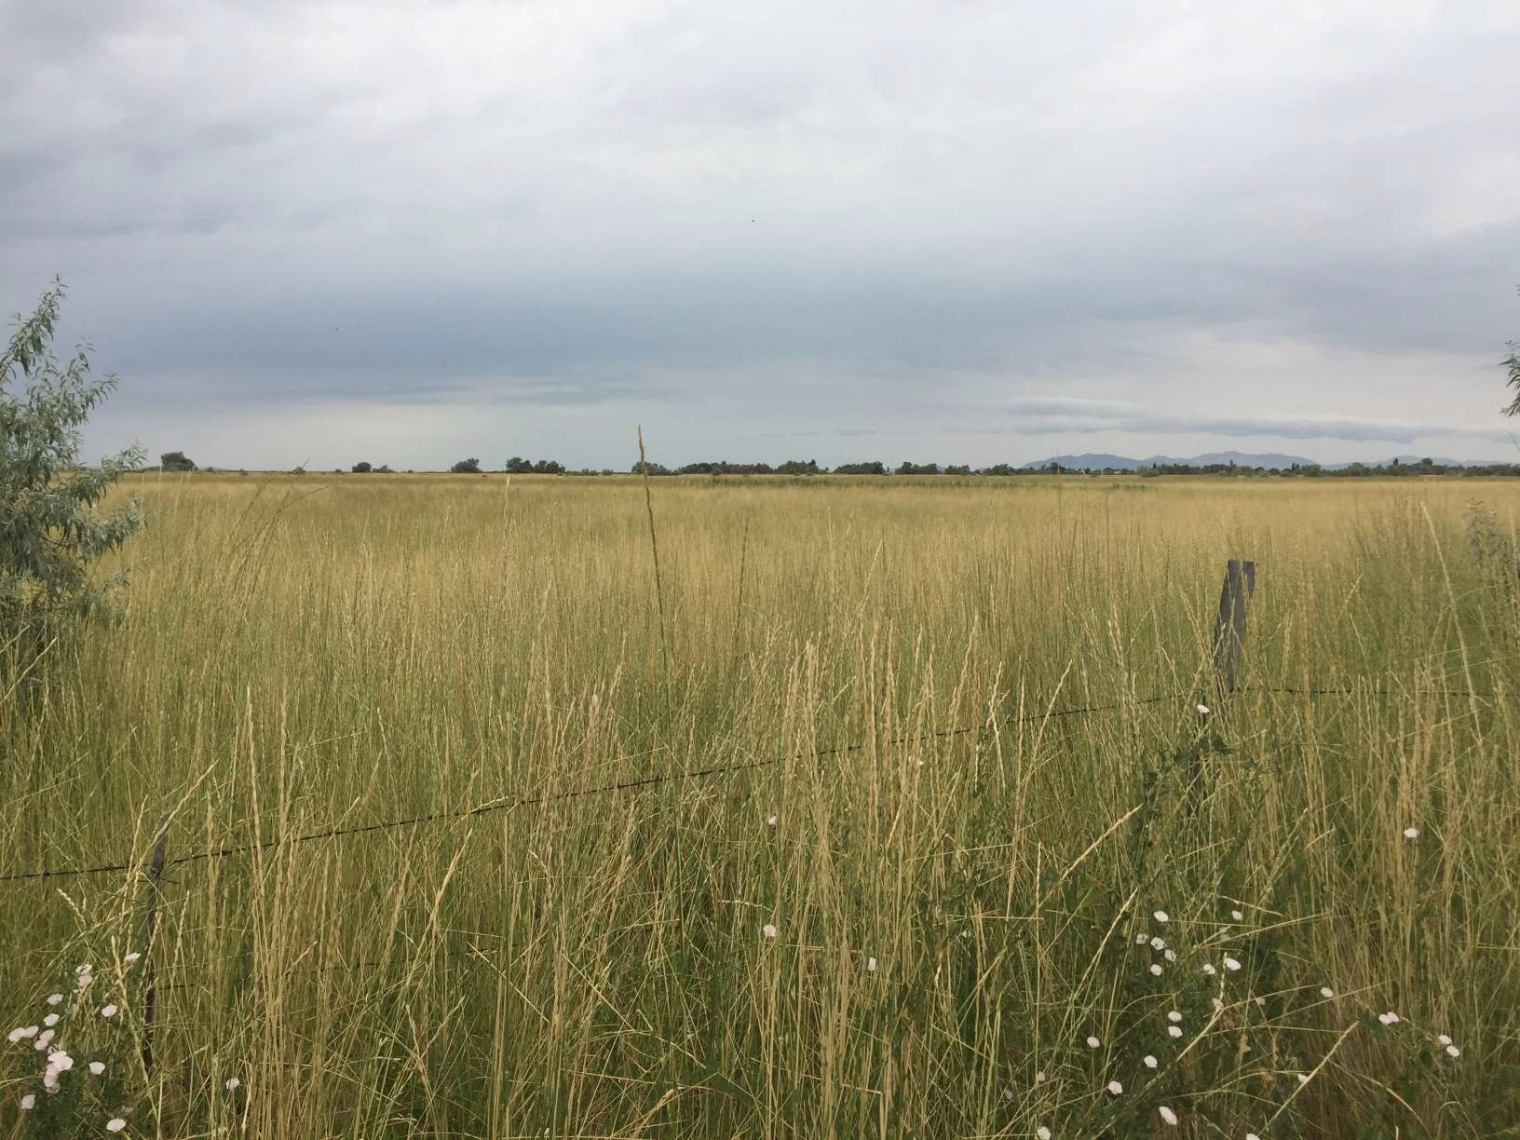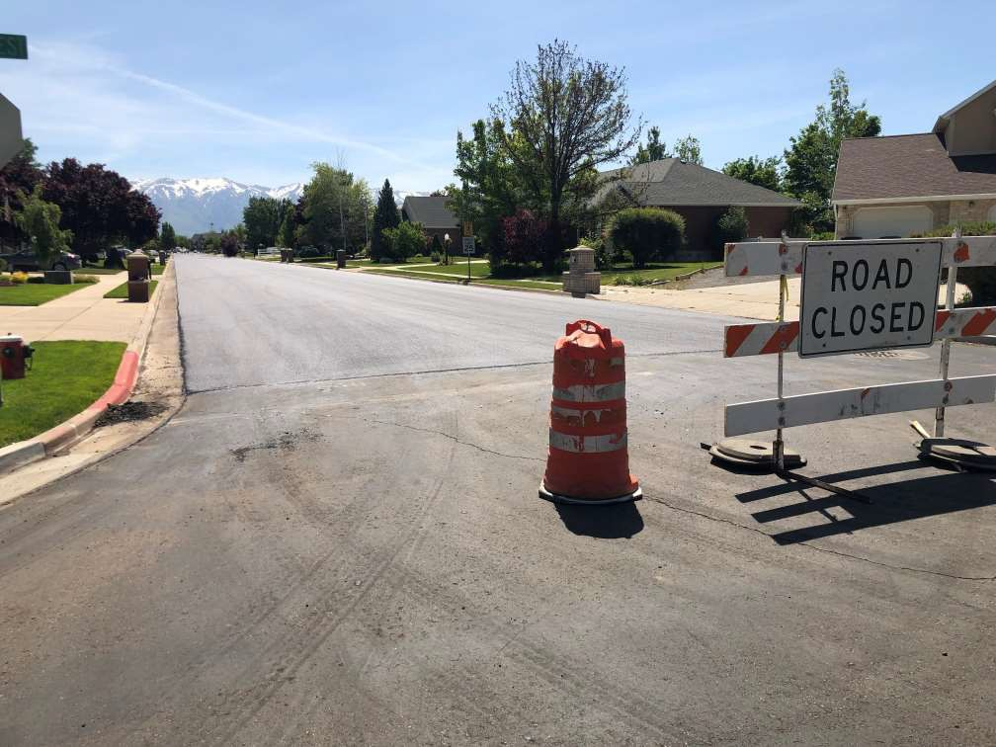

- Ongoing Needs Not Addressed by this Proposal
  - WDC Landscaping Improvements
  - Park Development
  - Park Land Acquisition
  - Street Repaving
  - Full Traffic Unit
NEEDS NOT BEING
ADDRESSED…

Main Points:
- In order to be cost-sensitive to citizens, there are needs the city has that have been left out.

PROPERTY TAX RATE – TRUTH IN TAXATION
Full-Service Cities Cities that have other taxing rates for fire or recreation districts Proposed Tax Increase

Centerville, Clearfield, Fruit Heights, South Weber, Sunset, Woods Cross and West Point are also holding Truth in Taxation Hearings.

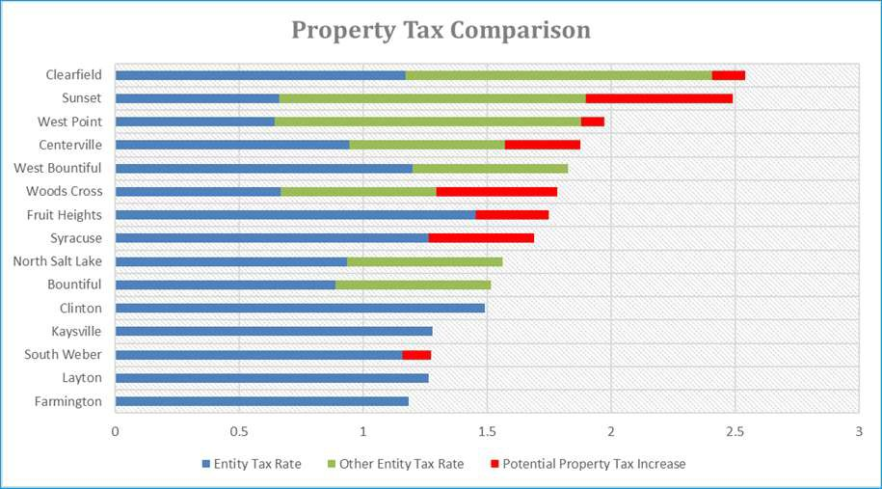Main Points:
- Explain the difference between the colors on the graph
- Indicate where Syracuse sits in comparison to other cities

ADDITIONAL COSTS = ADDITIONAL REVENUE?
The City has secured over $23.9 outside funding (grants) over t

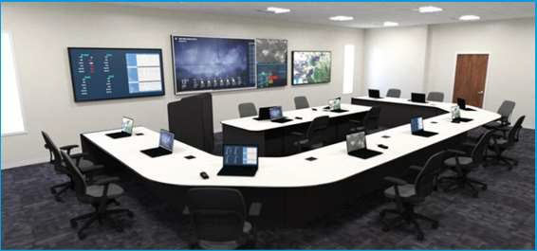Main Points:
Million in
he last 5 years.
- An often overlooked component of staffing, explain that maintaining adequate staffing also allows the city to pursue outside funding for its citizens.
- Explain that over the past 5 years, the staff and elected officials have worked together to secure over $23.9 million for the City in outside funding.

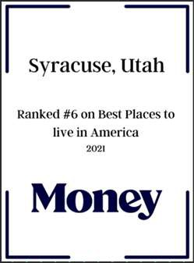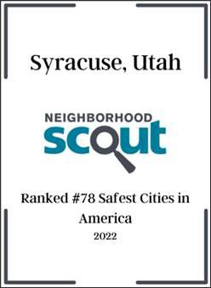
BALANCING QUALITY SERVICE WITH
AFFORDABILITY
Fire Rating: 3
CCR
Excellence Award
Top 15% in
Utah
5 Years
Straight
12 years straight

Main Points:
- Referring back to the City’s Mission, which includes “quality …services”, review some of the accolades given to the city.

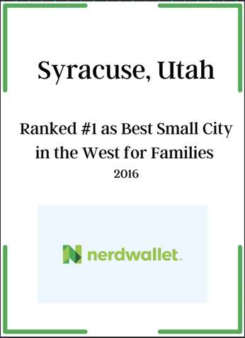
BALANCING QUALITY SERVICE WITH
AFFORDABILITY
R
e
op
U
2017
2018
2019
2020
2021

Main Points:

Fire T

CCR
ating: 3 Excellenc Award
15% in
tah 10 Years
Straight
- Referring back to the City’s Mission, which includes “quality …services”, review some of the accolades given to the city.

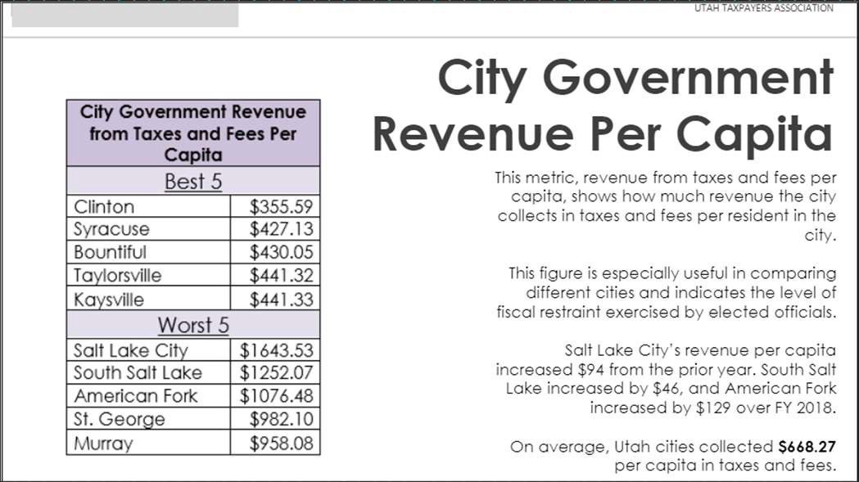

#2 Lowest City in Utah

Cost of Gov’t per Person
BALANCING QUALITY SERVICE WITH AFFORDABILITY

Main points:

Fire Rating: 3

Top 15% in Utah
- Referring to the mission statement, which includes “affordable services”, review the findings of the Utah Taxpayers Association’s latest report
- Explain that this rating compares cities in Utah and is an indicator of the level of fiscal restraint exercised by elected officials in your city.
- Point out that Syracuse ranks #2 in the state for lowest cost of government per capita.
- Point out that the Utah average for cities is $668.27 per capita in taxes and fees. Syracuse collects $427.13

BALANCING QUALITY SERVICE WITH AFFORDABILITY
#5 Lowest City in Utah

Cost of Gov’t per
$1,000 of Citizen Income

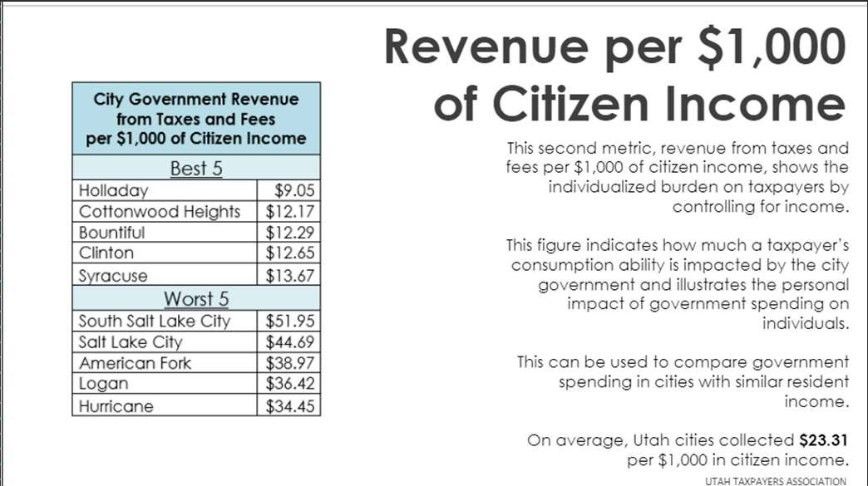Main points:

Fire Rating: 3

Top 15% in Utah
- Referring to the mission statement, which includes “affordable services”, review the findings of the Utah Taxpayers Association’s latest report
- Explain that this rating compares cities in Utah and is an indicator of the personal impact the city’s spending has on individuals.
- Point out that Syracuse ranks #5 in the state for lowest cost of government per
$1,000 of citizen income.
- Point out that the Utah average for cities is $23.31 per $1,000 in citizen income in collected revenue. Syracuse collects $13.67 (almost half the average)
- While it is always expected to be upset about a rising tax rate, there are strong arguments that support the idea that Syracuse City acts responsibly with citizen tax dollars.

