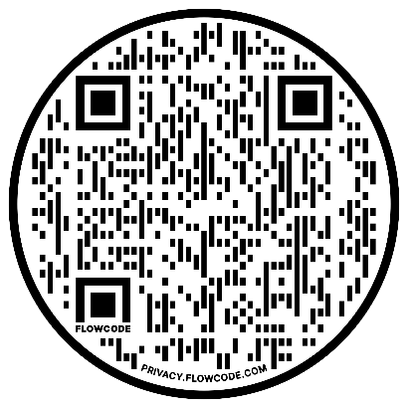
OPEB Board Agenda
Location: WebEx – Electronic Meeting Only
Link: https://bit.ly/opeb0714
Date: Thursday, July 14, 2022
Time: 3:00 - 4:00 PM

Agenda Items
 | - Roll Call | Darrin Casper
 | - Review minutes from 04/20/22  and move to approve | Darrin Casper
 | - $850k transfer to Moreton discussion | All

 | - Moreton presentation  - Revisit 50/50 allocation in September  - OPEB Eligibility Criteria  - Schedule next OPEB meeting | Jason Williams  All  Dave Delquadro  All



