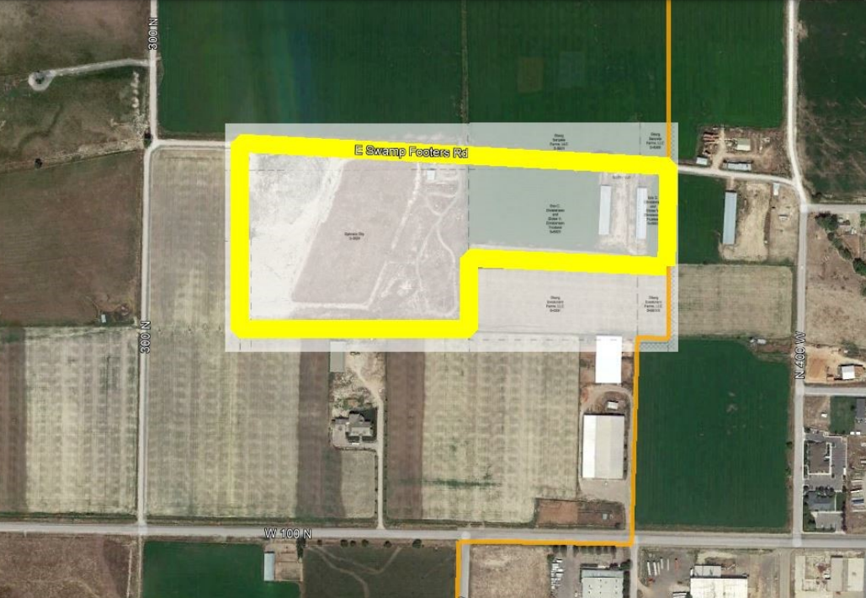

PARCELS S-5922, S-5923 AND S-5924 INTO THE LIMITS OF EPHRAIM CITY. 2. BASIS OF BEARINGS USED WAS NORTH BETWEEN THE SOUTHEAST CORNER AND THE EAST QUARTER CORNER OF SECTION 5, T.17 S., R.3 E., S.L.B. & M. 3. THIS ANNEXATION PLAT IS BASED ON RECORDED DOCUMENTS AS FILED IN THE SANPETE COUNTY RECORDER'S OFFICE. COUNTY SURVEYOR APPROVAL I, RYAN W. SAVAGE, A PROFESSIONAL LAND SURVEYOR AS PRESCRIBED BY THE LAWS OF THE STATE OF UTAH, HOLDING CERTIFICATE #183343, ACTING AS THE SANPETE COUNTY SURVEYOR, CERTIFY THAT THE PLAT SHOWN HEREON MEETS ALL APPLICABLE REQUIREMENTS TO THE BOUNDARY ACTION AND HEREBY APPROVE THIS PLAT AS A FINAL LOCAL ENTITY PLAT. PROFESSIONAL LAND SURVEYOR DATE SURVEYOR'S SEAL Located in the Southeast and Northeast Quarters of Section 5, T.17 S., R.3 E., S.L.B. & M. Sanpete County, Utah 2022 VICINITY MAP NOT TO SCALE ANNEXATION LOCATION 100 NORTH 400 WEST MAIN STREET BEGINNING AT THE EAST QUARTER CORNER OF SECTION 5, T.17 S., R.3 E., S.L.B. & M., SAID POINT OF BEGINNING ALSO BEING LOCATED ON THE EXISTING EPHRAIM CITY BOUNDARY AND THE NORTHEAST CORNER OF TAX PARCEL S-5922; THENCE SOUTH ALONG THE EAST LINE OF SECTION 5, THE EXISTING EPHRAIM CITY BOUNDARY AND THE EAST BOUNDARY OF TAX PARCEL S-5922, 389.40 FEET TO THE SOUTHEAST CORNER OF PARCEL S-5922; THENCE WEST ALONG THE SOUTH BOUNDARY OF PARCEL S-5922 AND THE SOUTH BOUNDARY OF PARCEL S-5923, 780.78 FEET TO THE SOUTHWEST CORNER OF PARCEL S-5923 AND A POINT ON THE EAST BOUNDARY OF PARCEL S-5924; THENCE ALONG THE BOUNDARY OF PARCEL S-5924 THE FOLLOWING COURSES: SOUTH 237.60 FEET, WEST 896.94 FEET, NORTH 742.52 FEET, S86°00'00"E 905.67 FEET TO THE WEST BOUNDARY OF PARCEL S-5923; THENCE ALONG THE BOUNDARY OF PARCEL S-5923 THE FOLLOWING COURSES: NORTH 1.47 FEET, S86°30'00"E 665.28 FEET AND SOUTH 13.20 FEET TO THE NORTHWEST CORNER OF PARCEL S-5922; THENCE EAST ALONG THE NORTH BOUNDARY OF PARCEL S-5922, 110.22 FEET TO THE POINT OF BEGINNING. CONTAINING 22.142 ACRES MORE OR LESS.

