Cottonwood Heights Public Works Department
Request for Proposals
Engineering Services for the Design of the Union View Trail
June 16, 2022

TABLE OF CONTENTS

Section 1 Contacts and Schedule 1
(1) Mailing Address 1
(2) Staff Contacts 1
(3) Schedule of Dates 1
Section 2 Project Overview 2
Section 3 Scope of Services 2
Section 4 Questions and Inquiries 2
Section 5 Ownership of Documents 3
(1) Proposal Documents 3
(2) Design Documents 3
Section 6 Proposal Format 3
(1) Cover Letter 3
(2) Conflict of Interest 3
(3) Qualification and Experience 3
(4) Resumes 4
(5) Proposed Methodology 4
(6) Project Schedule and Deliverables 4
(7) References 4
(8) Schedule of Costs and Fees 4
Section 7 Meetings 5
Section 8 Selection Process 5
(1) Objectives 5
(2) Selection 5
(3) Evaluation Criteria 5
Section 9 Disqualification 7
Section 10 Submission of Proposal 7
Section 11 Preliminary Drawing of Proposed Route 8
Section 12 Location of Project on City Map 9

Contacts and Schedule

Mailing Address
Cottonwood Heights Public Works Department
2277 East Bengal Blvd.
Cottonwood Heights, Utah 84121

Staff Contacts
- Andy Hulka, AICP, Senior Planner
(801) 944-7065
ahulka@ch.utah.gov
- Matthew Shipp, P.E., Public Works Director / City Engineer
(801) 944-7090
mshipp@ch.utah.gov
- Paula Melgar, City Recorder
(801) 944-7021
ahulka@ch.utah.gov

Schedule of Dates
- June 16, 2022 Release of Request for Proposal
- July 6, 2022 Deadline to Submit Written or Verbal Questions by 5:00 p.m. (MST)
- July 12, 2022 Submittal Deadline: Proposals Due by 3:00 p.m. (MST)
- July 14, 2022 Consultant Selection Notification
- July 19, 2022 City Council Approval and Contract
- July 21, 2022 City and Consultant Kickoff Meeting

Project Overview
Cottonwood Heights Public Works and Community & Economic Development Departments are requesting proposals to provide engineering services for the design of the Union View Trail located in the northwest section of Cottonwood Heights at approximately 1385 East and 7200 South.
This project is part of an overall city trails masterplan and will connect a section of that trail plan from the top of a slope to future connection. The proposed trail is approximately 1,500’ feet in length and approximately six (6’) feet wide. This meandering trail will be used by pedestrians and bicyclists.
Due to the geography, the trail will have many challenges in slope, drainage, and retainage. It is anticipated that the trail material will be a crushed limestone or like material.
The proposed trail is located on private property. Discussions with the property owner have begun. The consultant will need to prepare metes and bounds descriptions for either an easement or right of way from the existing property owner and the city.

Scope of Services
The following items are expected to be a part of the design and construction of the trail project. This is not meant to be an all-inclusive list for every aspect of the project but can be used by the consultant to determine if they wish to propose on the project. The successful consultant will be expected to prepare bid documents, construction drawings, and specifications for the work related to the following on the project.
- Survey and Right of Way
- Complete Engineering Design Services
- Landscaping Plans
- Retaining Wall Designs
- Stormwater Drainage
- Construction Documentation
- Contract and Compensation
- Scheduling
The final drawings will show enough details that competitive bids can be provided for construction work. The consultant will provide progress bid documents with cost estimates for review and comments. Construction submittals shall be submitted to the city for review at the 30%, 60%, and 90% stages of the design. Cost estimate submittals will be provided at the 90% and final design stage.

Questions and Inquiries
All questions pertaining to this request for proposal should be addressed to either
- Matthew Shipp, P.E., (801) 944-7090 or mshipp@ch.utah.gov
Or
- Andy Hulka, AICP, (801) 944-7065 or ahulka@ch.utah.gov
Question may be submitted anytime during the proposal process until July 12, 2022 at 5:00 p.m. (MST). Questions submitted after this time will not be answered. All questions submitted either verbally or in writing will be addressed to all proposers via email.

Ownership of Documents

Proposal Documents
Submitted information for the proposal to the city will become the property of the city and may be shared as per the state law unless specifically stated as a proprietary process.

Design Documents
All final documents, including but not limited to drawings, specifications, data, reports, summaries, correspondences, photographs, video and audio recordings, and any other materials with respect to the work performed shall be provided to the city upon completion of the work or upon request by the city. Any information obtained by the consultant in preforming the services of the contract shall become property of the city and shall not be released to others without prior written consent from the city.

Proposal Format
The proposal submission may not exceed fifteen (15) single sided standard sized (8½” x 11”) pages. The page limit does not apply to resumes (appendix), project schedule (appendix), one- page table of contents, and any folder or cover. Costs for preparing and submitting a response to this RFP are entirely the responsibility of the consultant.
The proposal content shall include:

Cover Letter
Provide a summary of the firm’s proposal contents, emphasizing qualifications and capabilities of the consultant and any sub consultants, if appropriate. The summary should indicate an understanding of design services required for performance.
The cover letter should be signed by an officer of the firm who is authorized to negotiate and contractually bind the firm with the city regarding the requested services. The designated project manager shall be the main contact with the city for technical and contractual issues and shall be responsible for the direction of day-to-day progress. Provide the telephone number, e-mail address, and the office location of the project manager.

Conflict of Interest
The Consultant shall disclose and list any financial, business, or other relationships with the City that may have an impact on the outcome on the required for performance of the project. A potential conflict of interest includes, but is not limited to, work related to contracts with other city departments, local land developers, current clients, and other parties who may have a financial interest in the outcome of the project. At the city’s discretion, a potential conflict of interest may be waived or factored into the final award decisions and/or modified scope of work.

Qualification and Experience
Summarize the qualifications and relevant experience for the consultant firm and any sub consultants related to items listed in Section 3 of this document.
Provide a summary of the firm’s overall capabilities, history, recent and related experience, and expertise. The proposed key personnel and support staff that are expected to provide engineering services should be identified. Provide information on the firm’s experience related to the project’s scope.
Provide information on the firm’s current workload, facilities, resources, and experience that clearly demonstrates its ability to successfully complete the project.
Provide the location of the firm’s office where the majority of the work will be completed, and the percentage of workload provided by that office.

Resumes
Provide a resume in the appendix for each of the proposed key personnel focusing on relevant experience and the assigned function of each key person.
The resume should provide information related to the project’s scope of work. Similar information is required for each sub-consultant utilized, if any, and the approximate percentage of their contribution.
The proposal should include a statement describing the firm’s commitment of the individuals proposed to perform the requested services.

Proposed Methodology
Describe your understanding of the project and challenges that may be encountered during this process and the way the firm would address these issues.
Describe the process or work plan your firm will utilize during the process of developing the project from preliminary design to final construction documents.
Describe the firms experience in working with private property owners and governmental entities.

Project Schedule and Deliverables
Provide a project schedule based on project tasks associated with the design based on the proposed methodology.
Provide milestones for the deliverable which include but not limited to design stages, preliminary survey data, proposed preliminary layout based on the survey, and final designs and specifications.

References
Provide a list of similar projects that the proposed key personnel have completed in the last five years. The projects listed should be similar as the project’s scope of work described in Section 3.
Should the city not reach a contact person with the information provided, the reference will not be considered in the evaluation.
The submitted references should include:

Project description and location

Description of services provided relevant to this project

Budget and schedule performance

Key personnel involved and sub-consultants employed

Client name, contact person, and current phone number, and e-mail address

Schedule of Costs and Fees
Each proposal shall include, in a separate sealed envelope, three (3) copies of the consultant’s schedule of costs and fees.
Each such proposal must provide a cost matrix broken down by project task and the number of hours per task including staff title and hourly rate. The schedule of costs and fees shall include current fee schedules, personnel wage rate sheets, and other costs.
The firm shall provide specific hourly rates for each class of employee, specialists, and/or sub consultant. The specific rates of compensation are to include an hourly breakdown, direct salary costs, salary additives, indirect costs, and fixed-fee or profit.
Other direct costs should be set forth as independent cost items. The schedule of costs and fees shall include a separate itemization of any additional costs, such as mileage, printing, postage, and other reimbursable expenses.

Meetings
While the city cannot anticipate the exact number of meetings required for the design of this project, the consultant should assume that the city staff will have a weekly update on the progress of the project. The consultant can expect to hold meetings with the staff at various stages of the project which will include review and redlines of plans at various stages. This will include a combination of in-person, virtual, and phone meetings depending upon the need.
The consultant can expect to hold meetings with the property owner and the city to discuss possible alternative and alignments during the preliminary design and final design phase.
The consultant can expect to hold meetings with the city’s Parks, Trails, and Opens Space Committee to review the plans before final drawings are completed (estimate two meetings).

Selection Process

Objectives
The city’s overall objective is the selection of a highly qualified consultant to perform the project work at a reasonable cost; therefore, it is the city’s intent that the selection process be fair and open, the selection of the consultant be based on clearly stated criteria, and that the proposal be evaluated by a qualified evaluation committee.

Selection
Upon the completion of the selection of a consultant, the city will work with the consultant to prepare a final scope of services and fees to be used in a city contract. If the city and the consultant cannot come to an agreement on a final scope of services and fees, then the city will end negotiations and begin negotiating with the second firm on the list.
Cost will not be the only determining factor in the proposal, so the consultant is encouraged to review the entire request for proposal.
The city reserves the right to reject any and all proposals at the discretion of the city at any point in the process of selection.

Evaluation Criteria
Firms will be evaluated by a panel of city employees to be determined by the public works director. The evaluation will be based on the following scoring matrix:

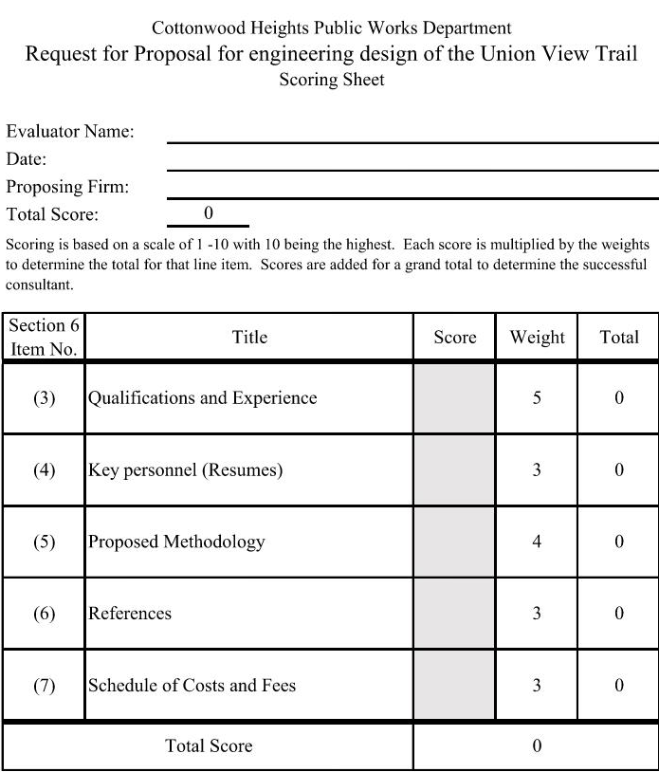

Disqualification
Non-responsive proposals will also receive no consideration. A “responsive” proposal conforms in all material respects to the RFP.
Proposals received after the deadline will be disqualified and rejected.

Submission of Proposal
Firms interested in submitting proposals pursuant to this Request for Proposal must provide three (3) bound copies of their proposal, three (3) copies of the fee and schedule, and one (1) thumb-drive of the package with the entire proposal in PDF format.
Proposals shall be submitted in two separate sealed envelopes as follows:
Three (3) proposals in one sealed envelope with the following on the outside:
Proposal for Engineering Services for the design of the Union View Trail
Date: July 12, 2022
Three (3) schedule of costs and fees in one sealed envelope with the following on the outside:
Fee and Schedule for Engineering Services for the design of the Union View Trail
Date: July 12, 2022
The two (2) envelopes and thumb drive shall be submitted in one sealed package to:
Paula Melgar, City Recorder
Re: Request for Proposal for Union View Trail
2277 East Bengal Blvd.
Cottonwood Heights, Utah 84121
Proposals must be received by 3:00 p.m. on July 12, 2022. Proposals received after this time will not be accepted or opened and returned to the proposer.

The city reserves the right to reject any or all proposals.

Published this 16th day of June 2022 by Paula Melgar, City Recorder

Preliminary Drawing of Proposed Route
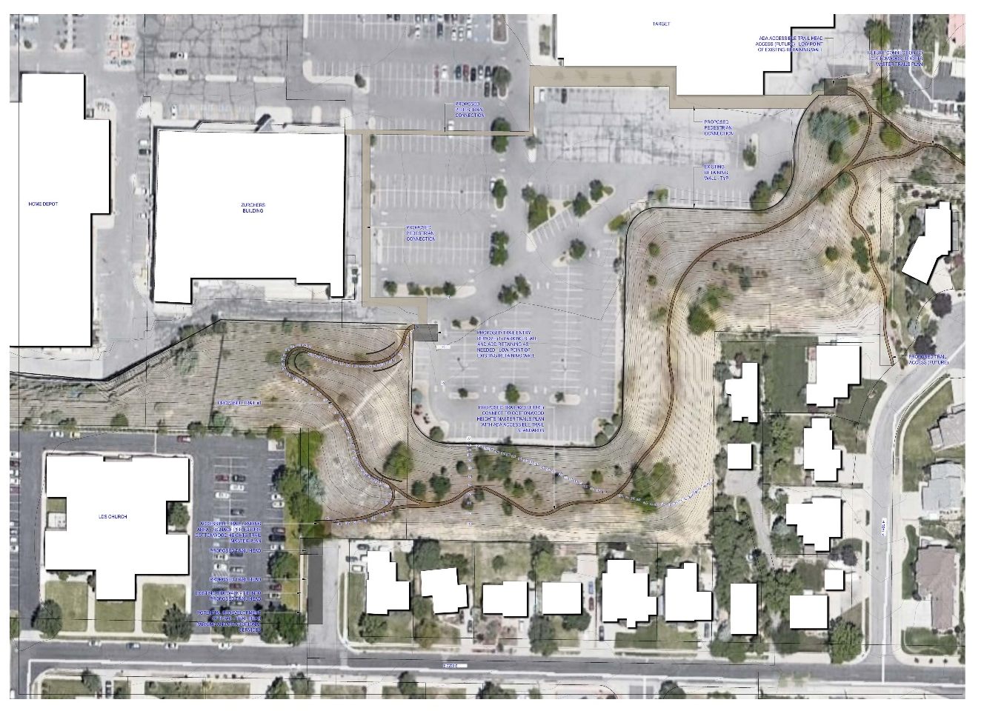

Location of Project on City Map

