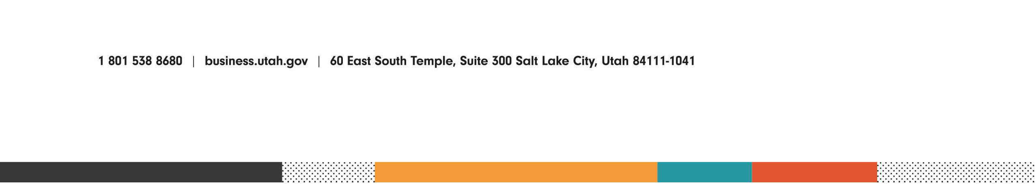
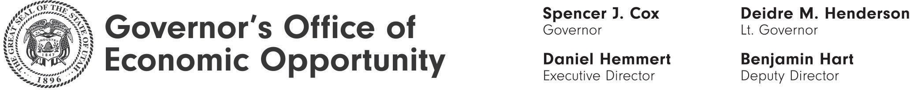

General Regulatory Sandbox Program Advisory Committee
June 16, 2022 – 1:30p.m.

Anchor Location- Canyonlands Conference Room
World Trade Center, 3rd Floor
60 E South Temple, Salt Lake City, UT

Agenda

Open and Public Meetings Act Training

Application Update - TowPro

Application Review - Nuttall, Brown & Coutts, BLLC

Electronic Participation
Zoom Meeting https://utah-gov.zoom.us/j/5957471740

