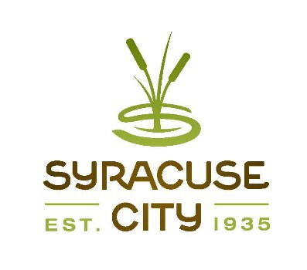SYRACUSE CITY
Syracuse City Special Redevelopment Agency (RDA) Meeting June 14, 2022 – immediately following the City Council Business Meeting, which begins at 6:00 p.m.
In-Person Location: Syracuse City Hall, 1979 W. 1900 S. Electronic: Via Zoom Meeting
Connect via telephone: +1-301-715-8592 US, meeting ID: 879 2280 3440
Streamed on Syracuse City YouTube Channel

Meeting called to order Adopt agenda
- Approval of minutes:
  - May 10, 2022 Special Meeting.
- Public Hearing: Proposed Resolution RDA R22-01 adopting the annual budget for the Fiscal Year (FY) 2022-2023 as required by Section 17C-1-601, Utah Code Annotated, 1953. (10 min.)
- Proposed Resolution RDA R22-02 authorizing the preparation of a draft Community Development Project Area Plan. (10 min.)
- Adjourn.
~~~~~
In compliance with the Americans Disabilities Act, persons needing auxiliary communicative aids and services for this meeting should contact the City Offices at 801-825-1477 at least 48 hours in advance of the meeting.

CERTIFICATE OF POSTING
The undersigned, duly appointed City Recorder, does hereby certify that the above notice and agenda was posted within the Syracuse City limits on this 9th day of June, 2022 at Syracuse City Hall on the City Hall Notice Board and at http://www.syracuseut.gov/. A copy was also provided to the Standard- Examiner on June 9, 2022.
CASSIE Z. BROWN, MMC SYRACUSE CITY RECORDER

