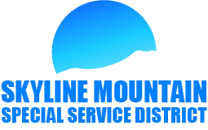

SMSSD Board Meeting
July 5th 2022
6pm

- Approval of last meeting minutes
- Approval of financials
- Discussions on Reviewing bids on Thad’s Peak Improvement projects
- Discussions on Connection Fees & Transfer fees
- Talk about Zoom meeting discussing Outside connections
- Second request for Well at Wilcox’s lot
- Notice of intent to prepare Impact fee posted 4-19-2022
- Update on water system
- Liens
- Growth
- New / Old Business
-Open time for customers on agenda
- Executive Meeting
- Adjourn

