1| Page Council Meeting______________________________________________________May 3, 2022

HENEFER TOWN COUNCIL MEETING
May 3, 2022
150 W Center Street
Henefer, UT 84033

Minutes of the Henefer Town Council meeting held May 3, 2022.

Roll Call: Mayor Kay H. Richins, Robin K. Riches, Detton L. Fawcett, Casey R. Ovard, James A. Rees, Shelley D. Richins, Mason Kjar, Ben Nielson, Casey Ovard, Brennen Richins, Tiana Hilton, Ben Hilton, Brent Ovard, Richard Breitenbeker.

Mayor Kay H. Richins opened the meeting at 7:00 p.m. The prayer was offered by Detton L. Fawcett and the Pledge of Allegiance was offered by Gerry Butler.

The new Fire Chief for the NS Fire District, Ben Nielson, introduced himself to the council. Ben informed the council that he has been in fire service for about 18 years. Jim Rees asked Ben to inform the council on the current fire fighter numbers. Ben explained that all of the fire fighters had been on furlough for an extended period of time. Currently, there are 25 fire fighters in service, some returning and some new. The level of service has been improved from fire fighters responding from home to responding from the Coalville Fire Station. Ben’s vision for the future is to have all fire stations in the NS Fire District staffed.

Robin Riches questioned what services are currently provided from the Henefer Fire Station. Ben explained that no services are currently being provided from this station, everything is coming out of Coalville. Currently firefighters are working 12-hour shifts, for a wage of $235.00/shift. There is also a call back stipend for available firefighters to respond, in case of a call.

Ben explained that there is also an ambulance stationed at the Coalville Fire Station to respond to surrounding areas.

Mayor Kay H. Richins questioned what equipment is stored in the Henefer Fire Station. Ben explained that Henefer currently has a fire engine with no tools, due to lack of maintenance. Ben informed the council that it is his goal to update equipment as soon as the budget will allow. Ben explained that he will be ordering all new turnouts for fire fighters. Unified Fire Authority has offered turnouts in the meantime, until the new turnouts arrive. Ben will also be discussing the purchase of new SCBA’s at the upcoming ACB meeting.

Casey Ovard expressed concern for spending money on things we want vs. things we need. Ben agreed with Casey and offered to meet to explain the things that the NS Fire District needs. Casey also expressed that he understands the need to progress and provide proper equipment.

Jim Rees expressed that it is his opinion that the turnouts need to be of very good quality to ensure the safety of the firefighters.

2| Page Council Meeting____________________________________________________May 3, 2022

The first item on the agenda was a business license for Connor Richins. Brennen Richins attended the meeting. Brennen explained that himself and his brother, Connor, are requesting a business license for their floor coating business. Brennen explained that his brother Jayce already has a business license, but Brennen & Connor are purchasing the business from him. Brennen informed the council that a minimal amount of product would be stored at the family farm, but most product would be stored in Ogden. The new business will be called B&C Coatings, LLC.

Mayor Kay H. Richins called for questions from the council. There were no questions. Mayor Kay H. Richins called for a motion to approve the business license for Brennen & Connor Richins. Casey R. Ovard made a motion to approve the business license for Brennen & Connor Richins. James A. Rees seconded the motion. VOTE: AYE: Mayor Kay H. Richins, Detton L. Fawcett, Casey R. Ovard, Robin K. Riches, James A. Rees NAY: none, ABSTAINING: none, ABSENT: none

The next item on the agenda was a business license for Braden Richins for an archery event. Braden was not in attendance.

The next item on the agenda was a public hearing for an amendment to the culinary water rate schedule for water overages. Mayor Kay H. Richins asked Ty Bailey to explain the purpose of the public hearing.

Ty informed the public that he has researched the current water rates for Henefer. Ty used a snapshot of the July 2021 usage to prepare an analysis of the water rates. Ty explained that there are currently 43 connections that are registering 0 usage. The very first thing Henefer needs to do is to make sure all meters are being read. Ty explained the following Analysis & Rate Proposal:

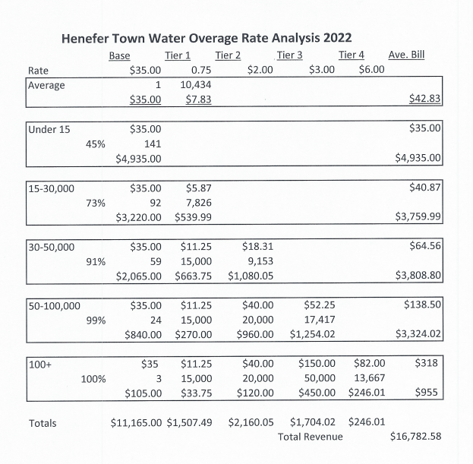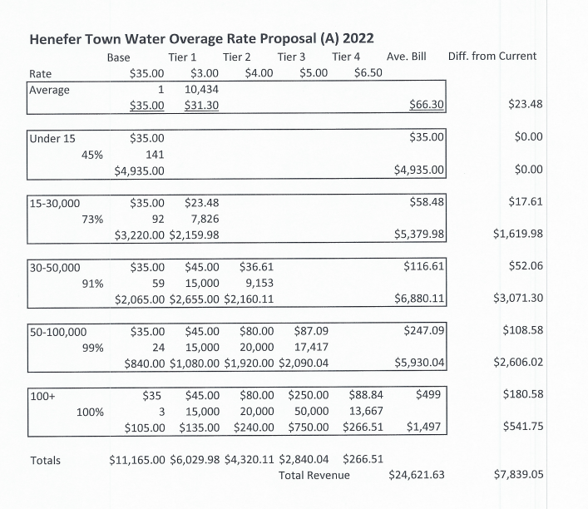

Ty explained that the town rate structure is a tiered system with the base rate of $35.00 for 15,000 gallons or $2.33/1,000 gallons. The rate of the first tier is $.75/1,000 for the next 15,000 gallons of usage. This is a huge discount for using double the water. Therefore, conservation doesn’t kick in until after you have used 50,000 gallons. The rate of tier 4, when you get to 100,000 + level is an appropriate

3| Page Council Meeting____________________________________________________May 3, 2022

ending point. Ty feels the middle tiers need to be revised to promote and give an incentive for conservation. Ty explained that in the future, when secondary water is available, the usage should decrease. This would be a good time to evaluate if the 15,000/gallon base is needed for indoor consumption. Ty expressed that when it gets to the point that water is not available for all the residents, conservation needs to be promoted. The rate structure should promote conservation.

Ty also presented a rate proposal that could be used for an emergency situation with the culinary water.

Ty informed the public that one of the funding sources for the secondary water system requires an average water rate based on the MAGI of Henefer. This rate will have to be met to qualify for the funding. Ty indicated that his rate proposal is a great place to start to demonstrate that the water bill is closer to what the State is going to require.

Mayor Kay H. Richins called for a motion to open the public hearing. Detton L. Fawcett made a motion to open the public hearing. Robin K. Riches seconded the motion. VOTE: AYE: Mayor Kay H. Richins, Detton L. Fawcett, Casey R. Ovard, Robin K. Riches, James A. Rees NAY: none, ABSTAINING: none, ABSENT: none

PUBLIC HEARING

Mayor Kay H. Richins opened the public hearing and called for questions and comments from the public.

Brent Ovard questioned what the suggested base rate is. Ty Bailey informed the public that it is 1.7 % of the MAGI. Ty explained that this would raise the water bill to approximately $100.00/month. This would include culinary and secondary water.

Brent inquired what the MAGI for Henefer is. Ty explained that it is approximately $76,000.00/household.

Brent inquired where we are with funding applications. Mayor Kay Richins explained that Henefer currently has an application in with the Division of Drinking Water. Henefer does not qualify for a grant due to the MAGI, so we have applied for a 2.1 million loan at 0% interest. Brent inquired about the total cost of the project. Mayor Kay Richins explained that this loan would be in addition to funding that has already been acquired. Mayor Richins informed the public that the total cost of the project is approximately 5.5 million. Mayor Kay Richins called for any further questions. There were no further questions from the public.

Mayor Kay H. Richins called for a motion to close the public hearing. Casey R. Ovard made a motion to close the public hearing. James A. Rees seconded the motion. VOTE: AYE: Mayor Kay H. Richins, Detton L. Fawcett, Casey R. Ovard, Robin K. Riches, James A. Rees NAY: none, ABSTAINING: none, ABSENT: none

COUNCIL MEETING RESUMES

4| Page Council Meeting____________________________________________________May 3, 2022

Ty explained that the chart that he presented is on a spreadsheet so the council can enter different amounts to explore different rate options. Jim Rees suggested that each tier of the rate schedule be 15,000 gallons.

Detton informed Ty that of the 43 meters that are registering 0 usage, at least 20 are being read but are inactive meters. Ty suggested that Henefer pay for the water usage at the parks and other Henefer owned facilities, so that every system funds itself.

Mayor Kay Richins suggested that the council review the proposed rate amendment for a decision at the June 7 council meeting.

The next item on the agenda was Brent Ovard with sewer lagoon updates. Brent informed the council that the new UV lights have been installed at the lagoons. The discharge from the lagoons was started on April 1 and had to be stopped on April 16 so that the representatives from Glasco could inspect the system. The representatives visited the lagoons and helped set up the wash system. The system was up and running by April 19 and the lagoons were discharged for an additional 7 days using the new light system.

Brent informed the council that there is excessive water weed growing in the lagoons which is causing problems. The water weed can clog the channel and prevent water from entering the UV system. Brent has been checking lagoons twice a day and the new lights seem to be working well. Brent will check with Rural Water to see if they have any experience in controlling the water weed.

Brent informed the council that a meter for the inlet needs to be purchased. Brent has contacted Mike with Global Sampson regarding the meter. Mike has provided a quote in the amount of $3700.00 for the meter. Brent explained that the meter can be installed in the existing metal container to be protected from the sun.

Brent and Detton informed the council of the following maintenance items that are needed at the sewer lagoons:

- The slides and wheels between the lagoons are broken.
- A permanent marker needs to be installed in the last lagoon to prevent accidental discharge.
- New headgates.
- Replacement of grates.
- Heating and air conditioning for the sewer lagoon building.

Detton informed the council that a shed will not be needed for the inlet meter. The new meter will be self-enclosed. Jim Rees indicated that he can help with the replacement of the grates.

Brent informed the council that a low-level shutoff for the UV lights is essential. It was not included in the system. Brent is working to get the shut-off.

The council gave approval to purchase the inlet meter and the other needed repair items.

5| Page Council Meeting____________________________________________________May 3, 2022

The next item on the agenda was a discussion of the nuisance ordinance for Henefer. Mayor Kay Richins informed the council that the only nuisance ordinance that has been adopted for Henefer was in 1939.

Mayor Richins feels it is important to prepare a new updated nuisance ordinance for our community. Mayor Richins informed the council that he has issued a verbal warning the owners of a property located in Henefer with many violations. Mayor Richins feels it is time to get the Summit County Health Department involved with this property.

Casey Ovard expressed that he feels it is time to involve the health department with the property.

Brent Ovard explained that with his years of experience working for the health department, it is very difficult to prove a health issue. The health department will be very limited in what action they can take.

Mayor Richins explained that the animals from the property are constantly in neighboring yards. The neighbor’s pets have been infected with illnesses from the bird droppings. These illnesses can also be transmitted to humans, which is a concern.

Mason Kjar, legal counsel for Henefer Town, commented on the issue. Mason informed the council that he has reviewed the old ordinance. Mason explained that because the ordinance is so old, it becomes difficult to implement. Also, Henefer does not have a civil code enforcement branch. Therefore, abatement of issues falls to either the Henefer Town Council through some sort of administrative power, or to the Summit County Sheriff’s Department. Mason explained that there are two State statutes that exist in addition to the Henefer ordinance, which could possibly govern this nuisance.
∙ Criminal Code 76-10-801 – Anything which is a danger to human health can be abate. This would be vested in the Summit County attorney.
∙ Civil Code 78-B6-1101 – Anything that is injurious to human health. Is indecent or offensive to the senses. This civil action needs to be brought by the injured party.

Mason explained that the Town Council needs to look at passing an ordinance. This needs to be a formalized ordinance which vests civil authority in the Town Council.

Jim Rees questioned if the ordinance could be retroactive. Mason informed him that ordinances are generally not retroactive. But, just like any nuisance, it is an ongoing situation. You can site for nuisances on a two-week cycle.

Jim explained that as mayor, he dealt with this issue. Summit County would not help with the enforcement of nuisance issues, due to the fact that it is a matter of opinion what defines junk. Mason explained that generally, across the state, municipalities are vested in defining what junk is. You can define junk in a local ordinance.

Casey Ovard questioned if it is an option to draft a new nuisance ordinance. Mayor Richins explained that Ty Baily would share a copy of Morgan’s nuisance ordinance, to help in the drafting of an ordinance for Henefer.

6| Page Council Meeting____________________________________________________May 3, 2022

Robin Riches explained that it is not just the property in question, there have been complaints about other properties. Robin feels that we need to address all other properties that are a hazard. Ty agreed that consistency is important.

Ty explained that the old nuisance ordinance references the Board of Health on the enforcement side. Ty feels it is worth contacting the Summit County Health Department. It will take a couple of months to draft and adopt a new ordinance. Ty explained that you can adopt a nuisance ordinance, but how do you enforce it. Ty suggested that Henefer make an administrative ordinance, with a code enforcement officer designated. The following steps could be implemented:
- The code enforcement officer makes contact with the property owner and gives a warning.
- A tiered fee schedule is associated with the ordinance. After the second warning a fee is charged. The fee schedule is from $50 - $500.
- At the end of the administrative code, the property owner is cited for non-compliance and/or non-payment.
- When the case goes to court, the judge can rule on the non-compliance.
Ty explained that in Morgan, the approach is on a complaint basis.

Mason explained that when you pass ordinances, you need to extricate yourself from the context. Mason suggested that the council decide what they want Henefer to be. The council needs to determine the best way to encourage everyone to take care of the property, so that Henefer is a good, productive, healthy town.

Ty informed the council that he will get them a copy of the Morgan nuisance ordinance so that they can review it to aid in drafting an ordinance for Henefer.

Ty questioned what the criminal abatement would be. Mason explained that if the Summit County attorney gets involved, they will determine if a misdemeanor has occurred. If so, the attorney will determine if it needs to be prosecuted. Following the criminal trial, the judge will issue an abatement. The home owner will be responsible for the cost to fix the property.

Mayor Kay Richins will contact Summit County Health Department.

The next item on the agenda was a public discussion. Mayor Kay Richins called for any comments from the public.

Gerry Butler expressed concern for the condition of the sidewalks along Main Street. Gerry suggested that citizens be encouraged to help clean up the sidewalks to make them more usable.

The next item on the agenda was a review of the April 5, 2022, Henefer Town Council meeting minutes. Grammatical and spelling corrections were suggested. Mayor Kay H. Richins called for a motion to approve the minutes. James A. Rees made a motion to approve the April 5, 2022 Henefer Town Council meeting minutes, once corrections are made. Robin K. Riches seconded the motion. VOTE: AYE: Mayor Kay H. Richins, Detton L. Fawcett, Casey R. Ovard, Robin K. Riches, James A. Rees NAY: none, ABSTAINING: none, ABSENT: none

7| Page Council Meeting____________________________________________________May 3, 2022

The next item on the agenda was a review of the April 11, 2022, Henefer Town Council Special Meeting minutes. Corrections suggested were: page 1, change utility bill to water bill. Mayor Kay H. Richins called for a motion to approve the minutes. Casey R. Ovard made a motion to approve the April 11, 2023, Henefer Town Council Special Meeting minutes, once corrections are made. Detton L. Fawcett seconded the motion.
VOTE: AYE: Mayor Kay H. Richins, Detton L. Fawcett, Casey R. Ovard, Robin K. Riches, James A. Rees NAY: none, ABSTAINING: none, ABSENT: none

The next item on the agenda was reports from council members.

Robin Riches informed the council that she has about ½ of the committees together for the 4th of July celebration. She is still looking for people for the parade, 3 on 3 basketball, and the daytime entertainment. Robin informed the council that the committee for the bike-a-thon would like to extend the routes. The three routes would be around John’s Park, around the meadow, and to Echo and back. Robin questioned if Henefer would have liability for the bike-a-thon, if it was on county roads. Mason explained that Henefer could have some liability. Casey Ovard expressed hesitation to expand the bike-a-thon to Echo due to liability reasons.

Ty suggested permitting through Summit County. Robin questioned who she would contact. Jim Rees suggested contacting the county manager, Tom Fisher. Ty informed the council that they should find out what the requirements are and then do their best to manage the event. Robin questioned if it would help the have a waiver signed for registration. Ty explained that the council would have to decide the best way to manage the event. Mason explained that a degree of common sense should be exercised for the events. Mayor Richins suggested placing signs to announce events on the roadways.

Robin informed the council that she had received a request for a boat regatta in the Weber River. The council did not feel that a boat regatta was a good idea at this time. Robin informed the council that there will be new events at the 4th of July Celebration. Jenny Adams will be overseeing a street art event and there will also be face painting as part of the festivities.

Robin questioned who had delivered dirt to the baseball diamond. Mayor Richins informed the council that Summit County Recreation had been working on the diamond. Shelley Richins informed the council that the tree over the baseball diamond needed trimming. Mayor Richins will contact John Brown to trim the tree.

Mayor Kay H. Richins informed the council that he will check with Summit County regarding the status of the small cities & town grant.

Casey R. Ovard informed the council that there was a sewer back up at the April Wells residence. Casey & Detton checked the manhole by the location and could see possible debris causing the issue. Casey suggested hiring a jet truck to clear the line. Casey and Ryan Mosher checked the lift station and it was operating fine. Mayor Kay Richins informed the council that he had spoken with Brent Ovard and he would like to hold off for a week or so on the jet truck until it could be used for routine maintenance on other lines in town. Casey feels it would be fine to wait for a week on the jet truck.

8| Page Council Meeting____________________________________________________May 3, 2022

Detton informed the council that Ryan & Casey had cleared the first blockage. Detton was called for a second blockage, which was cleaned out. Detton feels it is coming from the main. Detton has checked with April Wells, and the sewer is good at this time. Mayor Kay H. Richins instructed Shelley Richins to include a flyer with the utility bill to remind citizens to be careful what they put down the sewer. Detton suggested that the line be jetted within the next 2 weeks. Detton informed the council that he has submitted the water report.

Jim Rees reported that things are settling down with the NS Fire Department. Jim expressed concern for some of the fire fighters that were rehired. Jim also expressed concern for the budget to man all of the fire stations.

Robin questioned if Mayor Richins has found out any information of House Bill 303. Ty Baily will research the bill to determine if it affects Henefer.

Shelley Richins reported that about 100 of the radio read meters are currently transmitting to the office. The remainder of the meters will have to be manually read. Robin expressed concern that some of the meters are unable to be read. Mayor Kay Richins questioned who is responsible for the cost of excavation for the unreadable meters. Ty Baily informed the council that they need to have standards for meter placement in place. It is the responsibility of Henefer Town to fix the meters so that they can be read.

Mason Kjar informed the council that he has been hired by the law firm Fabian Vancott. The firm has no conflicts with Mason continuing to work with Henefer Town. Mason proposed that he continue working for Henefer on the same terms as previously agreed to. The only change will be that instead of Henefer paying Mason Kjar, they will pay the firm he works for. The town will have to sign a different retainer agreement, but the terms will remain the same.

Mayor Kay Richins called for a motion to adjourn the Henefer Town Council meeting. Detton L. Fawcett made a motion to adjourn the meeting. James A. Rees seconded the motion. VOTE: AYE: Mayor Kay H. Richins, Detton L. Fawcett, Casey R. Ovard, Robin K. Riches, James A. Rees NAY: none, ABSTAINING: none, ABSENT: none

