
HIDEOUT, UTAH TOWN COUNCIL REGULAR MEETING AND PUBLIC HEARING
May 12, 2022
Agenda
PUBLIC NOTICE IS HEREBY GIVEN that the Town Council of Hideout, Utah will hold its Regular Meeting and Public Hearing electronically for the purposes and at the times as described below on
Thursday, May 12, 2022.
This meeting will be an electronic meeting without an anchor location pursuant to Mayor Rubin’s May 11, 2022 No Anchor Site Determination Letter.
All public meetings are available via ZOOM conference call and YouTube Live.
Interested parties may join by dialing in as follows:

Zoom Meeting URL: | https://zoom.us/j/4356594739 To join by telephone dial: US: +1 408 638 0986
Meeting ID: | 435 659 4739
YouTube Live Channel: | https://www.youtube.com/channel/UCKdWnJad-WwvcAK75QjRb1w/

Regular Meeting and Public Hearing 6:00 PM

- Call to Order
  - No Anchor Site Determination Letter
- Roll Call
- Approval of Council Minutes
  - January 27, 2022 Town Council Meeting Minutes DRAFT
- Follow Up Discussion Items - Status on Previous Action Items
- Public Input - Floor open for any attendee to speak on items not listed on the agenda
- Public Hearing Items
  - Discuss and possibly approve a lot amendment to combine lots 74 and 75 in the Soaring Hawk subdivision
- Agenda Items
  - Reminder of Jordanelle Clean Up Day
  - Discussion and possible approval of a reallocation of funds for the budget ending fiscal year 6/30/2022
  - Possible adoption of Resolution 2022-R-XX to adopt the Town of Hideout Tentative Budget for Fiscal Year 2022-2023 and setting a Public Hearing for the Final Budget to be held on June 9, 2022
  - Discussion regarding the overflow of construction debris in the dumpsters
  - Update regarding the Dark Skies Ordinance
- Closed Executive Session - Discussion of pending or reasonably imminent litigation, personnel matters, and/or sale or acquisition of real property as needed
- Meeting Adjournment

Pursuant to the Americans with Disabilities Act, individuals needing special accommodations during the meeting should notify the Mayor or Town Clerk at 435-659-4739 at least 24 hours prior to the meeting.

HIDEOUT TOWN COUNCIL
10860 N. Hideout Trail Hideout, UT 84036
Phone: 435-659-4739
Posted 5/11/2022

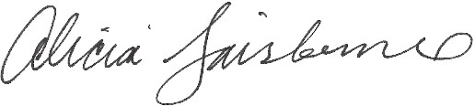


ATTEST:
Alicia Fairbourne, Town Clerk
May 11, 2022

DETERMINATION REGARDING CONDUCTING TOWN OF HIDEOUT PUBLIC MEETINGS WITHOUT AN ANCHOR LOCATION

The Mayor of the Town of Hideout hereby determines that conducting a meeting with an anchor location presents a substantial risk to the health and safety of those who may be present at the anchor location pursuant to Utah Code section 52-4-207(5) and Hideout Town Ordinance 2020-03. The facts upon which this determination is based include: The seven-day rolling percent and number of positive COVID-19 cases in Utah has been over 12.83% of those tested since April 29, 2022. The seven-day average number of positive cases has been, on average, 379 per day since May 4, 2022.
This meeting will not have a physical anchor location. All participants will connect remotely. All public meetings are available via YouTube Live Stream on the Hideout, Utah YouTube channel at: https://www.youtube.com/channel/UCKdWnJad-WwvcAK75QjRb1w/

Interested parties may join by dialing in as follows:
Meeting URL: https://zoom.us/j/4356594739 To join by telephone dial: US: +1 408-638-0986 Meeting ID: 4356594739
Additionally, comments may be emailed to hideoututah@hideoututah.gov. Emailed comments received prior to the scheduled meeting will be considered by Council and entered into public record.
This determination will expire in 30 days on June 10, 2022.

BY:

Phil Rubin, Mayor

Resolution 2022-R-05

A RESOLUTION APPROVING A SUBDIVISION AMENDMENT FOR LOTS 74 & 75 IN THE SOARING HAWK SUBDIVISION LOCATED IN HIDEOUT, UTAH

WHEREAS, owners of the property known as Lots 74 and 75 in Soaring Hawk Subdivision, located in Hideout, Utah, have petitioned the Town Council for approval of a subdivision amendment; and

WHEREAS, legal notice of the public hearing was published on the Town of Hideout’s website on April 11, 2022 according to the requirements of the Hideout Municipal Code; and

WHEREAS, the Planning Commission held a public hearing on April 21, 2022 to receive input on the proposed subdivision amendment for a lot combination; and

WHEREAS, the Planning Commission, on April 21st conducted a public hearing and forwarded a positive recommendation to the Town Council; and

WHEREAS, on May 12, 2022 the Town Council held a public hearing on the subdivision amendment; and

WHEREAS, it is in the best interest of Hideout, Utah to approve the lot combination for Lots 74 and 74 in the Soaring Hawk Subdivision in that this subdivision amendment is intended to comply with the Hideout Municipal Code, the 2010 Master Development Agreement (MDA), and the Technical Reports prepared by the Town Staff as well as all other recorded agreements.

NOW, THEREFORE BE IT RESOLVED by the Town Council of Hideout, Utah as follows:

SECTION 1. APPROVAL. The above recitals are hereby incorporated as findings of fact. The subdivision plats illustrating the lot combination as shown in Exhibit A is approved subject to the following findings of fact, conclusions of law, and conditions of approval:

Findings of Fact
- Soaring Hawk, Phase 2, was recorded on July 15, 2015.
- Soaring Hawk, Phase 2, was comprised of 60 lots (lots 48 – 108) at time of recordation and includes 23.49 acres.
- The property is located within the Town of Hideout along SR248, the east side about midway through Town.
- Zoning for the property is RSPA – Resort Specially Planned Area.
- The combined two lots (Lot 74 and 75) will create a single lot (0.46 acre total).
- The Town of Hideout entered into a Master Development Agreement (MDA) with the developer on March 11, 2010.
- All existing and required easements will be shown on the plat prior to recordation, including utilities, storm drainage, access, trails, snow storage, etc.
- No changes are proposed to the existing road alignment or uses associated with this plat.

Conclusions of Law
- The subdivision amendment, as conditioned, complies with Hideout Municipal Code.
- The subdivision amendment as conditioned, is consistent with the applicable State law

regarding subdivision plats.
- Neither the public nor any person will be materially injured as a result of approval of the proposed subdivision amendment as conditioned.
- Approval of the subdivision amendment, subject to the conditions stated herein, will not adversely affect the health, safety and welfare of the citizens of Hideout.
- If the Applicant requests an an extension for the subdivision amendment, the Hideout Municipal Code requires that these submittals “satisfy[ies] any new Town requirements pertaining to the public health, safety and welfare.”

Conditions of Approval
- The Town Attorney, Town Planner and Town Engineer will review and approve the final form and content of the subdivision amendment for compliance with State law, the Hideout Municipal Code, the Master Development Agreement and these conditions of approval, prior to recordation of the plat.
- The applicant will record the subdivision amendment at Wasatch County within six (6) months from the date of Town Council approval. If recordation has not occurred within six
(6) months’ time, this approval for the plat will be void unless a written request for an extension is submitted to the Town prior to the expiration date and the Town Council grants an extension.
- Non-exclusive public utility easements shall be indicated on the plats prior to recordation as approved by the Town Engineer and JSSD and consistent with the utility plan, including drainage easements.
- The primary dwelling unit will generally be constructed on what is currently delineated as Lot
75. Lot 74, as currently delineated, will generally be used as open space. There is an allowance for an encroachment of up to 25% for the house footprint on Lot 74 if needed per HOA Design Review Committee (DRC) review.
- No driveways or parking pads are permitted on Lot 74.
- No accessory structures are permitted on Lot 74.
- Per the HOA, the maximum house size can be increased to 125% of what is allowed on a single lot.
- The Applicant must adhere to all requirements of the Master HOA, including Design Review Committee (DRC) requirements.
- The Town must verify that no utility lines exist in the Public Utility Easement (PUE) that currently separates Lot 74 and Lot 75 (6’-0” on either side of lot line for a total width of 12’-0” wide). If utilities currently exist, the PUE must remain in place. If no utilities currently exist, the PUE may be abandoned in coordination with the Town Engineer and HOA.
- The Applicant agrees to complete subdivision construction permit, pay all required fees and post all required bonds before starting construction.
- The final plat (mylar) is subject to review may require additional notes and corrections.
- The exact language of the plat notes shall be finalized by the Town Attorney, Town Planner and Town Engineer as necessary to implement these conditions of approval and applicable provisions of the Hideout Municipal Code or State Code prior to Mylar signatures by the Town.

SECTION 2. EFFECTIVE DATE. This Resolution shall take effect upon publication.

PASSED AND ADOPTED this 12th day of May, 2022


TOWN OF HIDEOUT

Phil Rubin, Mayor



ATTEST:

Alicia Fairbourne, Town Clerk

A NEW DESIGN FOR THE

PROJECT REVISIONS
# DATE DESCRIPTION

Index of Drawings
Sheet

Item # 1.

Number Architectural
Sheet Name

0T-1 TITLE
TOPO SURVEY

LOT 74 & 75 SOARING HAWK
A NEW DESIGN FOR THE :
LIZ & DYLAN RESIDENCE
LOT 74 & 75 11562 N WHITE TAIL CT.
SOARING HAWK HIDEOUT, UT 84032

11562 N WHITE TAIL CT. HIDEOUT, UT 84032

Inside of Wall SQFT
LOCATION SQUARE FOOTAGE
LOWER LEVEL | 1,824 SF
MAIN LEVEL | 2,261 SF
TOTAL FINISHED | 4,084 SF
GARAGE | 760 SF
MECH. | 51 SF
STOR. / MECH. | 132 SF
TOTAL UNFINISHED | 943 SF
TOTAL INSIDE OF WALL 5,027 SF
A1.1 A2.0 A2.1 A2.2 A2.3 A3.0 A3.1 A4.1
SITE PLAN
1/4" LOWER LEVEL PLAN
1/4" MAIN LEVEL PLAN GROSS AREA PLANS NET AREA PLANS
3D AXONOMETRIC VIEWS
1/8" ELEVATIONS ROOF PLAN
1 FEBRUARY 2022

REVISIONS
THE ABOVE DRAWINGS AND SPECIFICATIONS AND THE IDEAS, DESIGN AND ARRANGEMENTS REPRESENTED THEREBY ARE AND SHALL REMAIN THE PROPERTY OF UPWALL DESIGN. NO PART THEREOF SHALL BE COPIED, DISCLOSED TO OTHERS OR USED IN CONNECTION WITH ANY WORK OR PROJECT OR BY ANY OTHER PERSON FOR ANY PURPOSE OTHER THAN FOR THE SPECIFIC PROJECT FOR WHICH THEY HAVE BEEN PREPARED AND DEVELOPED WITHOUT THE WRITTEN CONSENT OF UPWALL DESIGN. DESIGNS CAN NOT BE COPIED, DUPLICATED, OR COMMERCIALLY EXPLOITED IN WHOLE OR IN PART WITHOUT THE SOLE AND EXPRESS WRITTEN PERMISSION OF UPWALL DESIGN. VISUAL CONTACT WITH THESE DRAWINGS OR SPECIFICATIONS SHALL CONSTITUTE CONCLUSIVE EVIDENCE OF ACCEPTANCE OF THESE RESTRICTIONS. THESE DRAWINGS ARE AVAILABLE FOR LIMITED REVIEW AND EVALUATION BY CLIENTS, CONSULTANTS, CONTRACTORS, GOVERNMENT AGENCIES, VENDORS, AND OFFICE PERSONNEL ONLY IN ACCORDANCE WITH THIS NOTICE. WRITTEN DIMENSIONS ON THESE DRAWINGS SHALL HAVE PRECEDENCE OVER SCALED DIMENSIONS. CONTRACTORS SHALL VERIFY, AND BE RESPONSIBLE FOR, ALL DIMENSIONS AND CONDITIONS ON THE JOB AND THIS OFFICE MUST BE NOTIFIED OF ANY VARIATIONS FROM THE DIMENSIONS AND CONDITIONS SHOWN BY THESE DRAWINGS. SHOP DETAILS MUST BE SUBMITTED TO THIS OFFICE
FOR APPROVAL BEFORE PROCEEDING WITH FABRICATION.

Outside of Wall SQFT
LOCATION SQUARE FOOTAGE LOWER LEVEL 1,953 SF
MAIN LEVEL 2,427 SF
TOTAL FINISHED 4,380 SF

GARAGE STOR./ MECH.
TOTAL UNFINISHED TOTAL OUTSIDE OF WALL
898 SF
158 SF
1,056 SF
5,436 SF

Deck/Patio SQFT
LOCATION SQUARE FOOTAGE COVERED ENTRY 150 SF
GUEST DECK 61 SF
GYM DECK 117 SF
LOWER PATIO 402 SF
MAIN DECK 800 SF
MASTER DECK 109 SF TOTAL DECK/PATIO 1,639 SF

DEFERRED SUBMITTAL
ALL DEFERRED SUBMITTALS AND CHANGES TO PLANS MUST BE:
*-FIRST APPROVED BY THE ARCHITECT OF RECORD PRIOR TO SUBMITTING TO THE BUILDING OFFICIAL.
*-STRUCTURAL ENGINEER TO APPROVE ALL STRUCTURAL PLANS.
L
N
(801)485-0708

- FIRE SPRINKLER PLANS (Modified NFPA 13D)
- GAS PIPING SCHEMATIC TO BE PROVIDED BY CONTRACTOR
L
- TRUSS PLANS (IF APPLICABLE)
G
- STUCCO SYSTEM (IF APPLICABLE)
- LANDSCAPE SPRINKLER PLAN
- CONSTRUCTION MITIGATION PLAN
A
I
- GEOTECHNICAL SURVEY (IF APPLICABLE AS DETERMINED BY BUILDING OFFICIAL)
- SPECIAL INSPECTION CERTIFICATE FROM OUTSIDE INSPECTIONS FOR ALL WELDING ON THIS PROJECT
W
1930 S. 1100 E. S.L.C. UT 84106
- CONTRACTOR TO PROVIDE EXTERIOR LIGHTING SPECS PRIOR TO FOUR-WAY INSPECTION
S
- (3) BACKFLOW PREVENTORS TO BE INSTALLED
- POOL DESIGN BY OTHERS (IF APPLICABLE)
P
E

ARCHITECT

OWNER

STRUCTURAL ENGINEER

GENERAL CONTRACTOR
VICINITY MAPS
Code Analysis
- UTAH STATE ADOPTED CODES AS OF JULY 1, 2019
U
D

UPWALL DESIGN JOSH ARRINGTON
1930 SOUTH 1100 EAST SALT LAKE CITY, UTAH 84106
(801) 485-0708
EMAIL:josh@upwalldesign.com
LIZ SUMNER & DYLAN - -
BRANDT - -
2617 EAGLE COVE DR. - -
PARK CITY, UT 84060 - -
(541) 213-8723 - -
liz.sumner@gmail.com brandtdylan2@gmail.com
- 2015 IRC
- 2018 IBC
- 2018 IPC
- 2018 IMC
- 2018 IFGC
- 2017 NEC
BUILDING OCCUPANCY
R-3
TYPE 5B CONTRUCTION TWO STORIES
0T-1

Page 6

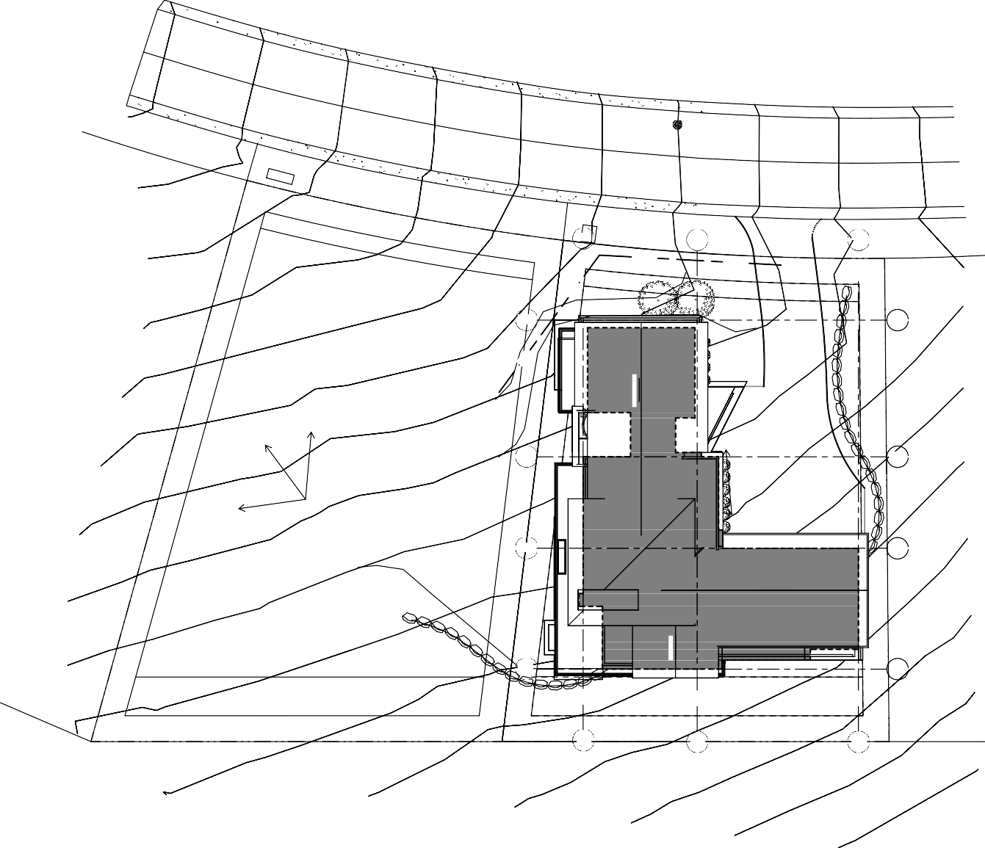


U P W A L L
D E S I G N
1930 S. 1100 E. S.L.C. UT 84106 (801)485-0708
A1.1
SITE PLAN
Item # 1.
1 FEBRUARY 2022
C

1
KEYNOTES
DESCRIPTION
NUMBER
6873
2
EL: 6900' - 6 3/4"
3
C
SITE
PLAN
SCALE: 1" = 10'-0"
0'
2.5' 5'
10'
20'
Page 8
LOD
6880

6872
LOD
LOD
SEWER
D
1
6872
2
6870
6870
3
D
LOD

EL: 6900' - 5 7/8"
B
A
6873
EL: 6886' - 0"
B
A

5 | 4 | 3 | 2 | 1 | SITE GENERAL NOTES
RETAINING WALLS (>4' OR SUPPORTING A SURCHARGE), SWIMMING POOLS, SOLAR AND/OR GEO-THERMAL HEATING SYSTEMS, AND PHOTO-VOLTAIC- AND/OR WIND-GENERATED ELECTRICAL SYSTEMS REQUIRE SEPARATE PERMITS. SEPARATE PLANS, SPECIFICATIONS AND APPLICATIONS ARE TO BE SUBMITTED  AND REVIEWED PRIOR TO ISSUANCE OF THESE PERMITS. | SURFACE WATER SHALL DRAIN AWAY FROM THE HOUSE AT ALL POINTS. DIRECT THE DRAINAGE WATER TO THE STREET OR TO AN APPROVED DRAINAGE COURSE, BUT NOT ONTO NEIGHBORING PROPERTIES. THE GRADE SHALL FALL A MINIMUM OF 6 INCHES WITHIN THE FIRST 10 FT. (IRC R401.3). | REESTABLISH NATURAL GRADE AND NATURAL VEGETATION. PROVIDE TEMP. IRRIGATION TO ASSURE ESTABLISHED VEGETATION. | CONTRACTOR TO FIELD VERIFY MIN.  3'-0" SEPARATION BETWEEN GAS AND ELECTRICAL LINES. | CONTRACTOR TO FIELD VERIFY LOCATION OF UTILITY LINES AS REQUIRED. | SITE GENERAL NOTES

A NEW DESIGN FOR THE :
LIZ & DYLAN RESIDENCE
LOT 74 & 75 11562 N WHITE TAIL CT.
SOARING HAWK HIDEOUT, UT 84032
THE ABOVE DRAWINGS AND SPECIFICATIONS AND THE IDEAS, DESIGN AND ARRANGEMENTS REPRESENTED THEREBY ARE AND SHALL REMAIN THE PROPERTY OF UPWALL DESIGN. NO PART THEREOF SHALL BE COPIED, DISCLOSED TO OTHERS OR USED IN CONNECTION WITH ANY WORK OR PROJECT OR BY ANY OTHER PERSON FOR ANY PURPOSE OTHER THAN FOR THE SPECIFIC PROJECT FOR WHICH THEY HAVE BEEN PREPARED AND DEVELOPED WITHOUT THE WRITTEN CONSENT OF UPWALL DESIGN. DESIGNS CAN NOT BE COPIED, DUPLICATED, OR COMMERCIALLY EXPLOITED IN WHOLE OR IN PART WITHOUT THE SOLE AND EXPRESS WRITTEN PERMISSION OF UPWALL DESIGN. VISUAL CONTACT WITH THESE DRAWINGS OR SPECIFICATIONS SHALL CONSTITUTE CONCLUSIVE EVIDENCE OF ACCEPTANCE OF THESE RESTRICTIONS. THESE DRAWINGS ARE AVAILABLE FOR LIMITED REVIEW AND EVALUATION BY CLIENTS, CONSULTANTS, CONTRACTORS, GOVERNMENT AGENCIES, VENDORS, AND OFFICE PERSONNEL ONLY IN ACCORDANCE WITH THIS NOTICE. WRITTEN DIMENSIONS ON THESE DRAWINGS SHALL HAVE PRECEDENCE OVER SCALED DIMENSIONS. CONTRACTORS SHALL VERIFY, AND BE RESPONSIBLE FOR, ALL DIMENSIONS AND CONDITIONS ON THE JOB AND THIS OFFICE MUST BE NOTIFIED OF ANY VARIATIONS FROM THE DIMENSIONS AND CONDITIONS SHOWN BY THESE DRAWINGS. SHOP DETAILS MUST BE SUBMITTED TO THIS OFFICE  FOR APPROVAL BEFORE PROCEEDING WITH FABRICATION. |  | REVISIONS

26' - 6"
D A3.1
2
3
64' - 0"

37' - 6"
1

11 3/4" 26' - 6" 1' - 0" 4' - 0" 1' - 0" 31' - 6"

16' - 0"
D
STOR. / MECH.
14' - 6"
GYM
OPEN
22' - 0"
D

BENCH
31' - 9"
22' - 9"
STORAGE
HIGH WINDOW
31' - 9"

BENCH
8' - 0"
COVERED ENTRY
PDR.
FOYER
9' - 9"

TWIN/TWIN UP
TWIN/TWIN
TWIN/TWIN

TWIN/TWIN
A A3.1
C
1' - 0"
ART
C A3.1
C

15' - 2"
81' - 1"
21' - 3"
17' - 0"
BUNK ROOM
13' - 3"
21' - 3"
21' - 3"
81' - 1"

TV

DW REF.
4' - 3"
OPEN

20' - 6"
B
B

9' - 6"
7' - 0"
D W
7' - 0"
ART
19' - 6"
FAMILY ROOM (FUTURE)

31' - 2"
L.
OPEN
10' - 6"

TWO-SIDED FIREPLACE
3' - 0"
28' - 1"

ART
MUD

LOCKERS
28' - 1"
26' - 0"
GARAGE
23' - 8"
MECH.

16' - 0"
D.W.
13' - 9"
GUEST BEDROOM (OFFICE)
SPA
14' - 7"
LOWER LEVEL A
1/4"
DOG WASH

GEAR STORAGE
A
2' - 1"

11 3/4" 4' - 6"

26' - 6"
22' - 0"
5' - 10"

64' - 0"
1
2
B A3.1
3

37' - 6"
31' - 8"

U P W A L L

D E S I G N
A NEW DESIGN FOR THE :

LIZ & DYLAN RESIDENCE

THE ABOVE DRAWINGS AND SPECIFICATIONS AND THE IDEAS, DESIGN AND ARRANGEMENTS REPRESENTED THEREBY ARE AND SHALL REMAIN THE PROPERTY OF UPWALL DESIGN. NO PART THEREOF SHALL BE COPIED, DISCLOSED TO OTHERS OR USED IN CONNECTION WITH ANY WORK OR PROJECT OR BY ANY OTHER PERSON FOR ANY PURPOSE OTHER THAN FOR THE SPECIFIC PROJECT FOR WHICH THEY HAVE BEEN PREPARED AND DEVELOPED WITHOUT THE WRITTEN CONSENT OF UPWALL DESIGN. DESIGNS CAN NOT BE COPIED, DUPLICATED, OR COMMERCIALLY EXPLOITED IN WHOLE OR IN PART WITHOUT THE SOLE AND EXPRESS WRITTEN PERMISSION OF UPWALL DESIGN. VISUAL CONTACT WITH THESE DRAWINGS OR SPECIFICATIONS SHALL CONSTITUTE CONCLUSIVE EVIDENCE OF ACCEPTANCE OF THESE RESTRICTIONS. THESE DRAWINGS ARE AVAILABLE FOR LIMITED REVIEW AND EVALUATION BY CLIENTS, CONSULTANTS, CONTRACTORS, GOVERNMENT AGENCIES, VENDORS, AND OFFICE PERSONNEL ONLY IN ACCORDANCE WITH THIS NOTICE. WRITTEN
Item # 1.

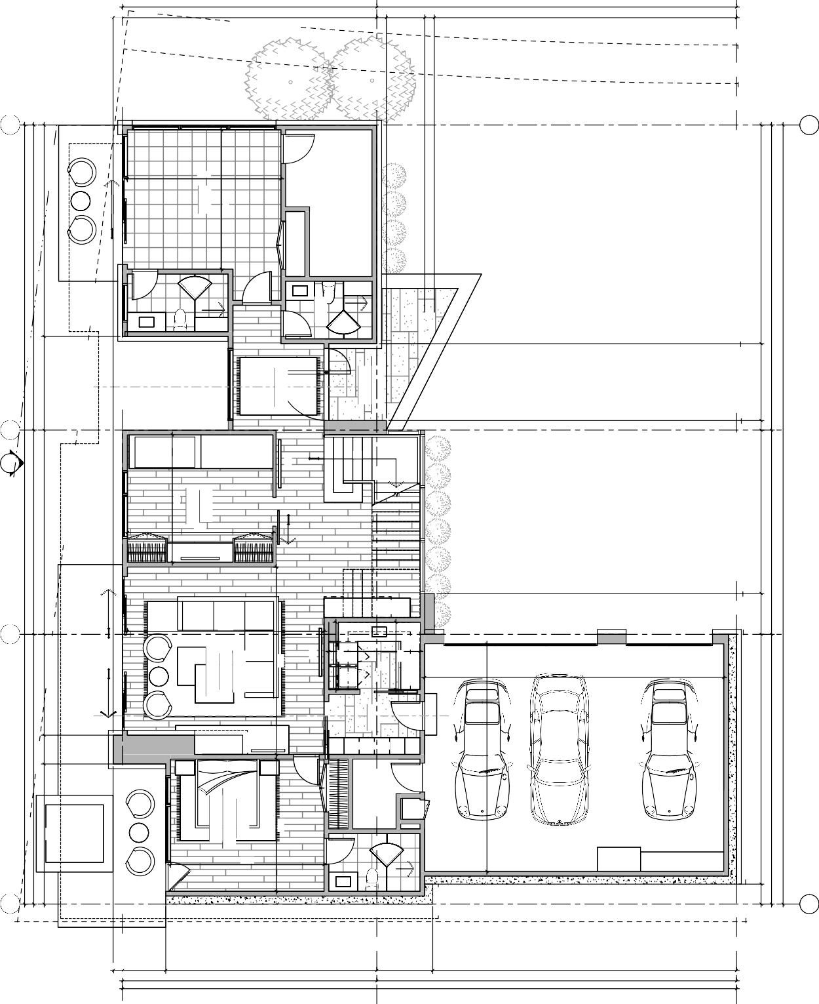















1930 S. 1100 E. S.L.C. UT 84106 (801)485-0708
1 FEBRUARY 2022
REVISIONS
PLAN
A2.0
1/4" LOWER LEVEL PLAN
SCALE: 1/4" = 1'-0"
LOWER LEVEL GARAGE MECH.
STOR. / MECH.
1,824 SF
760 SF
51 SF
132 SF
0'
1' 2'
4'
8'
Page 9
LOT 74 & 75
SOARING HAWK
11562 N WHITE TAIL CT.
HIDEOUT, UT 84032
DIMENSIONS ON THESE DRAWINGS SHALL HAVE PRECEDENCE OVER SCALED DIMENSIONS. CONTRACTORS SHALL VERIFY, AND BE RESPONSIBLE FOR, ALL DIMENSIONS AND CONDITIONS ON THE JOB AND THIS OFFICE MUST BE NOTIFIED OF ANY VARIATIONS FROM THE DIMENSIONS AND CONDITIONS SHOWN BY THESE DRAWINGS. SHOP DETAILS MUST BE SUBMITTED TO THIS OFFICE FOR APPROVAL BEFORE PROCEEDING WITH FABRICATION.

26' - 6"

64' - 0"
1
D A3.1
2
3

37' - 6"

1' - 0" 1' - 6" 25' - 0" 1' - 6" 1' - 0" 4' - 0" 1' - 0" 31' - 6"

16' - 0"
D
1' - 6"
1' - 6"
D

7' - 6"
15' - 0"
WALK-IN
14' - 0"
19' - 0"
MASTER SUITE
19' - 6"

ART
31' - 9"
31' - 9"

TV 1' - 6" 1' - 6"

W/D
14' - 3"
SOAK
9' - 6"

BENCH
A A3.1
WALK-IN
12' - 0"

11' - 6"
C
1' - 0"
ART
PDR.
1' - 3"
2' - 3"
C

STORAGE WALL
C A3.1

14' - 0"
81' - 1"
21' - 3"
21' - 1"
DOWN
8' - 6"
OPEN OFFICE
11' - 6"
21' - 3"
81' - 1"

22' - 6"
MAIN LEVEL
EL: 6886' - 0"
OPEN
7' - 6"

ART
B
2"
B
BENCH
19' - 6"
GREAT ROOM
FIRE

R F
DINING
OPEN
10' - 6"

TV ABOVE
20' - 10"

TWO-SIDED FIREPLACE
3' - 0"
28' - 1"

28' - 6"
28' - 1"
28' - 1"
14' - 0"
GUEST / OFFICE
RANGE

OPEN
GRILL
AL FRESCO
DECK
EL: 6886' - 0"
2' - 0"
7' - 0"

OPEN

DW SINK

T./R.

12' - 0"
P.
D.W.
5' - 7"

1' - 6" 1' - 0" 12' - 0"
A
A
4' - 0"
26' - 6"
10' - 6"

64' - 0"
1
2
B A3.1
3
37' - 6"
37' - 6"

U P W A L L

D E S I G N
A NEW DESIGN FOR THE :

LIZ & DYLAN RESIDENCE

THE ABOVE DRAWINGS AND SPECIFICATIONS AND THE IDEAS, DESIGN AND ARRANGEMENTS REPRESENTED THEREBY ARE AND SHALL REMAIN THE PROPERTY OF UPWALL DESIGN. NO PART THEREOF SHALL BE COPIED, DISCLOSED TO OTHERS OR USED IN CONNECTION WITH ANY WORK OR PROJECT OR BY ANY OTHER PERSON FOR ANY PURPOSE OTHER THAN FOR THE SPECIFIC PROJECT FOR WHICH THEY HAVE BEEN PREPARED AND DEVELOPED WITHOUT THE WRITTEN CONSENT OF UPWALL DESIGN. DESIGNS CAN NOT BE COPIED, DUPLICATED, OR COMMERCIALLY EXPLOITED IN WHOLE OR IN PART WITHOUT THE SOLE AND EXPRESS WRITTEN PERMISSION OF UPWALL DESIGN. VISUAL CONTACT WITH THESE DRAWINGS OR SPECIFICATIONS SHALL CONSTITUTE CONCLUSIVE EVIDENCE OF ACCEPTANCE OF THESE RESTRICTIONS. THESE DRAWINGS ARE AVAILABLE FOR LIMITED REVIEW AND EVALUATION BY CLIENTS, CONSULTANTS, CONTRACTORS, GOVERNMENT AGENCIES, VENDORS, AND OFFICE PERSONNEL ONLY IN ACCORDANCE WITH THIS NOTICE. WRITTEN
Item # 1.

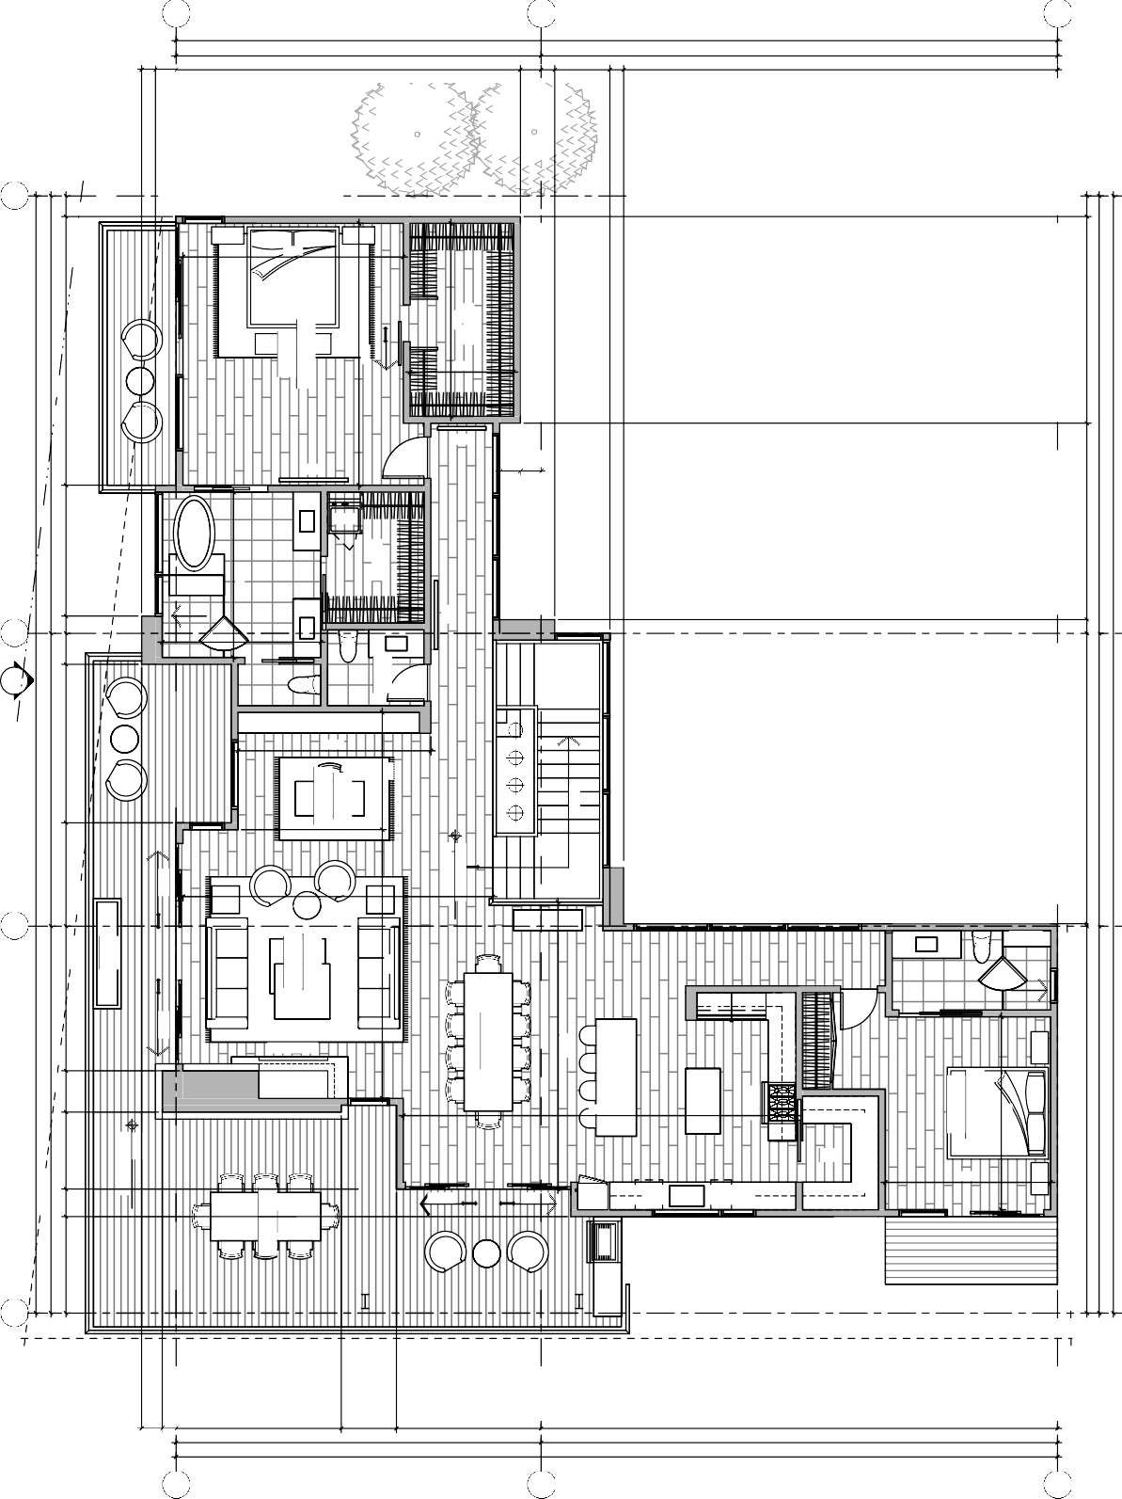
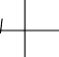




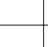









1930 S. 1100 E. S.L.C. UT 84106 (801)485-0708
1 FEBRUARY 2022
REVISIONS
MAIN LEVEL
PLAN
SCALE: 1/4" = 1'-0"
A2.1
1/4" MAIN LEVEL PLAN
0'
1' 2'
4'
8'
MAIN LEVEL
2,261 SF
Page 10
LOT 74 & 75
SOARING HAWK
11562 N WHITE TAIL CT.
HIDEOUT, UT 84032
DIMENSIONS ON THESE DRAWINGS SHALL HAVE PRECEDENCE OVER SCALED DIMENSIONS. CONTRACTORS SHALL VERIFY, AND BE RESPONSIBLE FOR, ALL DIMENSIONS AND CONDITIONS ON THE JOB AND THIS OFFICE MUST BE NOTIFIED OF ANY VARIATIONS FROM THE DIMENSIONS AND CONDITIONS SHOWN BY THESE DRAWINGS. SHOP DETAILS MUST BE SUBMITTED TO THIS OFFICE FOR APPROVAL BEFORE PROCEEDING WITH FABRICATION.





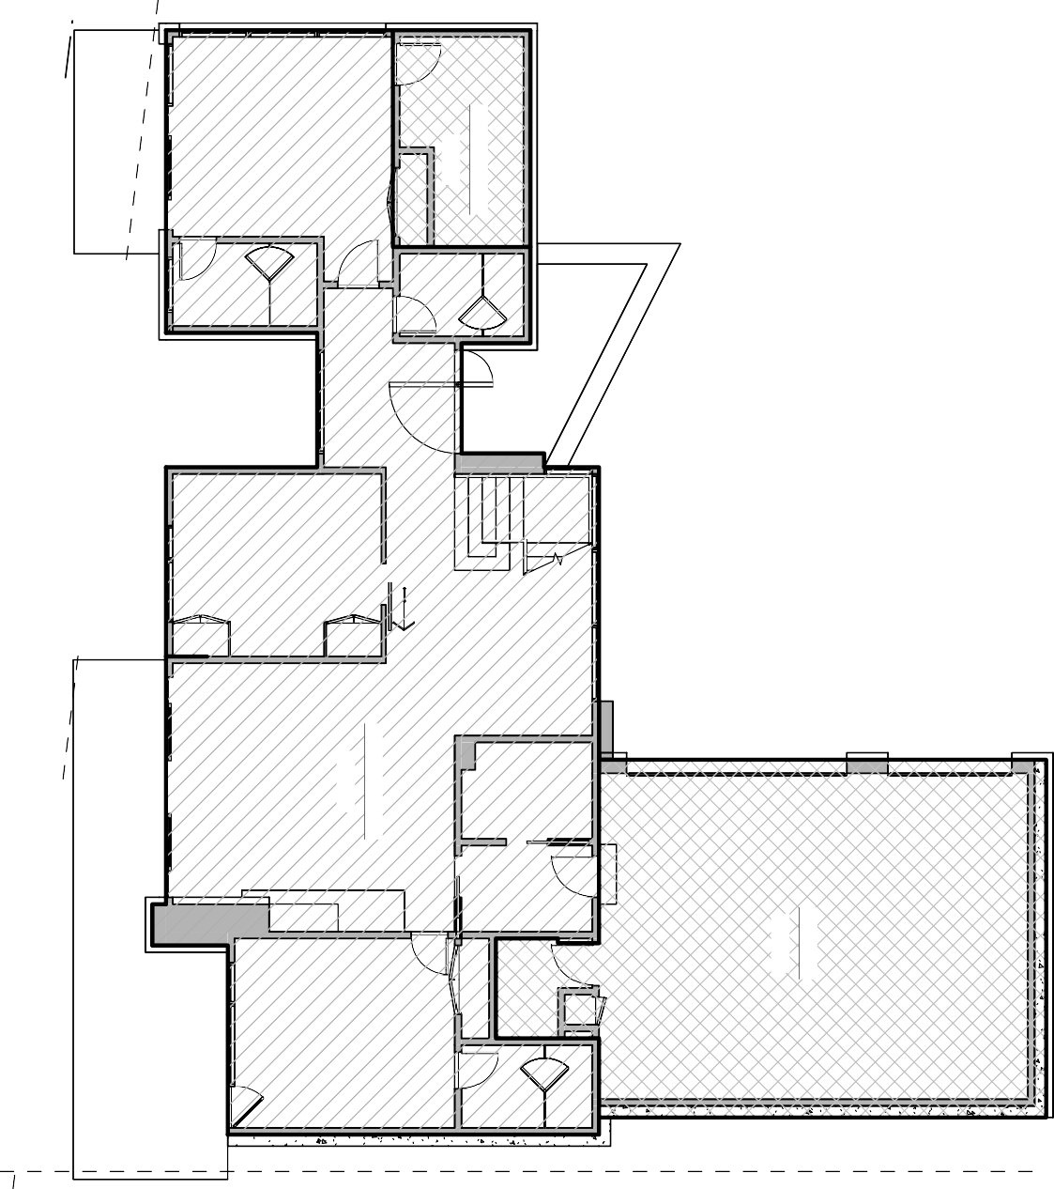
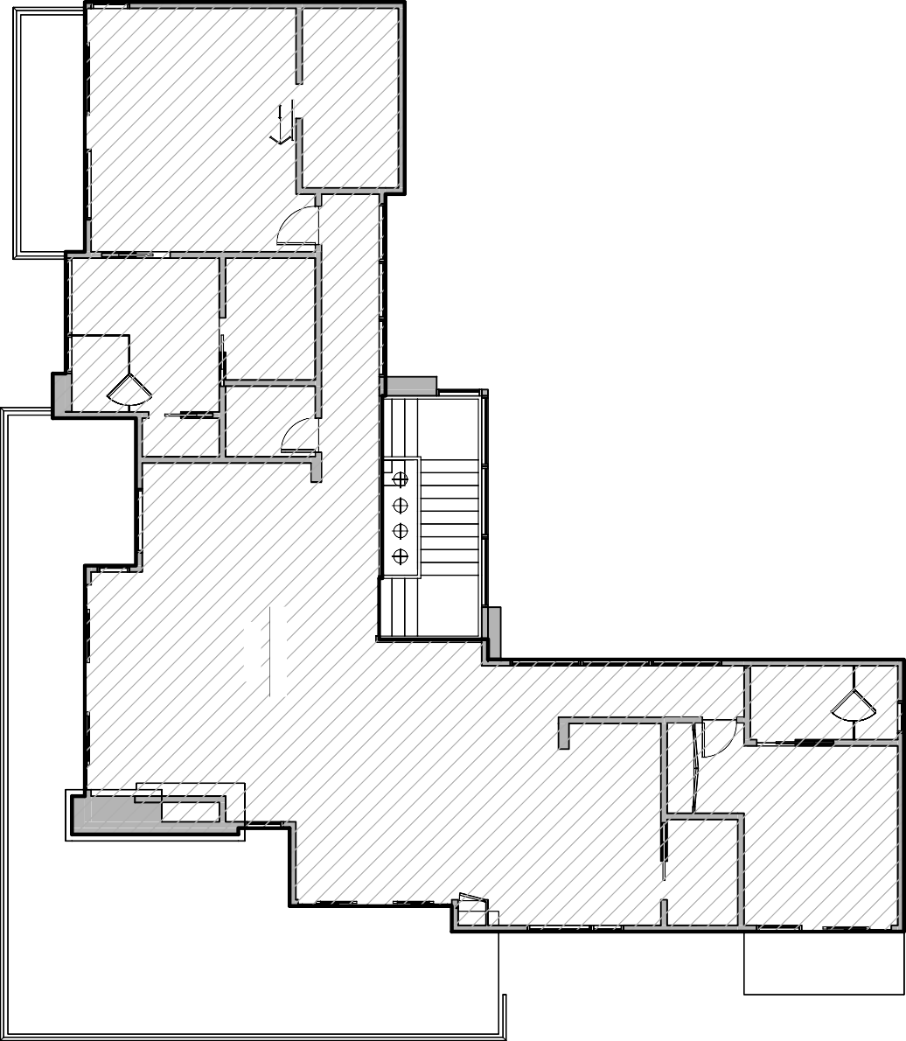
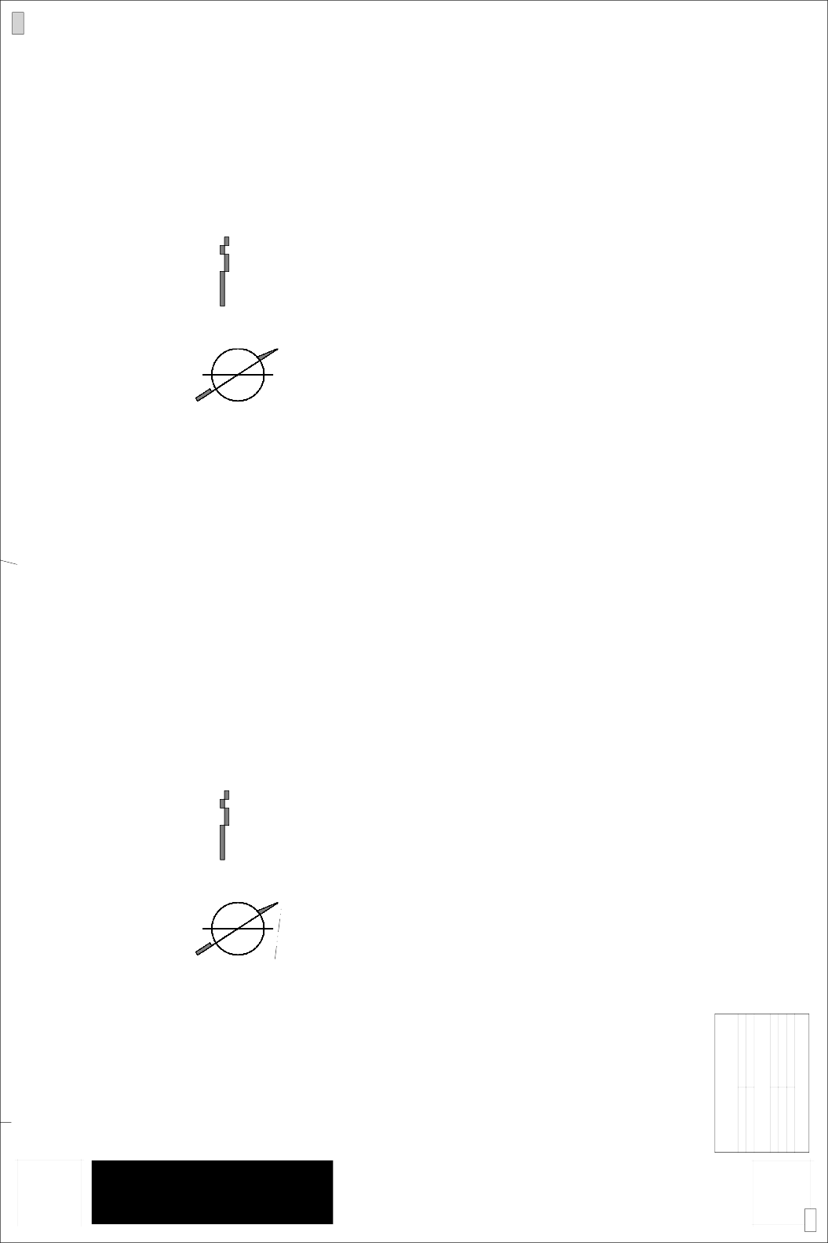
U P W A L L
D E S I G N
1930 S. 1100 E. S.L.C. UT 84106
(801)485-0708
A2.2
GROSS AREA PLANS
Item # 1.
Outside of Wall SQFT
LOCATION LOWER LEVEL MAIN LEVEL TOTAL FINISHED
SQUARE FOOTAGE 1,953 SF
2,427 SF
4,380 SF
GARAGE STOR./ MECH.
TOTAL UNFINISHED TOTAL OUTSIDE OF WALL
898 SF
158 SF
1,056 SF
5,436 SF
1 FEBRUARY 2022
GARAGE
898 SF
STOR./ MECH.
158 SF
LOWER LEVEL
1953 SF
MAIN LEVEL
2427 SF
MAIN LEVEL GROSS AREA
PLAN
SCALE: 1/8" = 1'-0"
LOWER LEVEL GROSS AREA
PLAN
SCALE:
1/8" = 1'-0"
2' 4'
8'
16'
2' 4'
8'
16'
0'
0'
Page 11

A NEW DESIGN FOR THE :
LIZ & DYLAN RESIDENCE
LOT 74 & 75 11562 N WHITE TAIL CT.
SOARING HAWK HIDEOUT, UT 84032
THE ABOVE DRAWINGS AND SPECIFICATIONS AND THE IDEAS, DESIGN AND ARRANGEMENTS REPRESENTED THEREBY ARE AND SHALL REMAIN THE PROPERTY OF UPWALL DESIGN. NO PART THEREOF SHALL BE COPIED, DISCLOSED TO OTHERS OR USED IN CONNECTION WITH ANY WORK OR PROJECT OR BY ANY OTHER PERSON FOR ANY PURPOSE OTHER THAN FOR THE SPECIFIC PROJECT FOR WHICH THEY HAVE BEEN PREPARED AND DEVELOPED WITHOUT THE WRITTEN CONSENT OF UPWALL DESIGN. DESIGNS CAN NOT BE COPIED, DUPLICATED, OR COMMERCIALLY EXPLOITED IN WHOLE OR IN PART WITHOUT THE SOLE AND EXPRESS WRITTEN PERMISSION OF UPWALL DESIGN. VISUAL CONTACT WITH THESE DRAWINGS OR SPECIFICATIONS SHALL CONSTITUTE CONCLUSIVE EVIDENCE OF ACCEPTANCE OF THESE RESTRICTIONS. THESE DRAWINGS ARE AVAILABLE FOR LIMITED REVIEW AND EVALUATION BY CLIENTS, CONSULTANTS, CONTRACTORS, GOVERNMENT AGENCIES, VENDORS, AND OFFICE PERSONNEL ONLY IN ACCORDANCE WITH THIS NOTICE. WRITTEN DIMENSIONS ON THESE DRAWINGS SHALL HAVE PRECEDENCE OVER SCALED DIMENSIONS. CONTRACTORS SHALL VERIFY, AND BE RESPONSIBLE FOR, ALL DIMENSIONS AND CONDITIONS ON THE JOB AND THIS OFFICE MUST BE NOTIFIED OF ANY VARIATIONS FROM THE DIMENSIONS AND CONDITIONS SHOWN BY THESE DRAWINGS. SHOP DETAILS MUST BE SUBMITTED TO THIS OFFICE  FOR APPROVAL BEFORE PROCEEDING WITH FABRICATION. |  | REVISIONS





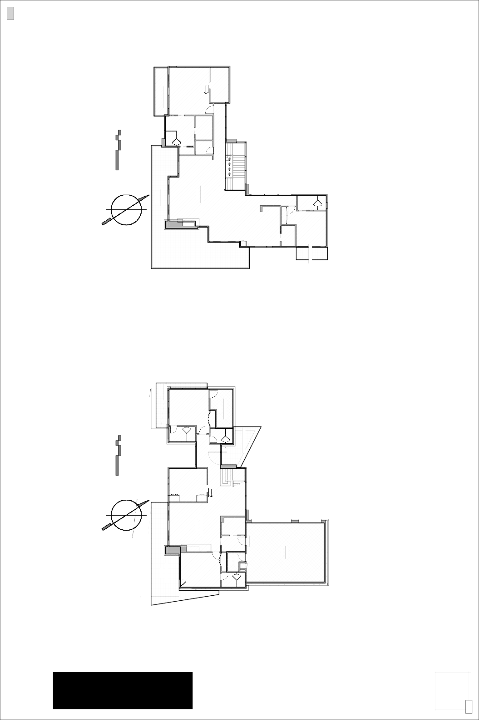
U P W A L L
D E S I G N
1930 S. 1100 E. S.L.C. UT 84106
(801)485-0708
A2.3
NET AREA PLANS
Item # 1.
1 FEBRUARY 2022
GUEST DECK
61 SF
GARAGE
760 SF
COVERED ENTRY
150 SF
MECH.
51 SF
STOR. / MECH.
132 SF
MAIN LEVEL
2261 SF
LOWER LEVEL
1824 SF
LOWER PATIO
402 SF
GYM DECK
117 SF
MASTER DECK
109 SF
MAIN DECK
800 SF
MAIN LEVEL NET AREA
PLAN
SCALE: 1/8" = 1'-0"
LOWER LEVEL NET AREA
PLAN
SCALE:
1/8" = 1'-0"
2' 4'
8'
16'
2' 4'
8'
16'
0'
0'
Page 12

TOTAL DECK/PATIO 1,639 SF | MASTER DECK | MAIN DECK | LOWER PATIO | GYM DECK | GUEST DECK | COVERED ENTRY | LOCATION | Deck/Patio SQFT
TOTAL DECK/PATIO 1,639 SF | 109 SF | 800 SF | 402 SF | 117 SF | 61 SF | 150 SF | SQUARE FOOTAGE | Deck/Patio SQFT

TOTAL UNFINISHED 943 SF  TOTAL INSIDE OF WALL 5,027 SF | STOR. / MECH. | MECH. | GARAGE | TOTAL FINISHED 4,084 SF | MAIN LEVEL | LOWER LEVEL | LOCATION | Inside of Wall SQFT
TOTAL UNFINISHED 943 SF  TOTAL INSIDE OF WALL 5,027 SF | 132 SF | 51 SF | 760 SF | TOTAL FINISHED 4,084 SF | 2,261 SF | 1,824 SF | SQUARE FOOTAGE | Inside of Wall SQFT

A NEW DESIGN FOR THE :
LIZ & DYLAN RESIDENCE
LOT 74 & 75 11562 N WHITE TAIL CT.
SOARING HAWK HIDEOUT, UT 84032
THE ABOVE DRAWINGS AND SPECIFICATIONS AND THE IDEAS, DESIGN AND ARRANGEMENTS REPRESENTED THEREBY ARE AND SHALL REMAIN THE PROPERTY OF UPWALL DESIGN. NO PART THEREOF SHALL BE COPIED, DISCLOSED TO OTHERS OR USED IN CONNECTION WITH ANY WORK OR PROJECT OR BY ANY OTHER PERSON FOR ANY PURPOSE OTHER THAN FOR THE SPECIFIC PROJECT FOR WHICH THEY HAVE BEEN PREPARED AND DEVELOPED WITHOUT THE WRITTEN CONSENT OF UPWALL DESIGN. DESIGNS CAN NOT BE COPIED, DUPLICATED, OR COMMERCIALLY EXPLOITED IN WHOLE OR IN PART WITHOUT THE SOLE AND EXPRESS WRITTEN PERMISSION OF UPWALL DESIGN. VISUAL CONTACT WITH THESE DRAWINGS OR SPECIFICATIONS SHALL CONSTITUTE CONCLUSIVE EVIDENCE OF ACCEPTANCE OF THESE RESTRICTIONS. THESE DRAWINGS ARE AVAILABLE FOR LIMITED REVIEW AND EVALUATION BY CLIENTS, CONSULTANTS, CONTRACTORS, GOVERNMENT AGENCIES, VENDORS, AND OFFICE PERSONNEL ONLY IN ACCORDANCE WITH THIS NOTICE. WRITTEN DIMENSIONS ON THESE DRAWINGS SHALL HAVE PRECEDENCE OVER SCALED DIMENSIONS. CONTRACTORS SHALL VERIFY, AND BE RESPONSIBLE FOR, ALL DIMENSIONS AND CONDITIONS ON THE JOB AND THIS OFFICE MUST BE NOTIFIED OF ANY VARIATIONS FROM THE DIMENSIONS AND CONDITIONS SHOWN BY THESE DRAWINGS. SHOP DETAILS MUST BE SUBMITTED TO THIS OFFICE  FOR APPROVAL BEFORE PROCEEDING WITH FABRICATION. |  | REVISIONS

U P W A L L
D E S I G N
1930 S. 1100 E. S.L.C. UT 84106
(801)485-0708
A3.0
3D AXONOMETRIC VIEWS
Item # 1.
1 FEBRUARY 2022
2
AXONOMETRIC VIEW
1
AXONOMETRIC VIEW
4
AXONOMETRIC VIEW
3
AXONOMETRIC VIEW
Page 13

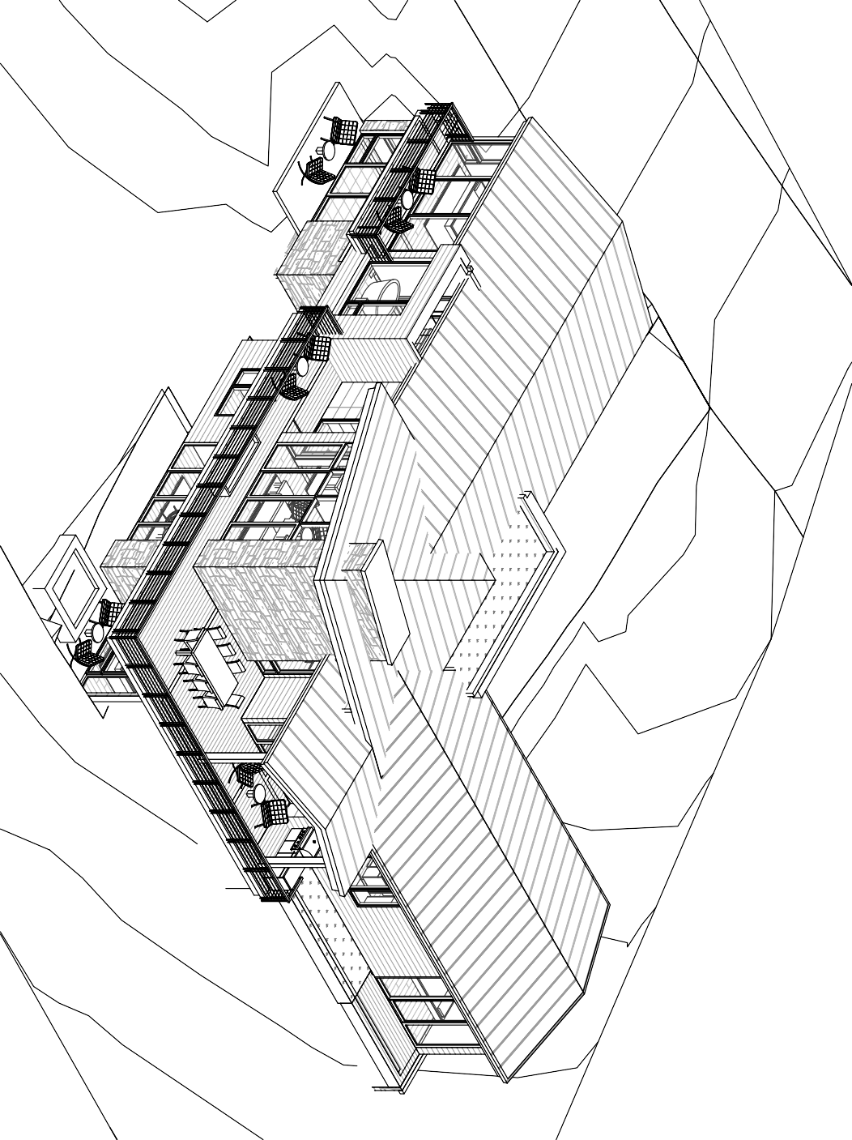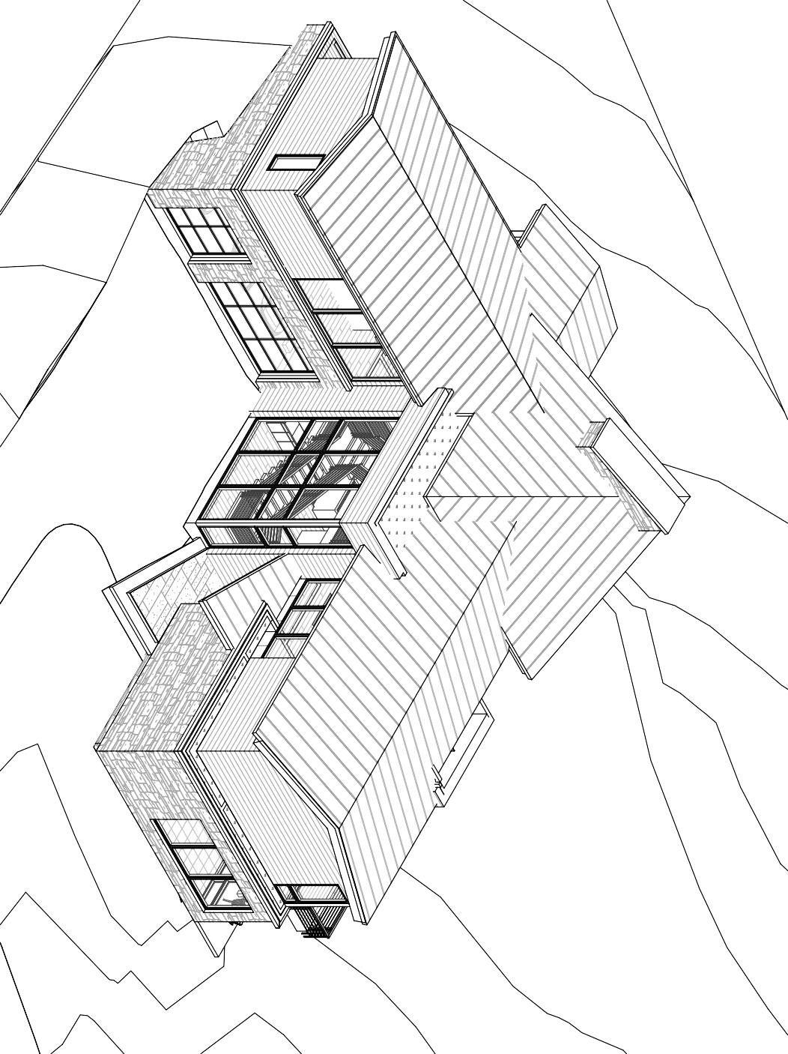

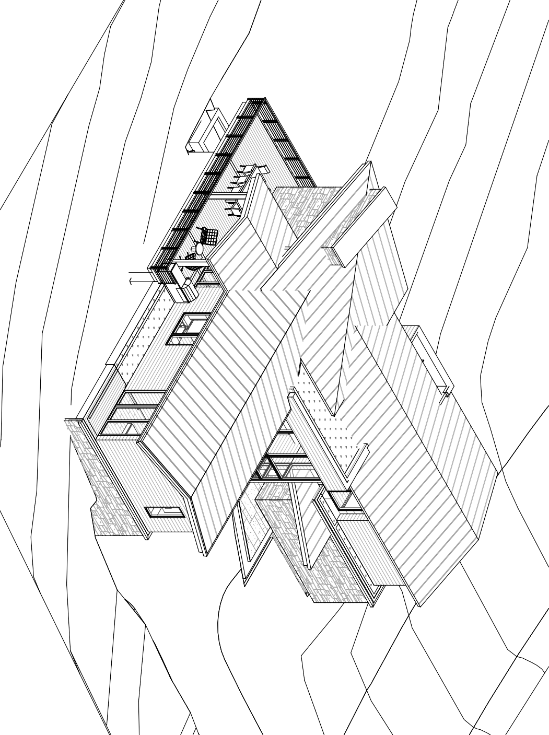
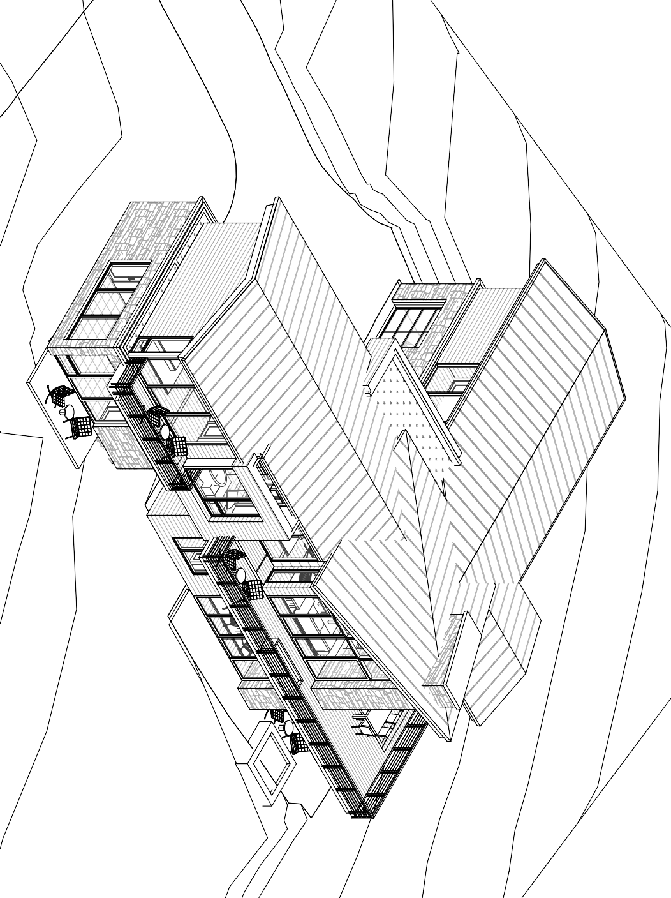

A NEW DESIGN FOR THE :
LIZ & DYLAN RESIDENCE
LOT 74 & 75 11562 N WHITE TAIL CT.
SOARING HAWK HIDEOUT, UT 84032
THE ABOVE DRAWINGS AND SPECIFICATIONS AND THE IDEAS, DESIGN AND ARRANGEMENTS REPRESENTED THEREBY ARE AND SHALL REMAIN THE PROPERTY OF UPWALL DESIGN. NO PART THEREOF SHALL BE COPIED, DISCLOSED TO OTHERS OR USED IN CONNECTION WITH ANY WORK OR PROJECT OR BY ANY OTHER PERSON FOR ANY PURPOSE OTHER THAN FOR THE SPECIFIC PROJECT FOR WHICH THEY HAVE BEEN PREPARED AND DEVELOPED WITHOUT THE WRITTEN CONSENT OF UPWALL DESIGN. DESIGNS CAN NOT BE COPIED, DUPLICATED, OR COMMERCIALLY EXPLOITED IN WHOLE OR IN PART WITHOUT THE SOLE AND EXPRESS WRITTEN PERMISSION OF UPWALL DESIGN. VISUAL CONTACT WITH THESE DRAWINGS OR SPECIFICATIONS SHALL CONSTITUTE CONCLUSIVE EVIDENCE OF ACCEPTANCE OF THESE RESTRICTIONS. THESE DRAWINGS ARE AVAILABLE FOR LIMITED REVIEW AND EVALUATION BY CLIENTS, CONSULTANTS, CONTRACTORS, GOVERNMENT AGENCIES, VENDORS, AND OFFICE PERSONNEL ONLY IN ACCORDANCE WITH THIS NOTICE. WRITTEN DIMENSIONS ON THESE DRAWINGS SHALL HAVE PRECEDENCE OVER SCALED DIMENSIONS. CONTRACTORS SHALL VERIFY, AND BE RESPONSIBLE FOR, ALL DIMENSIONS AND CONDITIONS ON THE JOB AND THIS OFFICE MUST BE NOTIFIED OF ANY VARIATIONS FROM THE DIMENSIONS AND CONDITIONS SHOWN BY THESE DRAWINGS. SHOP DETAILS MUST BE SUBMITTED TO THIS OFFICE  FOR APPROVAL BEFORE PROCEEDING WITH FABRICATION. |  | REVISIONS




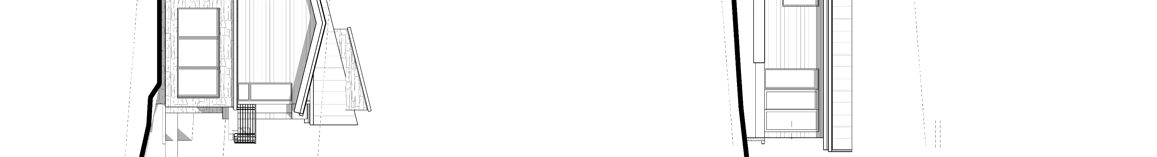
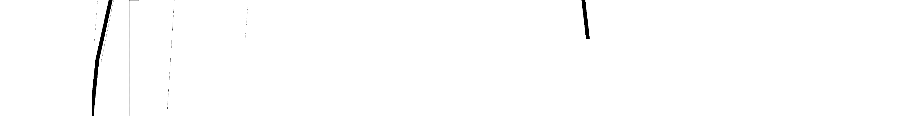

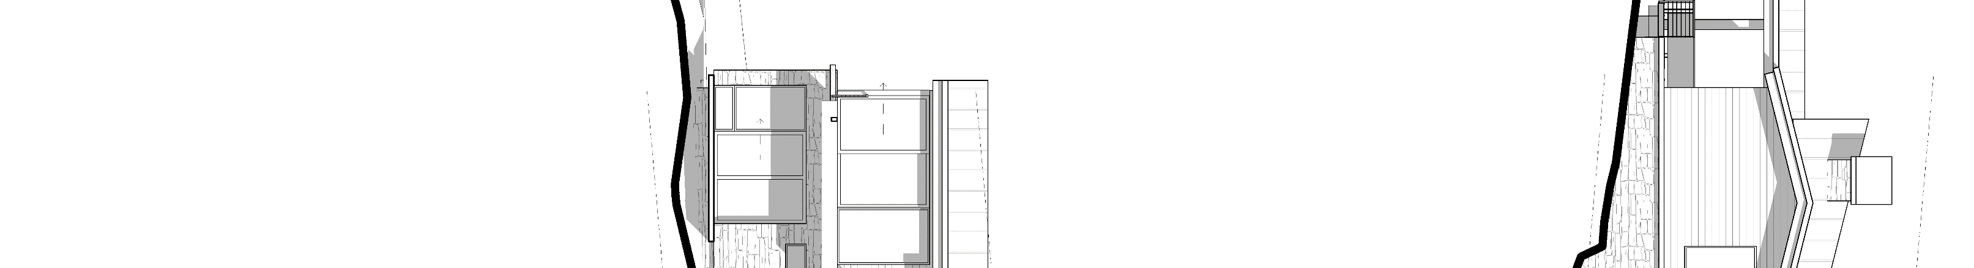
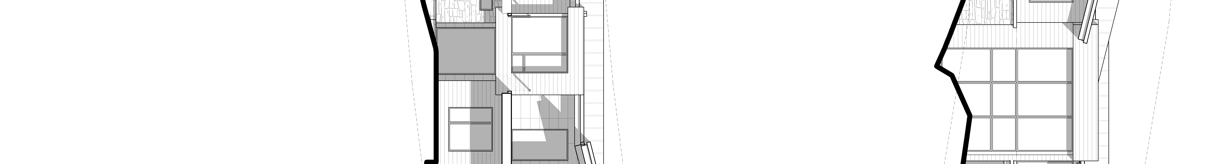
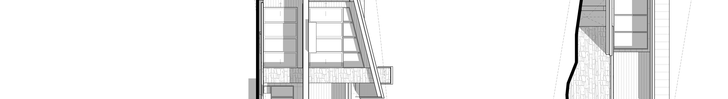
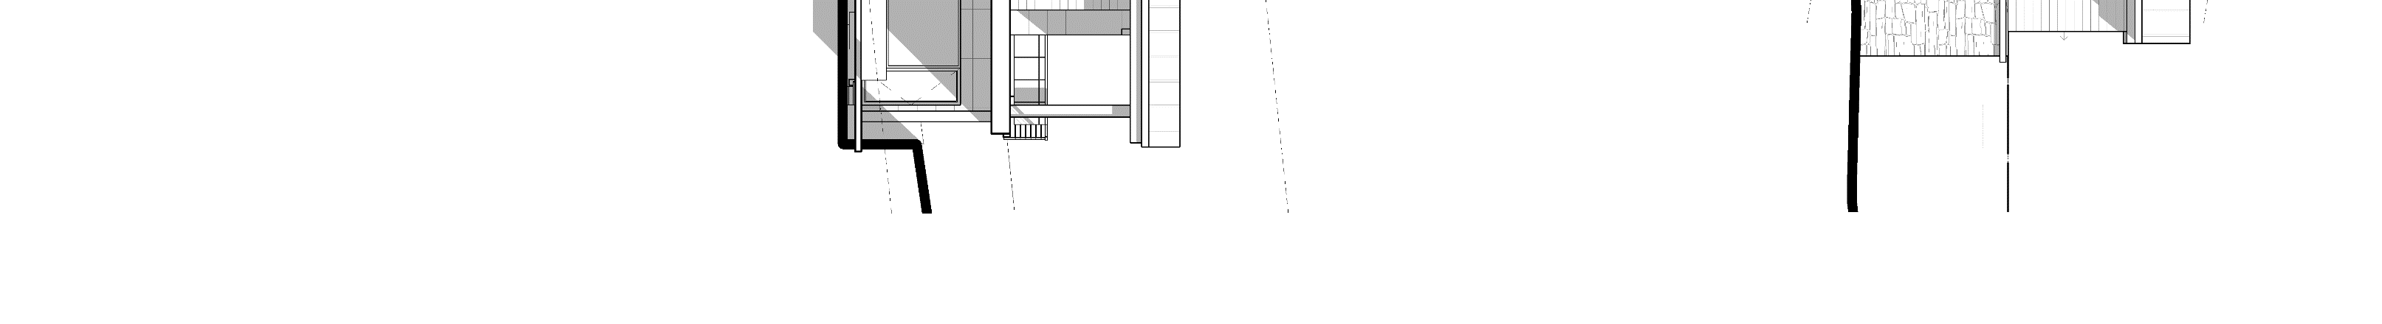

U P W A L L
D E S I G N
1930 S. 1100 E. S.L.C. UT 84106 (801)485-0708
A3.1
1/8" ELEVATIONS
Item # 1.
CEDAR FASCIA
TOP OF ROOF

EL: 6905' - 11"
?
TOP OF ROOF

EL: 6900' - 8"
1 FEBRUARY 2022
HORIZONTAL SIDING
STONE CAP
STONE VENEER
MAIN LEVEL 6886' - 0"

MAIN LEVEL
6886' - 0"
LOWER LEVEL 6874' - 0"

LOWER LEVEL
6874' - 0"
TOP OF ROOF

EL: 6905' - 11"
TOP OF ROOF

EL: 6900' - 5 7/8"
TOP OF ROOF

EL: 6899' - 8"
CEDAR FASCIA
STANDING SEAM METAL ROOF
STONE VENEER
NORTHEAST
HORIZONTAL SIDING
A ELEVATION
SCALE: 1/8" = 1'-0"
MAIN LEVEL 6886' - 0"

MAIN LEVEL 6886' - 0"
0'
2' 4' 8'
16'
LOWER LEVEL 6874' - 0"

LOWER LEVEL
6874' - 0"
SOUTHEAST
ELEVATION
B
TOP OF ROOF

EL: 6905' - 11"
SCALE:
1/8" = 1'-0"
TOP OF ROOF

EL: 6897' - 6 1/2"
2' 4'
8'
16'
0'
TOP OF ROOF

EL: 6900' - 8"
STANDING SEAM METAL ROOF
CEDAR FASCIA
HORIZONTAL SIDING
STONE VENEER

MAIN LEVEL 6886' - 0"

MAIN LEVEL
6886' - 0"
LOWER LEVEL 6874' - 0"

LOWER LEVEL
6874' - 0"
TOP OF ROOF

EL: 6900' - 8"
SOUTHWEST
TOP OF ROOF

EL: 6905' - 11"
C ELEVATION
32' HEIGHT RESTRICTION
STANDING SEAM METAL ROOF
CEDAR FASCIA
SCALE: 1/8" = 1'-0"
HORIZONTAL SIDING
2' 4'
8'
16'
0'
STONE VENEER
STONE CAP
MAIN LEVEL 6886' - 0"

MAIN LEVEL 6886' - 0"
LOWER LEVEL 6874' - 0"

LOWER LEVEL
6874' - 0"
LINE OF NATURAL GRADE
LINE OF FINISHED GRADE
NORTHWEST
D ELEVATION
SCALE: 1/8" = 1'-0"
0'
2' 4'
8'
16'
Page 14

A NEW DESIGN FOR THE :
LIZ & DYLAN RESIDENCE
LOT 74 & 75 11562 N WHITE TAIL CT.
SOARING HAWK HIDEOUT, UT 84032
THE ABOVE DRAWINGS AND SPECIFICATIONS AND THE IDEAS, DESIGN AND ARRANGEMENTS REPRESENTED THEREBY ARE AND SHALL REMAIN THE PROPERTY OF UPWALL DESIGN. NO PART THEREOF SHALL BE COPIED, DISCLOSED TO OTHERS OR USED IN CONNECTION WITH ANY WORK OR PROJECT OR BY ANY OTHER PERSON FOR ANY PURPOSE OTHER THAN FOR THE SPECIFIC PROJECT FOR WHICH THEY HAVE BEEN PREPARED AND DEVELOPED WITHOUT THE WRITTEN CONSENT OF UPWALL DESIGN. DESIGNS CAN NOT BE COPIED, DUPLICATED, OR COMMERCIALLY EXPLOITED IN WHOLE OR IN PART WITHOUT THE SOLE AND EXPRESS WRITTEN PERMISSION OF UPWALL DESIGN. VISUAL CONTACT WITH THESE DRAWINGS OR SPECIFICATIONS SHALL CONSTITUTE CONCLUSIVE EVIDENCE OF ACCEPTANCE OF THESE RESTRICTIONS. THESE DRAWINGS ARE AVAILABLE FOR LIMITED REVIEW AND EVALUATION BY CLIENTS, CONSULTANTS, CONTRACTORS, GOVERNMENT AGENCIES, VENDORS, AND OFFICE PERSONNEL ONLY IN ACCORDANCE WITH THIS NOTICE. WRITTEN DIMENSIONS ON THESE DRAWINGS SHALL HAVE PRECEDENCE OVER SCALED DIMENSIONS. CONTRACTORS SHALL VERIFY, AND BE RESPONSIBLE FOR, ALL DIMENSIONS AND CONDITIONS ON THE JOB AND THIS OFFICE MUST BE NOTIFIED OF ANY VARIATIONS FROM THE DIMENSIONS AND CONDITIONS SHOWN BY THESE DRAWINGS. SHOP DETAILS MUST BE SUBMITTED TO THIS OFFICE  FOR APPROVAL BEFORE PROCEEDING WITH FABRICATION. |  | REVISIONS

3" / 12" 3" / 12"
A A3.1
EL: 6900' - 8"

3" / 12"
B
3" / 12"
3" / 12"
EL: 6900' - 1"

EL: 6900' - 5 7/8"

3" / 12"
A
EL: 6899' - 8"

3" / 12"
3" / 12"



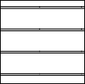
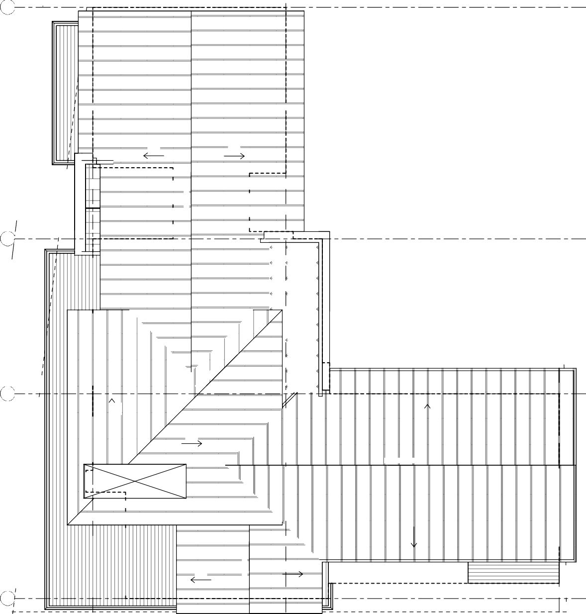












U P W A L L
D E S I G N
1930 S. 1100 E. S.L.C. UT 84106
(801)485-0708
A4.1
ROOF PLAN
Item # 1.
FIELD VERIFY DIMENSIONS AND T.O.P. W/ FLOOR PLANS AND ELEVATIONS
D
C
1 FEBRUARY 2022
1
1
2
EL: 6898' - 0"
2
3
3
ROOF
PLAN
SCALE: 1/4" = 1'-0"
D
C
B
A
1' 2'
4'
8'
0'
Page 15

STANDING SEAM METAL ROOFING

GREEN ROOF

ROOFING CONTRACTOR TO INSTALL STOW-STOP SYSTEM ON ALL ROOFS THAT SHED ONTO PATIOS, DECKS, DRIVEWAYS, OR ANY OTHER POTENTIALLY HAZARDOUS AREAS

CONTRACTOR TO ENSURE ADEQUATE INSTALLATION OF HEAT TAPE AT ALL DRAINS, DOWNSPOUTS, & GUTTER LOCATIONS

PROVIDE CONCEALED ROOF HEATING SYSTEM UNDER COLD ROOF CONDITIONS. VALLEYS, CRICKETS, RADIUS INTERSECTIONS, AND PEDESTRIAN AREAS. CONSULT W/ ARCHITECT & ELECTRICTIAN

ALL ROOF PENETRATIONS, INCLUDING PLUMBING AND MECHANICAL VENTS ARE TO BE GROUPED INTO A FALSE STONE FACED CHIMNEY.

A NEW DESIGN FOR THE :
LIZ & DYLAN RESIDENCE
LOT 74 & 75 11562 N WHITE TAIL CT.
SOARING HAWK HIDEOUT, UT 84032
THE ABOVE DRAWINGS AND SPECIFICATIONS AND THE IDEAS, DESIGN AND ARRANGEMENTS REPRESENTED THEREBY ARE AND SHALL REMAIN THE PROPERTY OF UPWALL DESIGN. NO PART THEREOF SHALL BE COPIED, DISCLOSED TO OTHERS OR USED IN CONNECTION WITH ANY WORK OR PROJECT OR BY ANY OTHER PERSON FOR ANY PURPOSE OTHER THAN FOR THE SPECIFIC PROJECT FOR WHICH THEY HAVE BEEN PREPARED AND DEVELOPED WITHOUT THE WRITTEN CONSENT OF UPWALL DESIGN. DESIGNS CAN NOT BE COPIED, DUPLICATED, OR COMMERCIALLY EXPLOITED IN WHOLE OR IN PART WITHOUT THE SOLE AND EXPRESS WRITTEN PERMISSION OF UPWALL DESIGN. VISUAL CONTACT WITH THESE DRAWINGS OR SPECIFICATIONS SHALL CONSTITUTE CONCLUSIVE EVIDENCE OF ACCEPTANCE OF THESE RESTRICTIONS. THESE DRAWINGS ARE AVAILABLE FOR LIMITED REVIEW AND EVALUATION BY CLIENTS, CONSULTANTS, CONTRACTORS, GOVERNMENT AGENCIES, VENDORS, AND OFFICE PERSONNEL ONLY IN ACCORDANCE WITH THIS NOTICE. WRITTEN DIMENSIONS ON THESE DRAWINGS SHALL HAVE PRECEDENCE OVER SCALED DIMENSIONS. CONTRACTORS SHALL VERIFY, AND BE RESPONSIBLE FOR, ALL DIMENSIONS AND CONDITIONS ON THE JOB AND THIS OFFICE MUST BE NOTIFIED OF ANY VARIATIONS FROM THE DIMENSIONS AND CONDITIONS SHOWN BY THESE DRAWINGS. SHOP DETAILS MUST BE SUBMITTED TO THIS OFFICE  FOR APPROVAL BEFORE PROCEEDING WITH FABRICATION. |  | REVISIONS


Saturday May 14th 10am to 12pm
2022
Jordanelle Community Clean-Up Day
Item # 1.

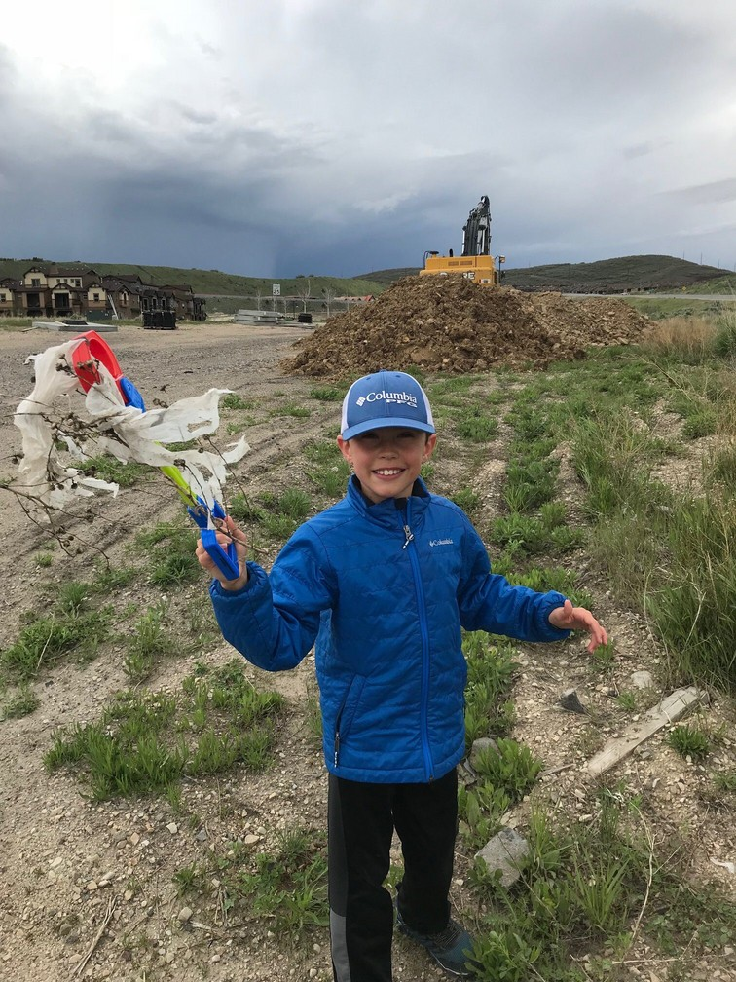


Sign up online to participate! Trash bags and a map of dumpster locations will be delivered the week before!
Return Around 12:00pm to the Retreat Clubhouse for catered lunch and socializing with neighbors.
Call Nikki 435-655-1612 for details and questions. More Details at www.thejordanelle.com/cleanup






sponsored by:

KW PARK CITY
KELLER WILLIAMS REAL ESTATE
Page 16

Ace Allak & Team NMLS #3811546

HIDEOUT, UTAH RESOLUTION NO. 2022-R-06
Item # 3.

A RESOLUTION ADOPTING THE TENTATIVE BUDGET FOR THE TOWN OF HIDEOUT, UTAH, FOR THE FISCAL YEAR 2023 BEGINNING JULY 1, 2022 AND ENDING JUNE 30, 2023 AND TO SET A TIME AND PLACE FOR A PUBLIC HEARING ON JUNE 9, 2022 AT 6:00 PM ELECTRONICALLY VIA ZOOM.

WHEREAS, State law requires the filing of a tentative budget for each municipality located within the State of Utah; and

WHEREAS, the Hideout Council ("Council”) met in a regular session on May 12, 2022, to consider, among other things, adopting a fiscal year 2023 tentative budget; and,
WHEREAS, the tentative budget complies with the requirements set out in U.A.C. § 105-107; and WHEREAS, the budget shall be reviewed, considered, and tentatively adopted by the governing body and
may be amended or revised in such manner as is considered advisable prior to final adoption.

WHEREAS, the Council shall set a time and date of June 9, 2022 at 6:00 PM to hold a public hearing concerning the fiscal year 2023 budget and FY 2022 amended budget and will publish public notice of the hearing as the requirements set out in U.A.C. § 105-108; and

NOW, THEREFORE BE IT RESOLVED BY THE CITY COUNCIL OF THE TOWN OF HIDEOUT, STATE OF UTAH,
as follows:

Section 1. That the Town of Hideout, hereby adopts the following tentative budget for the fiscal year beginning July 1, 2022 and ending June 30, 2023 attached here to as Exhibit 1.

Section 2. The Town of Hideout shall hold a public hearing on June 9, 2022 at 6:00 PM concerning the fiscal year 2023 budget and FY 2022 amended budget and will publish public notice of the hearing at least seven days before the hearing as the requirements set out in U.A.C. § 105-108.

Section 3. That this Resolution shall become effective immediately upon the passage thereof.

PASSED AND APPROVED this 12th day of May 2022.

TOWN OF HIDEOUT

By: Phil Rubin, Mayor

ATTEST:

Alicia Fairbourne, Town Clerk

Exhibit 1: Tentative Budget FY ending June 30, 2023 & Adjusted Budget FY ending June 30, 2022

Hideout - General Fund FY23 Budget
As of April FY22
Actual  Revenue FY21 |  |  | YTD/FCST FY22 | Budget FY23 |  | FY23 vs.  FY22 B(W) $ | FY23 vs. FY22 B(W) %
Total Taxes |  | $411,500 | $426,496 | $501,105 |  | $74,609 | 17%
Total License and Permits |  | $807,683 | $952,536 | $1,258,610 |  | $306,074 | 32%
Total Charges for Service |  | $27,046 | $2,226 | $2,500 |  | $274 | 12%
Total Miscellaneous Revenues |  | $11,384 | $10,294 | $11,145 |  | $850 | 8%
Total General Fund Revenues $1,257,613 |  |  | $1,391,553 | $1,773,360 |  | $381,808 | 27%
Expense
Total Salary/Wages/Benefits |  | $161,580 | $313,381 | $603,037 |  | ($289,656) | -92%
Total Administration |  | $82,712 | $87,221 | $115,278 |  | ($28,057) | -32%
Total Professional Services |  | $610,938 | $706,320 | $708,200 |  | ($1,880) | 0%
Total Public Safety |  | $53,599 | $15,815 | $81,089 |  | ($65,274) | -413%
Total Streets |  | $163,058 | $182,511 | $262,933 |  | ($80,423) | -44%
Total Parks |  | $530 | $2,875 | $15,000 |  | ($12,125) | -422%
Total Miscellaneous |  | $0 | $1,628 | $12,000 |  | ($10,372) | -637%
Total Debt Service |  | $26,175 | $26,961 | $27,200 |  | ($239) | -1%
Total General Fund Expenditure $1,098,592 |  |  | $1,336,711 | $1,824,738 |  | ($488,027) | -37%
Surplus/(Deficit) $159,021 |  |  | $54,842 | ($51,377) |  | ($106,219) | -194%

Hideout- Water Utility FY23 Budget
As of April FY22
Revenue / Expense |  | Actual FY21 | YTD/Fcst FY22 | Budget FY23 |  | FY23 vs. FY22 B(W) $ | FY23 vs. FY22 B(W) %
Total Revenues |  | $1,161,458 | $1,214,531 | $2,320,028 |  | $1,105,498 | 91.0%
Total Expenses |  | $742,684 | $987,556 | $2,080,370 |  | ($1,092,814) | -110.7%
Surplus/(Deficit) |  | $418,774 | $226,975 | $239,659 |  | $12,683 | 5.6%

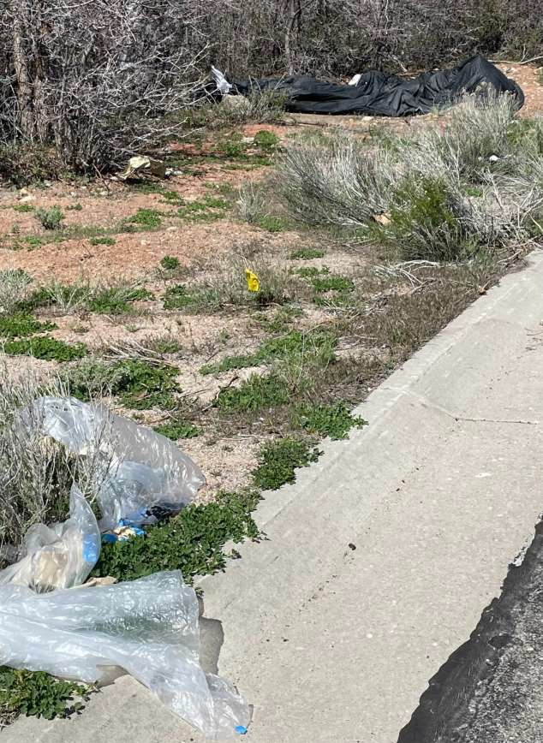



DARK SKIES LIGHTING

PURPOSE
It is the purpose and intent of this code to balance the goals of Hideout, to maintain its small-town character with the need to limit glare and light trespass, reduce night sky glow, conserve energy, provide safe lighting practices, and promote Dark Skies initiatives, while protecting individual property rights.
      - The use of outdoor lighting is often necessary for adequate nighttime safety and utility, but common lighting practices can also interfere with other legitimate public concerns. Principal among these concerns are:
        - The degradation of the nighttime visual environment by production of unsightly and dangerous glare.
        - Lighting practices that interfere with the health and safety of Hideout’s citizens and
visitors.
        - Unnecessary waste of energy and resources in the production of too much light or wasted light.
        - Interference in the use or enjoyment of property which is not intended to be illuminated at night, and the loss of the scenic view of the night sky due to increased urban sky glow.
        - Protect the quality of the natural ecology in the area.
      - The concerns of safety, utility and aesthetic appearance need not compete. Good modern lighting practices can provide adequate light for safety and utility without excessive glare or light pollution. In nearly all cases, careful attention to when, where and how much nighttime lighting is needed will lead to better lighting practices.
      - Accordingly, it is the intent of this code to require lighting practices and systems which will minimize or eliminate light pollution, glare, light trespass, and conserve energy while maintaining nighttime safety, utility, security and productivity.
      - In support of dark skies, events will be held two times per year to educate our community both about the value of this effort as well as about the sky itself. These events will be coordinated by the town of Hideout and may include visiting speakers and the creation of a dark skies community club or committee. These efforts will allow the Town of Hideout to pursue certification as a Dark Skies Community with the International Dark Skies Association.
      - Enforcement of this effort will be conducted by the enforcement officer under the direction of the mayor.

10.16.04 DEFINITIONS
Correlated color temperature (CCT): the temperature at which a blackbody emits radiant energy competent to evoke a color the same as that evoked by radiant energy from a given source (such as a lamp).
Dark sky fixture or fully shielded: any light fixture that is designed or shielded in such a manner that all light rays emitted by the fixture, either directly from the lamps or indirectly from the fixture are projected below a horizontal plane running through the lowest point of the shield.

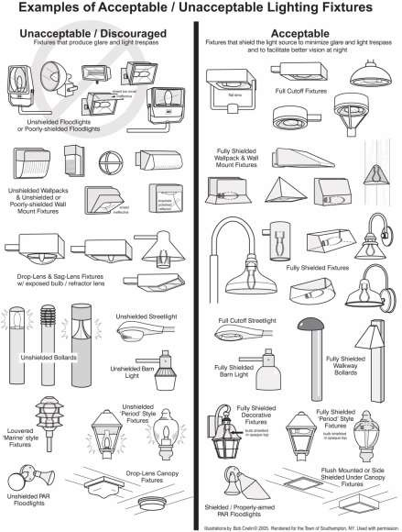

The lights on the left are non-conforming. Those on the right can be used in most cases. Depending on the mounting height and proximity to the property line, additional shielding may be necessary to prevent the luminous elements from being visible from any other property.

Dark sky shield: anything that is used to shield a light fixture so that it behaves as a fully shielded fixture. These include but are not limited to, for example, fixtures outfitted with caps or housings or installed under canopies, building overhangs, roof eaves or shielded by other structures, objects or devices.
Electronic messenger system (EMS): electronic messenger system with scrolling messages.
Emergency lighting: lighting as required by civil officers, agents, utilities and officials to perform their duties to maintain the public health, safety and welfare.

Full Cut-off Fixtures: fixtures, as installed, that are designed or shielded in such a manner that all light rays emitted by the fixture, either directly from the lamps or indirectly from the fixture, are projected below a horizontal plane running through the lowest point on the fixture where light is emitted.

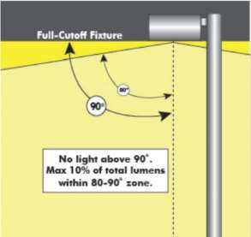
Full cutoff fixtures do not allow any light to be emitted above the fixture. The fixture controls glare by limiting the light output at 10 degress below the horizontal.

Holiday lighting: temporary lighting for a specific celebration which may be one of the following types:
- Holiday lighting is permited from December 1st – March 31st and must be turned off from midnight to 6am daily.
- Festoon type low-output lamps, limited to small individual bulbs on a string.
- Uplighting of wreaths and similar holiday items is permitted provided that individual lamps are less than 10 watts and 70 lumens.
- Low-output lamps (less than 50 watts and 750 lumens) used to internally illuminate yard art.
- Flood or spotlights producing less than 2000 lumens each whose light source is not visible from any other property.
Kelvin: relating to, conforming to, or having a thermometric scale on which the unit of measurement equals the Celsius degree and according to which absolute zero is equal to –273 degrees Celsius.
Light fixture: any device intended to produce outdoor illumination.
Light trespass: light emitted from fixtures designed or installed in a manner that unreasonably causes
light to fall on a property other than the one where the light is installed, in a motor vehicle driver’s eyes,
or upwards toward the sky.

Lumen: a unit of luminous flux equal to the light emitted in a unit solid angle by a uniform point source of one candle intensity.
Major addition: enlargement of 25% or more of the buildings gross floor area, seating capacity, or parking spaces, either with a single construction project or cumulative series of construction projects after the enactment of this ordinance. The term also includes replacement of 25% or more of installed outdoor lighting.
Minor addition: enlargement of less than 25% of the buildings gross floor area, seating capacity or parking spaces, either with a single construction project or cumulative series of construction projects after the enactment of this ordinance. The term also includes replacement of less than 25% of installed outdoor lighting.
Motion sensor: any device that turns a light fixture on when it detects motion and off when motion stops or very shortly thereafter (5-10 minutes).
Nits (candela): the base unit of luminous intensity in the International System of Units that is equal to the luminous intensity in a given direction of a source which emits monochromatic radiation.
Switch: any device that can be manually controlled by a person to turn a light fixture on and off. For the purpose of this chapter, switches include motion sensors, but switches do not include light sensors or timers.
Temporary: refers to lighting as required by citizens to carry out legally approved activities for durations as specified in the permits for those activities. These include but are not limited to, for example, activities such as nighttime agricultural operations, construction work lighting, and seasonal decorations, but in no case for more than a period of 60 days without an exemption granted by the town of Hideout.

10.16.06 APPLICABILITY AND EXEMPTIONS
All exterior outdoor lighting installed after the effective date hereof in the town shall conform to the requirements established by this chapter. This chapter does not apply to indoor lighting. However, light trespass from interior lighting that negatively impacts adjacent properties is also prohibited.
- Exemptions.
  - Temporary lighting for decoration/seasonal, theatrical, television, performance areas, and construction sites, except as allowed by permit at the discretion of the town council.
  - Town entrance lighting such as trees with strings of white lighting at the intersection of North Hideout Trail and SR248 and the trees within the traffic circle at the western terminus of North Hideout Trail.
  - Underwater lighting in swimming pools and other water features.
  - Lighting that is only used under emergency conditions.
  - Lighting required by federal, state, county or city ordinances and regulations.
  - Outdoor recreational facilities are exempt from lumen cap and shielding but must comply with 3,000 degrees Kelvin temperature requirement. Lights must be extinguished promptly after a sponsored event.

10.16.08 OUTDOOR LIGHTING STANDARDS.
- Temperature of Lamps. Lamps shall not exceed a maximum correlated color temperature (CCT) of 3,000 degrees Kelvin.
- Lamp and Shielding. All light fixtures are required to be fully shielded and installed so that the shielding complies with the definition of a fully shielded light fixture.
- Light Trespass Standard. All light fixtures, including motion sensing fixtures and security lighting, shall be aimed and shielded so that the direct illumination shall be confined to the property boundaries of the source, including any public or private street or road.
- Signs:
  - Front Lit: Any light with the intention to illuminate a sign must be oriented from the top and shine down.
  - Back Lit:
    - The sign design may not contain any more than 10 percent white, including lettering.
    - Transparent or clear materials are not allowed.
    - Nonface portions of the sign (e.g., background and sides) shall be made of completely opaque material.
    - Internal lights must not exceed 3,000 degrees Kelvin if greater than or equal to 1,500 lumens.
  - Neon: Any sign consisting of more than three feet of neon must be extinguished no more than four hours after sundown during daylight savings and six hours during regular mountain time.
  - Electronic:
    - EMS signs are for public safety purposes only and prohibited for private or commercial use.
    - Luminance levels for operation after sundown and until sunrise shall not exceed 100 nits (candela per square meter) as measured under conditions of a full white display.
    - Messages appearing on Electronic Messenger Systems (EMS) shall not be displayed for less than 30 seconds and require no longer than 0.25 seconds to transition from one message to another. Moving text is prohibited.
    - The luminous surface area of an individual EMS shall not exceed 50 square feet.
    - EMSs shall not be placed within 1,500 feet (300 meters) of other off-premises changeable electronic variable message sign on the same side of the highway, regardless of face orientation.
    - EMSs shall not be placed within 1,500 feet (300 meters) of residential areas.
    - The device owner or the permit holder shall continuously monitor signs 24 hours per day, including monitoring the reliability of hardware, software, network and other support infrastructure.
    - Signs shall contain a default mechanism so that in the event 10 percent or more of an EMS’s LED emitters have failed, the sign will immediately revert to an unlit black screen and remain in such condition until the malfunction is corrected.
- Parking Lots:
  - Spot or flood lighting of parking lots from a building or other structure is prohibited.

  - The overall height of any light post used to illuminate parking lots in commercial zones shall not exceed 20 feet. All post mounted parking lot lights shall be set back from property lines a distance that is determined appropriate by the planning commission.
  - The overall height of any light post used to illuminate parking lots in residential zones shall not exceed 16 feet.
  - The lighting in commercial parking lots must be turned down by at least 75% of all light fixtures (or 75% of total light emitted) two (2) hours after closing time in the evening or from 10pm to 6am, whichever is the most restrictive.
  - All parking lot lighting shall use full cutoff fixtures.
- Gas Station Canopies. Gas station canopies may be illuminated, provided all light fixtures are mounted on the undersurface of the canopy, all light fixtures are full cutoff and diffusers are not visible from locations off the property. Except for directed beam lighting, merely placing the fixtures on the underside of the canopy does not qualify as fully shielding the light fixture. Directed beam lighting mounted under the canopy is allowed, provided the light source cannot be seen from outside the property boundaries.
- Total Outdoor Light Output Standards – Commercial and Multifamily Uses.
  - Total outdoor light output shall not exceed 15,000 lumens per net acre for all development except single-family residential uses. This cap is not intended to be achieved in all cases or as a design goal. Instead, design goals should be the lowest levels of lumens necessary to meet the lighting requirements of the site.
  - Seasonal decorations are not counted toward this limit.
- Total Outdoor Light Output Standards – Single-Family Residential Uses:
  - Outdoor lighting for single-family residential uses is subject to a lumen per net acre cap of 10,000 lumens net.
  - Outdoor lighting for single-family residential uses is subject to the lamp fixture and shielding requirements.
- Roadway/Streetlights. Streetlights are allowable as recommended by the public works administrator or town council. All streetlights shall utilize lamp types that are energy efficient and minimize sky glow and other negative impacts of artificial lighting. They shall not exceed 10,000 lumens per net acre. Lighting shall meet safety concerns with a goal of using the lowest levels of lumens necessary.
- New Public Lighting – Streetlights/Public Property and Rights-of-Way:
  - All new streetlights are allowed as recommended by public works administrator and town council. They will adhere to all standards as indicated including energy efficient lighting which minimizes sky glow. They shall not exceed 10,000 lumens per net acre. Lighting shall meet safety concerns with a goal of using the lowest levels of lumens necessary.
  - Public Property. Properties owned by Hideout such as parks and other community gathering spaces will adhere to all standards as indicated. They will adhere to all standards as indicated including energy efficient lighting which minimizes sky glow. Lighting shall meet safety concerns with a goal of using the lowest levels of lumens necessary.
  - Rights-of-Way. All rights-of-way will adhere to all standards as indicated including energy efficient lighting which minimizes sky glow. Lighting shall meet safety concerns with a goal of using the lowest levels of lumens necessary.

  - All new public lighting will be part of the planning and zoning process in which public buildings, public property and rights-of-way lighting is determined. This will be incorporated as part of the zoning process moving forward to ensure compliance with this chapter.
- Prohibited Lighting:
  - Up lighting to illuminate buildings, other structures or vegetation.
  - Flashing, blinking, intermittent or other lights that move or give the impression of movement, not including temporary holiday lighting.
  - Floodlights or spotlights affixed to buildings for the purpose of lighting parking lots or sales display lot areas.
  - Searchlights, laser source lights or any similar high intensity light.
  - Except when used in window signage pursuant to subsection (10.16.06 (4.C) of this section, neon or luminous tube lighting, either when outdoor mounted or indoor mounted, if visible beyond the property boundaries.

10.16.10 LIGHTING CONTROL.
- Light fixtures with motion sensors and/or timers are required to minimize the duration of nighttime lighting from midnight to 6 a.m.
- Fully shielded fixtures are required where any lights, even those below 1,500 lumens, are mounted on structures or poles higher than the first level above ground level to protect the view of the night sky, minimize ground reflection, and reduce light scatter beyond the property line.
- Statuary and flags shall be lit from above to minimize sky glow.

10.16.12 IMPLEMENTATION.
- New Uses, Buildings and Major Additions or Modifications: All building permit applications must include an outdoor lighting plan which includes the following information:
  - The location of all existing and proposed light fixtures (may be included on site plan).
  - Specification sheets for all existing and proposed light fixtures.
  - Acknowledgement that the Applicant has received notification of this Article.
  - Verification that a residential or commercial construction project requiring a building permit application has complied with the provisions of this code section shall occur during the final electrical inspection done by the towns designated building inspector.
- Minor Additions or modifications: If the work requires a permit than the procedures shall be the same as for a Major addition.
- New Lighting. Any new lighting on the site shall meet the requirements of this code with regard to shielding and lamp type; the total outdoor light output after the modifications are complete shall not exceed that on the site before the modification, or that permitted by this code, whichever is larger.
- Resumption of Use after Abandonment. If a property or use with nonconforming lighting is abandoned, then all outdoor lighting shall be reviewed and brought into compliance with this code before the use is resumed.
- Existing Lighting: On or before three years, all outdoor lighting shall comply with this code. This may be done through replacement or retrofitting.
- Public Roadways:

  - In general, this code does not apply to county and state rights-of-way. However, all new streetlights on such roadways or rights-of-ways must be fully shielded.

10.16.14 ENFORCEMENT AND PENALTIES.
All code, including lighting code, requires enforcement. Lighting code enforcement is essential to achieving a sustained reduction of light pollution and conservation of the night sky.
- The penalty for violation of any portion of this chapter shall be:
  - First Notice. A notice to the property owner requesting compliance within three months.
  - Second Notice. If after three months the violation exists a notice will be given to appear before the Hideout Town Council to discuss options to come into compliance.
  - Third Notice. If after six months a violation of the provisions of this chapter shall be an infraction punishable by penalties up to $1,000 per day per residential/commercial unit.
- Violations regarding 10.16.10 lighting control (not withstanding 10.16.14.1) :
  - First notice. A notice to the property owner requesting compliance within 72 hours.
  - Second notice. If after 72 hours a violation of this light control shall be an infraction punishable by penalties up to $50 per day until compliance.

10.16.16 CONFLICTS.
Where any provision of federal, state, county, or city statutes, codes, or laws conflicts with any provision of this code, the most restrictive shall govern unless otherwise regulated by law. If any provision of the Hideout Town Code should conflict with the provisions of this chapter, this chapter shall supersede and be the controlling and enforceable provision.

