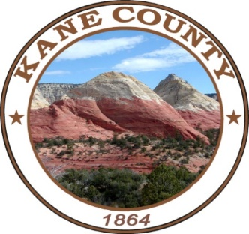
Kane County
Public Lands Department

76 North Main Street ▪ Kanab, UT 84741
435.644.4964

NOTICE OF PUBLIC MEETING

Notice is hereby given that the Kane County Resource Development Committee and the Kane County Recreation and Transportation meetings will be held on Wednesday, May 18, 2022, at 9:00 a.m. and 10:00 a.m. Located in the Kane County Commission Chambers, 76 North Main, Kanab, UT.

This meeting is available via conference call at 435-676-9000, participant code 168030#.

For questions pertaining to this meeting contact Clayton Cutler, Public Lands Coordinator at 435-644-4366 or ccutler@kane.utah.gov.

Dated May 9, 2022
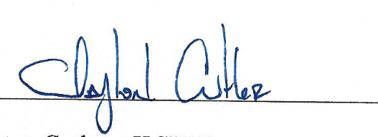

___
Clayton Cutler, Public Lands Coordinator

