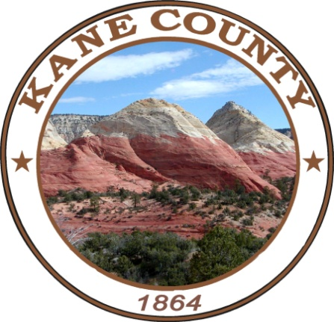
May 18, 2022
9:00 am
76 North Main Street ▪ Kanab, UT 84741
435.644.4964

Kane County
Public Lands Department

Resource Development Committee Meeting

AGENDA
Call to Order: Bart Battista
Invocation:
Pledge of Allegiance:

- Approval of minutes:
- 03-16-2022 Resource Development Committee Meeting
- 04-20-2022 Interagency Meeting Minutes.
- Updates/Projects:
    - Grazing
    - Committee updates

- Adjourn

Recreation & Transportation Special Service District Meeting
*Meeting will begin after Resource Development Meeting is adjourned.

AGENDA
Call to Order – Tony Wright

- Approval of 03-16-2022 R&T meeting minutes.
- Follow up on State certification

Financial Update:
- Update on RTSSD funds - Clayton
- Checks and Signatures Review
- Kelly Stowell-Funds projects
- Updates-Committee

Adjourn.

- Phone in – 435-676-9000 –Enter participant code- 168030
NOTICE OF SPECIAL ACCOMMODATION DURING PUBLIC MEETINGS:
In compliance with the Americans with Disabilities Act, individuals needing special accommodations (including auxiliary communicative aids and services) during this meeting should notify Clayton Cutler. Agenda items may be accelerated or taken out of order without notice as the Committee deems appropriate. All items to be placed on the agenda contact Clayton Cutler by noon Monday, prior to the meeting.
ccutler@kane.utah.gov 435-644-4366

