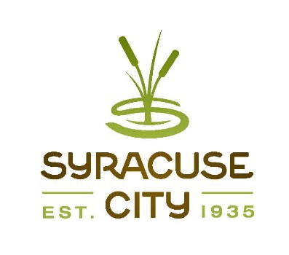SYRACUSE CITY
Syracuse City Special Redevelopment Agency (RDA) Meeting May 10, 2022 – immediately following the City Council Business Meeting, which begins at 6:00 p.m.
In-Person Location: Syracuse City Hall, 1979 W. 1900 S. Electronic: Via Zoom
Connect via telephone: +1-301-715-8592 US, meeting ID: 813 9494 4051
Streamed on Syracuse City YouTube Channel

Meeting called to order Adopt agenda
- Consideration and/or action regarding proposed sale of City-owned land located at approximately 2068 W. 1900 S. (10 min.)
- Adjourn.
~~~~~
In compliance with the Americans Disabilities Act, persons needing auxiliary communicative aids and services for this meeting should contact the City Offices at 801-825-1477 at least 48 hours in advance of the meeting.

CERTIFICATE OF POSTING
The undersigned, duly appointed City Recorder, does hereby certify that the above notice and agenda was posted within the Syracuse City limits on this 5th day of May, 2022 at Syracuse City Hall on the City Hall Notice Board and at http://www.syracuseut.gov/. A copy was also provided to the Standard- Examiner on May 5, 2022.
CASSIE Z. BROWN, MMC SYRACUSE CITY RECORDER

