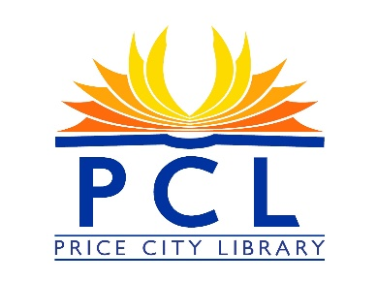

PRICE CITY LIBRARY BOARD MEETING AGENDA
Monday April 11th 2022
Price City Hall room 106
4:00 P.M.

- Call to Order
- Roll Call
- Approval of Minutes
- Approval of Program Reports/Monthly Statistics
- Board Members informational comments on pertinent items not on the agenda.
- Public Comments/Questions (3-5 minutes)

- New Business
- Open Meeting Training

- On Going Business
- Library Fines
- Little Libraries

- Agenda Items for the Next Meeting
- Adjournment

Next Library Board Meeting: May 9th 2022

Monthly Circulation summary
January 2022 Totals
Circulation 1898
Internet total usage 179
Books use 150
Story time 72
Outside programs 0
Outside program attendance 0
YA programs 0
Reference 183
Patrons 1978

Monthly Circulation summary

February 2022 Totals
Circulation 1530
Internet total usage 226
Books used 234
Story-time 28
Take & Makes 149
Off-Site Programs 0
Off-Site Programs Attendance 0
Programs 5
Programs Attendance 38
YA Programs 0
YA Programs Attendance 0
Reference 174
Patrons 1949

Monthly Circulation summary

March 2022 Totals
Circulation 1806
Internet total usage 257
Books used 367
Story-time 58
Take & Makes 75
Off-Site Programs 0
Off-Site Programs Attendance 0
Programs 6
Programs Attendance 87
YA Programs 0
YA Programs Attendance 0
Reference 194
Patrons 2131

