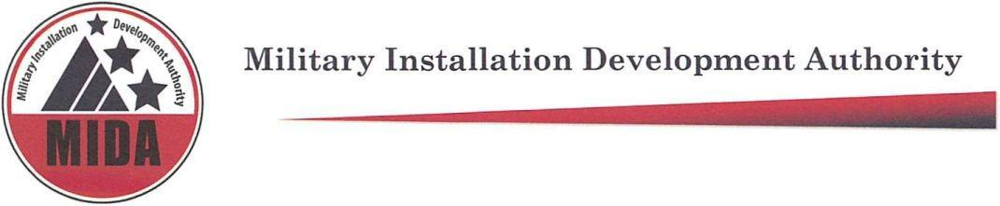

MIDA Board Meeting Pending Minutes April 20, 2022 @ 4:30pm

Board Members Present: Gary Harter, Steve Farrell, Jerry Stevenson, Mike Ostermiller

Board Members Excused: Gage Froerer, Stuart Adams, Mark Shepherd, Ben Hart^

^Non-voting board member

Agenda item (1) Welcome: Jerry Stevenson

Agenda Item (2) Adjourn Open Meeting and have a Closed Strategy Session Meeting, pursuant to Section 52-4-205(1)(d), to Discuss the Purchase, Exchange, or Lease of Real Property

Mike Ostermiller: Motion to adjourn Open Meeting and have a Closed Strategy Session Meeting, pursuant to Section 52-4-205(1)(d), to Discuss the Purchase, Exchange, or Lease of Real Property

Steve Farrell: Second

Gary Harter, Steve Farrell, Jerry Stevenson, Mike Ostermiller vote “aye” in favor of adjourning open meeting to have a closed strategy session meeting. None are opposed. The motion passes.

Meeting adjourned at: 4:31

Meeting Attendees: Paula Eldredge, Ashley Burr, Paul Morris, Mike Ostermiller, Heather Kruse, Richard Catten, Mike Davis, Steve Farrell, Jerry Stevenson, Gary Harter, Kendall Crittendon, Dustin Grabau, Spencer Park, Danny Goode, Mark Nelson, Kendall Crittendon, Scott Sweat, Jeff Wade, Wendy, Natalie Foster, Heber, Paula, Jen Hunsaker

