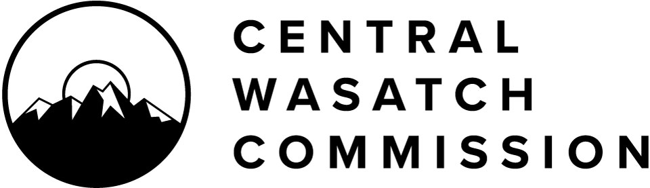

Central Wasatch Commission Board Meeting Agenda Monday, May 2, 2022
3:30 p.m. – 5:30 p.m.

Notice is hereby given that the Central Wasatch Commission will hold a meeting at approximately 3:30 P.M., or soon thereafter, on Monday, May 2, 2022. This meeting will occur both in-person and virtually via ZOOM. The anchor location is Millcreek City Hall, 3330 South 1300 East, Millcreek, UT. For those wishing to attend the meeting virtually, the public may register for the meeting through the following link. Once registered, meeting attendees will receive an email with a personal meeting access link and a call-in number for those whose only option is to call in.

https://us06web.zoom.us/webinar/register/WN_v0nGI8L-SKq_k9mvCLvIDA

The public may provide comments to the CWC during this meeting through Zoom or in-person in the Council Chambers at Millcreek City Hall. In-person attendees may fill out a comment card and online participants may either fill out the comment form at the link below or provide comment as a virtual meeting attendee via Zoom following instructions from the Chair. Written public comments received before commencement of the meeting will be either summarized or read into the record by the Chair or a designee. Such comments should be submitted via the following:

https://forms.gle/KSw4M3TFrLrLeLb38

Please note: For in-person meeting attendees, masks are no longer required at Millcreek City Hall, but are welcome for any attendees who prefer to continue using them. We will continue to monitor the situation take any reasonable precautions for the public and staff.

Civility and decorum should be applied in all discussions and debate. Difficult questions, tough challenges to a point of view, and criticism of ideas and information are legitimate elements of a free democracy in action. Public officials and the public are encouraged to refrain from making belligerent, personal, impertinent, slanderous, threatening, abusive, or disparaging comments.

3:30 P.M. Opening

- Chair of the Board Christopher F. Robinson will open the CWC Board meeting.
- (Action) The Board will consider approving the minutes of the April 4, 2022, Board meeting.
- (Action) Consideration of Resolution 2022-19 expressing gratitude to Councilmember Max

Doilney for his work and service to the Central Wasatch Commission.

3:40 P.M. CLOSED SESSION

Chair Robinson will invite the Board to commence a closed session for the purposes for to discuss the character, professional competence or physical or mental health of an individual as authorized by UTAH CODE ANN. 52-4-205(1)(a).

4:15 P.M. CLOSED SESSION ENDS

4:15 P.M. CWC BOARD MEETING RECONVENES

4:15 P.M. Central Wasatch Commission Leadership and Compensation

Chair Robinson will lead the Board in a discussion regarding leadership of the Central Wasatch Commission in light of the pending June 30, 2022 retirement of current Executive Director Ralph Becker.

4:30 P.M. Stakeholders Council Update

Stakeholders Council leadership will provide a monthly update to the Board.

4:40 P.M. Committees and Projects

Executive/Budget/Audit Committee
CWC Treasurer/Secretary Jeff Silvestri will update the board on the tentative budget for FY 22/23 (copy included in the meeting packet) for action at end of the meeting.

4:50 P.M. Public Comment

5:00 P.M. Commissioner Comment 5:10 P.M. Action Items
- Consideration of Resolution 2022-20 Approving Entry into Independent Contractor Agreements for Legal, Financial, Auditing, Lobbying and Transcription Services.
- Consideration of Resolution 2022-21 Approving Entry into the Third Amendment to an Interlocal Cooperation Agreement with Utah State University for a Visitor Use Study for Big and Little Cottonwood Canyons.
- Consideration of Resolution 2022-22 Approving Entry into the Fourth Amendment to an Interlocal Cooperation Agreement with the University of Utah for the Environmental Dashboard.
- Consideration of Resolution 2022-23 Tentatively Adopting a Tentative Budget for the Period of 1 July 2022 through 30 June 2023; Providing for Public Inspection of Such Budget; Establishing the Time and Place of Public Hearing to Consider Adoption of Such Budget; and Providing for Publication of Such Public Hearing.
- Consideration of Resolution 2022-24 Approving Execution and Delivery of a “Public Entity Resolution” to the Office of the Utah State Treasurer.

- Consideration of Resolution 2022-25 Releasing and Appointing Members of the Stakeholders Council.
- Consideration of Resolution 2022-26 Approving Short Term Projects and Associated Funding.
- Consideration of Resolution 2022-27 Approving Signers on Zions Bank Accounts.

5:30 P.M. Adjourn Board Meeting

Chair of the Board Christopher F. Robinson will close the CWC Board meeting.

CERTIFICATE OF POSTING:
At or before 3:30 p.m. on April 29, 2022, the undersigned hereby certifies that the above notice and agenda was:
  - Posted on the Utah Public Notice Website created under UTAH CODE ANN. 63A-16-601;
  - Posted at the CWC’s principal office; and
  - Provided to the Salt Lake Tribune and/or Deseret News and to a local media correspondent.
The audio recording and transcript of the meeting will be posted for public review. Members of the Commission will/may participate electronically. Meetings may be closed for reasons allowed by statute. Final action may be taken in relation to any topic listed on the agenda, including but not limited to adoption, rejection, amendment, addition of conditions and variations of options discussed. In compliance with the Americans with Disabilities Act, individuals needing special accommodations or assistance during this meeting shall notify the CWC’s administrator at (801)230- 2506 at least 24 hours prior to the meeting. TDD number is (801)270-2425 or call Relay Utah at #711.

Kaye Mickelson: Central Wasatch Commission Administrator

