UTAH SCHOOLS FOR THE DEAF AND THE BLIND
Advisory Council Agenda April 28, 2022
OEC Campus

GENERAL SESSION AGENDA (Tab 1)

4:30 p.m.
- Welcome

4:30 – 4:45 p.m.
- Public Comments

ACTION ITEMS

4:45 – 4:50 p.m.
- CONSENT CALENDAR APPROVAL ACTION ON:
  - Advisory Council Minutes of March 24, 2022 (Tab 2)
contact Tamara Flint (801) 629-4712
or tamaraf@usdb.org for more information.

  - Vacancy Report as of April 21, 2022 (Tab 3)
contact Carl Empey (801) 629-4723 or carle@usdb.org for more information.

  - Donated Account Summary ending March 31, 2022 (Tab 4)
contact Carl Empey (801) 629-4723 or carle@usdb.org for more information.

It is recommended that the Advisory Council review and approve the Advisory Council minutes of March 24, 2022, the Vacancy Report as of April 21, 2022, and the Donated Accounts Summary as of March 31, 2022.

4:50 – 5:15 p.m.
- Review of FY23 Carry Forward Projects (Tab 5) INFORMATION ITEMS
5:15 – 5:30 p.m.
- Germany Presentation to the Advisory Council

5:30 – 5:45 p.m.
Online Content Development
- - Adam Billings (Tab 6)

5:45 – 6:10 p.m.
- USB Portrait of a Graduate - Susan Patten (Tab 7)
USD Portrait of a Graduate - Michelle Tanner

6:10 - 6:25 p.m.
- FY23 Monthly Budget Update ending March 31, 2022 (Tab 8)

6:25 - 6:35 p.m.
- Presentation on New USDB Building (Tab 9)

6:35 - 6:50 p.m.
- Superintendent Report

6:50 - 6:55 p.m.
- Future Agenda Items
- May - USB London Study Abroad

6:55 - 7:00 p.m.
- Other

Public Comment
Individuals are welcome to address the Advisory Council. Please contact Tamara Flint (801) 629-4712 or tamaraf@usdb.org with 24 hours advance notice with your name and the group you represent and a link will be shared with you. Each person will be limited to three minutes. Total time allotted for public comments will be a total of 15-minutes. Anyone needing more time should make that request in writing and arrange to be on the agenda at the next meeting.

Notice of Procedure to Get on the USDB Advisory Council Agenda
Anyone interested in being on the agenda should contact Chairperson Philippe Montalette at (801) 674-2445 / pmontalette1@gmail.com., Superintendent Joel Coleman at (801) 629-4712 / joelc@usdb.org, or Tamara Flint at (801) 629-4712/ tamaraf@usdb.org. Please do so by the Friday of the week prior to the meeting.

Notice of Special Accommodation at Public Meetings
In compliance with the Americans with Disabilities Act, individuals needing special accommodations (including auxiliary communicative aids and services) during this meeting should notify Tamara Flint (801) 629-4712 or tamaraf@usdb.org at least three working days prior to the meeting.

UTAH SCHOOLS FOR THE DEAF AND THE BLIND
Advisory Council Meeting Summary March 24, 2022
Openshaw Education Center

4:30 p.m. - General Session

Attending:

John Clements, Voting Member
Katie Groves, Voting Member (Zoom) Karen Harrop, Voting Member (Zoom) Aunilie Hathaway, Voting Member Jennifer Hayes, Voting Member (Zoom) Sterling Hilton, Voting Member
Sundie Marx, Non-Voting Member (Zoom)
Philippe Montalette (Chair), Voting Member (Zoom) Jill Weiss, Non-Voting Member
Ray Wright (Vice-Chair), Voting Member

Also Attending:

Joel Coleman, Superintendent Carl Empey, Finance Director Tamara Flint, Executive Assistant
Susan Patten, USB Associate Superintendent (Zoom) Michelle Tanner, USD Associate Superintendent (Zoom)

Interpreters:

Andrea Rathbun, Interpreter Nathan Suitter, Interpreter

Others:
Sarah Erb Amy Zaharis

- Welcome and Pledge of Allegiance

Mr. Wright welcomed Council members and guests in attendance to the March 24, 2022 Advisory Council meeting held at the Openshaw Education Center.
Superintendent Coleman led the Council in the pledge of allegiance.

- Public Comments

There were no public comments.

ACTION ITEMS
- Consent Calendar

Mr. Wright asked Council members if they had any questions or concerns with the February 24, 2022 consent calendar. There were no questions or concerns from Council members. Ms. Hathaway moved to accept the Advisory Council minutes for February 24, 2022, the Vacancy Report as of March 17, 2022 and the FY22 Donated Accounts Summary for February 28, 2022. Mr. Clements seconded the motion. All Council members were in favor.. Motion carried.

INFORMATION ITEMS

- Student Report on Trip to Washington DC

Ms. Tanner thanked Todd Keith for preparing the Washington DC video that we a are about to share with Council members.

JMS Visits Washington DC - [AudioDescribed]

Students shared some of their favorite things about the trip that included going to Gallaudet University, visiting museums, seeing the beautiful architecture and going on the tours.

Mr. Clements thanked the students for sharing their experiences. It is so great to be able to get a glimpse of this experience through the eyes of students. Mr.
Wright also thanked the students for coming tonight to share their experiences in person.

- Student Report on Deaf Theater Competition

Ms. Tanner informed Council members that actors from both Deaf West and Sunshine 2.0 came to provide training for our students. Drama is very important to some of our students.They shared many pictures of students and specific things they were taught. They noted that one of the actors taught them how important it is to be funny and show emotions, be creative and to show and express their individual personalities. The students also enjoyed meeting students from other schools who participated. They were challenged to create a script in a few minutes and act it out.

Ms. Tanner noted that they had so many guests come to the performance Saturday night, that they had to add extra chairs. They had approximately 250- 300 people attend. USDB won best collaboration and 2nd in best duo and trio. We are planning to provide this next year and are hopeful that it will grow bigger and bigger each year. Ms. Tanner thanked the students for coming to present to the Advisory Council and a special thanks to staff members for making this a reality including Kevin Berrigan, Nathan Harrison and Cindy Andersen.

- Advisory Council Positions Ending June 2022

Mr. Wright asked Ms. Flint to provide Council members a summary of Council members whose terms will be expiring at the end of June 2022. All members whose terms are expiring have served three terms. Ms. Flint provided a summary that included:

  - Philippe Montalette - Person who is Deaf or Hard of Hearing
  - Sterling Hilton - Person who is Deafblind or Parent of a Deafblind child
  - Karen Harrop - Person with interest or knowledge of Deaf, Blind and/or Deafblindness
  - Sundie Goulding - Teacher of the Blind or Visually Impaired (Non-voting)

The application deadline is April 15, 2022. Council members will review applications following the April 28, 2022 and send recommendations to the State Board of Education for their review/appointment.

- FY22 Budget Update as of February 28, 2022

Mr. Empey notified the Council that year to date expenditures for FY2022 are
$29,154,682 as of February 28, 2022. All areas covered in the Financial Report are operationally capable, with a remaining budget balance of $20,356,465. Total number of students served as of February 28, 2022 was 2,629.

Mr. Empey asked the Council if there were any questions or concerns regarding the Financial Report. There were no additional questions or concerns regarding the Financial Report from Council members.

Mr. Empey reviewed the status of Enrichment Funds as of February 28, 2022. USDB has spent approximately $770,312 of its annual $1,446,000 FY22 Enrichment Funds budget. All remaining Enrichment Funds will be forwarded to the next fiscal year. Larger expenses such as international trips, Seventy 48 boat race and the audiology van will be hitting the budget in the next couple of months. Mr. Empey asked the Council if there were any additional questions or concerns regarding the Enrichment Funds.
Mr. Montalette wondered what the status of the audiology van was. Mr. Empey noted that we have not paid anything towards the audiology van yet. They did come back to us and wanted more money for a heavier chassis, but our purchasing manager went back to the RFP that included the heavy duty chassis and they agreed to provide it at no additional cost. Mr. Empey also noted that we will probably not receive the audiology van until January or February, so the money will just move forward to the FY23 Enrichment Fund project list.

Mr. Empey asked that we get volunteers for the Enrichment subcommittee to review the FY23 Enrichment fund project list prior to the April 28, 2022 Advisory Council meeting. The list should be compiled by next week and the Associate Superintendents will attach the supporting documentation. We should be able to share that out in the next couple of weeks.

Mr. Wright asked for volunteers. The FY23 Enrichment subcommittee members will be Mr. Wright, Mr. Montalette and Ms. Hathaway.

There were no further questions or concerns regarding the Enrichment Funds expenditures from Council members.

Mr. Empey provided an update on USDB Donated funds. The balance as of February 28, 2022 was $284,173.38. Mr. Empey asked the Council if there were any questions or concerns regarding the Donated funds. There were no questions or concerns regarding the USDB Donated Funds from Council members.

Mr. Empey reviewed the status of the Education Foundation as of February 28, 2022. The balance was $1,239,879.02. Mr. Empey asked the Council if there were any questions or concerns regarding the Education Foundation funds.
There were no questions or concerns regarding the USDB Education Foundation from Council members.

- Superintendent Report -

Facility Update:

- Millcreek portable - It finally has power. Carpet will be finished and teacher supplies will go in. Next will be a last minute punch list to include an alarm inspection before a letter of occupancy can be issued.

- St. George Portable - It is coming along. We will be ready for the 2022-23 school year.

- FY23 Budget Preparation - We are currently working on finalizing the FY23 budget. Carl is guiding us through this process and is keeping us on
track. Associates are also working with him on their individual units. We are also working on updating educator salaries. We will submit the budget to the State Board of Education during the May meeting. We should be able to share it with the Advisory Council at the May meeting.

Deaf School News -

Germany Trip - There will be eight students traveling to Germany from April 6-16, 2022. We will report back to the Council during the April meeting.

CEASD - We are hosting the 2022 CEASD conference April 22-25, 2022. There will be more information to follow. This will be the first time that
Superintendents have met in person since COVID. There are currently about 100 people that have registered. We will provide a tour of our SLC campus on April 25th with our JMS students guiding the tour.

Graduation - May 26, 2022 11:00 am at the Ogden campus.

Blind School News -

London Study Abroad - We have had great applicants for our study abroad trip to London. Lessons will be provided to prepare students for the trip May 3-10, 2022. We will also be integrating ECC skills and they will be learning English history to help the students prepare for the different excursions.

Seventy-48 Boat Race- We accepted all the applicants that applied. At the end of next week we will have our first parent/student meeting. We will be going to Lake Powel to practice rowing at the end of March. We have 5 boys and 5 girls going this year of which two are campus students and eight are outreach students. They started working on the boats this week. We also purchased a trailer with racks to hold the boats and also makes it easier to roll them in and out of the trailer. Students will also be helping with the assembly and disassembly of the boats this year.

- Future Agenda Items

Report on Deaf Online Content Development- Adam Billings Deaf and Blind presentation of Portrait of a Graduate Germany trip

Please email any future agenda items to Philippe Montalette or Tamara Flint.

- Other

Council members decided to have the remaining Advisory Council meetings in person at the OEC, since we will have presentations from students on their study abroad trips. Mr. Wright thanked everyone for attending/joining the meeting.

The March 24, 2022 Advisory Council meeting ended at 5:30 p.m.

USDB Vacancy Report as of April 21, 2022
Includes vacancies for next school year
State/
Enrichment
Org | Job Title | DPR | Schedule | Salary Range | F/P | Funds
5210 | Teacher Aide | 6 vacancies | AE | $9.10 - $18.00 | P | S
 | Educator for the Blind/VI | 3 vacancies | AH | $7.25 - $99.99 | F | S
 | Office Technician II/Medical Assistant | 40050613 | AE | $10.89 - $18.21 | P | S
5220 | Outreach Educator for the Blind/VI | 2 vacancies | AH | $7.25 - $99.99 | F | S
 | Assistant Director | 10016384 | AE | $29.63 - $66.95 | F | S
5310 | Teacher Aide | 40050250 | AE | $9.10 - $18.00 | P | S
 | Educator for the Deaf/HH | 40050034 | AH | $7.25 - $99.99 | F | S
5320 | Educator for the Deaf/HH | 2 vacancies | AH | $7.25 - $99.99 | F | S
5330 | Teacher Aide | 40050875 | AE | $9.10 - $18.00 | P | S
 | Outreach Educator for the Deaf/HH | 40050231 | AH | $7.25 - $99.99 | F | S
5340 | Teacher Aide | 3 vacancies | AE | $9.10 - $18.00 | P | S
 | Assistant Director | 40050193 | AE | $29.63 - $66.95 | F | S
5400 | Office Specialist | 40050546 | AE | $11.49 - $19.766 | F | S
 | Intervener | 8 vacancies | AE | $12.93 - $20.50 | P | S
 | Substitute Intervener | 21 vacancies | AE | $12.93 - $20.50 | P | S
 | DeafBlind Teacher | 40050488 | AH | $7.25 - $99.99 | F | S
6110 | Audiologist | 40050134 | AH | $7.25 - $99.99 | F | S
6135 | O&M | 40050317 | AH | $7.25 - $99.99 | F | S
6290 | Substitute Educational Interpreters | 4 vacancies | AH | $7.25 - $99.99 | P | S
6370 | Braille Proofreader Aide | 2 vacancies | AE | $10.30 - $16.37 | P | S
6410 | Deaf Mentor | 40050315 | AE | $11.49 - $19.57 | F | E
6610 | Substitute Bus Driver | 40050473 | AE | $18.54 - $28.84 | P | S
6730 | Custodian | 40050325 | AE | $8.97 - $13.48 | P | S
 | Custodian | 40050675 | AE | $8.97 - $13.48 | F | S
 | General Maintenance Worker | 2 vacancies | AE | $11.49 - $17.26 | F | S
 | Custodial Supervisor | 40050448 | AE | $11.49 - $21.28 | F | S
 | Office Technician | 40050408 | AE | $10.02 - $15.92 | F | S

USDB DONATED FUNDS OVERALL SUMMARY

March 31, 2022
5210 BLIND CAMPUS SERVICES RYAN GREENE
DF12 BLIND CLASSROOMS $ 2,438.68
DF13 BLIND STEP PROGRAM $ 833.75
DF17 MEMORY BOX $ 1,990.42
5220 BLIND OUTREACH BRANDON WATTS
DF18 VISION CONSULTANTS $ 921.11
5310 KBS MARTIN PRICE
DF30 KBS DISCRETIONARY $ 7,767.62
DF35 DEAF RESIDENTIAL ACTIVITIES $ 4,128.03
5320 ASL JENNIFER SALAZAR
DF43 DEAF CENTRAL DISCRETIONARY $ 275.12
5330 DEAF SOUTH DEANNA GLASSER
DF46 DEAF SOUTH DISCRETIONARY $ 5,103.03
DF49 A. BREINHOLT DISCRETIONARY FUND $ 9,443.05
5340 JMS RACHEL BENEDICT
DF48 JMS DISCRETIONARY FUND $ 25,768.53
DF53 JMS STUDENT BODY GOVERNMENT $ 3,335.80
DF54 JMS GRANT SOCIAL SKILLS $ 1,041.97
5400 DUAL SENSORY ERIN FARRER
DF19 DEAF/BLIND DISCRETIONARY FUND $ 2,376.70
DF21 DEAFBLIND ACTIVITIES $ 22,512.14
5500 PIP-BLIND KAREN BORG
DF22 PIP BLIND FAMILY CAMP $ 7,742.40
5510 PIP-DEAF STEPHANIE MORGAN
DF56 PIP DEAF FAMILY CAMP $ 17,795.96
6400 USDB DONATED FUNDS JOEL COLEMAN
DF01 USDB BLACK FOUNDATION $ 9,090.00
DF02 ADVISORY COUNCIL FUNDS $ 6,208.31
DF03 RURAL PROGRAMS $ 3,000.00
DF04 SUPERINTENDENT DISCRETIONARY FUND $ 43,945.27
6430 USD ADMINISTRATION MICHELLE TANNER
DF21 USD ACTIVITIES DONATED ACCOUNT $ 24,203.66
DF23 USD DISCRETIONARY FUND $ 7,412.40
DF25 DEAF ATHLETICS $ -
DF29 DEAF SCIENCE $ 4,133.30
DF57 LOANER HEARING AID BANK $ 1,843.03
DF69 DEAF STUDY ABROAD $ (844.51)
DF71 CONFERENCES $ 26,690.39
6440 USB ADMINISTRATION SUSAN PATTEN
DF08 USB DISCRETIONARY FUND $ 7,962.20
DF09 BLIND OLYMPICS $ 8,421.83
DF10 PLAYGROUND EQUIPMENT FOR THE BLIND $ 1,800.51
DF11 SPACE CAMP FOR THE BLIND $ 7,816.80

 | DF58 | PRESCRIPTION GLASSES/LOW VISION AIDS $ 7,047.16
 | DF61 | STUDENT BRAILLE MATERIALS | $ 200.00
 | DF63 | DEVICES FOR THE BLIND/SLC | $ 1.20
 | DF64 | DEVICES FOR THE BLIND | $ 440.14
 | DF72 | BLIND STUDY ABROAD | $ 3,374.00
6135 | PHYSICAL THERAPY |  | CANDACE GEORGE
 | DF16 | ORIENTATION & MOBILITY | $ 38.00
6115 | SPEECH THERAPY |  | CANDACE GEORGE
 | DF60 | SPEECH/ LANGUAGE | $ -
6370 | USIMAC |  | ARMANDO VENEGAS
 | DF62 | M. WHITE'S READING PROGRAM | $ 4.80
6630 | COMMUNICATIONS |  | SUSAN THOMAS
 | DF07 | GENERAL MEMORIAL FUNDS | $ 1,477.87
 | DF59 | EMERGENCY KITS | $ 47.68
6900 | INFORMATION TECHNOLOGY |  | JARED FELT
 | DF66 | TECHNOLOGY LENDING | $ 3,413.04

Sum of Donated Funds | $ 281,201.39

Function Code2 | FY23 Enrichment Fund Projects |  | FY21 Request | FY22 Request | Superintendent | Expenses | Balance | Board Approval
 | Tanner | Extra-Curricular Activities for the Deaf | $235,000 | $235,000 | $250,000
 | Tanner | Study Abroad Trip - India | $20,000 | $50,000 | $30,000
 | Tanner | PIP Family Activities | $10,000 | $10,000 | $10,000
 | Tanner | Deaf Mentor Program | $350,000 | $350,000 | $375,000
 | Tanner | Statewide ASL Course Development | $75,000 | $150,000 | $50,000
 | Tanner | Audiology Van | $0 | $200,000 | $200,000
 | Tanner | InfiniD | $8,000 | $0 | $0
 | Tanner | After School Reading Clinic Expansion | $25,000 | $25,000 | $0
 | Tanner/Patten | ERC Books | $20,000 | $35,000 | $35,000
 | Tanner/Patten | Harmony Music Therapy for Deaf and Blind |  | $48,000 | $60,000
 | Patten | Extra-Curricular Activities for the Blind | $124,000 | $103,000 | $110,000
 | Patten | PIP Expanded Core Actitvities | $0 | $15,000 | $20,000
 | Patten | Expanded Core for the Blind | $125,000 | $125,000 | $150,000
 | Patten | INSITE Evaluation Tool | $30,000 | $10,000 | $15,000
 | Patten | Blind Mentorship | $10,000 | $10,000 | $10,000
 | Patten | Genote | $30,000 | $30,000 | $30,000
 | Patten | Aira | $5,500 | $0 | $0
 | Patten | CVI Connect | $2,000 | $4,000 | $4,000
 | Patten | EyeOn Device | $0 | $30,000 | $0
 | Patten | Assistive Technology | $0 | $0 | $100,000
 | Patten | Study Abroad | $25,000 | $25,000 | $40,000
 | Patten | Adaptive Learning Materials Center (ALMC) | $0 | $0 | $25,000
 | Patten | Seventy-48 Boat Race | $0 | $45,000 | $0
 |  | Totals | $1,094,500 | $1,500,000 | $1,514,000
 | Tanner | School Community Land Grant [1] | $0 | $26,000 | $28,771
 |  | 6200/PVF/A6410L

- I am working with Paula Plant to learn about our upcoming amounts and to complete the new plans by 5/3/2022.

Germany Study Abroad

Presented by the Students that Attended

Introductions

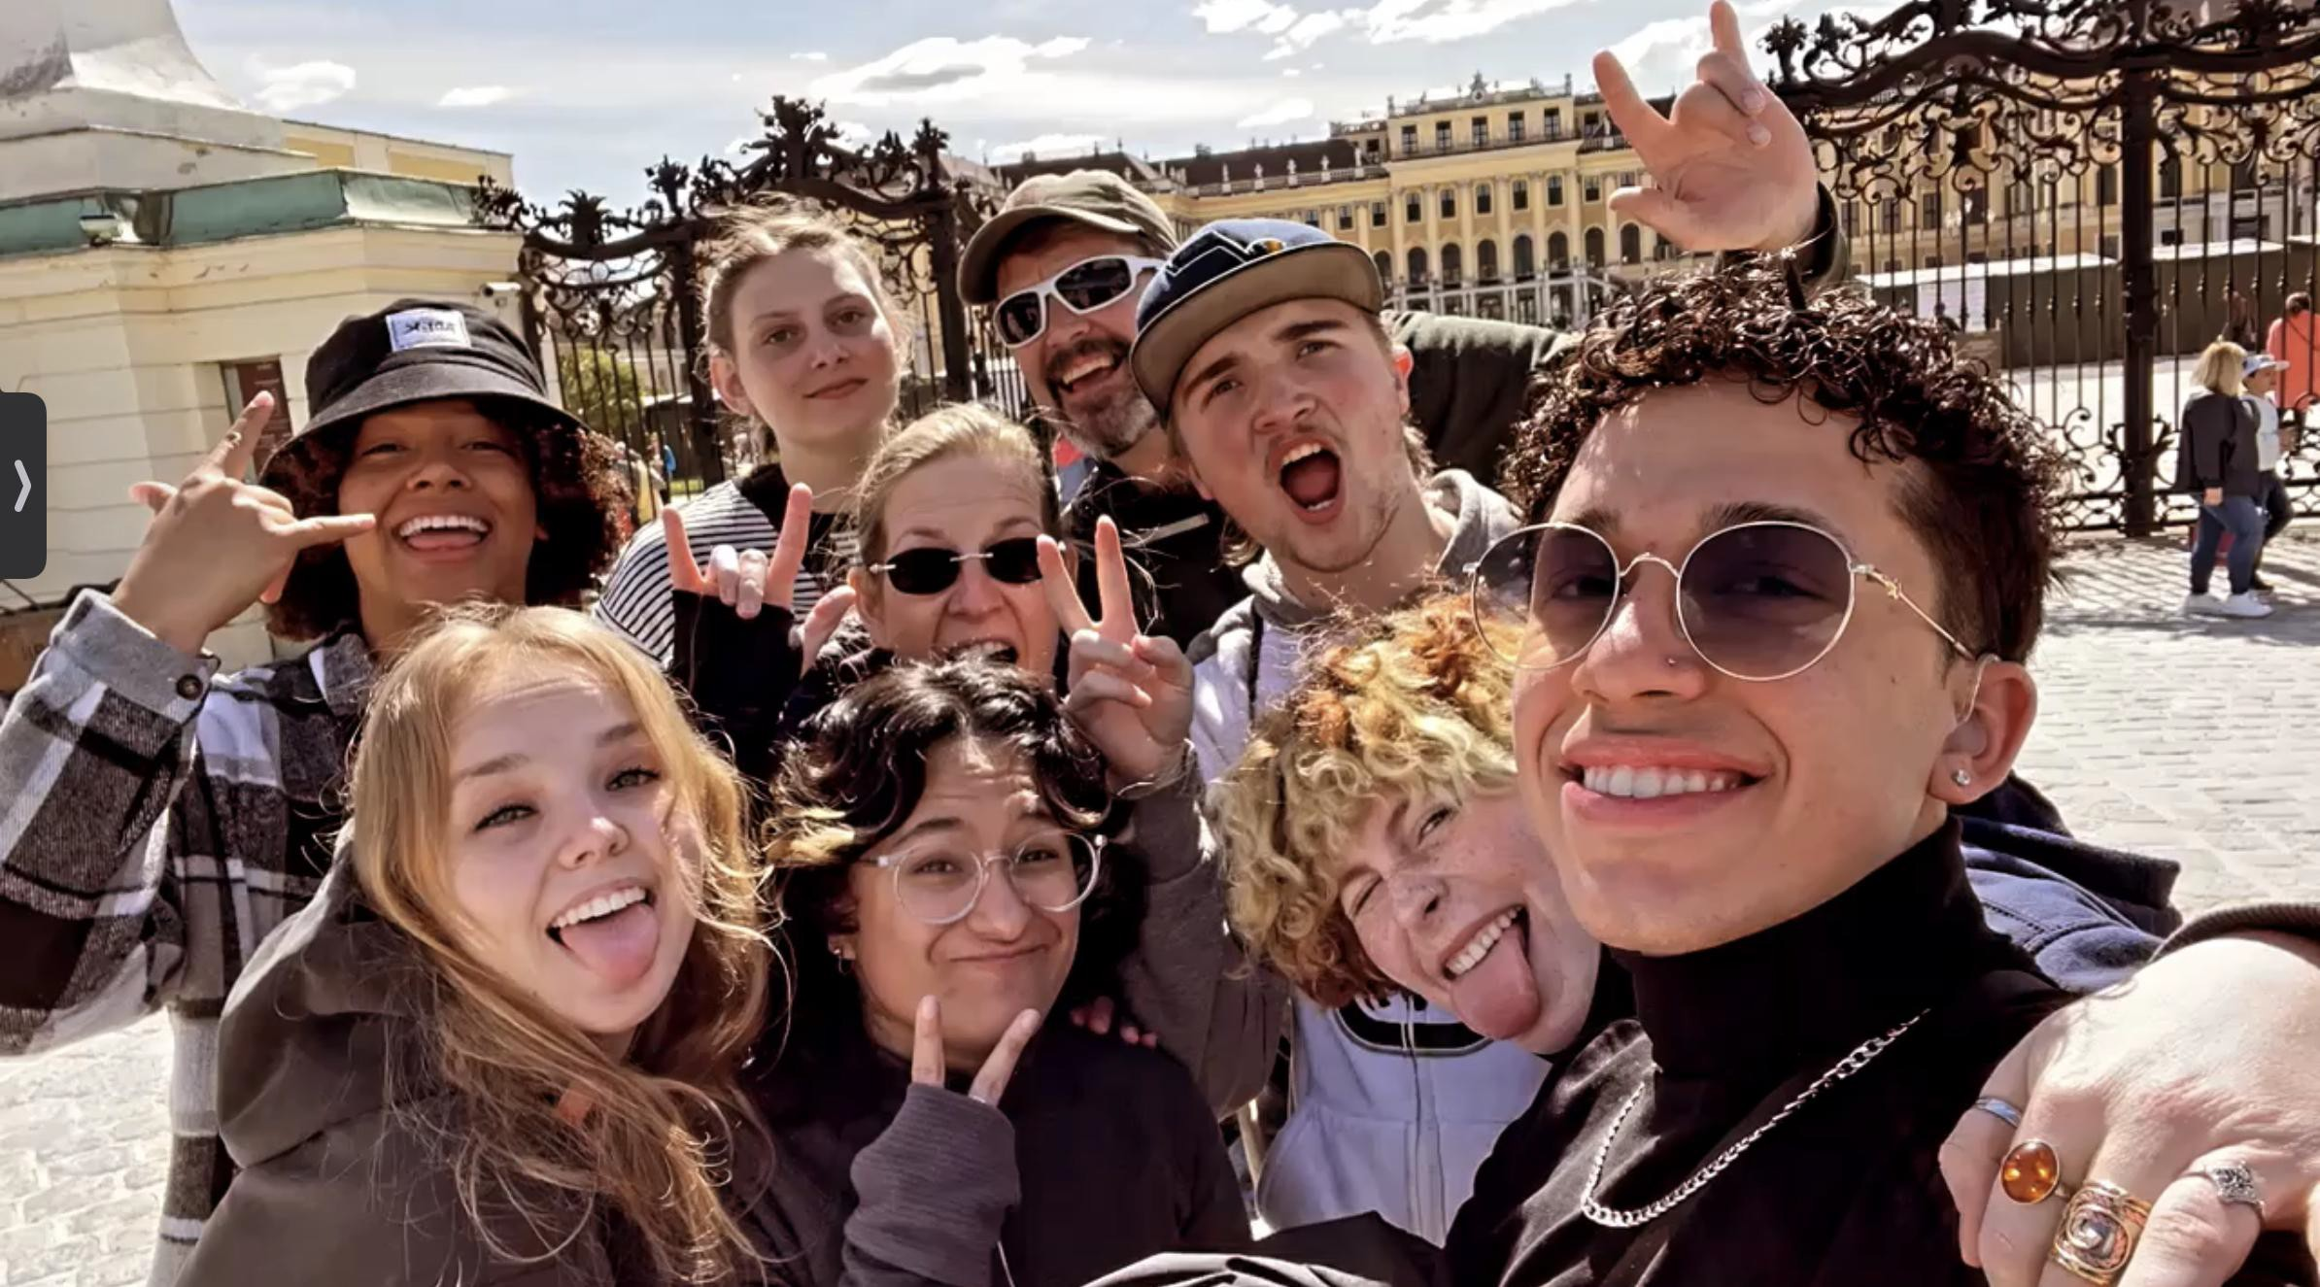
Brooklynn Anderson Margo Leichty Pablo Maya
Kaity Morrison Brayden Neil Mariyah Saldana Nadia Suarez

Our Guides Darren Frazier and Kilian Spillner

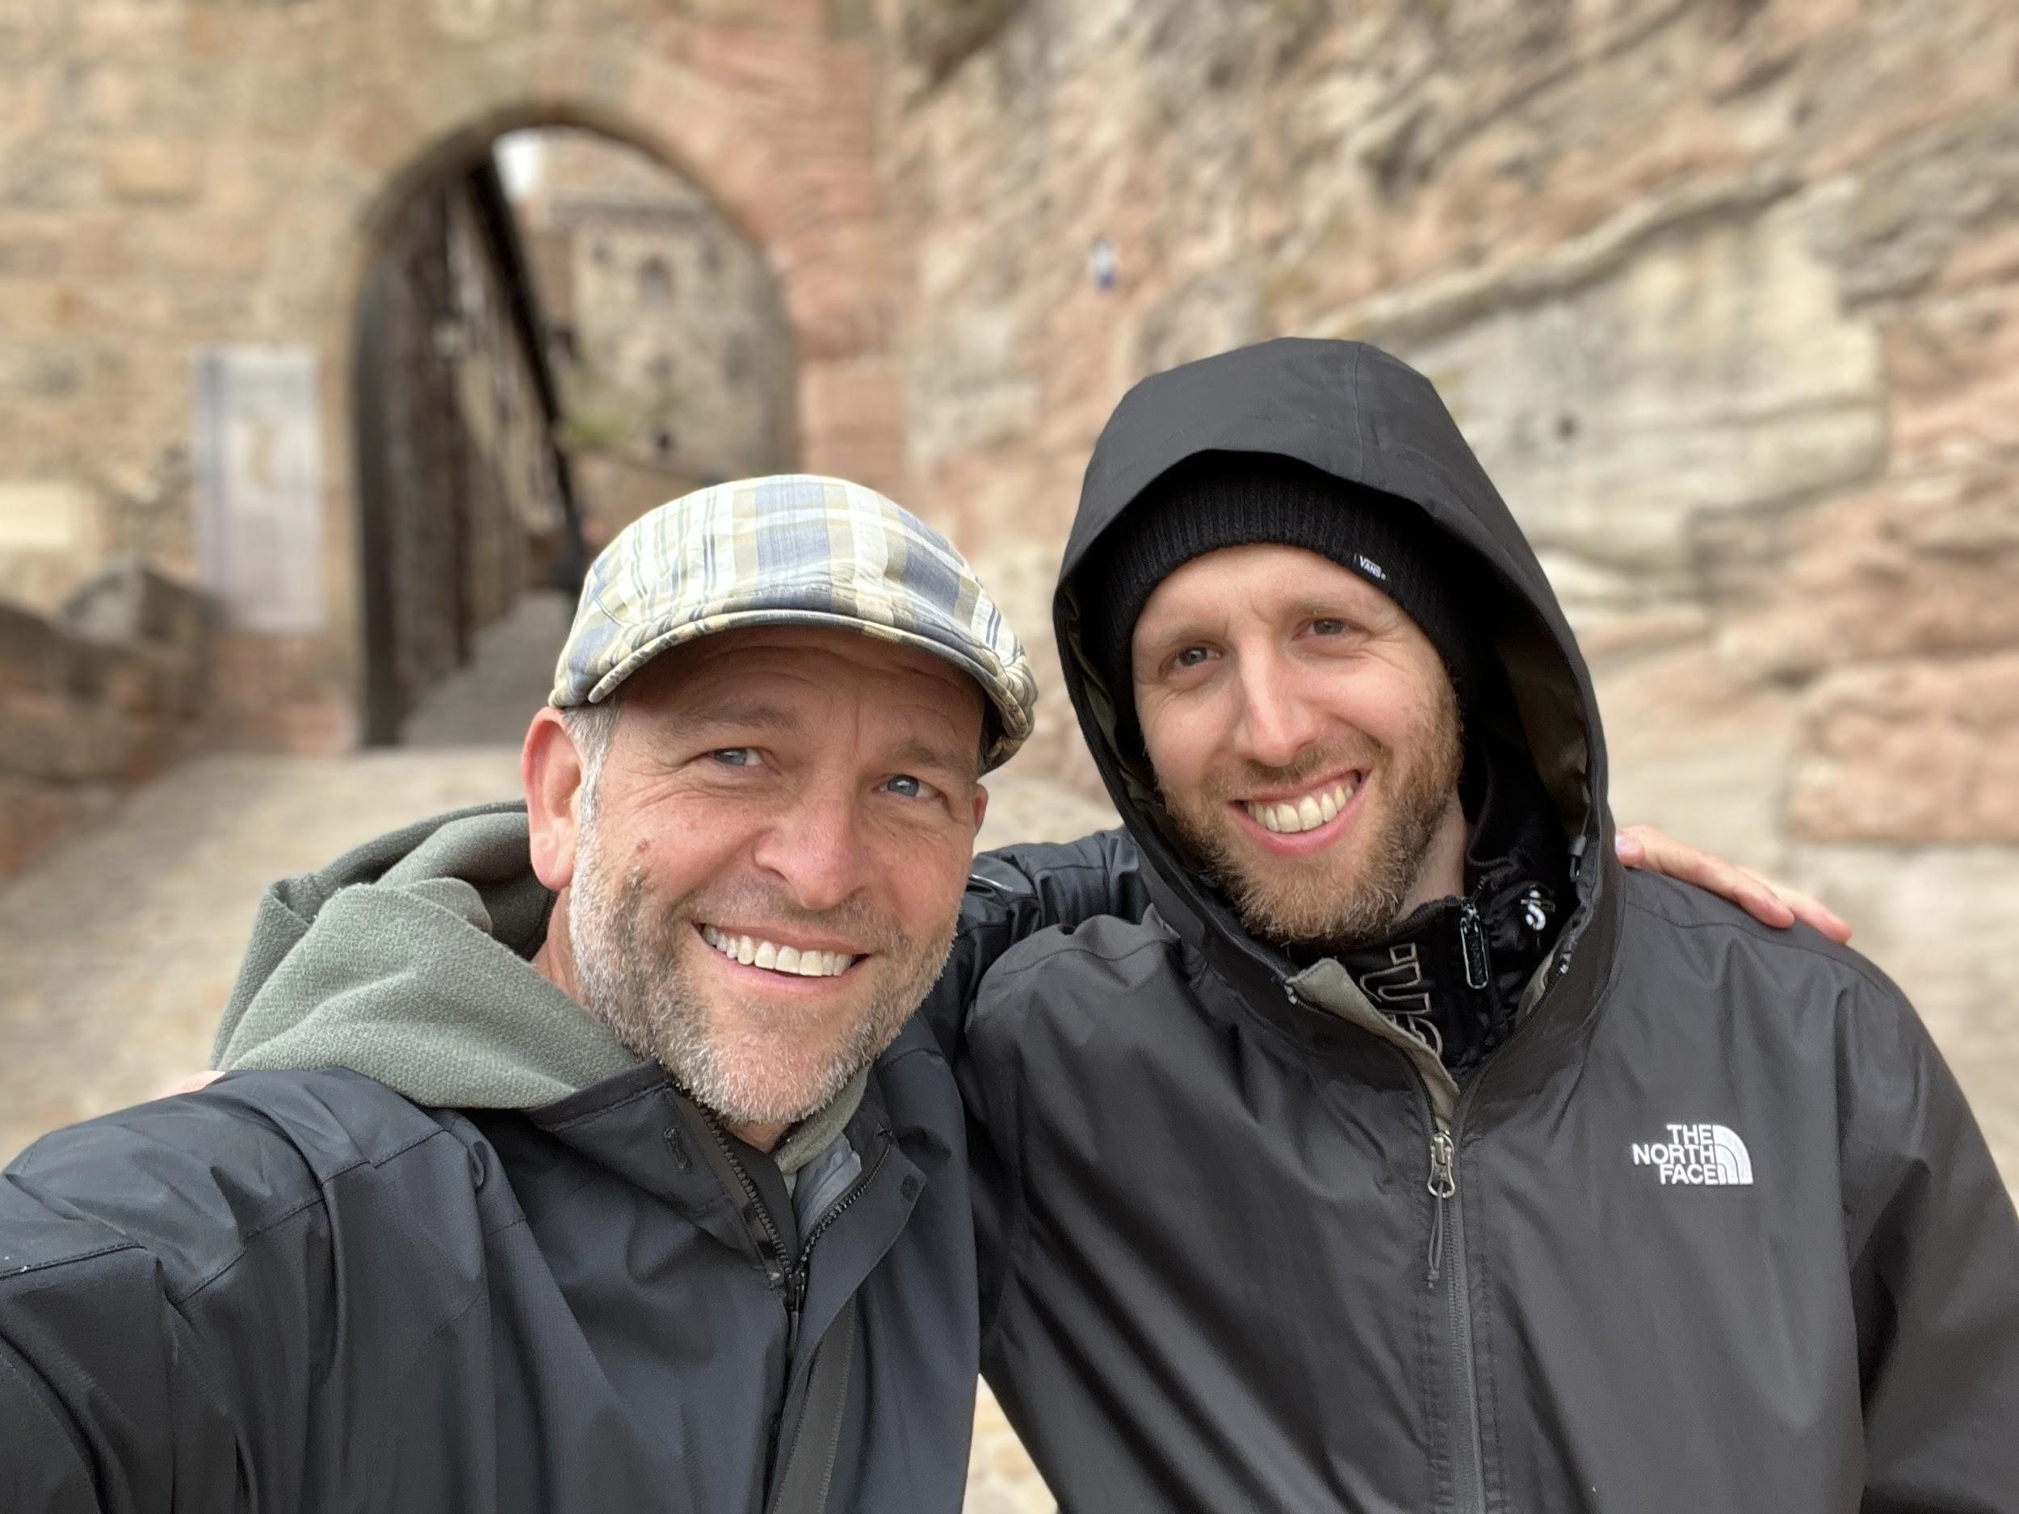
They both work for Hands on Travel.

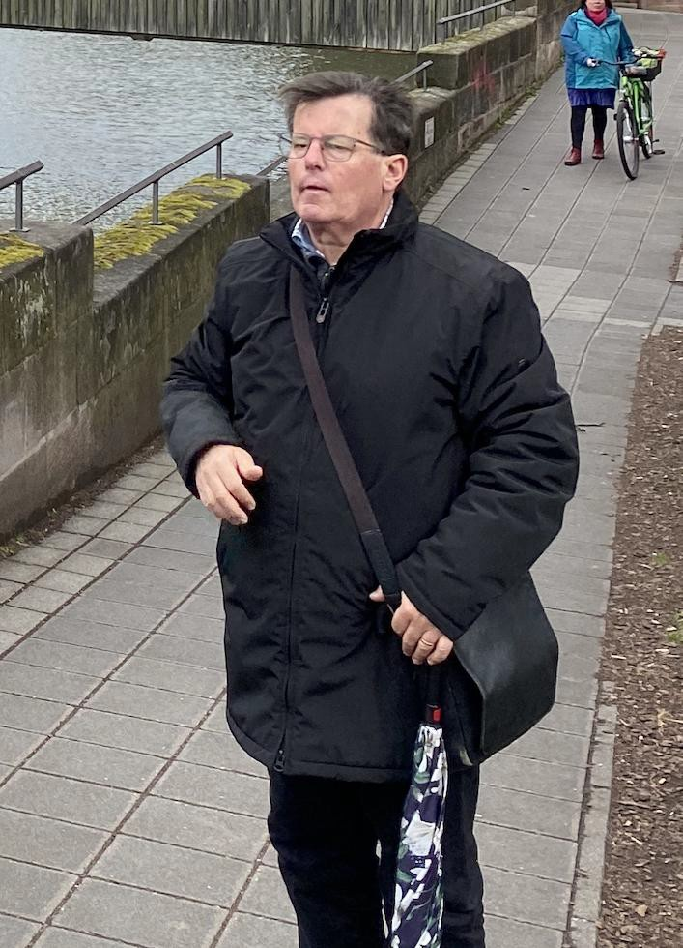
Guest Guides

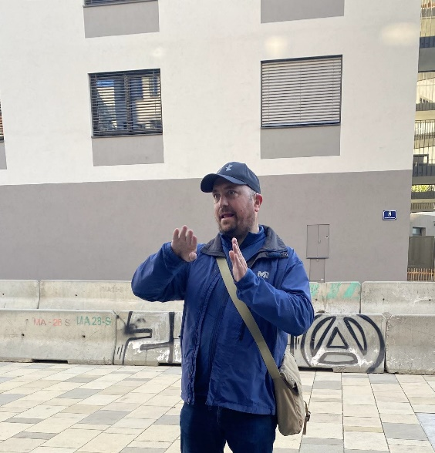
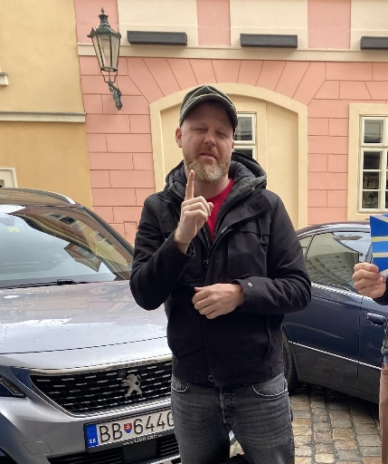
Nüremberg-

Dresden-
Prague-

Vienna- Klause

Day 0: Flying to Munich

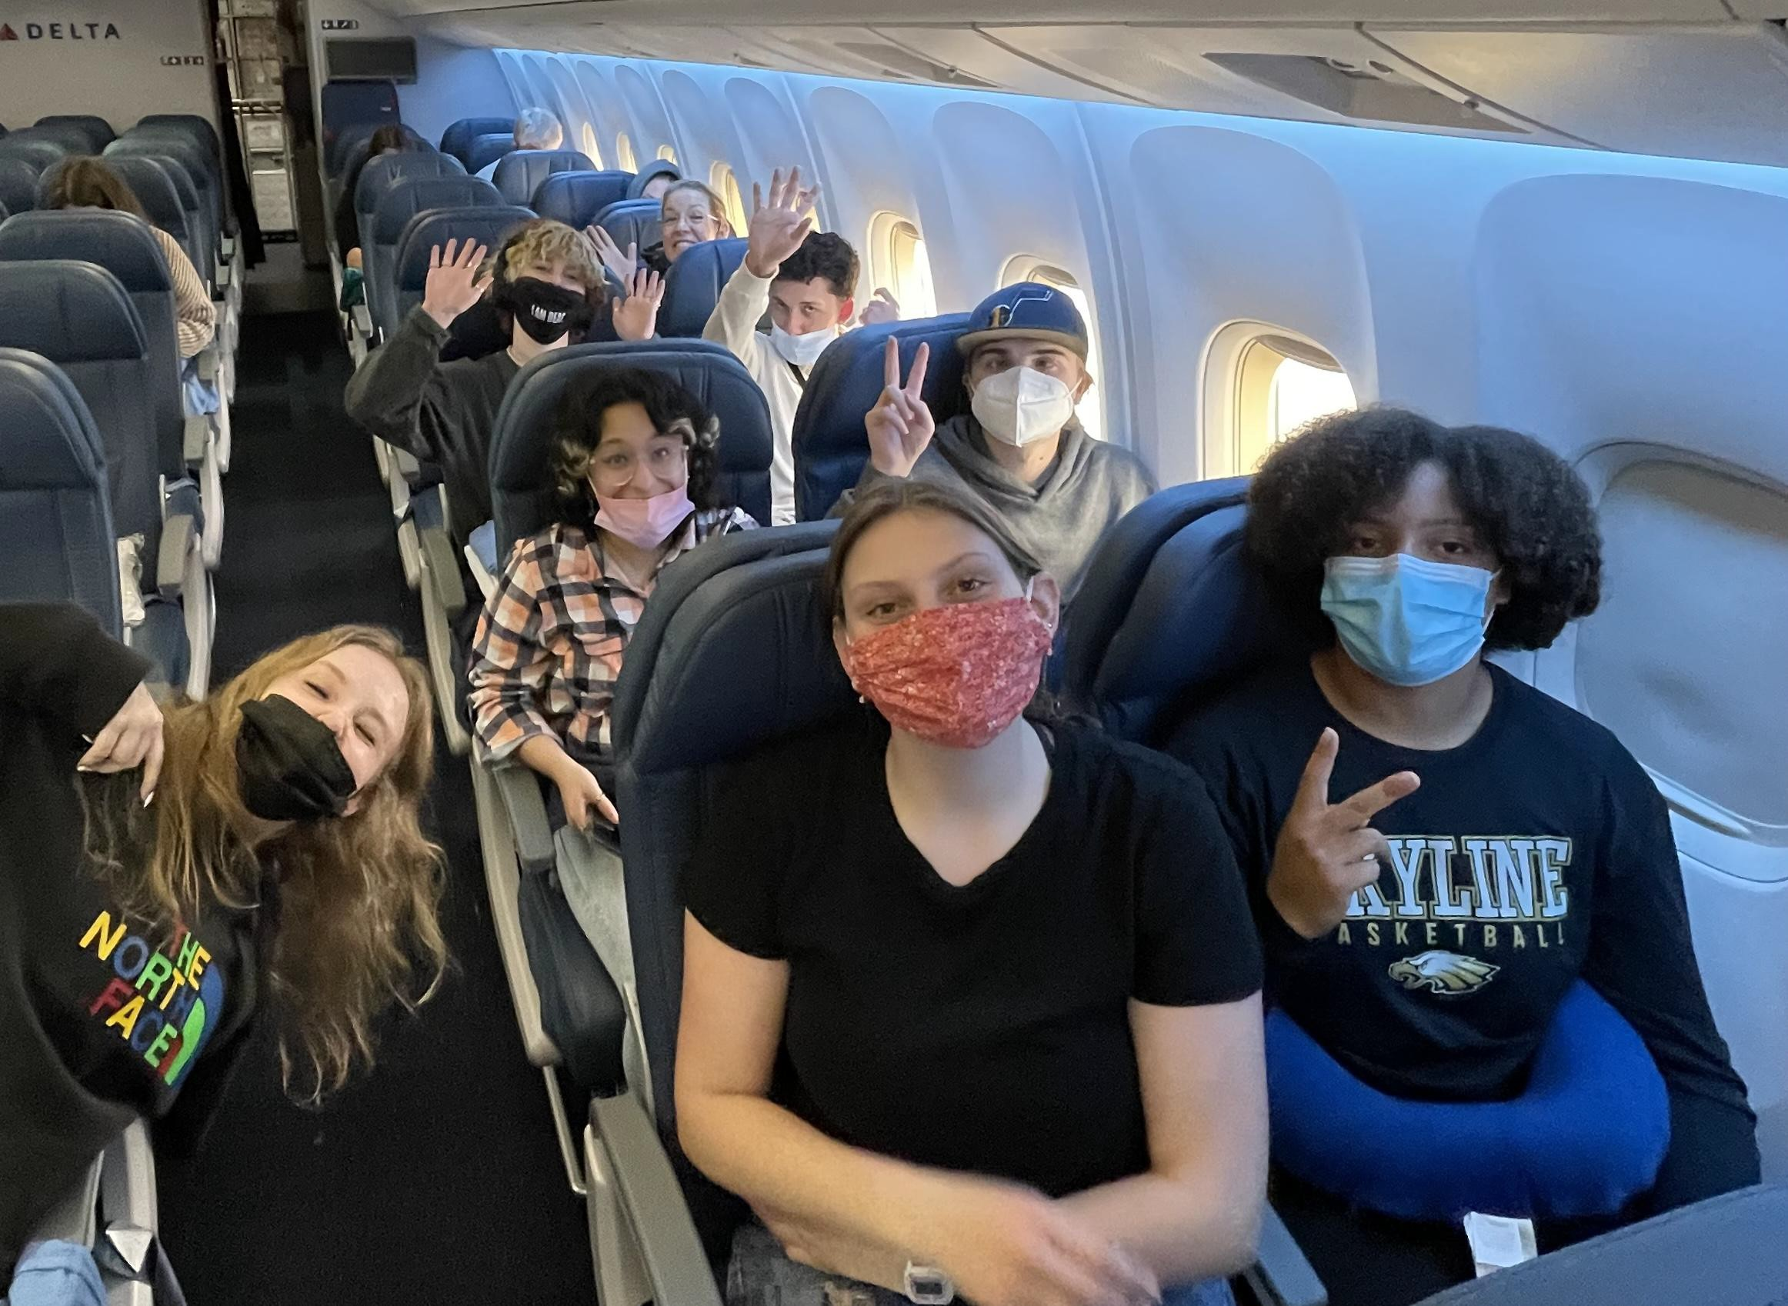
We were excited but we didn’t know what to expect!

Day One: Munich

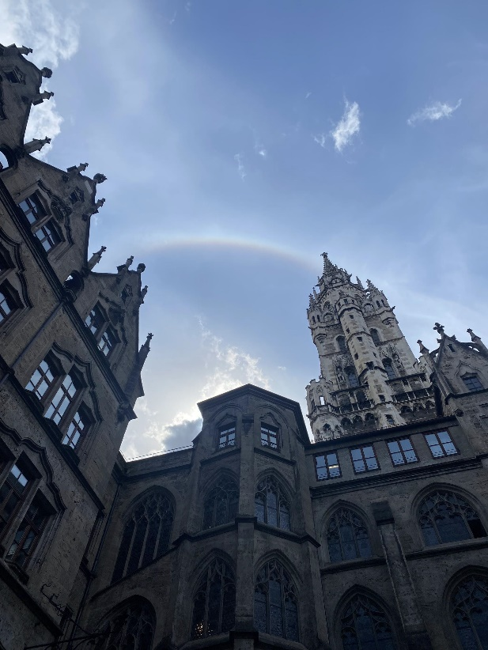
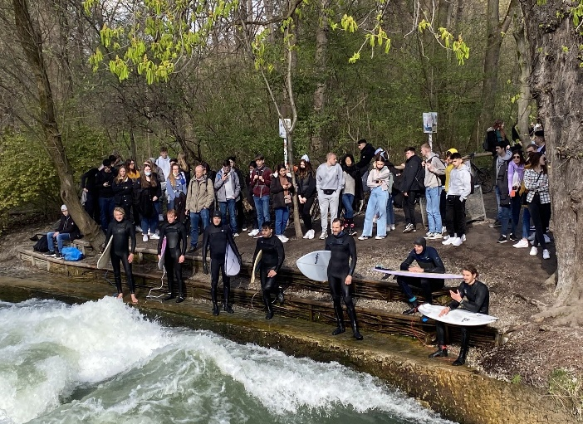
We started off the day at the Marienplatz. Later we went up 12 stories at St. Peter’s Church and saw a beautiful view of all of Munich.
In the afternoon we explored the other side of Munich and saw the Surfing River!

Day Two: Nüremburg

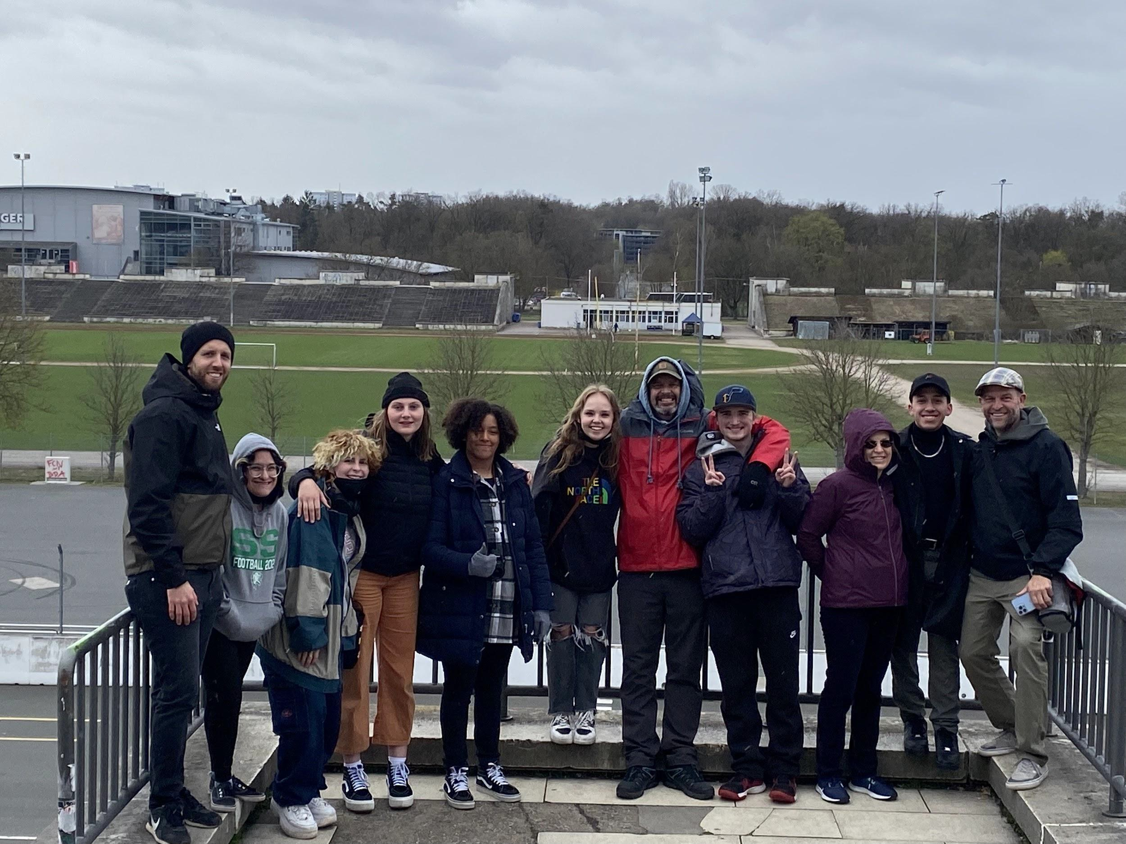
We saw the Nazi Party Rally Grounds and, learned a lot about the start of WW2 inside the museum.

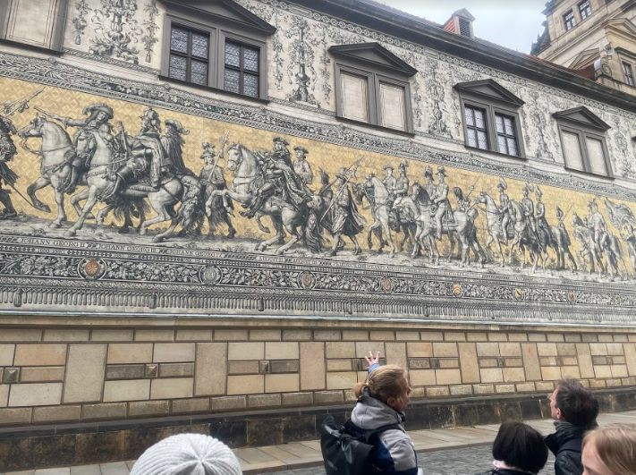
Day Three: Dresden
The 101 meters consist of 24,000 porcelain tiles from the German town of Meissen. The procession ends near the entrance to the Church of the Holy Trinity where so many of the men portrayed in this mural are buried. This is the world's largest porcelaine artwork and is quite a site to see.

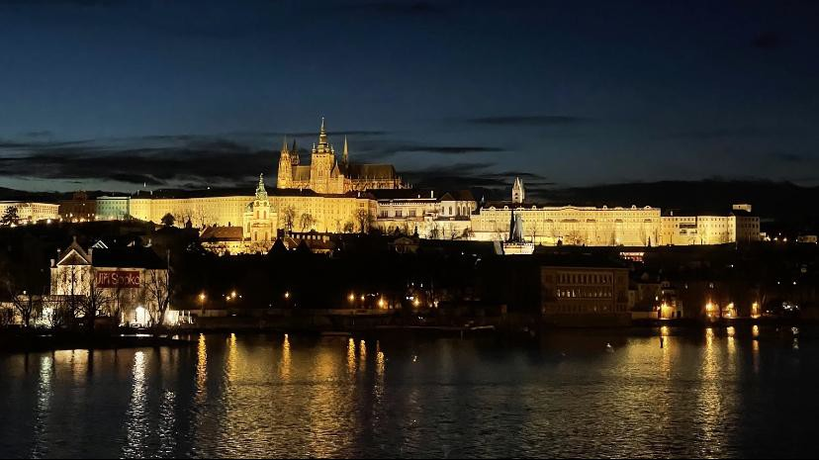
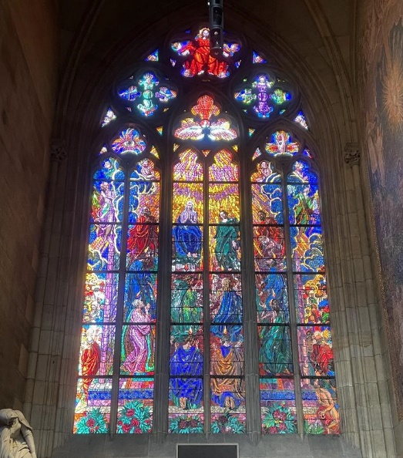

Day Four: Prague
It was a beautiful view of the night in Prague. We went to see the Prague castle and the inside was very beautiful. Also this castle was built in the late 9th century and
we learned the history about how the Prague castle became so famous. This was founded in 880 as a seat of power for the Bohemain Kings.

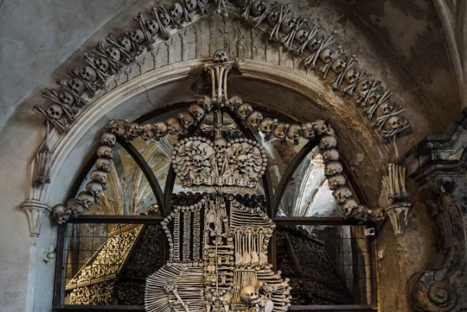
Day 5: Kutna Hora + Cesky Krumlov

The Cemetery Church (Ossuary) was a part of the oldest Cistercian monastery in Bohemia founded in 1142. During the Hussite wars there were about 10,000 dead buried in Sedlec. The major reconstruction of the monastery began in the Baroque period in the early 18th century. The bones were disinfected and bleached with chlorinated lime and placed in original patterns.

Day 6: Vienna

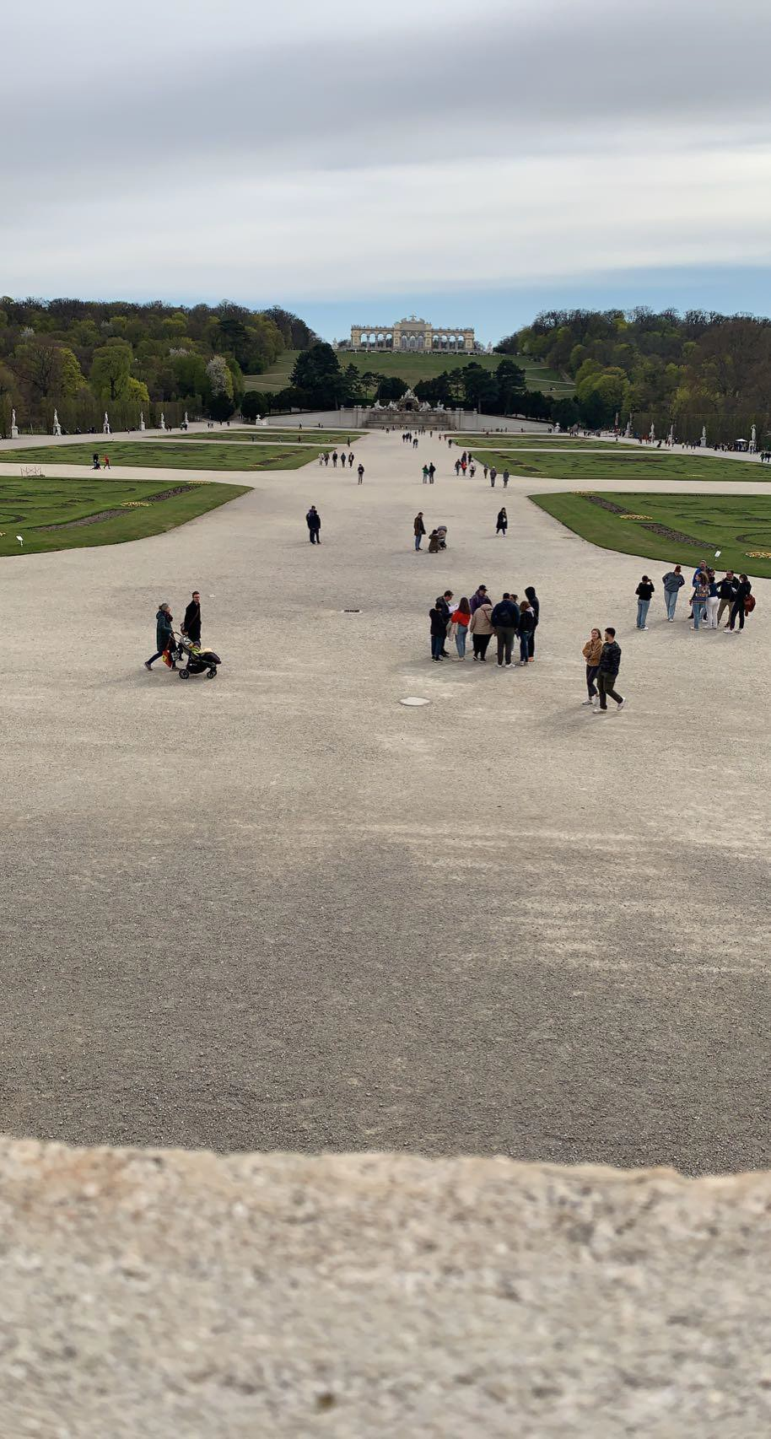
In the summer around the late 1700’s - 1800’s lots of people would come to eat and celebrate a war that was won.
In the winter during the same time period Maria Teresa, who loved her garden had very many children.

We visited the home of the Emperor and Empress, “Sisi.” She was very famous for her beauty and obsession with her weight. She had hair to her ankles and it took 3 hours to do her hair every day. That is when she learned other languages. She didn’t like being an empress. She love exercising and the outdoors.

Day 7: Hallstatt

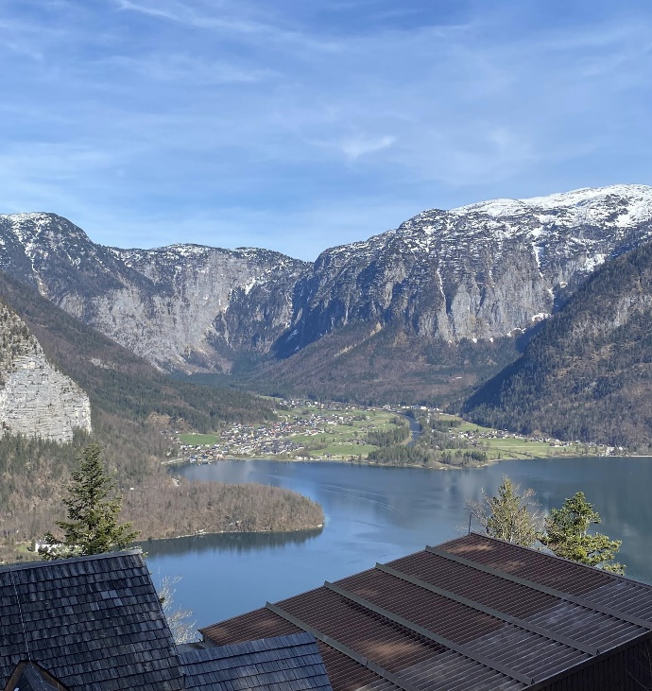
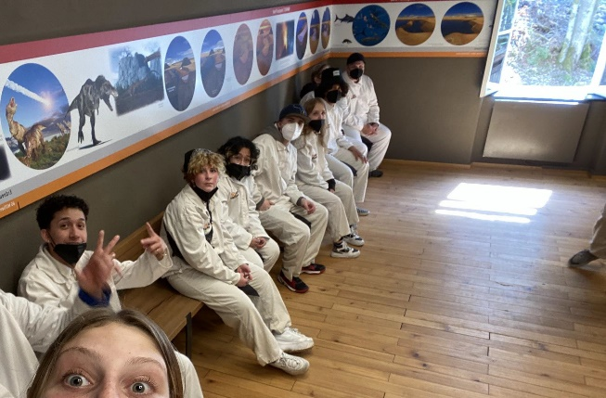
We spent the day at the Salzwelten, the world’s oldest salt mine! The beautiful town of Hallstatt is the area that inspired the movie “Frozen”.

We loved sliding in the mines!

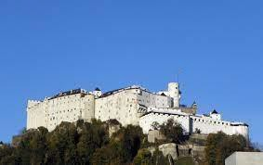
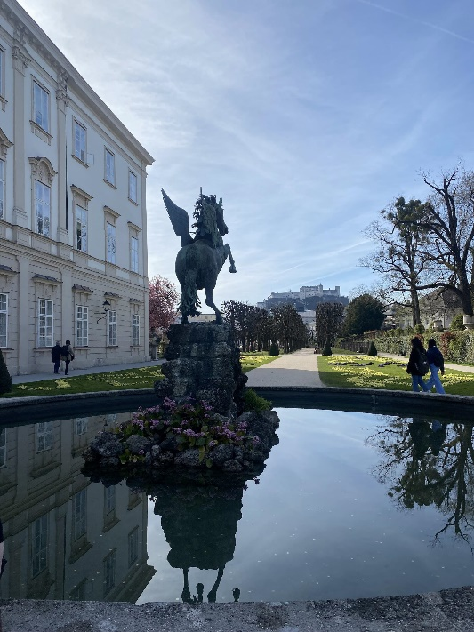

Day 8: Salzburg

- "The Sound of Music" was filmed at Schloss Leopoldskron in Austria. The palace’s Venetian Room served as a model for the ballroom scene in the film. It was also the backdrop for the private performance of the marionette theater.

- Fortress Hohensalzburg is one of the largest existing 11th century fortress complexes in Europe. The fortifications were built to protect the prince bishops and the principality from attack.

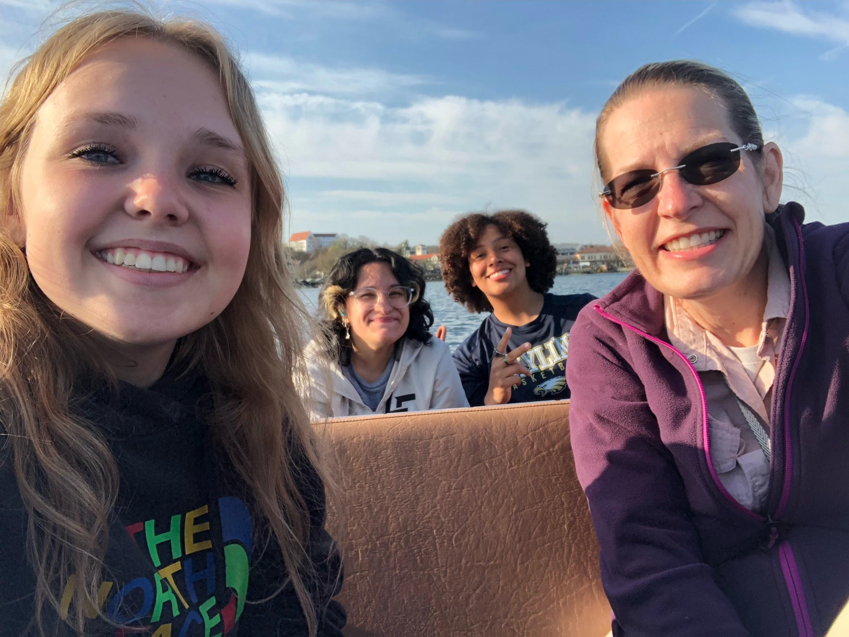
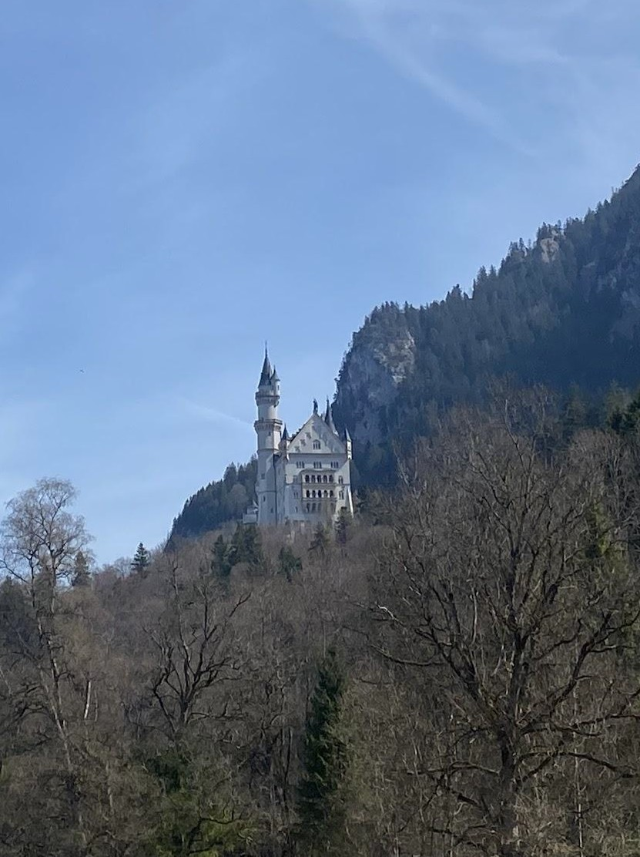
Day 9: Füssen

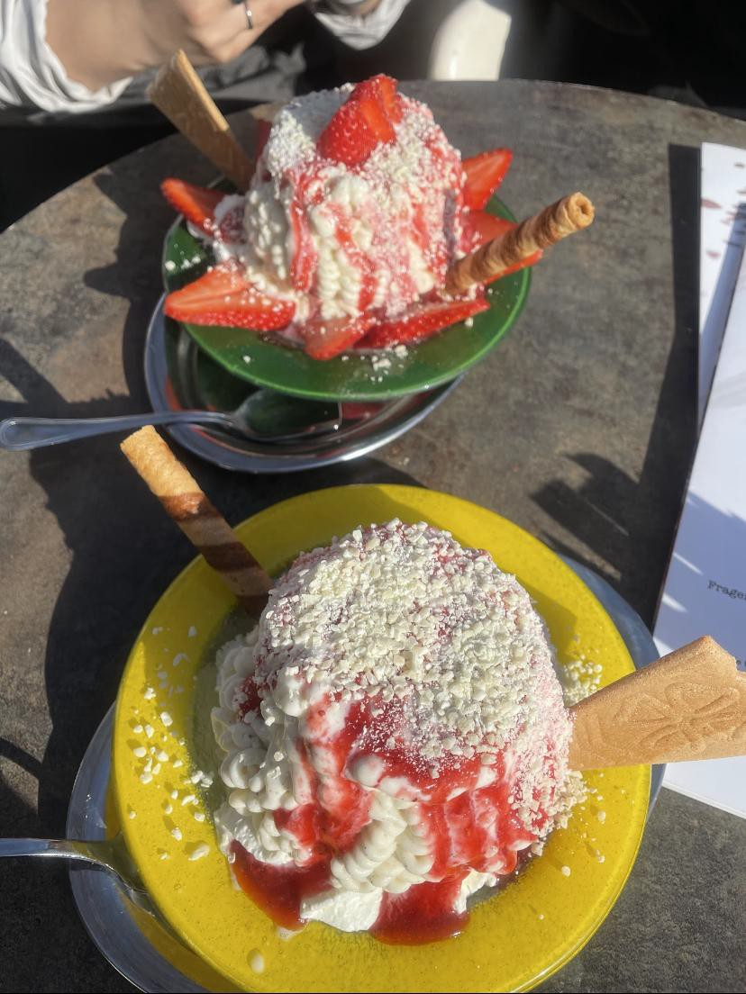
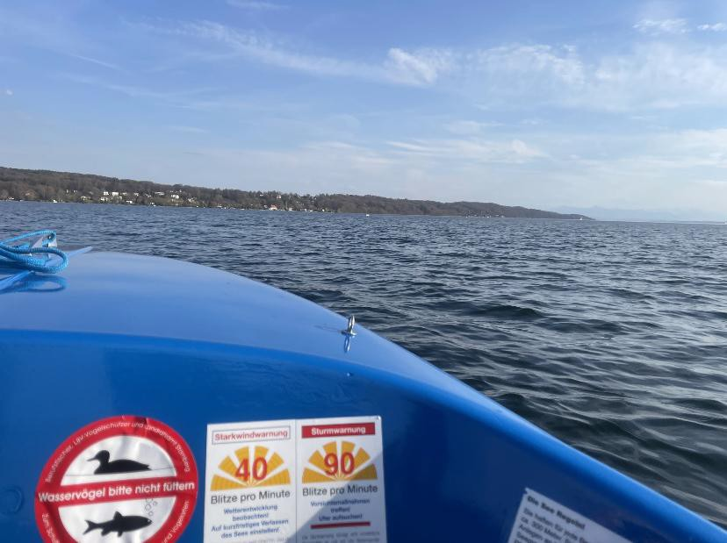
We ordered gelato with strawberry, but it looked like real spaghetti and sauce. It was really good. Then we went drove a boat. It was a fun to ride in a boat. We went to the Neuschwanstein Castle tour and it looked like the sleeping beauty castle from the 1959 movie.

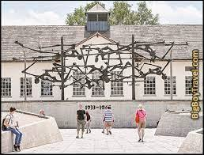
Day 10: Munich

We visited Dachau the last day. This was the prototype of Nazi concentration camps. At least 160,000 prisoners passed through the main camp, and 90,000 through the branches. Incomplete records indicate that at least 32,000 of the inmates died there from disease, malnutrition, physical oppression.

Dachau was one of the most notorious Nazi concentration camps. It was in operation from the beginning of the war until the end. During World War II, inmates were used as involuntary guinea pigs for experiments.

Day 11: Time to Go Home!

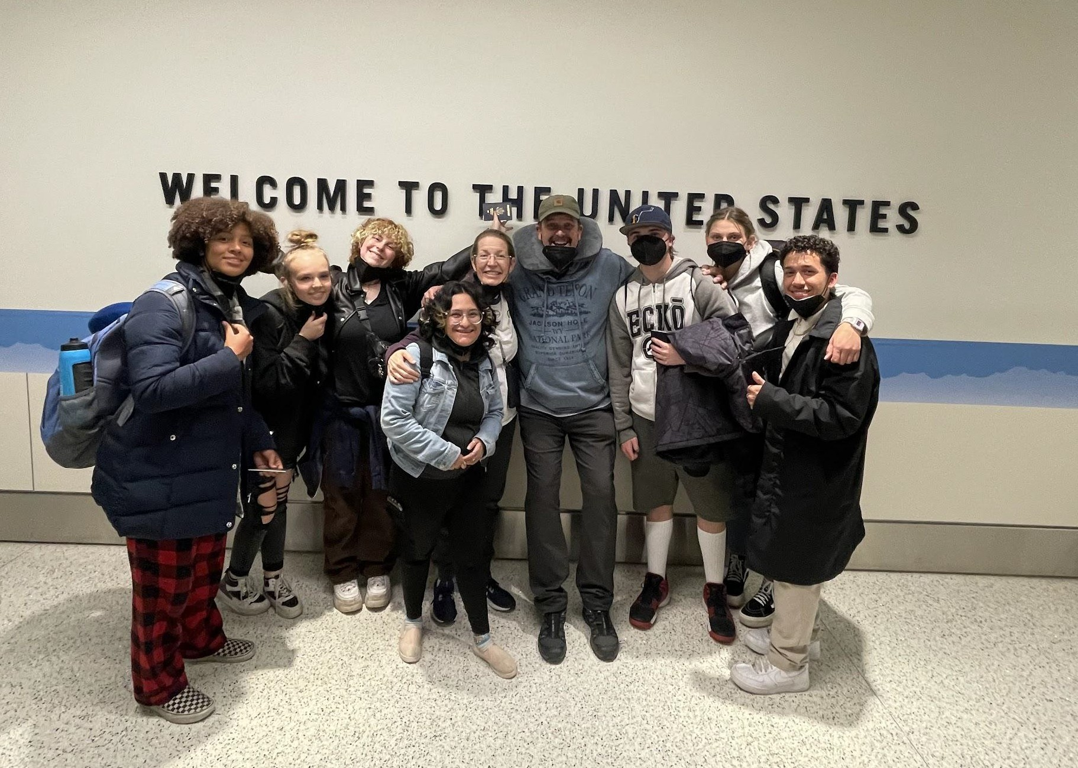
We were happy and sad to come home. We had a great time and learned A LOT!

Signs We Learned: Countries & Cities

Europe
Germany (Munich - München, Dresden, Nürnberg, Berlin, Füssen...) Czech (Prague, Cesky Krumlov)
Austria (Vienna, Salzburg Poland
Cambodia Finland

German Signs We Learned

Want
Thank you very much SCH
ß God Yes
School Euro Jewish
Bathroom - Water Closet

Czech Signs We Learned

Mother Water Peace Beautiful Bury Center/City

Universal Signs We Learned

Explain Have Normal
Person/people
Numbers (Example: 1965, 1482… ) Deaf

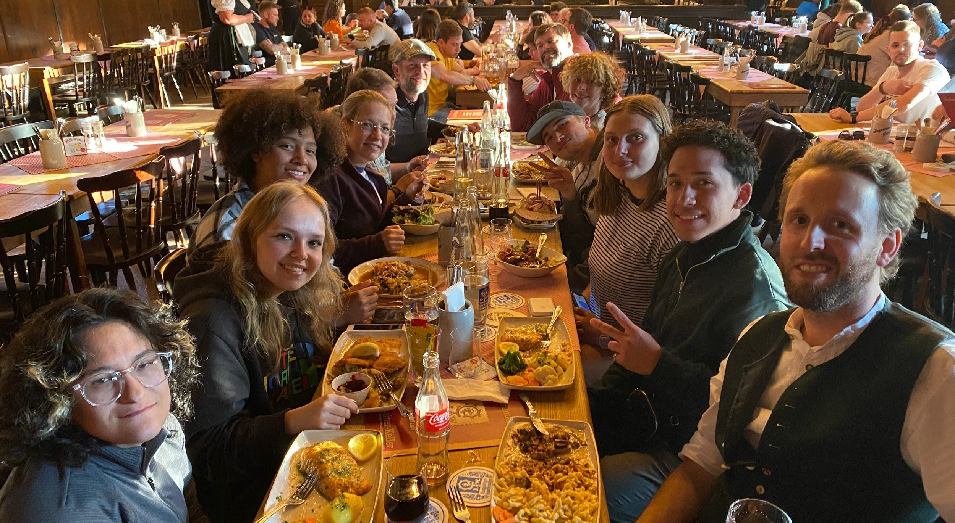
Food

Authentic German food at Augustiner-Keller for our Farewell dinner.

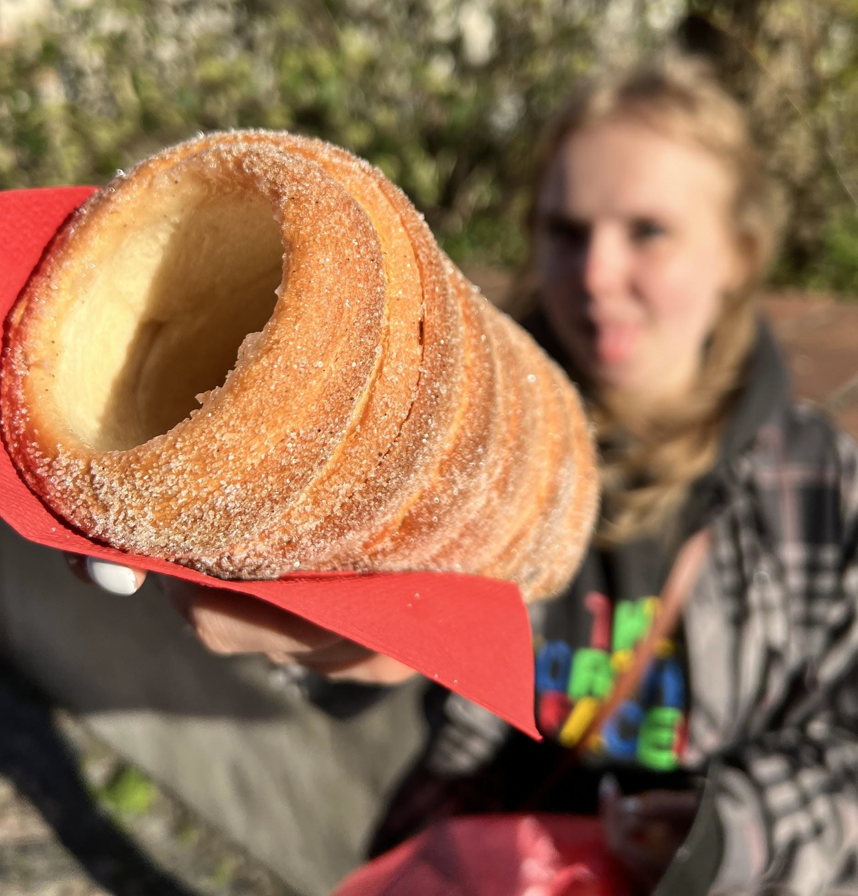
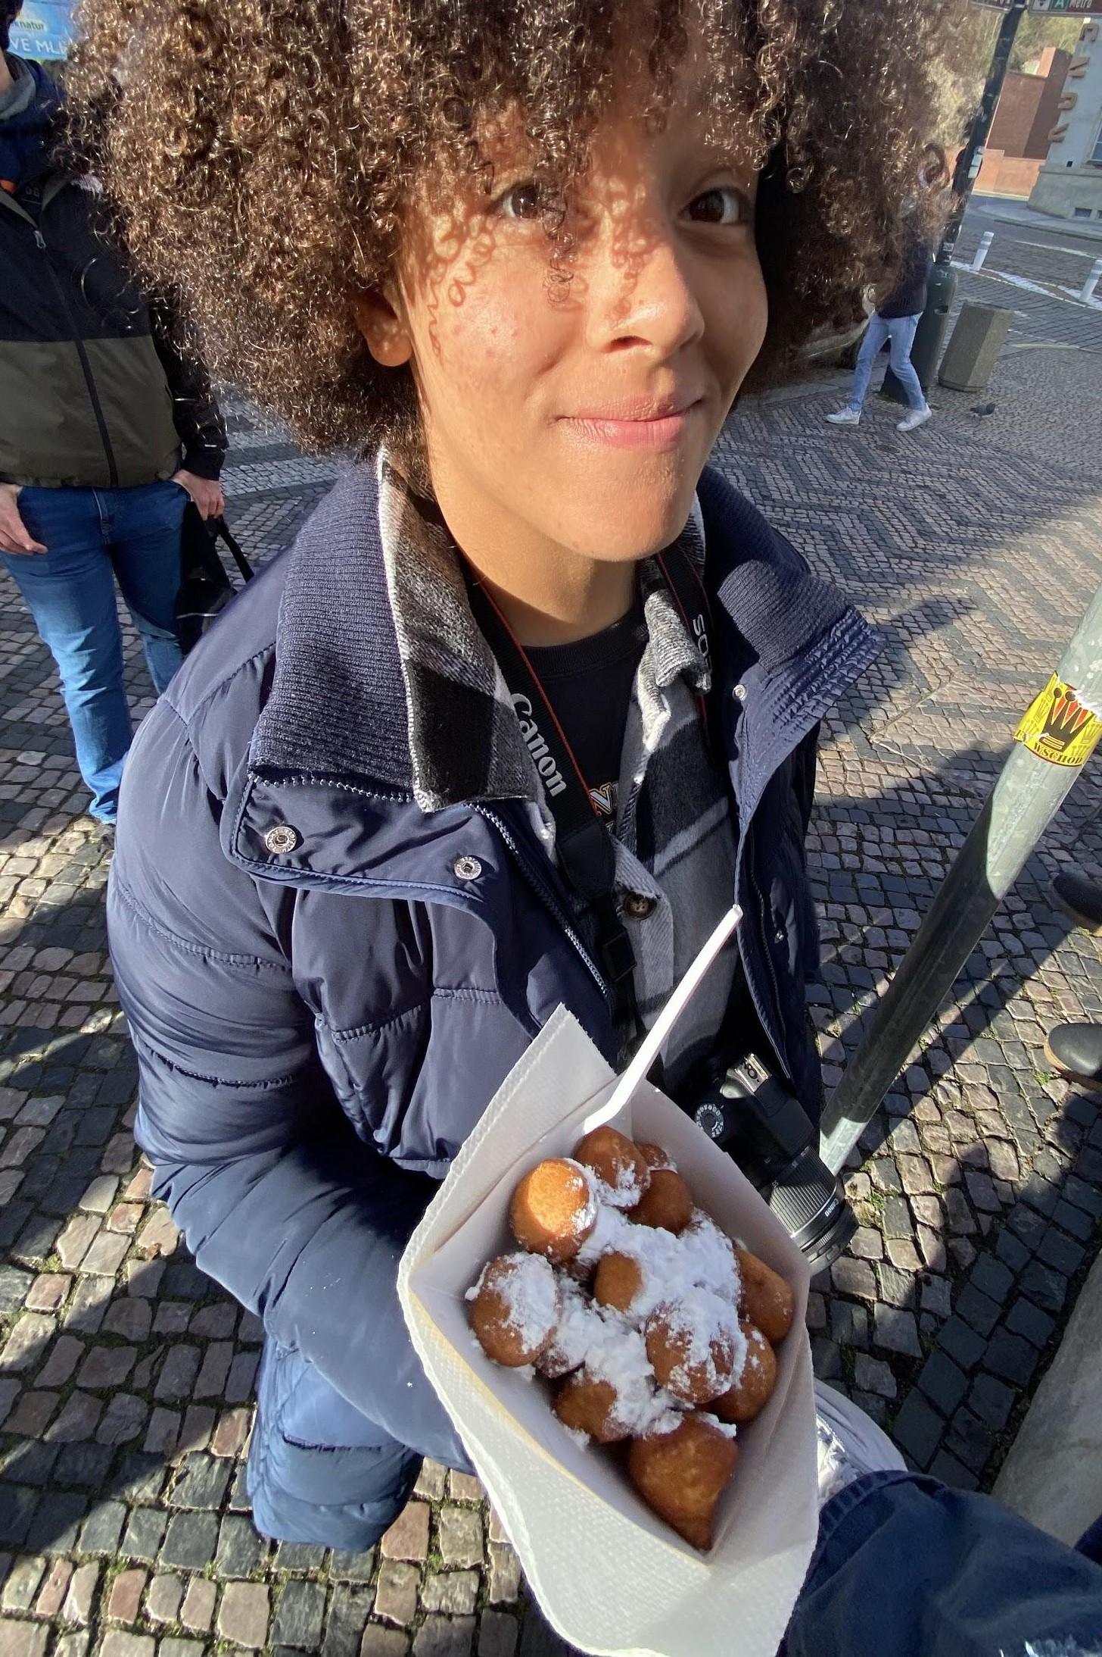
Always had to stop for the Fresh Pastries at the markets.

Building Differences

Toilets Bathrooms Plugs Doors
Light switches

Gas Prices

Since they use the Metric System in Europe the gas was per Liter. That's about 4x as expensive as it would be in America even though it was only 2 or 3€.

Danke!
Questions?

Online Content Development
2021-2022

Mission and Goals

Create elementary content for Deaf and Hard of Hearing Students K-6.
  - Make it accessible

Make it easy to access
  - Make it stand alone as a class

Current Status on Courses

Content to be Piloted
ASL
Kindergarten - Currently piloted at JMS 1st Grade -
2nd Grade - LA, Science, Social Studies 3rd Grade - LA and Science
4th Grade - Math
5th Grade- Math, Science, Social Studies
Content Not Completed
2nd Grade - Voice Overs and Math 3rd Grade - Math and Social Studies
4th Grade - Social Studies and Science and Math Voice Overs
5th Grade - English Partial course 6th Grade - Entire Course

Next Steps
- Align Content to Schoology
- Share Completed Content

Complete Missing Subjects

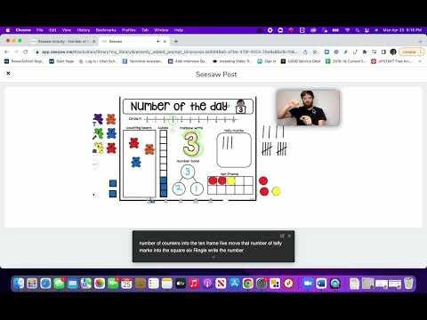
Examples of Content
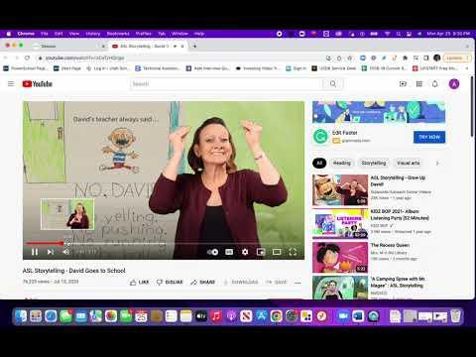
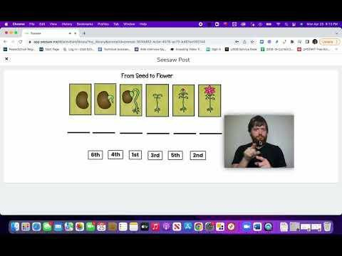

Lessons Learned

- Just Do It
- Use What You Have
- Be Clear About Expectations with Developers
- Implement Content Early


Utah School for the Blind
Bridges Programs

Bridges High School Bridges Residential Life
Bridges Employment Pathway Bridges Access Pathway

Bridges Community Readiness
Preparatiion now.. Success for lliife..

Learn more about the Expanded Core here

Personalized Learning

Utah Core Standards
Portrait of a Graduate

Expanded Core Curriculum

Learn more about Bridges here

The Bridges programs are for students in grades 9th through post high school. Each of these programs are designed to provide individualized instruction to give students the tools and skills they need to successfully transition to the next step in life.
We accomplish our goals by

Monthly teacher PD, collaboration to support 21st century teaching
Student- centered planning with Futures Meetings

Individual Residential Plan

Community based instruction, mentoring & experiences
Competency based learning

Utah School for the Blind Bridges Programs:

Bridges High School Bridges Residential Life
Bridges Community Readiness Bridges Employment Pathway Bridges Access Pathway

Banner graphic that reads: Preparation now. Success for life.

A pie chart graphic that illustrates that half of a Bridges student’s academic needs are based on the Utah core standards. The other half is broken into three equal parts with each part representing: Utah Portrait of a Graduate, the Expanded Core Curriculum and Personalized learning.

There are two graphics that have links:
Graphic 1: Learn more about the Expanded Core here Graphic 2: Learn more about the Bridges Programs here

The Bridges programs are for students in grades 9th through post high school. Each of these programs are designed to provide individualized instruction to give students the tools and skills they need to successfully transition to the next step in life.

We accomplish this by:
Monthly teacher PD, collaboration to support 21st century teaching Student-centered planning with Futures Meetings
Individual Residential Plan Competency based learning
Community based instruction, mentoring & experiences

Utah School for the Deaf Portrait of a Graduate: A roadmap to D.E.A.F.
success
Dr. Tanner & Dr. Harrison

What does graduation mean?

Graduation usually means:

Passing HS classes
  - Meeting the state requirements

Getting a diploma
  - Becoming a legal adult

But… shouldn’t it mean:

Knowing what you want to do with your life
  - Setting goals and working towards them

Having interpersonal skills
  - Being motivated, respectful, and curious

i.e. being ready for life after school

COMMUNITY

COLLEGE

CAREER

Portrait of a Graduate
  - Encourages holistic thinking about students

  - Focuses on essential:
    - Knowledge
    - Skills
    - Attributes
  - Document that guides:
    - Culture
    - Pedagogy
    - Purpose
  - Changes graduation from “4 years in HS seats” to “12+ years
of preparation for the future”

Creating a Portrait

We began with focus groups of administrators and some teachers.

Focus Groups
We did focus groups with educators across all campuses - using the Post-It Note Protocol.

Educator Groups

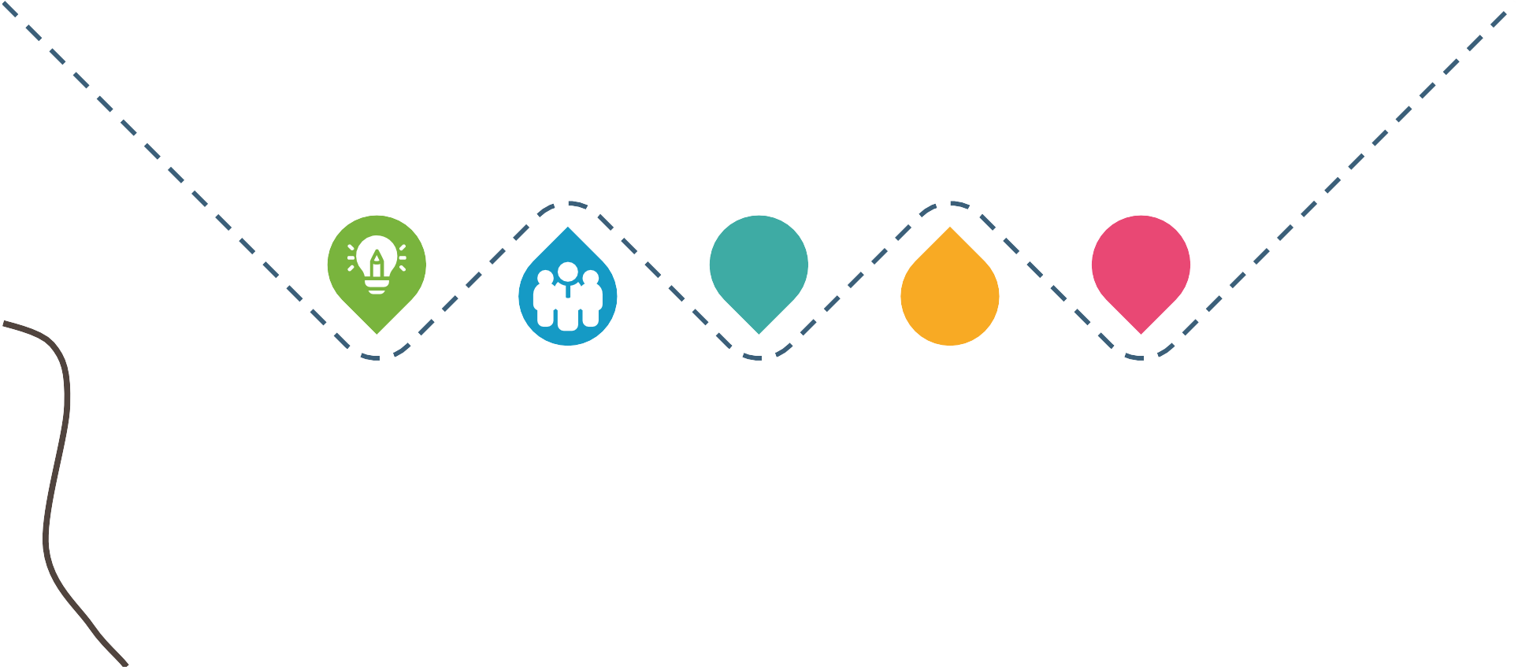



Initial Vision
Based on nationwide trends, we had an initial vision of wanting a Portrait.

State
Involvement
We became involved in the state of Utah’s efforts to create a statewide Portrait of a Graduate.

Training &
Feedback
We sought feedback from teachers, related services, interpreters, and other school staff. Participated in PoG trainings.

Our Next Steps

PIP to Post-High Alignment
Use the portrait to unite vision and approach from PIP to high school, campus to outreach, LSL to ASL/English.

Increase our focus on student outcomes, holistic development, and true-readiness for graduation.

Student-Outcome
Focused

Community Feedback
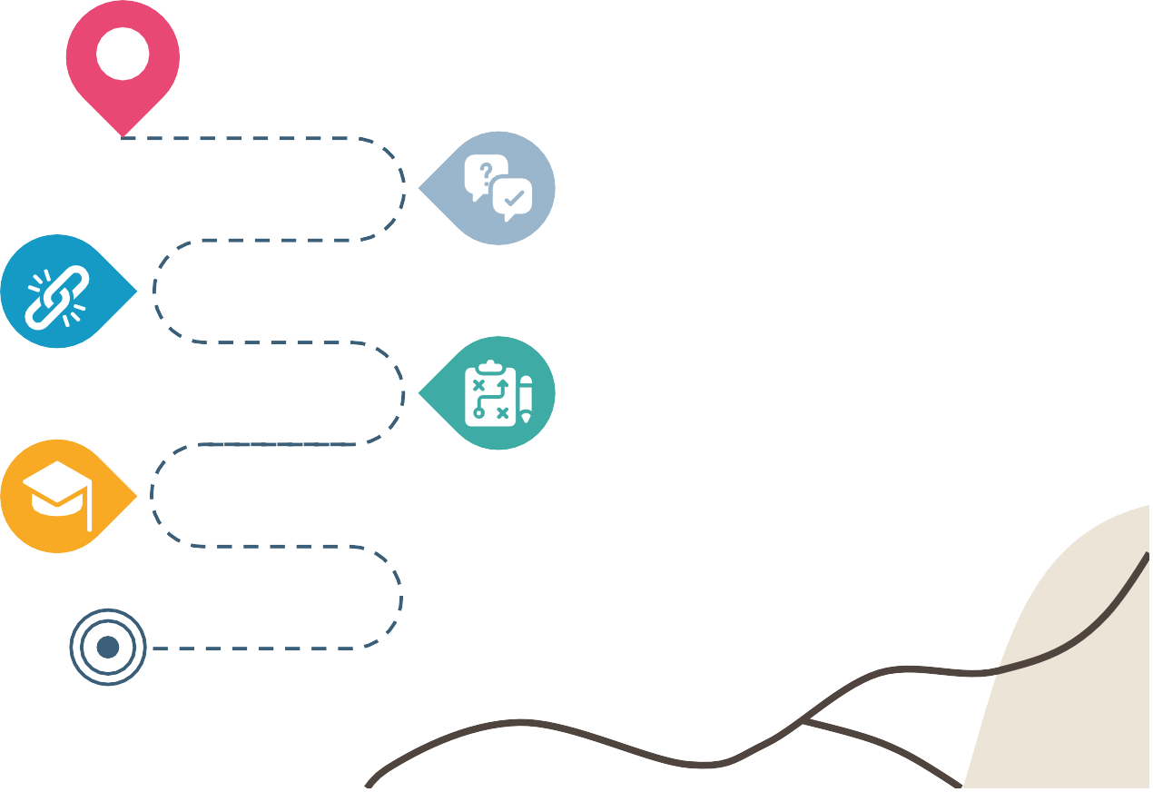
Seek feedback from parents, stakeholders, and Deaf
communities.

This can’t just be a paper or a buzzword, we have to make everything applicable to our
educators.
Practice Applicability

How Does the Portrait Help USD Educators?

Culture Shift
Our settings should be infused with the holistic elements of the Portrait and focus on best practices.
Common Language

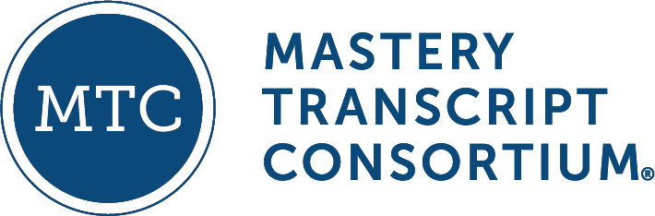
Whether outreach or campus, PIP or high school, LSL or ASL/English - common terminology & vision connects us.

Student-Centered
Teaching and learning isn’t about this year - it’s about a student’s future life.

One For All
No educator works in isolation - we all have a shared goal.

USD’s Portrait of a D.E.A.F. Graduate


Deaf Identity
Deaf Identity leads a person to communicate powerfully, advocate boldly, and contribute to their communities.

Autonomy
Autonomy is having the self- confidence to think and act independently while also engaging in meaningful interactions with others.

Excellence
Excellence is the ability to demonstrate depth of knowledge and skill proficiency in key areas of
learning.

Foundations for Life
Foundations for life guide life decisions, influence behavior, shape goals, offer a sense of direction, and
create meaning.


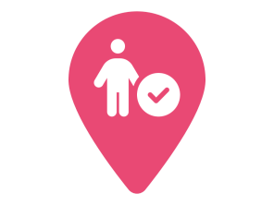
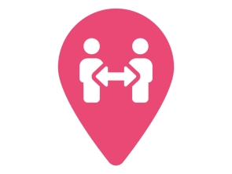

Deaf Identity

 | Pathways to Deaf Identity
Communication | ASL Literacy | Deafhood | Self-Determination





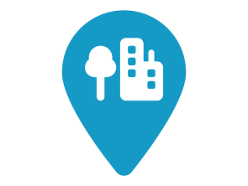
Excellence

 | Pathways to Excellence
Academic  Mastery | Civic & Community Literacy | Financial  Literacy | Digital  Literacy







Autonomy

 | Pathways to Autonomy
Wellness | Critical Thinking & Problem Solving | Creativity & Innovation | Collaboration & Teamwork
Curiosity



Foundations for Life
 | Pathways to Foundations
Honesty, Integrity, & Responsibility | Hard Work & Resiliency | Lifelong Learning & Personal Growth | Service
Respect & Empathy

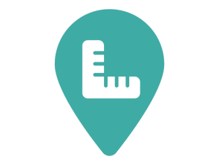





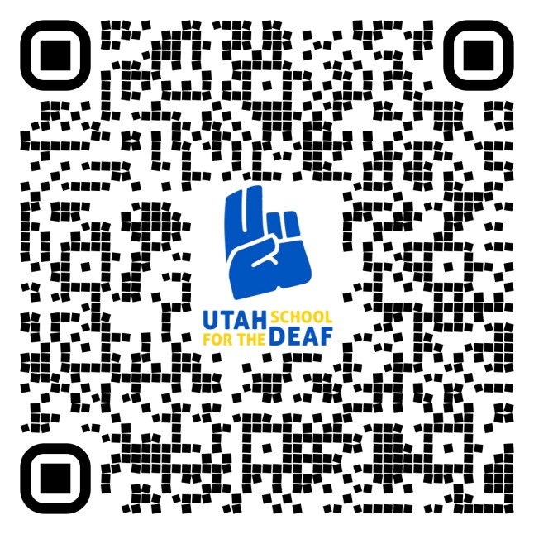
Utah’s Portrait of a Graduate
y
QR c
he
ode re
bit.l
????
https://bit.ly/USDPoG

Utah School for the Deaf Portrait of a Graduate:
A Roadmap for D.E.A.F. Success

Deaf Identity
Deaf Identity leads a person to communicate powerfully, advocate boldly, and contribute to their communities.

Autonomy
Autonomy is having the
self-conﬁdence to think and act independently while also engaging in meaningful interactions with others.

Excellence
Excellence is the ability to demonstrate depth of knowledge and skill proﬁciency in key areas of learning.

Foundations for Life
Foundations for life guide life decisions, inﬂuence behavior, shape goals, offer a sense of direction, and create meaning.

Deaf Identity
Communication ASL Literacy Deafhood Self-Determination

Excellence
Academic Mastery
Civic & Community Literacy
Financial Literacy
Digital Literacy

Autonomy
Wellness Critical Thinking &
Problem Solving
Creativity & Innovation
Collaboration & Teamwork
Curiosity

Foundations
Honesty, Integrity, & Hard Work &
Lifelong Learning &
Service Respect & Empathy





Responsibility
Resiliency
Personal Growth

Using this roadmap requires teaching & learning by G.P.S.

Graduation Focused
Being ready for graduation and adulthood starts in PIP and is the responsibility of all teachers - every year. We collaborate schoolwide and school-to-home to do what’s best for students. The four areas of the Portrait impact how we think and act on graduation requirements.

Personalized Learning
We teach using personalized, competency-based approaches that use digital teaching and learning to give the best possible educational experience for students. In preschool and elementary, we use the Badge Books to keep our focus on student growth.

Student Centered
Holistic, language-rich, empowering teaching and learning allows students to prepare themselves for their own futures.

Guiding Documents for a Student’s Journey








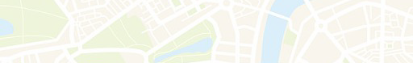
IEP

The IEP (or IFSP or 504), with full parent and student participation, guides our personalized approach; transition plans for age 14+ guide the entire IEP.

The full resources of the Portrait of a Graduate give full descriptions and ideas for application.

Portrait of a Graduate

State Standards & Graduation Plans

State standards and graduation requirements provide expectations and structure for us to aim our instruction toward.
The Mastery Transcript and USDB policies provide a framework for competency-based teaching, learning, and grading.






Mastery Transcript

FY2022 USDB FINANCIAL REPORT
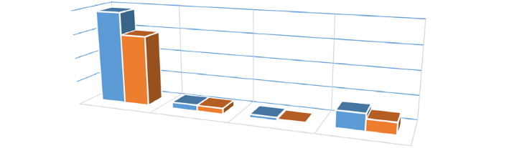
March 31, 2022
FY2022
TOTAL REVENUE TO BUDGET COMPARISON

$40,000,000

$30,000,000

$20,000,000
Budget
$10,000,000
Actual
$-
State
Federal
Dedicated Credits
Agency Transfers

FY2022 ESTIMATED REVENUE
(not including ENRICHMENT FUNDS)
 |  | Expected | Received | Remaining
State | 78% | $ 38,866,200 | $ 29,480,900 | $ 9,385,300
Federal | 5.1% | $ 2,527,447 | $ 2,413,430 | $ 114,017
Dedicated Credits | 3% | $ 1,279,000 | $ 628,568 | $ 650,433
Agency Transfers | 14% | $ 7,021,463 | $ 4,931,635 | $ 2,089,828
TOTAL | 100% | $ 49,694,110 | $ 37,454,532 | $ 12,239,578

FY2022 MONTHLY EXPENDITURES (not including ENRICHMENT FUNDS)
$45,000,000

$40,000,000
78%
FY2022 BUDGET & EXPENDITURES COMPARISON
As of 03/31/2022
$35,000,000

$30,000,000

$25,000,000

$20,000,000

$15,000,000
FY2022 Budget Allocation
$10,000,000
17%
YTD Expenses 03/31/2022
$5,000,000
0%
0%,
2%
3%
$-
Personnel
Services
Travel In Travel Out of Current
State
State Expenses
DP Current DP Capital Capital
Expenses ExpendituresExpenditures
 | % | FY2022 Budget Allocation | YTD Expenses 03/31/2022 | Budget Balance 03/31/2022
Personnel Services | 78% | $ 38,714,713 | $ 24,911,748 | $ 13,802,965
Travel In State | 0% | $ 174,475 | $ 84,157 | $ 90,318
Travel Out of State | 0% | $ 57,025 | $ 7,529 | $ 49,496
Current Expenses | 17% | $ 8,295,534 | $ 5,882,404 | $ 2,413,130
DP Current Expenses | 2% | $ 944,400 | $ 624,423 | $ 319,977
DP Capital Expenditures | 0% | $ - | $ 36,452 | $ (36,452)
Capital Expenditures | 3% | $ 1,325,000 | $ 957,261 | $ 367,739
TOTAL | 100% | $ 49,511,147 | $ 32,503,974 | $ 17,007,173

Straight Line Projection >5% of budgeted amount Straight Line Projection <5% of budgeted amount

2021-2022 Number of Students Served
 |  | Sep-21 | Oct-21 | Nov-21 |  | Dec-21 | Jan-22 | Feb-22 | Mar-22 | Apr-22 | May-22 | Jun-22
PIP |  | 501 | 538 | 547 |  | 538 | 536 | 554 | 569
Self Contained |  | 321 | 314 | 319 |  | 299 | 300 | 328 | 335
Direct |  | 330 | 326 | 343 |  | 330 | 401 | 325 | 329
Consult |  | 442 | 471 | 469 |  | 471 | 474 | 473 | 476
Subtotal |  | 1594 | 1649 | 1678 |  | 1638 | 1711 | 1680 | 1709 | 0 | 0 | 0

Additional Services Provided Per Student
Orientation & Mobility |  | 368 | 367 | 461
Interveners |  | 55 | 48 | 49
Deaf-Blind |  | 131 | 131 | 133
Interpreting |  | 70 | 70 | 58
Audiology Referrals |  | 147 | 143 | 154
Current Referrals |  | 73 | 82 | 55
Subtotal |  | 844 | 841 | 910

294 | 338 | 329 | 328
47 | 47 | 45 | 45
135 | 135 | 133 | 130
201 | 204 | 214 | 222
147 | 98 | 161 | 157
63 | 69 | 67 | 88
887 | 891 | 949 | 970 | 0 | 0 | 0

TOTAL |  | 2,438 | 2,490 | 2,588

2,525 | 2,602 | 2,629 | 2,679 | 0 | 0 | 0

FY2021 LAND GRANT/ENRICHMENT FUNDS FY2022 DONATED FUNDS FY2021 EDUCATION FOUNDATION
ESTIMATED |  | 3/31/2022
FY2022 Beginning Balance | $ 1,070,511 | $ 1,070,511
FY2022 Projects/Expended | $ 1,446,000 | $ 856,473
FY2022 Estimated Revenue | $ 875,000 | $ 740,204
Remaining Available Funds | $ 499,511 | $ 954,242

 | Prior Month | 3/31/2022
State | $ 284,173.38 | $ 281,201.39
Total | $ 284,173.38 | $ 281,201.39

 | Prior Month | 3/31/2022
PTIF BALANCE | $ 1,239,879.02 | $ 1,250,520.80
Total | $ 1,239,879.02 | $ 1,250,520.80

FY2022 USDB BUDGET STATUS REPORT
As of March 31, 2022
SUMMARY - OPERATIONS
FY2022 BEGINNING BALANCE (For Information Only)
TOTAL REVENUE
TOTAL EXPENSES

ACTUAL | BUDGET | Budget Remaining (OVER) | % Actual to Budget
 |  | -
37,454,532 | 50,733,757 | 13,279,225 | 74%
32,503,974 | 49,511,147 | 17,007,173 | 66%

 |  | ACTUAL | BUDGET | Budget Remaining (Over) | Funding Source
REVENUE - Operations |  |  |  |  | Dedicate Credit Dedicate Credit Dedicate Credit Dedicate Credit Federal Federal Federal  State State State State State State State State State State State State State State State State State State State State Federal State State
 | SALE OF GOODS/SERVICES - Canteen Sales SCHOOL CONTRACTS  ROOM/BUILDING RENTAL MISC. REVENUE  FEDERAL GRANT MEDICAID  MEDICAID ADMIN CLAIMING GENERAL FINANCIAL LITERACY AMERICAN RESCUE PLAN ESSER III BABY WATCH  BLIND LITERACY ACT  CLASSROOM SUPPLIES FOR EDUCATORS DEAF/BLIND GRANT  ESY FOR SPECIAL EDUCATORS IDEA PRE-SCHOOL  IDEA SCHOOL AGE IDEA SAGE TESTING  POSITIVE BEHAVIOR PLAN SAAM SS TEACHER SUPPLEMENTAL SALARY PROGRAM TEACHER STUDENT SUCCESS ACT( TSSA) EDUCATOR SALARY ADJUSTMENT  GROW YOUR OWN TEACHER AND COUNSELOR PROGRAM SCHOOL LAND TRUST  SUICIDE PREVENTION PLAN (SUPV) TRANSPORTATION  USIMAC OFFICE SUPPORT  USIMAC Fund Transfer CHILD NUTRITION PROGRAM PRE ETS GRANT EDUCATIONAL FUNDS  GAIN/(LOSS) ON DISPOSAL OF FIXED ASSETS | 1490 | 2,000 510  1,276,500 657,874  - (4,593)  500 (3,358)  110,447 (29,050)  2,287,000 208,462  60,000 (35,148)  15,000 15,000  190,750 190,750  50,000 50,000  10,000 10,000  30,000 4,724  35,000 -  95,000 66,566  57,938 57,938  200,000 200,000  243,025 243,025  325,000 289,848  53,881 13,832  900,000 216,016  75,000 -  952,516 212,312  3,000 -  4,600,000 1,600,000  35,000 -  150,000 -  70,000 (30,247)  40,000 (33,538)  38,866,200 9,385,300  - -
 |  | 618,626
 |  | 4,593
 |  | 3,858
 |  | 139,497
 |  | 2,078,538
 |  | 95,148
 |  | 25,276
 |  | 35,000
 |  | 28,434
 |  | 6,999
 |  | 35,152
 |  | 40,049
 |  | 683,984
 |  | 75,000
 |  | 740,204
 |  | 3,000
 |  | 3,000,000
 |  | 35,000
 |  | 150,000
 |  | 100,247
 |  | 73,538
 |  | 29,480,900

ACTUAL
BUDGET
Budget Remaining % Actual to
(OVER) Budget
EXPENSES - OPERATIONS

- of 2
TOTAL REVENUE- Operations 37,454,532 50,733,757 13,279,225

PERSONNEL SERVICES | 24,911,748.24 | $ 38,714,713 | $ 13,802,965 | 64%
TRAVEL IN STATE | 84,156.64 | $ 174,475 | $ 90,318 | 48%
TRAVEL OUT OF STATE | 7,528.74 | $ 57,025 | $ 49,496 | 13%
CURRENT EXPENSES | 5,882,404.07 | $ 8,295,534 | $ 2,413,130 | 71%
DATA PROCESSING CURRENT EXPENSE | 624,422.82 | $ 944,400 | $ 319,977 | 66%
DATA PROCESSING CAPITAL EXPENDITURES | 36,452.40 | $ - | $ (36,452) | #DIV/0!
CAPITAL EXPENDITURES | 957,261.21 | $ 1,325,000 | $ 367,739 | 0%
TOTAL EXPENSES- Operations | 32,503,974 | 49,511,147 | 17,007,173 | 66%

ACTUAL | BUDGET | Budget Remaining (OVER) | % Actual to Budget
SUMMARY - ENRICHMENT FUND

FY2022 BEGINNING BALANCE (For Information Only) | 1,070,511
TOTAL ESTIMATED REVENUE | 952,516 | 1,446,000 | 493,484 | 66%
TOTAL ACTUAL EXPENSES | 856,473 | -

 |  | ACTUAL | BUDGET | Budget Remaining | % Actual to  Budget
REVENUE |  |  |  |  | 85%
 | COLLECTION FROM TRUST LAND (SITLA) | $ 740,204 | $ 875,000 $ 134,796 |  | 85%
85%
TOTAL REVENUE $ 740,204 $ 875,000 $ 134,796

 |  | ACTUAL | BUDGET | Budget Remaining (OVER) | % Actual to Budget
EXPENSES
 | PERSONNEL SERVICES | $ 464,712 | $ 500,000 | $ 35,288 | 93%
 | TRAVEL IN STATE | $ 16,165 | $ 50,000 | $ 33,835 | 32%
 | TRAVEL OUT OF STATE | $ 83,523 | $ 50,000 | $ (33,523) | 167%
 | CURRENT EXPENSES | $ 274,458 | $ 450,000 | $ 175,542 | 61%
 | DATA PROCESSING CURRENT EXPENSE | $ 1,327 | $ - | $ (1,327) | #DIV/0!
 | DATA PROCESSING CAPITAL EXPENDITURES |  | $ - | $ - | #DIV/0!
 | CAPITAL EXPENDITURES | $ 16,288 | $ - | $ (16,288) | 0%
TOTAL EXPENSES |  | $ 856,473 | $ 1,050,000 | $ 193,527 | 82%
 | Note: Total Payroll % of Total Expenditures | 54%

- of 2

Function Code | FY22 Enrichment Fund Projects |  | Superintendent | Expenses 03/31/2022 | Encumbered | Balance Remaining 03/31/2022 | Board Approval
EF2201 | Tanner | Extra-Curricular Activities for the Deaf | $235,000 | 151,660 |  | 83,340 | 05/06/21
EF2202 | Tanner | Study Abroad Trip - Germany | $50,000 | 33,200 |  | 16,800 | 05/06/21
EF2203 | Tanner | Harmony Music Therapy for PIP & LSL | $48,000 | 26,700 |  | 21,300 | 05/06/21
EF2204 | Tanner | PIP Family Activities | $10,000 | 2,547 |  | 7,453 | 05/06/21
EF2205 | Tanner | Deaf Mentor Program | $350,000 | 265,957 |  | 84,043 | 05/06/21
EF2206 | Tanner | Statewide ASL Course Development | $150,000 | 131,981 |  | 18,019 | 05/06/21
EF2207 | Tanner | Audiology Van | $200,000 | - | 200,000 | - | 05/06/21
EF2208 | Tanner | After School Reading Clinic Expansion | $25,000 | 2,556 |  | 22,444 | 05/06/21
EF2209 | Tanner/Patten | ERC Books | $35,000 | 32,649 |  | 2,351 | 05/06/21
EF2210 | Patten | Extra-Curricular Activities for the Blind | $103,000 | 37,612 |  | 65,388 | 05/06/21
EF2211 | Patten | PIP Expanded Core Actitvities | $15,000 | 3,422 |  | 11,578 | 05/06/21
EF2212 | Patten | Expanded Core for the Blind | $125,000 | 91,025 |  | 33,975 | 05/06/21
EF2213 | Patten | INSITE Evaluation Tool | $10,000 |  |  | 10,000 | 05/06/21
EF2214 | Patten | Blind Mentorship | $10,000 |  |  | 10,000 | 05/06/21
EF2215 | Patten | Genote | $30,000 | 19,400 |  | 10,600 | 05/06/21
EF2216 | Patten | CVI Connect | $4,000 | 3,915 |  | 85 | 05/06/21
EF2217 | Patten | EyeOn Device | $30,000 |  |  | 30,000 | 05/06/21
EF2218 | Patten | Study Abroad | $25,000 | 20,000 |  | 5,000 | 05/06/21
EF2219 | Tanner | School Community Land Grant | $26,000 | 10,835 |  | 15,165 | 11/04/21
EF2220 | Patten | Seventy 48 Boat Race | $45,000 | 23,013 |  | 21,987 | 11/04/21
 |  | Totals | $1,526,000 | $856,473 | $200,000 | $469,527
 |  |  |  |  |  |  |  |  |  | 3



USDB 2023 Facilities Funding (May 2022)

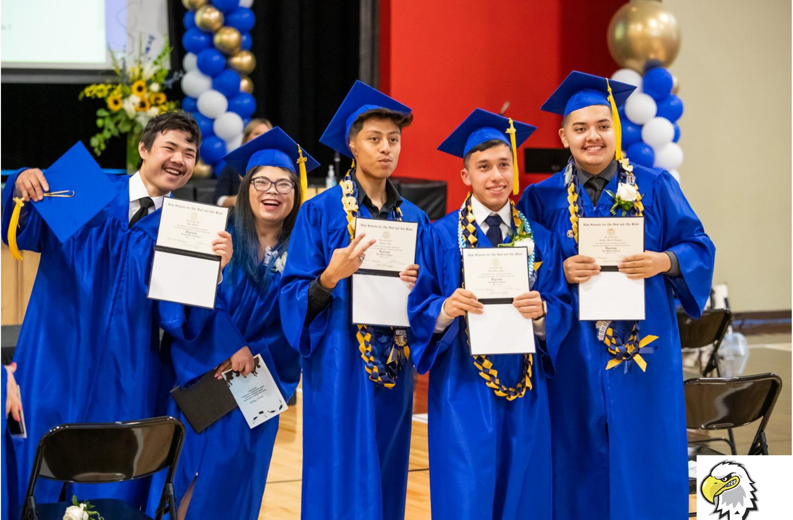

UTA H SCMOOL OR DEAF

- UTAH
SCHOOLS FOR THE DEAF AND THE BLIND
r,

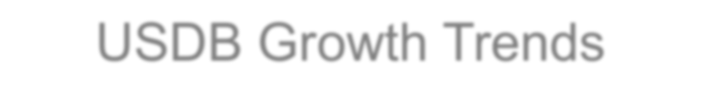
USDB Growth Trends
The next 5-10 years

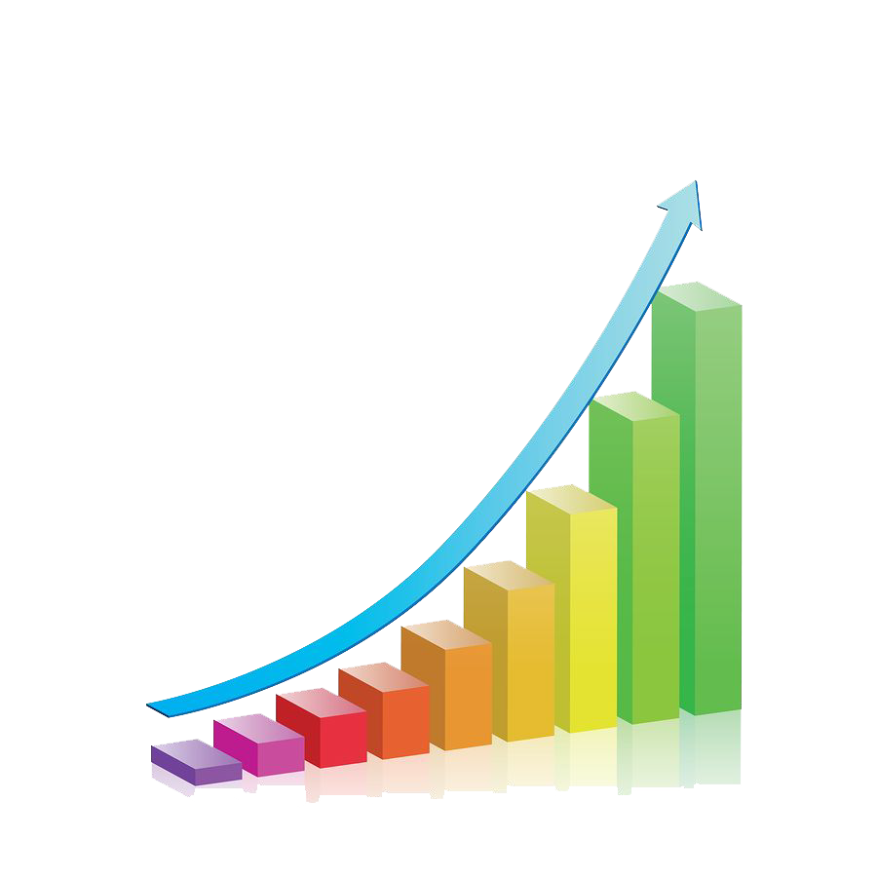
- Wasatch Front - Steady growth
- Utah County - New Capacity
- District requests - Provo, Tooele, Weber
- Washington County growth
- Returning ASL Students
- Online courses for Deaf students
- Increased need for interpreters
- Increased support for districts and charters

f) o}:l}: CAPITAL FACILITY TlMELINE

Jul 2014 - Oct 2016 OEC Design and Build

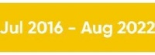
♦ifHf·i h♦ JMS Roof Reconstruction and Interior Renovations
Ogden Campus Renovations

Springville Design and Build Jul 2016 - Jan 2020

Millcreek Portable Replaced Jul 2021 - Mar 2022

St. George Portable Relocation Jul 2021 - Mar 2022

SLC High School Land Purchase, Design and Build

St. George Elementary School Design and Build
Jul 2021 - Aug 2025

Sept 2022 - Aug 2025

Outdoor Family Learning Center 2017 -TBD

Key Questions

Why is the per student cost so high to build USDB facilities?
  - Why don’t districts contribute to USDB?

Do districts “double dip” when they receive outreach services from USDB?
  - Why does USDB lose space in district classrooms?

Why do ASL students return to USDB?

5 OF 12

Guiding Principles

Core mission and fiduciary duty
  - Students not served
- Students not served effectively

Cost effectiveness
  - Cost savings
  - Cost avoidance

- 6 OF 12

Specific Items We Must Consider

Design Complexity
  - Non-classroom space (offices, food service, etc.)

Market and Timeline (3 year projects)
  - State Building Standards (DFCM)

Student Access to Programs (rural travel vs. urban)
  - Educator Access to Students (outreach, travel south)

- OF 12

Architect Complexity Lists

Specialty Construction for Deaf Education:
-Enhanced Acoustic Wall construction - STC 64 (Sound Transmission Coefficient)
-Resilient Sound Isolation Clips
-Resilient Channels
-Sound Caulking
-Puddy Pads around all Penetrations
-Enhanced Acoustic Ceilings
-Technology requirements in classrooms
-Microphones
-Loop System - for hearing aids
-FM Broadcasting System / Personal FM - for cochlear implants
-Observation Cameras for Parent Education
-Headphone Jacks for Parent Education
-Message Net type system throughout building
-Scrolling Clocks
-Visual PA systems
-DeafSpace Guidelines
-Increased glass for unobstructed sight lines for ASL communication
-Flashing Signal Indicators
-Smart Boards in Classrooms
Specialty Construction for Blind Education:
-Controlled Temperature Changing Lighting
-Resonance Floors for vibrations
-Tactile Wall Panels for navigation
-Controlled daylighting
-Enhanced Accessibility
-Audible Cues
-High Contrast Flooring Elements
-Tactile Transitions at Room Entrances
-Adaptive Equipment
-Mobility Equipment Storage
--Smart Boards in Classrooms
-Snoezelen Room for DeafBlind
-Observation Windows for Parent Education
-Structural supports for overhead adaptive equipment

Specialty Construction for Orientation and Mobility in USDB schools:
-Adaptive Physical Education Features for Physical Disabilities
-Gross Motor Skills
-Fine Motor Skills
-Vestibular Skills
-Sensory Gardens and Play Equipment

- OF 12

Architect Complexity Lists

Specialty Construction for Clinical Resources in USDB schools:
-Psychological Assessment
-Therapy Rooms
-Sibling Rooms
-Parent Outreach
-Consult Rooms
-Vision Clinic
-Braille Translation
-Sound Booths
-Hearing Aid Fitting & Repair
-occupational therapy

Specialty Construction for Life Skills in USDB schools:
-Teaching Kitchen
-Vocational Training
-Occupational Therapy
-Stem Education
-Performing Arts
-Gymnasium

- OF 12

The Puzzle: More complex than designing for iust Deaf or iust Blind
Blind

Or
Hard of Hearing
Accessibility & Inclusive Design Adaptive Services
Or
Visually Impaired

AS--L L-SL


Orientation &

Clinical Life Skills
Wayfin-d-in-g-& D-eaf

American Sign
Listening &
Mobility
Resources -TeachingKitchen
Navigation
Blind

Language

-DeafSpace Guidelines
Spoken Language
-Adaptive Physical Ed
-Gross Motor Skills
- Au d io logy Suite -Vocatio al Training -High Contrast
-Vision Clinic -Occupational Therapy -Points of Reference
-Cause/Effect
-Snoezelen Room

-Un-obstructed Sight Lines
-Visual Connections

-Speech & Language
-Hearing & Balance
-Fine Motor Skills
-Vestibular Skills
-Stem Education
-Consult Room - Per form ing Arts
-Psych Assessment G .
-Experiments in Light
-Tactile Features
-Resonance Floor
-Vibrations

-Int erpreter Communication
-Tradition and Culture

-Cochlear Implants
-Hearing Aids
-Exploration Gardens
-Therapy Rooms
-Braille Translation
-Sibling Rooms
Early Childhood Education
- ymnas1um
-Tactile transitions
-Audible cues
-Low Glare
-Tactile Paths
-Held Tight
-Changing Room

(fitting & repair)
-Broadcasting Systems
-Loop Systems [ st
l -Parent Involvement

-Cane-ing education
-Orthogonal corners
-Controllable Lighting
-High Accessibility

:i: : :PA Systemsa n-: : : : : :: : gn
-Signal Indicators
-Video Communications
A'} 9
r uc t ion
_ _ _ _ _ _ _

-Vision
-Cultural
-Philosophical
,

-Early Intervention
-Confidence
-Competence
-Adaptive equipment

.I-\
AJA Conferenc e on Archilec lure 2019 June 6-8. LasVegas
-Technology & Research
-Relational Learning
-Leadership in Education
-Independence
-Observation
-Infant/ Toddler/ Preschool/ Elementary

Salt Lake High School

- OF 12

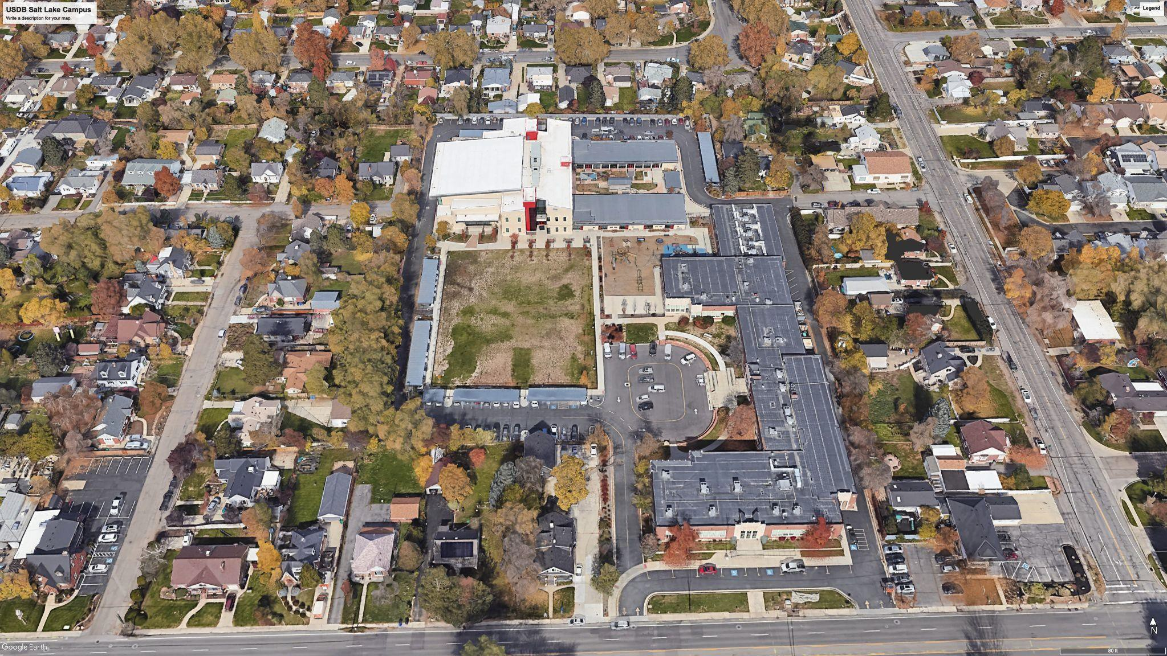

- OF 12

- OF 12

Purpose/Justification:
Salt Lake High School Building
Specific Requirements/Programming:

  - USDB Salt Lake Campus needs space for secondary (Jr. High and High School) classrooms and offices
  - Legislature funded $900,000 for land acquisition in FY22
  - Property acquired in September 2021
  - Pre-programming feasibility study completed in October 2021 to determine site and building requirements
  - Old home use for 3 classes during design process
Design and build request includes:
    - 9 classrooms, 8 offices, bathrooms, group spaces
    - Request includes 3 year inflation estimate

    - Programming & Design $1,108,329
    - Site costs $665,422
    - Building Costs $13,269,564

    - Total Requirement: $15,062,215 Total (One Time)


Performance Measures/Projected Outcomes:

  - USDB secondary students will have an adequate facility for their educational needs that meets ADA standards for access
  - Allows USDB to provide a Free and Appropriate Public Education (FAPE) to our special education students as mandated by the federal IDEA.

Impact if not Funded:

- Current facility will not comply with ADA Requirements
- Students continue to learn in non-optimal repurposed spaces
- Educators do not have access to proper resources
- Children with disabilities subject to inferior learning environment compared to their non-diabled peers
- Students may be forced into programs not designed for their unique needs

Salt Lake High School - Items to Consider

  - Why now? Deaf students not thriving in local High Schools, pulled back 3 years ago for core classes
  - Interpreters for elective classes at Olympus HS & Evergreen JHS
  - Current space inadequate for student needs (OEC, Stage, meeting rooms)
  - Crowding not conducive to optimal learning
  - Needs for office, therapy and other specially designed space
  - Little house not ADA compliant
  - 15 year plan or more
  - Letters from parents
  - More than just classrooms
    - office space
    - therapy rooms
    - group gathering space
    - Weight room
    - facilities space
  - Purchased site ($665,000)
  - Number of students (FT, part time, itinerant, etc.)

15

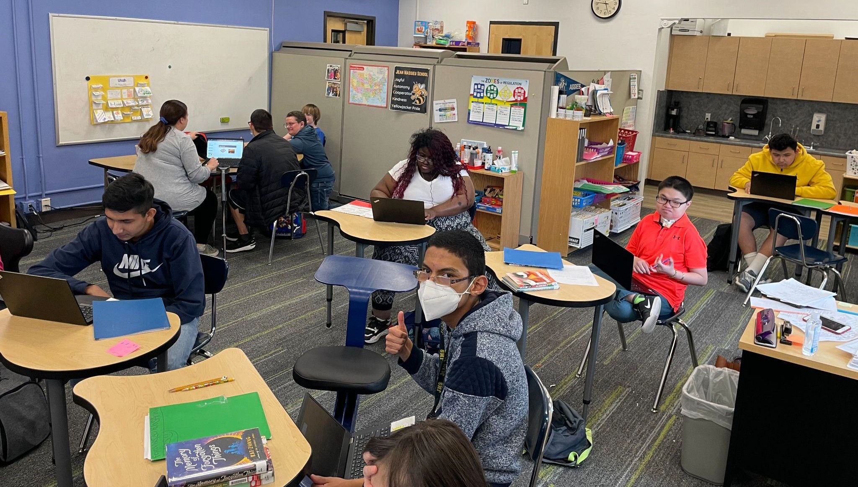

- OF 12

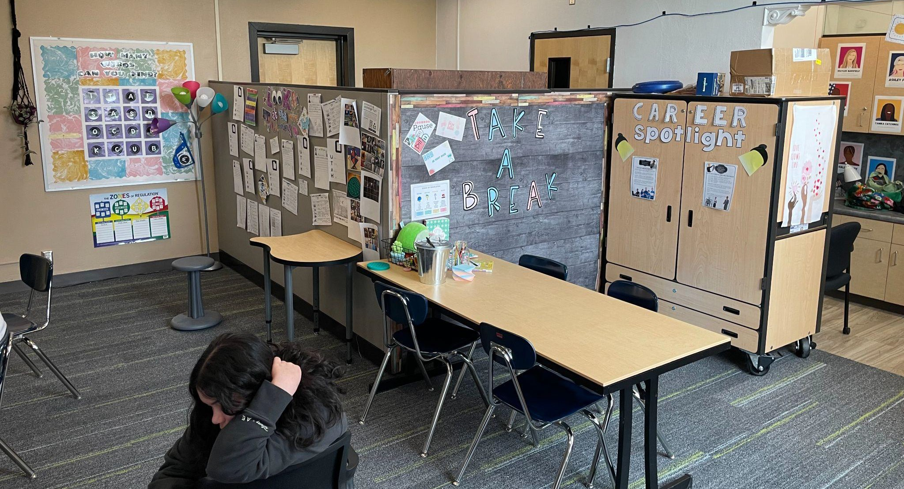
- OF 12

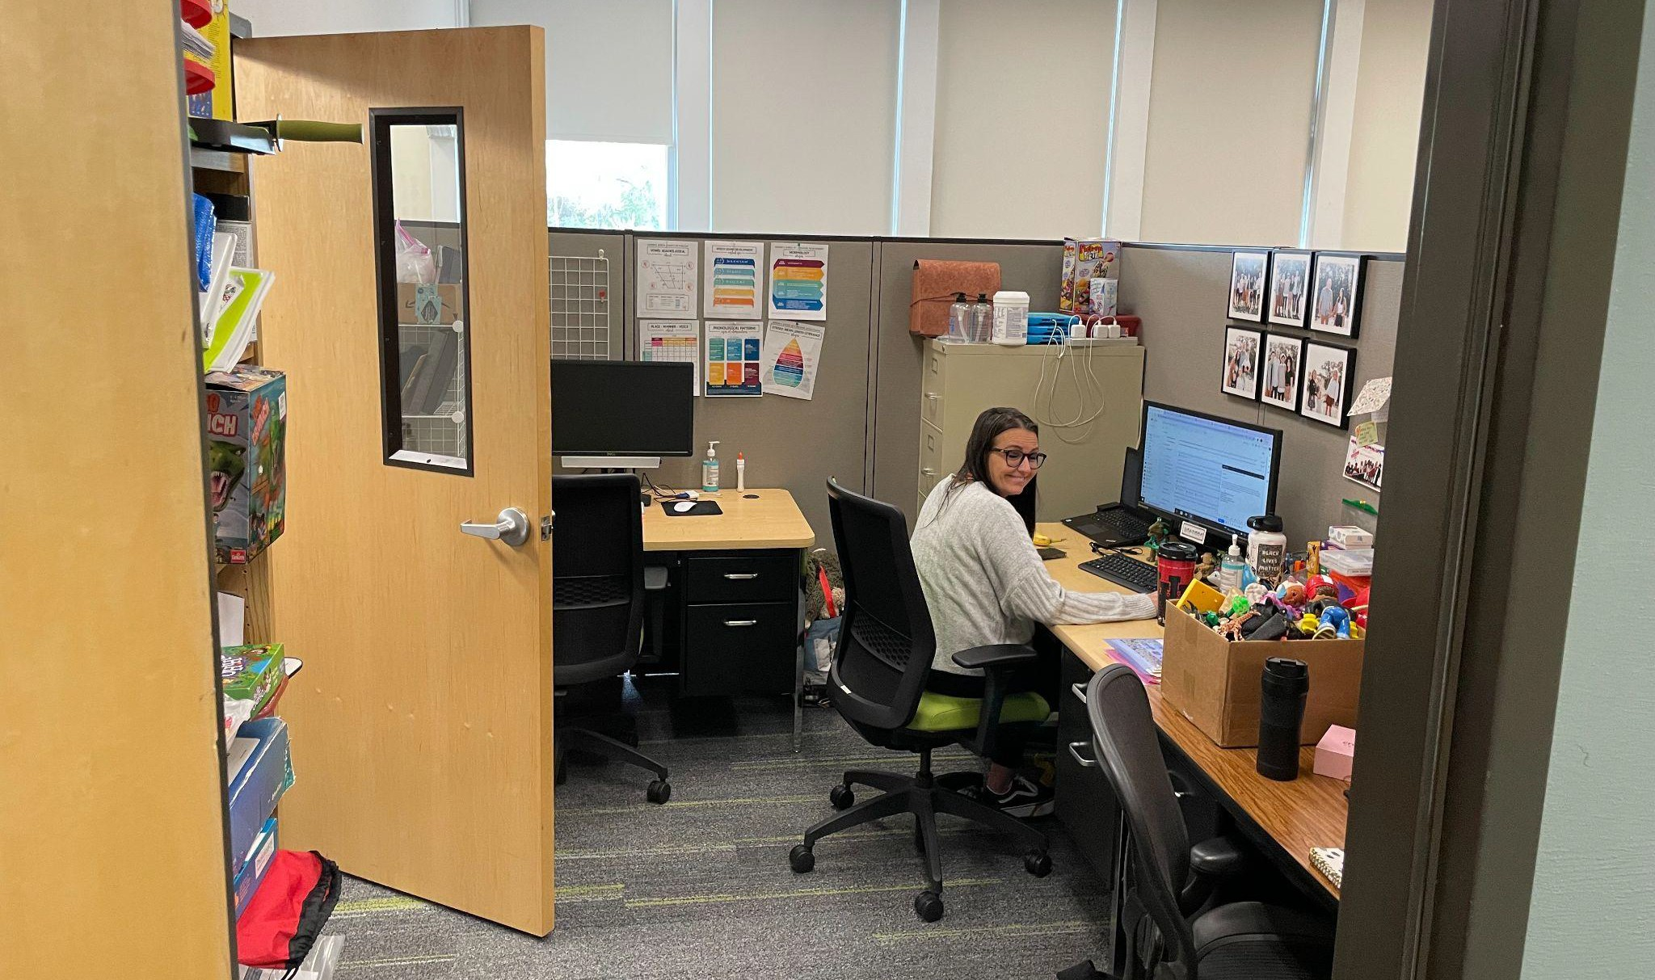

- OF 12

- OF 12

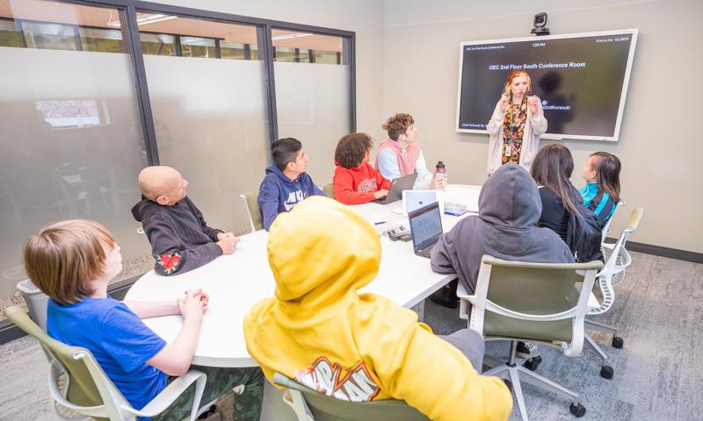

- OF 12

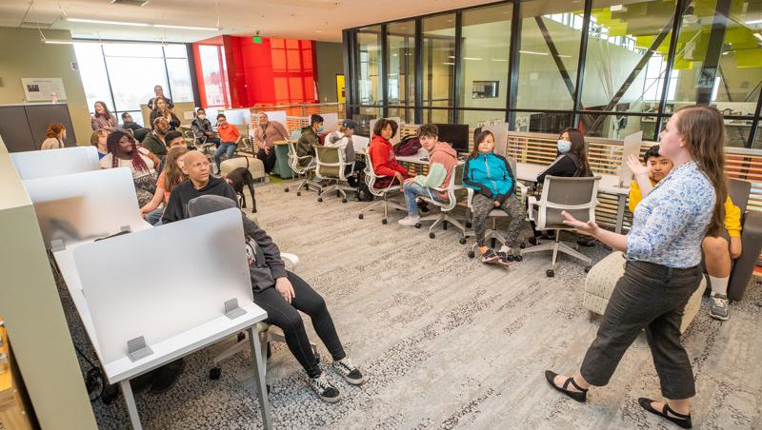

- OF 12

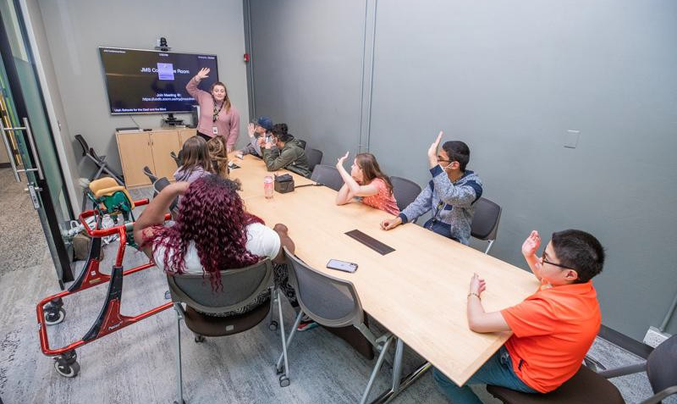

- OF 12

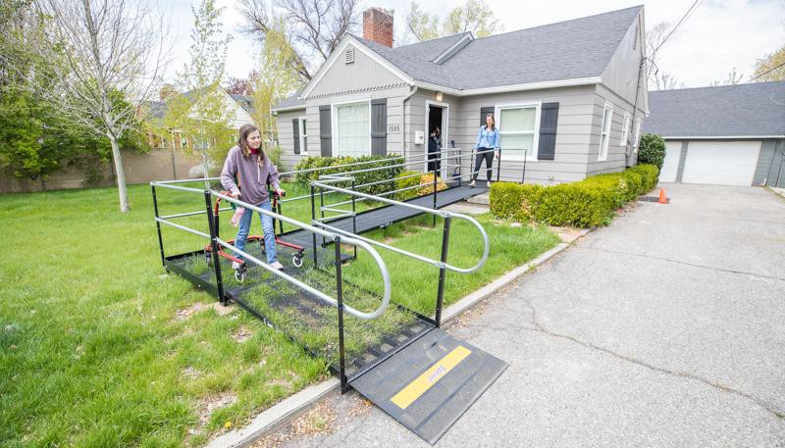

- OF 12

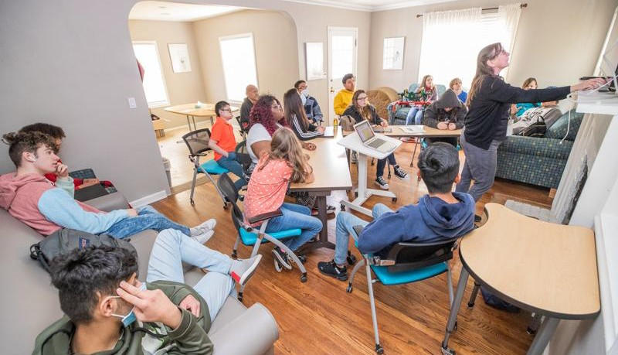

- OF 12

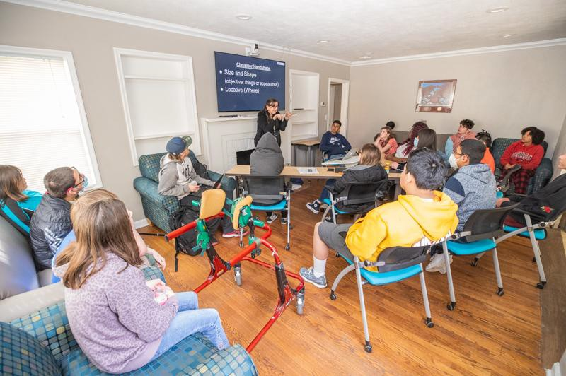
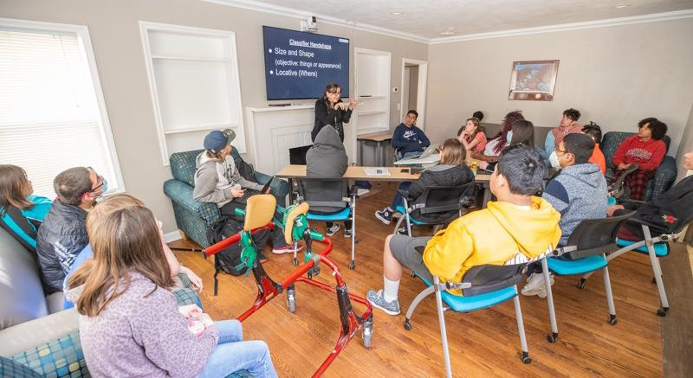

- OF 12

St. George School

- OF 12

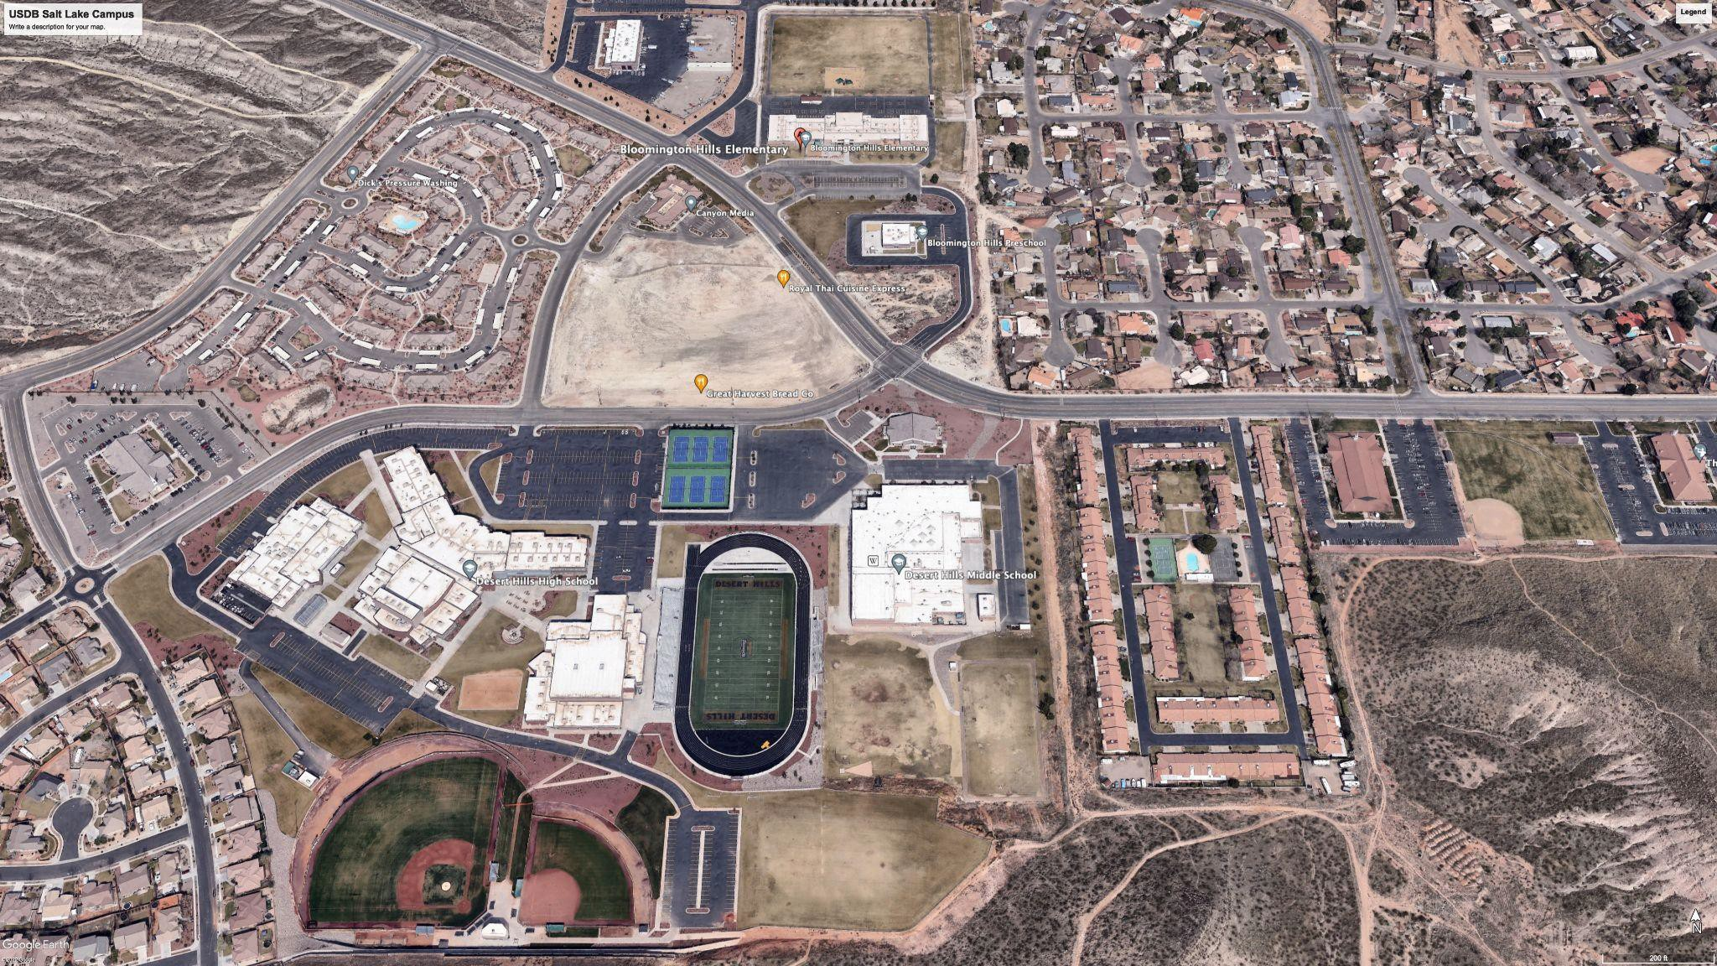
3

4

5

1
2

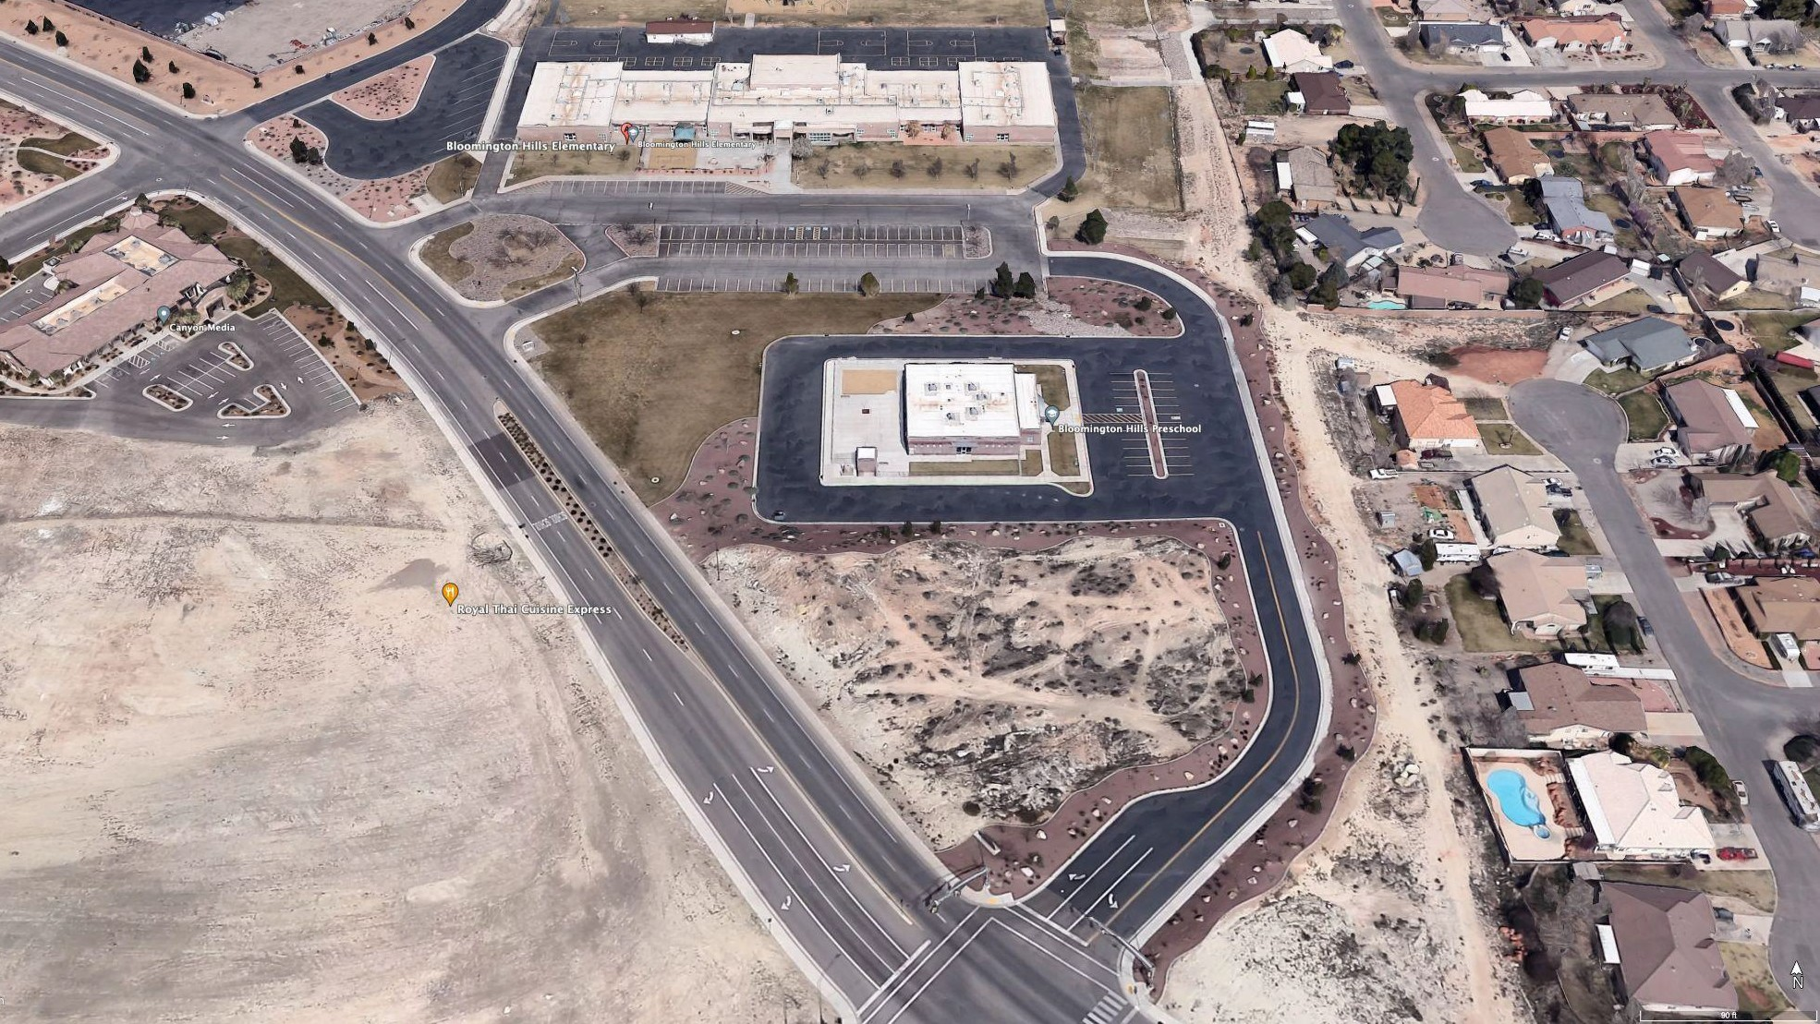

- OF 12

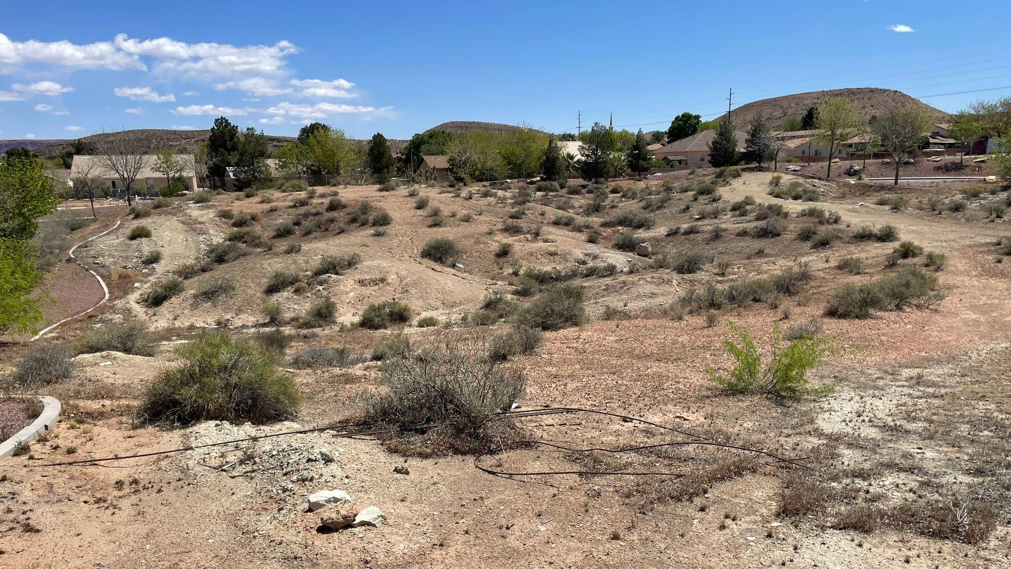

- OF 12

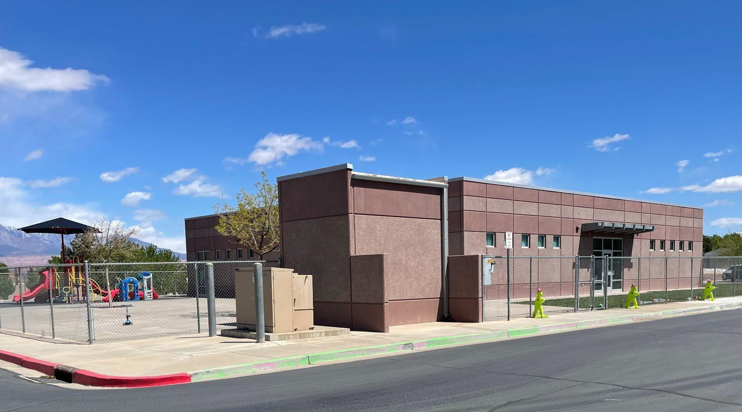

- OF 12

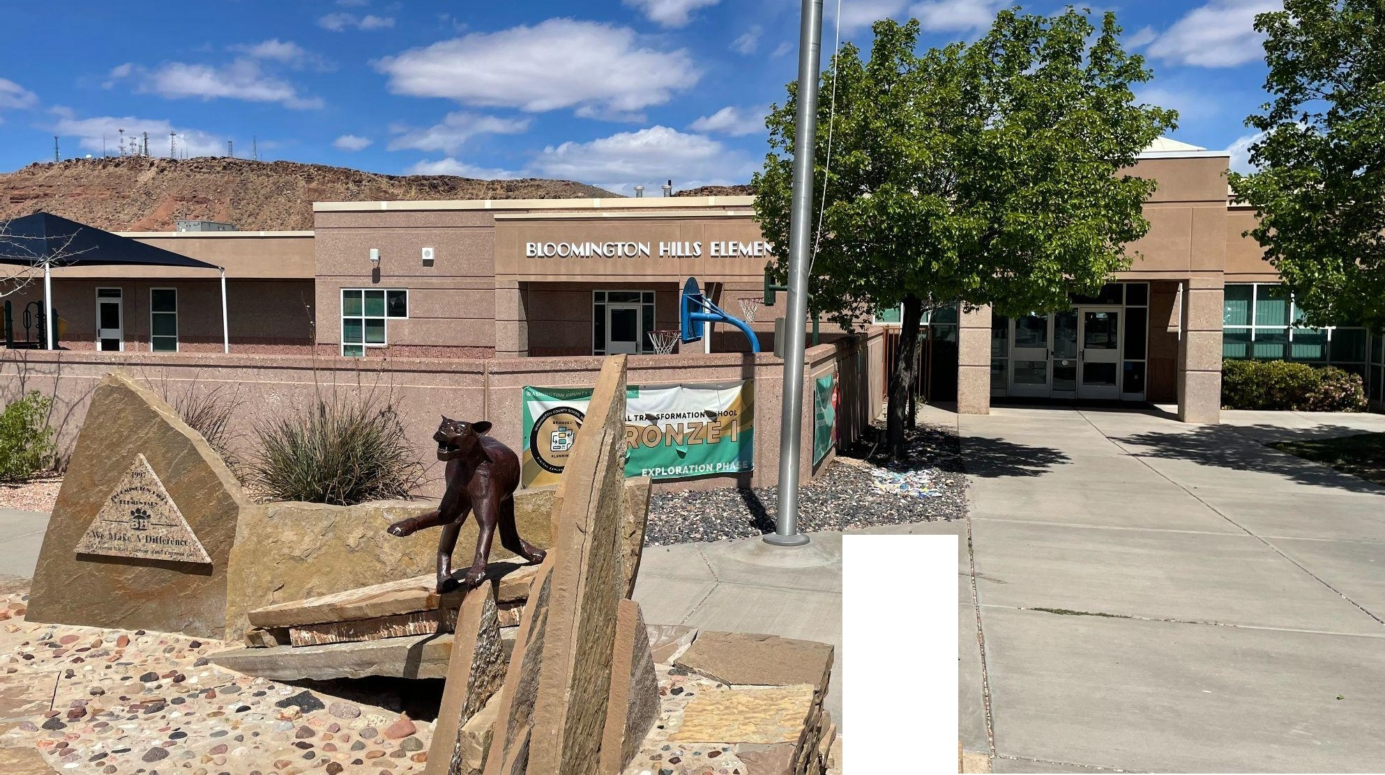

-l

Purpose/Justification:
St. George School Building
Specific Requirements/Programming:

- Washington County is an extremely high growth area
- Temporary modular building at Bloomington Elementary has 4 USD preschool classrooms - none for USB, elementary, or secondary students
- Unique partnership with Washington School District
  - Estimated 20%+ savings
  - WSD providing land and construction management
Building consists of:
- 10-12 classrooms, offices, flex space, bathrooms, storage
- Shared playground and parking areas
- Request includes 3 year inflation estimate

- Programming & Design $1,085,145
- Site costs $610,947
- Building Costs $12,247,238

- Total Requirement: $13,943,329 Total (One Time)

Performance Measures/Projected Outcomes:

- USDB students will have an adequate facility for their educational needs
- Allows USDB to provide a Free and Appropriate Public Education (FAPE) to our special education students as mandated by the federal IDEA.
Impact if not Funded:

- Students continue to learn in non-optimal repurposed spaces
- Educators do not have access to proper resources
- Children with disabilities subject to inferior learning environment compared to their non-diabled peers
- Students may be forced into alternative
programs not designed for their unique needs

St. George - Items to Consider

  - “Our classrooms” vs. district classrooms
  - St. George program closed in 2008
  - Extremely high growth and projected growth area
  - Deaf, Blind, and Deaf-Blind programs currently in borrowed space from WCSD and Arrowhead Academy
  - Losing borrowed space immediately
  - Current space inadequate for student needs
  - No office, therapy or other specially designed space
  - No headquarters for administration or itinerant services
  - Current cost over $106,000 for travel from
Wasatch Front
  - 150+ students in SW region, currently only serving 15-20 in deaf classrooms, no blind. (Est. how many future kids)
  - 15 year plan or more
  - No service for post high school students
  - WCSD letter of support
  - Iron County letter of support
  - Letters from parents
  - Donated land (est. value here)
  - Ideal location near elementary, middle, and high schools
  - quantify services not being provided that will be
  - Discuss ability to recruit and retain professionals locally ₃₃

2022 Staff Travel to Southern Utah

Over $106,000

- OF 12

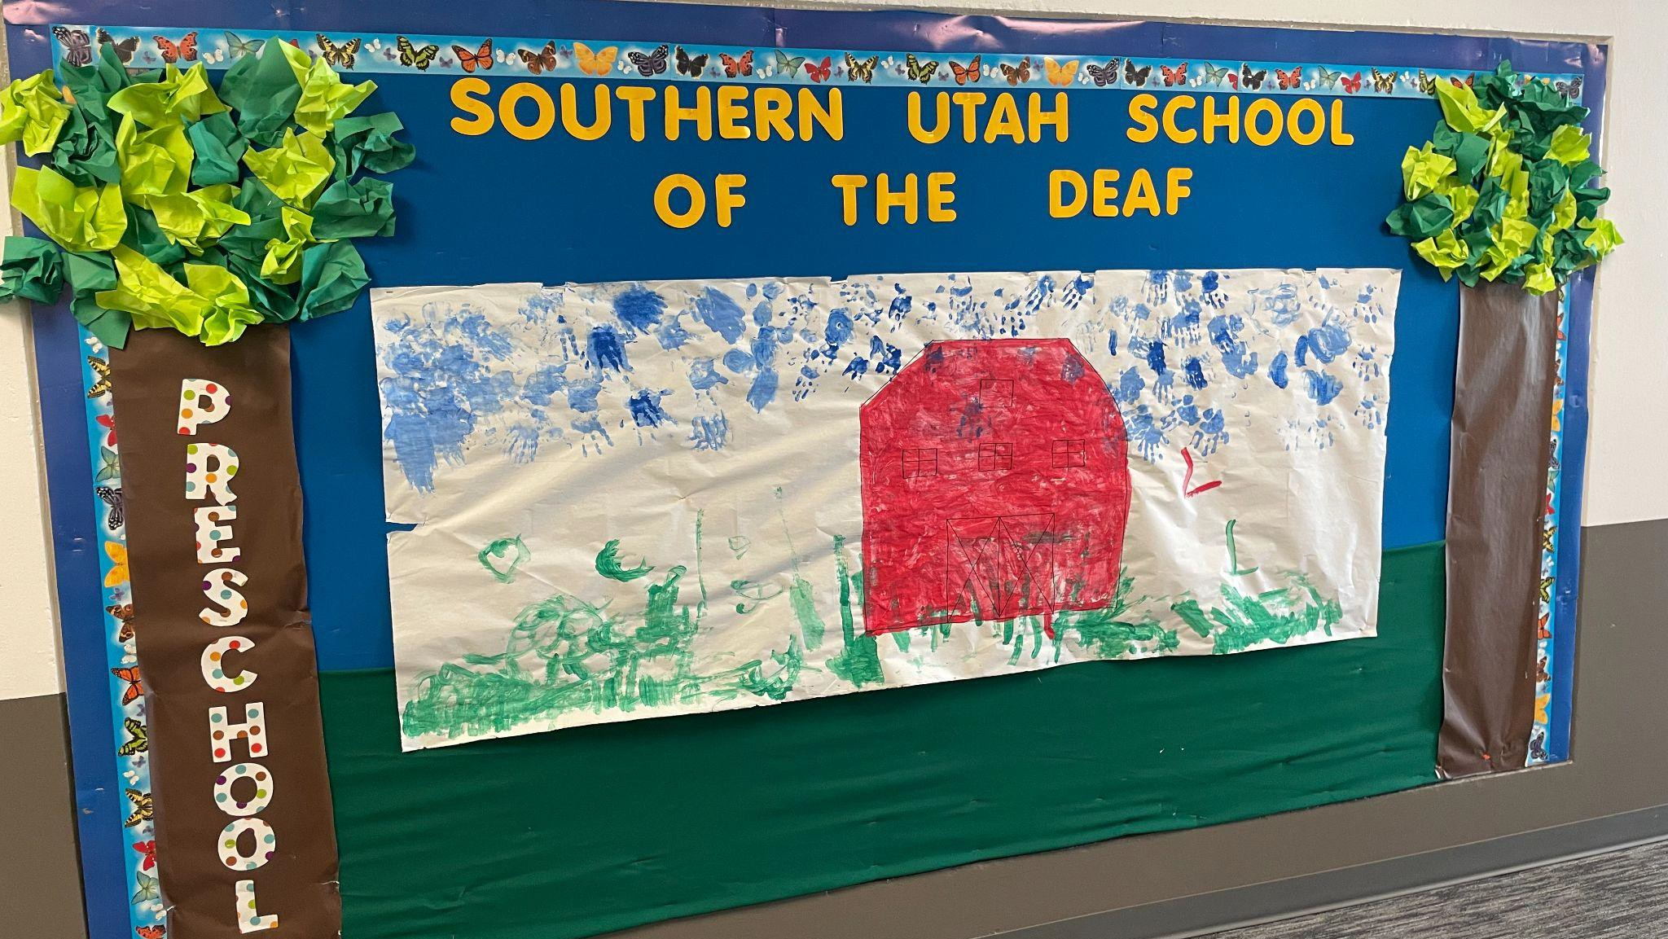

- OF 12

- OF 12

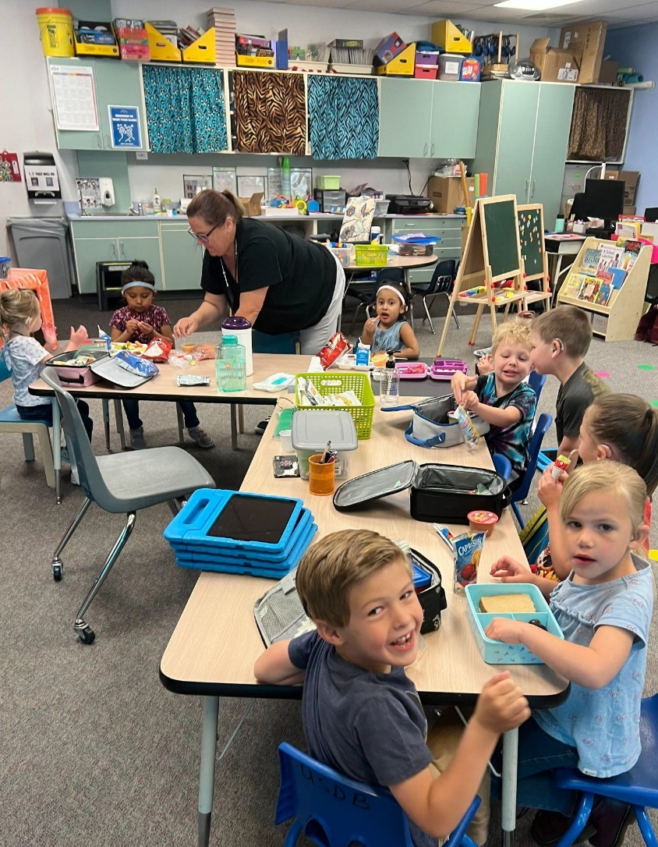
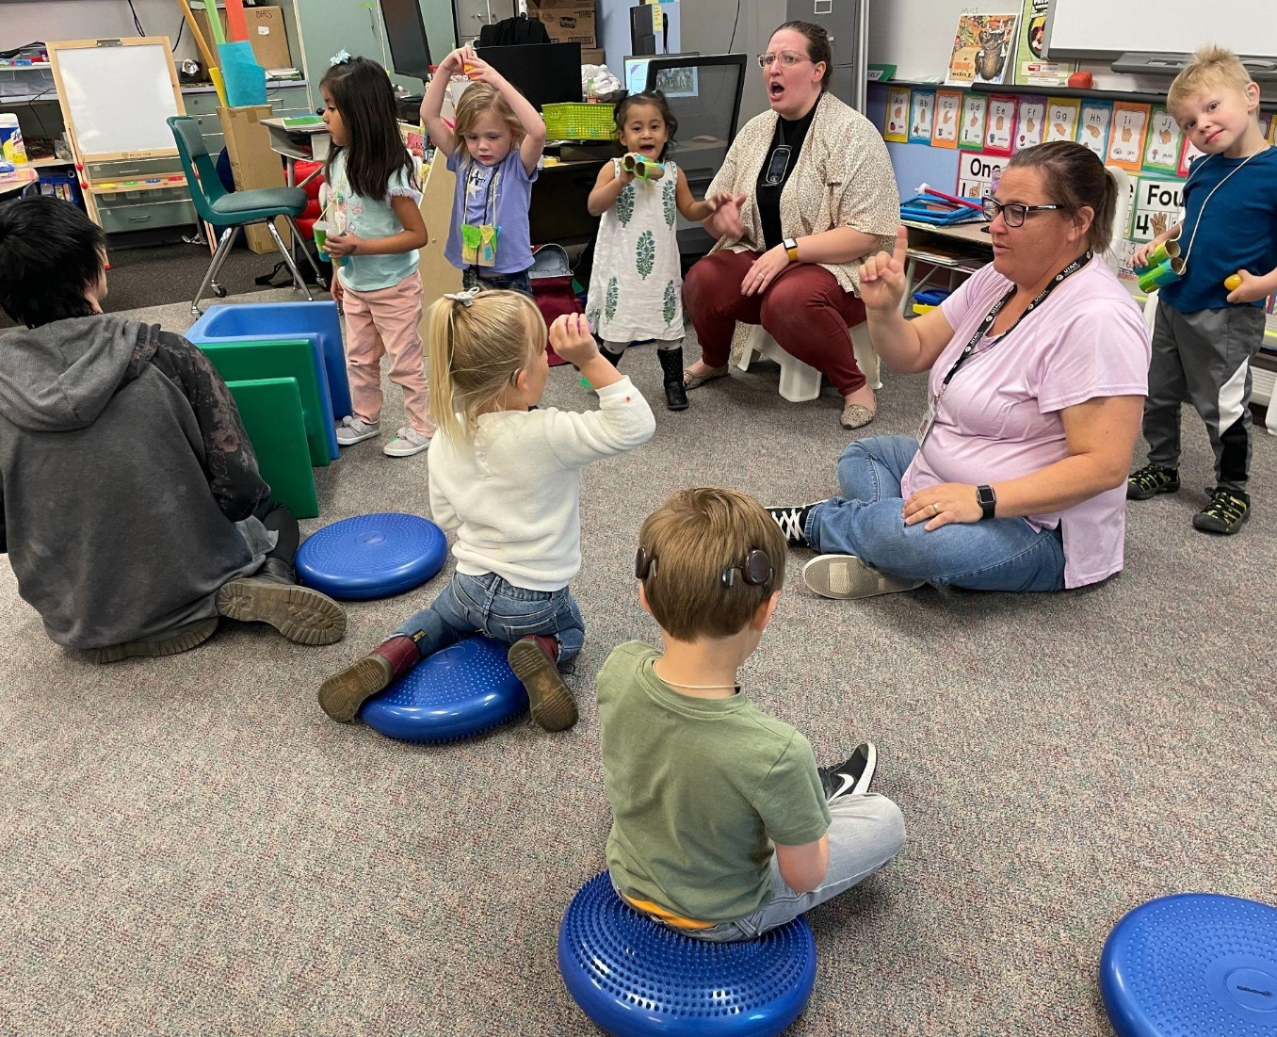

- OF 12

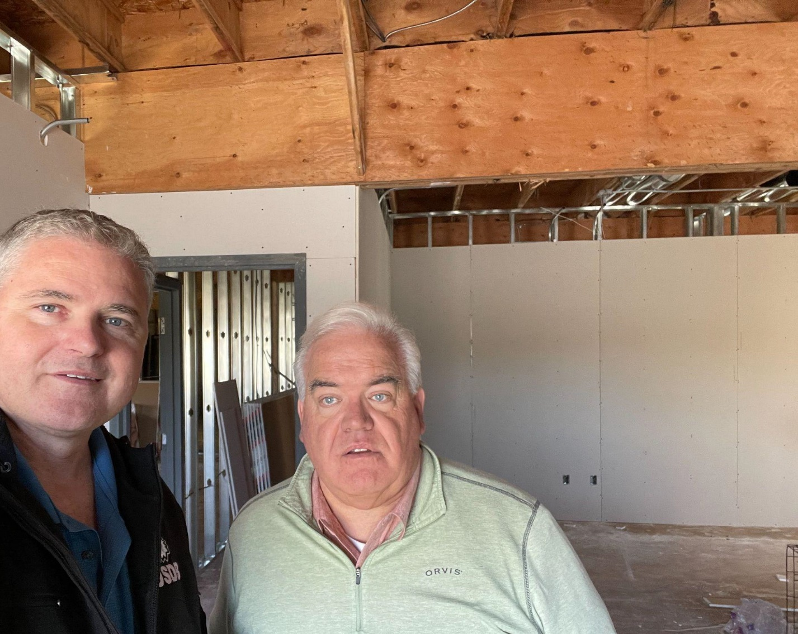
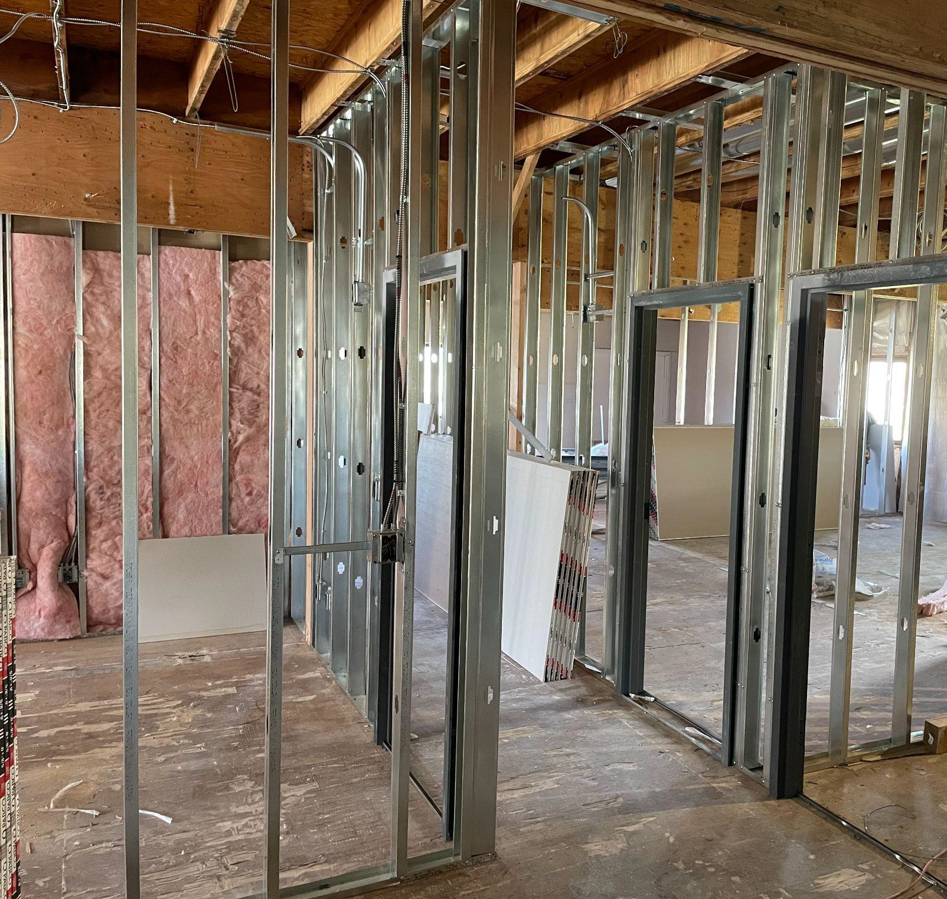

- OF 12

Thank you for your support.

- OF 12



Upcoming School Plan - USDB
2022-2023 School LAND Trust Plan

Goal Entry – Reading, math, science & social studies
- Goal. Deaf, blind and deaf-blind students at USDB will have access to various curriculum tools to improve reading, math, science, and social studies during the 2022-2023 school year.
- Academic Areas. Select the academic area(s) this goal will address.

CTE (Career and Technical Education)
College and Career Readiness
English/Language Arts Mathematics
Science Social Studies

- Measurements.
- Tools and assessments will include the purchase of:
  - Purchase supplemental reading curriculum materials $10,000
  - Beable (Transition curriculum); $2,500
  - NWEA MAP (Assessment tool); $2,200
  - Homecourt PBL Subscription (Project-based Learning tool); $400
  - BrainPOP (Science & Social Studies resources); $3,500
  - STEM items (Purchase of STEM manipulatives/tools); $1,000
  - Library books (Books for the reading clinic); $500
  - Braille materials (Reading materials for the blind); $1,000
  - Online technology (Used in online platforms for accessibility) $5,000
  - Manipulatives for student use: $1000

- Action Steps and Expenditures. List the specific steps of the Action Plan to reach this goal. Each expenditure must be included in the Action Plan Steps. Explain how/why it is needed to implement the Action Plan.

- Action Plan Steps will be entered by number.
- Student learning throughout the organization will be supported by the renewal of the following online tools: Beable, NWEA MAP assessment, Benchmark Education, PBL, BrainPOP, Braille materials, GoReact, ST Math, manipulatives, and supplemental Curriculums to enhance the learning of students.
- USDB will continue to support the USDB students in class and during our after-school activities by purchasing supplies, library books, and online resources to improve reading skills.

School LAND Trust Funding
Carry-over Distribution Total Available Expenditures School LAND Trust Funding FY2022-FY2023
Expected Total Expenditures 2021-2022 $26,750 Carry-over to 2022-2023 $628.50
Distribution 2022-2023 $28,142.99
Total Available for 2022-2023 $28,771.49 Planned Expenditures by Category with Goal Number

Planned Expenditures Enter the following for each expenditure in the goal.
- Books and Technology
- Supplies
- Associated Action Plan step number.
  - (1) Purchase books and technology for the 2022-23 school year: $26,750
  - (2) Purchase other necessary supplies to administer the reading activities: $2,000.

Expenditure Categories (choose subcategories)
- Books and Technology
  - Beable (Transition curriculum); $2,500
  - NWEA MAP (Assessment tool); $2,100
  - Homecourt PBL Subscription (Project-based Learning tool); $400
  - BrainPOP (Science & Social Studies resources); $3,500
  - Library books (Books for the reading); $9,000
  - Braille materials (Reading materials for the blind); $5,000.
  - SEL Supplemental Curriculum $5,000
- Supplies
  - Manipulatives for student use: $1000

- Digital Citizenship/Safety Principles Component
Does this academic goal include a component to implement digital citizenship or safety principles?
Yes No
If ‘Yes’ is selected, an answer to the following question is required.
Total expenditures in this limited expenditure category may not exceed $7,000 total for the plan, consistent with R277-477. Enter any expenditures to implement this component of an academic goal with the expenditure category and the Action Plan step.

- Estimated Carry-over (as needed if the carry-over is >10%) No anticipated carry forward amount.
Funds to be carried over should be identified for a specific future need and should not be saved for unexpected contingencies.

Please explain why the Estimated Carryover to 2022-2023 of $ N/A of the Estimated Distribution for 2021-2022 of $ N/A .
- Funding Changes
is more than the 10%

If expenditures in a plan are provided through a different funding source, making funds available to implement the goals in this plan, how will the funds be used differently to implement this plan? N/A
Be sure to provide an adequate explanation of academic use so the school board may approve the alternate use of the funds as part of this plan. An adequate explanation may prevent the need to amend the plan.
Please indicate the goal numbers(s)and explain how the increased funds will further implement the action plan(s). Any increased funds will purchase more online educational technology or supplies to run the reading activities.
- Publicity
The plan and the expenditures will be included on the USDB website under the School Community Council webpage
- Approval
Please indicate the voting results to approve this school plan.
Number that is approved: ? Number that did not approve: ? Number absent: ?

