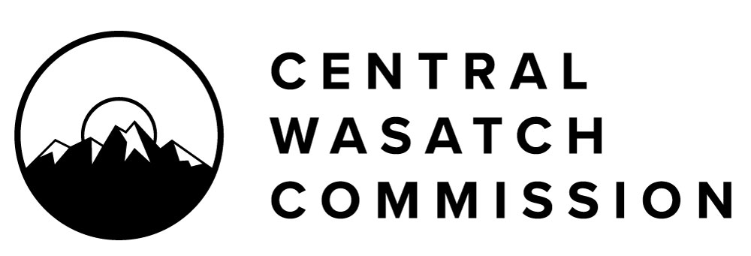

FOR IMMEDIATE RELEASE
April 20, 2022

CENTRAL WASATCH COMMISSION (CWC)
Lindsey Nielsen, Associate Director
801-706-1004, lindsey@cwc.utah.gov

CENTRAL WASATCH COMMISSION RELEASES A BETA VERSION OF THE ENVIRONMENTAL DASHBOARD FOR PUBLIC REVIEW AND OPENS A PUBLIC COMMENT PERIOD THROUGH WEDNESDAY MAY 4, 2022

SALT LAKE CITY, UT – The Central Wasatch Commission released a beta version of its Environmental Dashboard for public review and comment on Wednesday, April 20th. A public comment period on the beta Environmental Dashboard is open through Wednesday, May 4, 2022. The public may access the beta Environmental Dashboard at this link: https://cwcedb.utah.edu/

The Environmental Dashboard is a tool for the public, land managers, policy makers and technical users to learn about the historic and current environmental conditions of the Central Wasatch. The Dashboard contains five environmental elements: air quality and climate, geology and soil, vegetation communities, water, and wildlife, and existing data for each element has been gathered and presented for public access. The boundaries for this environmental dashboard project are based on naturally occurring hydrologic units (or drainage areas) and are independent of the Central Wasatch Commission’s jurisdictional boundary.

Chair of the Central Wasatch Commission, Christopher F. Robinson remarked on the release of the beta Environmental Dashboard, “It is the goal of the Central Wasatch Commission that the Environmental Dashboard is an educational tool that is utilized by everyone, ranging from school-aged children to policymakers and scientific researchers. The Dashboard provides a centralized hub for decades of data for water, air, soil, wildlife, and vegetation in the Central Wasatch. We have worked to make that data accessible, and are proud to release this first, beta version of the Environmental Dashboard to the public for review. It is the culmination of nearly seven years of work on the project.”

The Dashboard is a project and outgrowth of the 2015 Mountain Accord agreement. On March 15, 2016, The Brendle Group, Inc. entered into an agreement with Salt Lake County whereunder Brendle agreed to develop the "Mountain Accord Environmental Monitoring and Adaptive Management Plan, referred to as the Environmental Dashboard. On April 23, 2018, Salt Lake County delegated the management of the Environmental Dashboard to the Central Wasatch Commission (CWC), who has since managed the project. The Brendle Agreement formally ended in 2019.

The CWC project objectives are to:
an adaptable digital product, that could evolve with new information over time,
- to add a public involvement component, and
- to establish a broad spectrum of users as the audience for the Environmental Dashboard.

The Central Wasatch Commission has used the University of Utah (DIGIT and Ehleringer labs) to develop the Environmental Dashboard. The beta version of the Dashboard is the culmination of the project work since 2015.

Following the release of the beta Environmental Dashboard, a two-week public comment period will commence, scheduled April 20th – May 4th. The public may submit comments by:

- Emailing comments@cwc.uath.gov;
- Submitting a comment form at cwc.utah.gov; or
- Mailing written comments no later than May 4th to:
CWC Offices
41 N Rio Grande Street
Ste 102
Salt Lake City, UT 84101

The Central Wasatch Commission is hosting two Open Houses that will serve as beta Environmental Dashboard presentation and discussion forums for the public to engage directly with the developers of the Environmental Dashboard and with Central Wasatch Commission staff. Those Open Houses will take place:

- April 20, 2022, 3:00 p.m. via Zoom and in-person as part of the Central Wasatch Commission Stakeholders Council meeting at the Wasatch Front Regional Front Offices, located at The Gateway
- April 27, 2022, 5:30 p.m. via Zoom

The final version of the Environmental Dashboard is scheduled for rollout during the June 6, 2022, meeting of the Central Wasatch Commission Board.

The public may access the beta Environmental Dashboard at this link: https://cwcedb.utah.edu/

Please note: the data and information displayed on the Dashboard have been collected and assembled by various federal, state, and local governmental agencies other than the Central Wasatch Commission. The CWC’s purpose in providing this Dashboard is to make such information available to the public in a free, centralized location.

ABOUT THE CENTRAL WASATCH COMMISSION
The Central Wasatch Commission is an inter-governmental entity with jurisdictions in the Town of Alta, the Town of Brighton, Cottonwood Heights, Millcreek City, Park City, Salt Lake City, Sandy City, Summit County, with the Utah Transit Authority and Metropolitan District of Salt Lake and Sandy as ex-officio members. Building on the work of Mountain Accord, the Commission seeks to engage the public, build consensus, and coordinate the actions in the Central Wasatch Mountains. Learn more at cwc.utah.gov.

###

For further information, please contact Lindsey Nielsen at 801-706-1004, or lindsey@cwc.utah.gov

