OPEB Board Meeting
Wednesday, November 17th, 2021 – 12:30 PM –1:00 PM
WebEx – Electronic Meeting Only
Meeting video/audio (log in first)
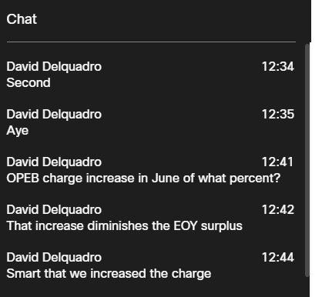
- Roll Call
Trustees Present:
K. Wayne Cushing, County Treasurer
David Delquadro, Council Fiscal Manager (via chat, had problems with microphone)
Lori Okino, Fiscal Administrator, Mayor Operations
Other Attendees:
Brett Carlson, ESR Manager, Mayor’s Financial Administration
Shanell Beecher, Director of Accounting, Mayor’s Financial Administration
Jim Sakellariou, Chief Deputy Treasurer
Mari Vellido, Internal Services Manager, Mayor’s Financial Administration
Absent:
Darrin Casper, Deputy Mayor of Finance and Chief Financial Officer
No members of the public attended.

- Review minutes from 06/30/21 and move to approve
Mr. Delquadro was having audio and microphone issues, so he motioned/voted through the chat.
Mr. Cushing asked the board members if they had a chance to review the minutes from June 30th, 2021.
Ms. Okino motioned to approve the minutes and the group was in favor.

- Year-End Projection – Brett Carlson
(item #4 (YE Projection – Brett Carlson) and #3 (Annual Report Review Draft – Shanell Beecher, All) were swapped.
Mr. Carlson moved on to discuss item #4 - Year End Projection and said that he and Vardhan Nadkarni looked at the OPEB Trust Fund on November 17th, 2021, and projected the fund until December 31, 2021, as shared on the Jan Dec 2021 Proj OPEB Trust Fd spreadsheet. (screenshot attached, review file)
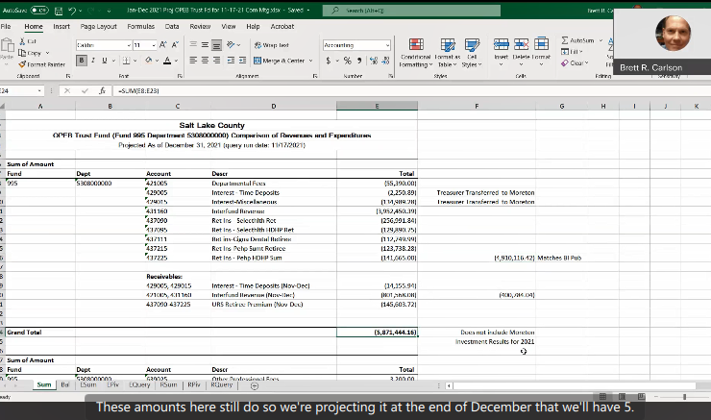
As of November 17, there was $4.9 million in revenue and $5.871 million will be projected at the end of December in recorded revenue. This does not include any adjustment for the Morton investment results for 2021.
The recorded expenses were $3.9 million, and the payables that still needed to be paid like reinsurance, Medicare supplements, and dental were projected to be about $760,000 in expenses. There will be about $75,000 in RX rebates. The projected expenses is $4.605 million which is under the $1.265 million in revenue that can be moved towards reserves in addition to investment gains.
Mr. Cushing asked Mr. Carlson if there was any kind of increase in 2021 because of moving insurance issues to 2021 from 2020 because of COVID delaying elective type of claims.
Mr. Carlson noted that in 2020, there were $4.1 million in expenses and in 2021 there will be an increase to $4.5 million due to a rebound due to the COVID scare and the OPEB charge was increased.
In 2020, there were $849,000 in unrecognized investment gains (market value), but without that, the fund was positive $1.3 million and revenues in 2021 are close to what it was ($1.265 million) and are sitting in the books at Morton.
In the chat, Mr. Delquadro asked what the percentage amount was of the OPEB charge increase in June and Mr. Carlson replied that it was 10% and then Mr. Delquadro typed that the “increase diminishes the EOY (End-of-Year) surplus” and that it was “smart that the charge was increased.” Ms. Okino appended that the contribution added did not account for the increase in the expenses in June.
Mr. Carlson added that the 10% amounted to $437,000 but the increase in the expenses will eat up the OPEB charge increase, so nothing extra was added, and the year before there was an 18% decrease and the fund is not where it was pre-COVID.
Mr. Cushing then said that the OPEB charge will be revisited in the next meeting to see where it ended up.
- Annual Report Review/Draft Edits
Ms. Beecher was able to join the meeting after a meeting she was in went over. She asked if there was anything that the group had for changes and Ms. Vellido included the changes that were submitted and compiled with changes that were suggested.
The group spent 13 minutes reviewing and editing the final draft and Mr. Cushing asked if the draft needed to be approved right then and Ms. Beecher said that it could be approved via e-mail after the draft was sent out to the group. (attached)
- Mr. Cushing asked if anyone had any new items of business or motion to adjourn.
The group did not have any and the meeting was adjourned at 1:58 PM.

The next OPEB meeting was scheduled for Wednesday, February 16th at 11:30 AM via WebEx.

