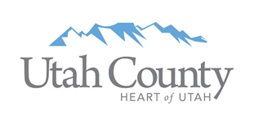

Utah County Tourism and Tax Advisory Board Meeting
Monday, April 18, 2022 @ 11:30am
Sundance Mountain Resort

Agenda

11:30 am Welcome & Working Lunch

11:40 am TTAB 2021 Items
Funding Review update – Danny Wheeler

12:00 pm CITY OF SARATOGA SPRINGS/UTAH LAKE COMMISSION – Saratoga Springs North Marina
Project Funding Request: $5,000,000
Project Reviewer: Kurt Christenson
Project Presenter: Lars Anderson

12:30 pm PROVO CITY– Rock Canyon Trailhead Enhancements
Project Funding Request: $2,658,144
Project Reviewer: John Garfield
Project Presenter: Doug Robins, John Bunderson

1:00 pm TTAB Priority Listing & Additional Discussion
Review current request
Motions

1:30 pm Other Business

2022 Meeting Dates
June 6th – Springville Museum of Art
August 1st – Hyatt Place Provo
October 3rd – Hyatt House Pleasant Grove
December 5th – Provo Marriott Hotel & Conference Center

Roundtable

Next Meeting
Monday, June 6th
11:30am – 2:00pm
Host – Rita Wright (Springville Museum of Art – possible change)

2:00 pm Adjourn

