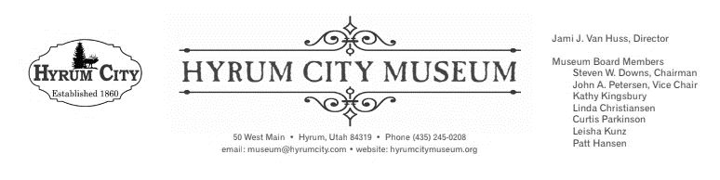
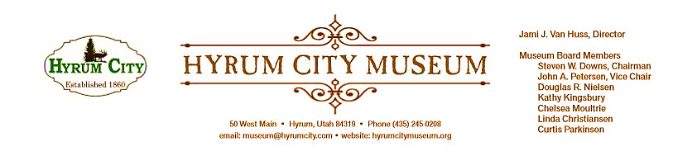

MINUTES OF THE HYRUM CITY MUSEUM BOARD MEETING AUGUST 10, 2021 AT THE MUSEUM BOARD ROOM 50 WEST MAIN STREET, HYRUM, UTAH

CONVENED: 6:02 pm
ROLL CALL, CALL TO ORDER, and WELCOME: Chairman Downs welcomed everyone and called the meeting to order.

THOSE IN ATTENDANCE: Steve Downs, John Petersen, Leisha Kunz, Courtney Cochley, Kathy Kingsbury, Jami Van Huss, Linda Christiansen, Patt Hansen, and Craig Rasmussen.
Curtis Parkinson was excused.
REVIEW OF MINUTES: Patt was excused from the July 13, 2021 meeting, so the minutes need to be changed to reflect she wasn’t in attendance. John motioned to approve the minutes of July 13, 2021, Linda seconded, all voted aye, and the minutes were approved unanimously with that change.
BUSINESS:
- Summer Activities Report
Our pizza passport party was a success with about 50 attendees. Only one family who RSVPed did not show up, but came in later and picked up their prizes since they had car trouble that morning. We had many new people participating this summer and received very positive and helpful feedback on the program. For this month’s Second Saturday event, we’ll hold the official public grand opening of H2O Today on August 14th. We will resume in-person Back in Time children’s activities in September and the 2021—2022 schedule with themes is planned.
- H20 Today Update
It is here! The board is very impressed with how it has turned out and with Courtney’s partner exhibit called Bear River Boa Ogoi: The River is Life. The VIP Grand Opening on August 7th went very well and Jami and Courtney are impressed with the support we received from Utah Humanities, the Utah Division of Arts & Museums, the Utah Division of History, and all of our local partners. There are twelve other companion exhibits throughout the Bear River Heritage Area, along with multiple activities, so all locations are participating in a passport program to both help connect our organizations and also encourage community members to participate in multiple events. All of the museum’s Second Saturday events will be water-related through February. There is a comprehensive calendar and map on the Bear River Heritage Area website with more information on all of the exhibits and programs. We also have dedicated Facebook and Instagram accounts to help promote the exhibition.
- Virtual Activity Resource Review
Jami led a discussion based on an article she distributed to the board that analyzes data about audience expectations regarding continued virtual accessibility to museum programming. Ultimately, there is much greater accessibility with online programming, however, it requires more resources and is logistically much more difficult. There was some discussion about how to offer a hybrid event so that some children were at the museum while others could join online. We also discussed a point made in the article about the major drawback of virtual programming being lack of socialization with other children.

After thinking through offering it as a Zoom class, logistics regarding materials, and other factors, the board determined that museum staff would continue to offer the program on Facebook live at a separate time during the week, and then in-person the three days during the usual time. Then, make packets with any of the left-over supplies that children who watch online can pick-up the next week. This solution balances offering accessibility and not costing too much in resources (both supplies and staff time).

- Other Reports from Board Members
Right now we do not have an intern lined up for fall semester, but we do have one for spring semester. Stuart was very productive and will be greatly missed.
Linda suggested adding a plaque under the poster of the fort in the front to give John credit for creating it. Jami will follow-up.
Jami is working with the city’s power superintendent to get new track lighting installed in the expanded exhibition area while H2O Today is on exhibit.
ADJOURNMENT: 6:57 PM
Dates to Note:
September 11 Second Saturday, 10:00 am—3:00 pm, Historic Hydro Tours
September 14 Board Meeting, 6:00 pm
September 28—30 Back in Time, 1:00—1:30 pm each day, Sandy Surprises
October 8 Second Saturday, 10:00 am—3:00 pm, Where Does H2O Go?
October 12 Board Meeting, 6:00 pm
October 19—21 Back in Time, 1:00—1:30 pm each day, A Sea of Tricks and Treats
October 26—28 Museum Closed for UMA Conference

_____________________________
Steven Downs
ATTEST: Chairman

________________________________
Jami J. Van Huss
Museum Director
Approved:
As Written:_______________________

