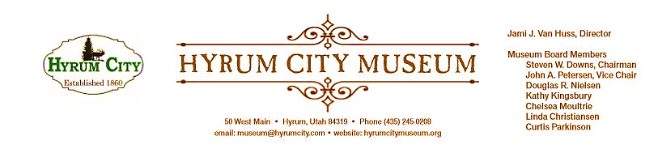

MINUTES OF THE HYRUM CITY MUSEUM BOARD MEETING DECEMBER 10, 2019
AT THE MUSEUM BOARD ROOM 50 WEST MAIN STREET, HYRUM, UTAH

CONVENED: 6:07 pm

ROLL CALL, CALL TO ORDER, and WELCOME: Chairman Downs welcomed everyone and called the meeting to order.

THOSE IN ATTENDANCE: Jami Van Huss, Elisabeth Cropper, Steve Downs, Linda Christiansen, Craig Rasmussen, Curtis Parkinson, John Petersen, Leisha Kunz, and Kathy Kingsbury.

REVIEW OF MINUTES: John motioned to approve the minutes of November 12, 2019. Curtis
seconded. All voted aye and the minutes were approved unanimously as written.

BUSINESS:
1. Programs Report
November Back in Time: The kids made turkeys and each feather had something they were
grateful for written on it. The kids learned how Thanksgiving got its roots from Harvest
Festival/Feasts that began centuries ago in Europe. They were also taught the history of turkeys
and how it has been a part of the American culture for centuries before European settlers even
arrived. Jami took a special trip to Bear River Head Start to teach the kids there as they were
unable to come to the museum this time. Again, we received feedback that the parents like that
there is learning involved and that the parents don’t have to plan/clean up at all.

December Friday Family Movie: Only Jami’s kids came to the family movie. There was an issue
with the sound but it was okay for the small audience. Jami took the time to clean out the closet
and change out the decorations. December movies have consistently had low attendance in the past and Jami proposed not doing a December movie next year and the board agreed.

2. StEPs-UT Report
Elisabeth and Jami went to the workshop on historical structures. This is good for Jami since the museum staff has been given the responsibility of taking care of the cabins as well as the Elite Hall. One thing with structures is being proactive in conservation instead of reactive. The training talked about having plans for how you are going to handle maintenance and other issues. There was emphasis on defining historical resources, ie. the difference between structures and districts as well as the difference between restoration and rehabilitation of a building.

3. Exhibit Update
Exhibit changes are going well. New artwork exhibit featuring Eric Linton is up in the City Council Chambers and the Reflections winners are exhibited in the Community cases. The timeline exhibit is almost done. The traveling exhibition, Utah Women Making History will arrive on Thursday Jan 2, be installed on Friday, and open on Saturday, Jan 4.

4. New Board Member Suggestions
Curtis talked to Pat Hansen and she was very receptive. Her husband, John was with her and was interested in being on the board as well. Jami was wondering if we invite just Pat or both. Following discussion, the board suggested she invite Pat for the Museum Board with the understanding that her husband is invited to help and support and perhaps even and hold John’s name in reserve or for The Historical Committee.

5. 2020 Activities
Object Marking Workshop, January 6, City Council Chambers, 11:00 am—1:00 pm.
Board Meeting and Officer Elections, January 14, 6:00 pm, be here or be elected to something!
Annual Board Training and Dinner, January 31, 6:30 pm, Civic Center.

OTHER REPORTS FROM BOARD MEMBERS:
Church History Museum in Salt Lake has an exhibit on Women and the Suffrage Movement from Utah through 2020—Jami highly recommends seeing it.

Curtis checked in with Doug and while he’s still having many health issues, he is feeling better.

ADJOURNMENT: 6:45 pm

Dates to Note:
Jan 10: Friday Family Movie Night @ Elite Hall, 6:00 pm, Abominable
Jan 14: Board Meeting, 6:00 pm
Jan 21--23: Back in Time, 1:00--1:30 pm each day
Jan 31: Board Dinner and Training, Hyrum Civic Center, 6:30 pm
Feb 7: Friday Family Movie Night @ Elite Hall, 6:00 pm, The Addams Family
Feb 11: Board Meeting, 6:00 pm
Feb 10--15: Museum Closed
Feb 18--20: Back in Time, 1:00--1:30 pm each day

_____________________________
Steven Downs
ATTEST: Chairman
________________________________
Jami J. Van Huss
Museum Director

Approved:
As Written:_______________________

