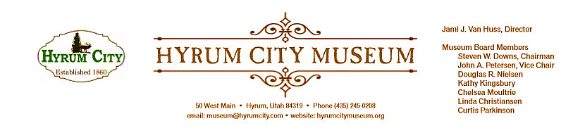

MINUTES OF THE HYRUM CITY MUSEUM BOARD MEETING AUGUST 13, 2019 AT THE MUSEUM BOARD ROOM 50 WEST MAIN STREET, HYRUM, UTAH

CONVENED: 6:07 pm
ROLL CALL, CALL TO ORDER, and WELCOME: Chairman Downs welcomed everyone and called the meeting to order.

THOSE IN ATTENDANCE: Jami Van Huss, Steve Downs, Chelsea Moultrie, Craig Rasmussen, John Petersen and Kathy Kingsbury. Linda Christiansen, Doug Nielsen, Elisabeth Cropper and Curtis Parkinson were excused.

REVIEW OF MINUTES: Approving the minutes from July was deferred until the next meeting.

BUSINESS:
1. Activities Report
Pioneer Games: All the activities went really well and there were about 60-70 people who attended and a lot of them have attended other activities at the museum.
Pizza Party: About 40 children qualified for the Pizza Party and there were 8 children who had achieved a “black out” and received a special prize. Jami reported that it was around 15% increase in attendance and she bought 8 pizzas from Dominos. She also had evaluation forms and there were no negative comments given and the “Blank” squares/volunteer opportunities on the Passport were favorites.
Patriotic Dance: Craig reported that around 120 people attended and they were mostly Hyrum residences and USU students. He also reported that late July is a great time to have this dance for next year and that there was a lot of excitement over the upcoming renovations to Elite Hall.
2. StEPs Update
The Hyrum City Museum has earned certificates from AASLH for the first three StEPs modules: Gold for the Mission, Vision, Governance module and Bronze for both the Management and Audience modules.

Jami reported on the first workshop from the current module, which is Collections. They discussed the principle that “a museum without a collection isn’t a museum,” so the collection is a primary responsibility and we need to take it seriously. She also discussed the immense public trust that museums are subject to, so all information and interpretation needs to be documented, accurate, and objective. Plus, being good stewards over collections is crucial, so we must keep good records of who donated them and if we ever deaccession collections, any profits must be used to either purchase artifacts or conservation materials to care for the existing collection. Finally, since we are a “collecting museum” it is our responsibility to ensure that we have the resources to properly care of these items, which includes creating a secure environment for both storage and exhibition.
3. Historic Homes Tour/ Elite Hall Fall Harvest Festival: Sept. 7th
Steve and John agreed to be guides for the tour again this year and Jami will arrange for the Senior Center’s new 15-passenger van. She will also look into the possibility of using CVTD City Buses. There were suggestions to add the Bean and Pea Processing plants, the Trolley Stations and the Galloping Goose to the tour. Jami wants to record the tour and add it to our digital collection. Fall Harvest Festival will have a chili/soup in bread bowl dinner, bake sale, petting zoo, rock wall, activities, and dance. Jami asked the board to come and support this event at Elite Hall.
4. Utah Museum Association Conference
The conference will be held in Brigham City Sept. 18--20 and Jami will email the program link and registration information for anyone interested in attending.
5. Community and City Council Art Exhibit
Some ideas for art exhibits are Eric Linton, Pat Brimhall (American Girl Doll Clothing), Logan City School Paintings and if anyone has more ideas to email Jami with ideas.
OTHER REPORTS FROM BOARD MEMBERS:
Elisabeth would like a list of residences that can give an oral history of the City of Hyrum.
Chelsea resigned as the secretary and informed the board that the September meeting will be her last. She is moving to Davis County and expressed the interest helping with Hot Wheels and Hot Dogs next year.
ADJOURNMENT: 7:08 pm
Dates to Note:
Sept 10: Board Meeting, 6:00 pm
Sept 10--12: Back in Time, 1:00--1:30 pm each day
Sept 18--20: UMA Conference, museum closed
Sept 28: Utah History Conference, museum closed
Oct 8: Board Meeting, 6:00 pm

_____________________________
Steven Downs
ATTEST: Chairman

________________________________
Jami J. Van Huss
Museum Director

Approved:
As Written:_______________________

