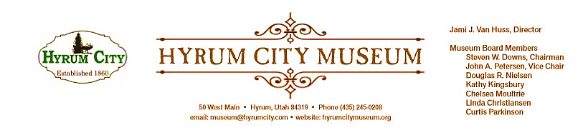

MINUTES OF THE HYRUM CITY MUSEUM BOARD MEETING JULY 9, 2019 AT THE MUSEUM BOARD ROOM 50 WEST MAIN STREET, HYRUM, UTAH

CONVENED: 6:07 pm
ROLL CALL, CALL TO ORDER, and WELCOME: Chairman Downs welcomed everyone and called the meeting to order.

THOSE IN ATTENDANCE: Jami Van Huss, Steve Downs, Chelsea Moultrie, Craig Rasmussen, Linda Christiansen, John Petersen and Kathy Kingsbury. Doug Nielsen, Elisabeth Cropper and Curtis Parkinson were excused.

REVIEW OF MINUTES: John motioned to approve the minutes of June 11, 2019, Linda seconded, all voted aye and the minutes were approved unanimously as written.

BUSINESS:
1. Activities Report
Rodeo Games: Jami reported around 60-70 participants and the activities were: trail mix making, boondoggles, stamping leather keychain tags, coloring pages, and ring toss.
Growing Up Navajo Presentation: Around 85 people attended and Jami was able to record the presentation for the museum archive and hopes to make it available on YouTube.
Grand Old Flag: Jami thanked Steve for using his flag collection and reported that around 350 people attended. There were a lot of kids that had their passports stamped. Steve also said that he has photos to add to the Main Street Display.
2. Upcoming Activities
Pioneer Games: July 18th 1:00-3:00 pm
There will be corn husk dolls, marbles and jacks games, chalkboard slate decoration, bee art activity, and sheep cookies.
Patriotic Big Band Dance: 20th from 7:00-10:00 pm with the cost of $2 a ticket.
The museum will pay the USU Big Band Swing Club to instruct and Cache Community Big Band to provide the music. The foundation will decorate the hall and use several of Steve’s flags.
Passport to Fun Pizza Party: Aug 8th 12:00-1:30 pm
There will be a new “black out” prize for those who have filled out their entire card.

3. StEPs Module Update
Chelsea reported on the last workshop in the Audience Module and spoke about the exercises that helped them think about potential audience members for the museum. They talked about the stumbling blocks that would prevent someone from coming and ways that the museum could eliminate those obstacles. Jami spoke about having a “membership” program with bi-annual newsletters and other perks like discounts for the shop, pins/bumper stickers and maybe a “Night at the Museum” event. The next module will be Collections and Jami will be applying for the certificates for the first three modules.
OTHER REPORTS FROM BOARD MEMBERS:
The board talked about inviting Burton Lumber’s 1923 Lumber Truck to be featured at Hot Wheels and Hot Dogs and to copy photos from the Gunnell Dental Office to add to our Main Street Display. It was also suggested that we get photos of the bean factory and pea vinery.

We have been awarded a $4,000 UDAM Grant for permanent and secure storage that will be built this winter.

Chelsea talked about getting a new Main Street banner made for HWHD event. Our current banner is 2ftx 17ft and we could go as large as 3.5ft x 36ft with our new banner. The board also talked about getting feather banners that say things like: Museum Open, New Exhibit, etc.
ADJOURNMENT: 7:15 pm
Dates to Note:
Aug 8: Passport to Summer Pizza Party, 12:30-1:30pm
Aug 13: Board Meeting, 6:00 pm
Sept 7: Fall Harvest Festival, Historic Tours of Hyrum
Sept 10: Board Meeting, 6:00 pm
Sept 10--12: Back in Time, 1:00--1:30 pm each day

_____________________________
Steven Downs
ATTEST: Chairman

________________________________
Jami J. Van Huss
Museum Director

Approved:
As Written:_______________________

