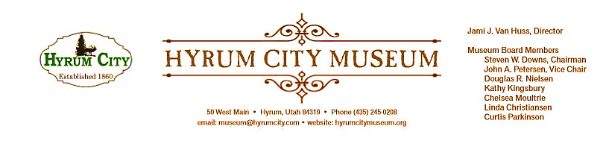

MINUTES OF THE HYRUM CITY MUSEUM BOARD MEETING JUNE 11, 2019 AT THE MUSEUM BOARD ROOM 50 WEST MAIN STREET, HYRUM, UTAH

CONVENED: 6:15 pm
ROLL CALL, CALL TO ORDER, and WELCOME: Chairman Downs welcomed everyone and called the meeting to order.

THOSE IN ATTENDANCE: Jami Van Huss, Steve Downs, Chelsea Moultrie, Craig Rasmussen, Linda Christiansen, John Petersen, Elisabeth Cropper and Curtis Parkinson. Doug Nielsen and Kathy Kingsbury were excused.

REVIEW OF MINUTES: Linda motioned to approve the minutes of May 21, 2019, John seconded, all voted aye and the minutes were approved unanimously as written.

BUSINESS:
1. Upcoming Activities
Rodeo Games June 25, 1:00—3:00 pm: Jami asked for help with this event and for volunteers to arrive around 12:30 pm to help set up. Some ideas for activities are coloring pages, boots bean bag toss, DIY trail mix, boondoggles and a leather stamping station. Chelsea and Steve volunteered to provide materials for the leather stamping station.

Growing Up Navajo Presentation June 27, 7:00 pm (Civic Center): Rose Johnson-Tsosie will be presenting an hour-long presentation about growing up in Hyrum and finding her birth family. Jami asked for board members to help set up chairs and the sound system at 6:00 pm. There will also be refreshments at the presentation.

Grand Old Flag July 4, 10:00 am—3:00 pm (Elite Hall): Steve will be setting up his flags at the Elite Hall on July 3rd. We need volunteers to come help set things up and to bring irons/boards to prepare the flags to be displayed. Jami will be setting up a small historic Main Street display and Chelsea will bring signs for outside. We will also need help cleaning up after the event from 3:00—3:30 pm.

2. Hot Wheels and Hot Dogs Evaluation
Jami passed out a preliminary budget, which itemized income totals. The highlights are:
Total Gross Income: $9,785, Expenses: $1,500, Grand Total Net: $8,631. Chelsea reported that 2,986 tickets were sold for the drawings which amounts to around $746. The silent auction items sold for a total of $1,574.

The board members then discussed their Hot Wheels and Hot Dogs Evaluation sheets.
Promotion Suggestions: More posters in Brigham City, Tremonton and North Cache. New banners for over the road, on the fence, and feather banners for next year
Food Suggestions: More orange soda, lemonade, root beer, hotdog buns, popcorn, trays and two grills for next year. Less onions and condiment table flow suggestions.
Layout: No cars parked in front of Treat Tent and Lunch Line areas and another speaker.
Cars: Have cars arranged in a circle at the front to receive awards, have registration paid in advance for reserved spots, have people pay more for reserved parking and limit two saved spots per one early car.

OTHER REPORTS FROM BOARD MEMBERS:
No other reports at this time
ADJOURNMENT: 7:30 pm
Dates to Note:
July 9: Board Meeting, 6:00 pm at Kindred Reading Room
July 18: Pioneer Games, 1:00--3:00 pm
July 20: Patriotic Big Band Swing Dance, 7:00--10:00 pm at Elite Hall
July 24: Pioneer Day, Museum Closed
Aug 8: Passport to Summer Fun Pizza Party, 12:30--1:30 pm
Aug 13: Board Meeting, 6:00 pm at Kindred Reading Room

_____________________________
Steven Downs
ATTEST: Chairman

________________________________
Jami J. Van Huss
Museum Director

Approved:
As Written:_______________________

