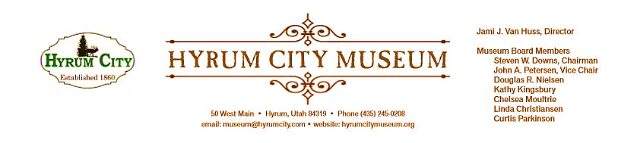

MINUTES OF THE HYRUM CITY MUSEUM BOARD MEETING APRIL 9, 2019 AT THE MUSEUM BOARD ROOM 50 WEST MAIN STREET, HYRUM, UTAH

CONVENED: 6:10 pm

ROLL CALL, CALL TO ORDER, and WELCOME: Chairman Downs welcomed everyone and called the meeting to order.

THOSE IN ATTENDANCE: Jami Van Huss, Elisabeth Cropper, Steve Downs, John Petersen, Chelsea Moultrie, Craig Rasmussen, Linda Christiansen, Kathy Kingsbury, Doug Nielsen and Curtis Parkinson.

REVIEW OF MINUTES: John motioned to approve the minutes of March 12, 2019, Doug seconded, all voted aye and the minutes were approved unanimously as written.

BUSINESS:
1. Board Resource Training Fundraising Follow Up
The board presented the ideas of allowing the use of our scanner to digitize photos at a small fee to the public, promoting a Grandparents Day at the museum, emailing a monthly newsletter, and having vintage car rides around the City Square for a small admission. Some suggestions for items to sell at the soon-to-come Hyrum Museum Store were postcards, Elite Hall ornaments, buttons, lanyards, wooden items from Hawn’s, and “kissing wall” items. Jami also suggested anything that represents Hyrum Lore like the Indian Princess, the Hyrum Reservoir Monster, Old Ephraim skull, Blacksmith Fork Canyon, and JBS air fresheners. Jami also spoke with Todd about sales tax and turning cash in monthly to the City offices.

2. StEPs-UT Update
The March workshop was on how to engage our audience and how to work with other organizations to bring awareness to our museum. Craig suggested us working with the Cache DUP chapter and to keep an eye out for other like-minded organizations we can work with. Jami added that our new assignment for this module is to evaluated an exhibit or event at the museum and it was decided that we will evaluate Diversity Night. We will send out a survey to those who provide their email addresses and collect their feedback.

3. Diversity Night 2019
This year our Diversity Night will be centered around the Northwestern Band of the Shoshone Nation and how the completion of the railroad affected them. Chairman Darren Parry will be speaking Saturday, April 20 from 5:30—8:00 pm in the City Council Chambers. Following the presentation, there will be food after the speaker and a few children’s activities in the museum.

4. Hot Wheels and Hot Dogs
Everyone gave updates on sponsorships. Jami said she will pick up around 800 hot dogs from Theurer’s and ice cream from Casper’s the Friday before the event. Craig will speak to the Youth Council about helping and Steve will print out our flyers/posters for the event as soon as the graphic designer is finished updating them.

OTHER REPORTS FROM BOARD MEMBERS:
Jami handed out the new stickers that will be given at the front desk to those who visit the Hyrum Museum.

Our application in partnership with the Bear River Heritage Area for the Smithsonian’s “Waterways” traveling exhibition in 2020--2021 has been accepted and there will be companion exhibits throughout the valley. Craig reported that he mentioned this to the City Council and they are very excited about it.

ADJOURNMENT: 7:35 pm

Dates to Note:
May 21: Board Meeting, 6:00 pm
May 27: Memorial Day Open House, 9:00--12:00 noon
June 1: Hot Wheels and Hot Dogs, 10:00--3:00 pm
June 11: Board Meeting, 6:00 pm
June 25: Rodeo Games Children’s Activity, 1:00--3:00 pm
July 4: Grand Old Flag Event, 11:00--3:00 pm @ Elite Hall

_____________________________
Steven Downs
ATTEST: Chairman

________________________________
Jami J. Van Huss
Museum Director

Approved:
As Written:_______________________

