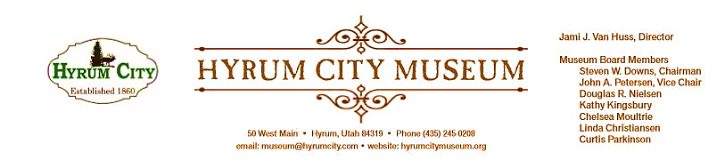

MINUTES OF THE HYRUM CITY MUSEUM BOARD MEETING ​MARCH 12​, 2019​ AT THE MUSEUM BOARD ROOM 50 WEST MAIN STREET, HYRUM, UTAH

CONVENED: 6:05 pm

ROLL CALL, CALL TO ORDER,​ and WELCOME: Chairman Downs welcomed everyone and called the meeting to order.

THOSE IN ATTENDANCE: Jami Van Huss, Elisabeth Cropper, Steve Downs, John Petersen, Chelsea Moultrie, Craig Rasmussen, Linda Christiansen and Kathy Kingsbury. Doug Nielsen and Curtis Parkinson were excused.

REVIEW OF MINUTES: The following corrections were made to the minutes: strike the mention of the mounted elk head and Madelene’s name will be taken off the header. With these corrections John motioned to approve the minutes of February 12, 2018, Linda seconded, all voted aye and the minutes were approved unanimously.

BUSINESS:
1. StEPs-UT Report
Craig reported that this was the last workshop for the Management module and that we will be starting the next module on Audience. He explained that hiring questions, employee roles and employee evaluations and emergency procedures were discussed. Jami commented that her take away was how an employee and employer need to be in a circle of communication. Discussion followed and some suggestions to better prepare the museum for emergencies are door sensors, epi-pens, a first aid kit, and emergency practice drills for the entire building. The next StEPs-UT meeting is March 25th.

2. Baby Animal Days Booth
Jami passed around a sign-up sheet to help man a booth at baby animal days. She explained that the museum will be sharing a booth with the Hyrum Heritage Foundation and it will include a fishpond as well as flyers promoting HWHD and Passport to Summer.

3. Board Resource Training
Jami handed out a technical leaflet from AASLH History News for the board to read over. It
was a list of effective ways that small museums/organizations raise money in their community. She asked the board to look through this resource and let her know if any of these spark ideas. Next meeting each member of the board will talk about an idea that could work for us here in Hyrum.

4. Hot Wheels and Hot Dog Sponsor Assignments
The board went around and gave updates the HWHD Sponsorships they were assigned. Everyone was reminded to get as many final answers by the April meeting as possible. Marketing material will be printed and ready to distribute for the first of May, so we will need to have logos by the April meeting. Jami reported that she received an email asking if the face painting booth could waive their fee this year or give a percentage of their profits to the board. She also was asked if the Mountain Crest High School Band could sell cotton candy at this event as a fundraiser. After some discussion, the board resolved to turn down both requests because we want to be consistent with our vendor guidelines and not make exceptions. Jami will notify both groups.

OTHER REPORTS FROM BOARD MEMBERS: Steve reported that he will print more Hyrum Homes Tour books and change the header for the next meeting.

ADJOURNMENT: 7:15 pm

Dates to Note​:
April 3--6: Baby Animal Days Booth
April 9: Board Meeting and HWHD Final Sponsorships
April 20: Diversity Activity, 5:30--8:00 pm
May 14: Board Meeting
May 27: Memorial Day Open House
June 1: Hot Wheels and Hot Dogs

_____________________________ Steven Downs
ATTEST: Chairman

________________________________
Jami J. Van Huss
Museum Director

Approved:
As Written:_______________________

