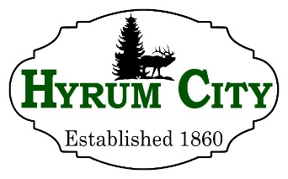
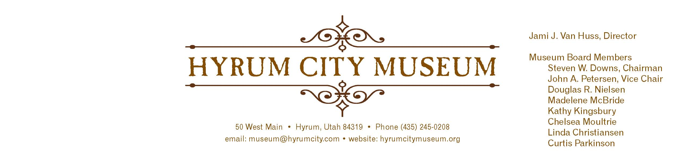

MINUTES OF THE HYRUM CITY MUSEUM BOARD MEETING ​FEBRUARY 12​, 2019​ AT THE MUSEUM BOARD ROOM 50 WEST MAIN STREET, HYRUM, UTAH

CONVENED: 6:10 pm

ROLL CALL, CALL TO ORDER,​​ and WELCOME: Chairman Downs welcomed everyone and called the meeting to order.

THOSE IN ATTENDANCE: Jami Van Huss, Elisabeth Cropper, Steve Downs, John Petersen, Chelsea Moultrie, Craig Rasmussen, Linda Christiansen, Doug Nielsen and Curtis Parkinson. Kathy Kingsbury was excused.

REVIEW OF MINUTES: John motioned to approve the minutes of January 8, 2018, Curtis seconded, all voted aye and the minutes were approved unanimously as written.

BUSINESS:
1. Exhibit Updates
Steve and John will come in this Friday to place the trains into the Community Exhibit display cases. Jami reported that the back exhibit is open and that the Branding exhibit is on loan from the BRHA. This exhibit will go to North Logan Library beginning in the summer. Elisabeth reported that someone featured in this exhibit had enjoyed seeing himself in it. Jami also said she has more to display for the Veterans Exhibit and she is working with an intern to complete the Fire and Police Exhibit in the corner. The Main Street Exhibit has a plan and Jami will work more on it after our Hot Wheels and Hot Dogs event. Elisabeth reported that she may know someone with Veteran items from Desert Storm. Jami suggested using the Smithsonian display kiosks for the Boy Scout exhibit. Jami reported the class she teaches in the Fall will be working on an exhibit about focusing on music in Cache Valley from the late-1800s to the opening of Elite Hall this will include band uniforms and instruments already in the museum’s collection.

2. Strategic Plan Update
Jami presented the Strategic Plan 2019--2020, starting in 2020 we will move to a five-year plan that will have deadlines for upcoming projects. Jami added a brief the history of the museum
and she made a few other changes and corrections. Steve asked for a motion to approve the Strategic Plan and the board approved it unanimously.

3. Hot Wheels and Hot Dogs
Jami distributed a list of sponsor assignments for 2019 and the sponsorship forms that businesses will fill out the bottom of and return to us. She refreshed everyone’s memory regarding the different level of sponsorships and an easy way to reach out to retailers. Chelsea will collect items and money if needed. Our next board meeting will be the deadline for contacting the different retail locations. The following are the sponsor assignments: Steve: Down’s Printing, Hyrum Tire & Auto Repair and Alloy Wheel Repair. John: Autumn Pride, Hair Station, Mountain Yard Art, West Motor Company and Stucky Chiropractic. Doug: Old Gristmill and McDonalds. Craig: Charlie’s Ice Cream, Advance Auto Parts, Cal Ranch, Kartchner Homes and Blackstone Products. Curtis: Renegade Sports, Autozone (South) and Sharp Transportation. Linda: Reeds Pharmacy, Cox Honeyland and Hyrum Senior Center. Madelene: Integrated Electrical Sol, Hyrum 66, Jack’s Tire and Oil, Icon and Hyrum Short Stop. Jami: Darrell’s Appliance, Weston Restorations, Pepsi, Frito-Lay, Theurer’s Quality Meats, Al’s Trophies and Frames, Gwen Christiansen, Willow Valley woodworking, Tractor Guy, Macey’s and Kettlecorn of Cache Valley. Chelsea: Many other places.

OTHER REPORTS FROM BOARD MEMBERS: Curtis offered to let Jami look at some of his scouting items from the 1950s. He also suggested contacting Richard Williams about photos of trains. The board members shared memories of Dr. Burgess and Otey Benson and talked about adding recorded anecdotes from community members.

ADJOURNMENT: 7:30 pm

Dates to Note​:
March 8: Family Movie Night
March 12: Board Meeting
April 3-6: Baby Animal Days Booth
April 9: Board Meeting
April 20: Diversity Activity

_____________________________
Steven Downs
ATTEST: Chairman

________________________________
Jami J. Van Huss
Museum Director

Approved:
As Written:_______________________

