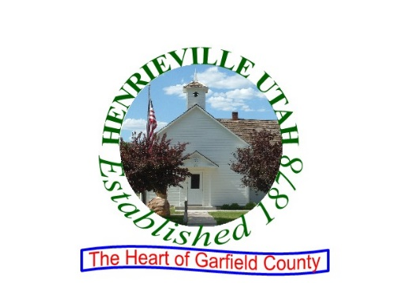
Council Members

Ray Overson, Roads
Cliff Mathews, Community Development
Daniel Medina, Parks and Recreation
Jennilee Shakespear, Water

Clerk
Marie Jaggar
Mayor
Dale Pollock
P.O. Box 125 70 W. Main St. Henrieville, Utah 84736-0125 Phone 435-679-8581

Entity: HENRIEVILLE TOWN
Body: HENRIEVILLE TOWN COUNCIL
Subject: Grant Proposals
Notice Title: Community Development Block Grant (CDBG) Second Public Hearing
Notice Type: Hearing
Date and Time: MAY 4, 2022, 7:00PM

Description/Agenda:

COMMUNITY DEVELOPMENT BLOCK GRANT (CDBG) SECOND PUBLIC HEARING NOTICE

HENRIEVILLE TOWN will hold a public hearing to discuss the project determined to be applied for in the CDBG Small Cities Program in Program Year 2022. Henrieville proposes to submit an application for the HENRIEVILLE TOWN PLAYGROUND PROJECT located at 70 West Main, Henrieville, UT 84736. Comments will be solicited on project scope, implementation and its effects on residents. The hearing will begin at 7:00 P.M. on MAY 4, 2022, and will be held at HENRIEVILLE TOWN HALL, 70 WEST MAIN, HENRIEVILLE, UTAH 84736. Further information can be obtained by contacting MARIE JAGGAR at 435-679-8581. In compliance with the Americans with Disabilities Act, individuals needing special accommodations (including auxiliary communicative aids and services) during this hearing should notify MARIE JAGGAR at HENRIEVILLE TOWN OFFICE AT 70 WEST MAIN, HENRIEVILLE, UTAH 84736 at least three days prior to the hearing. Individuals with speech and/or hearing impairments may call the Relay Utah by dialing 711. Spanish Relay Utah: 1.888.346.3162.

Published the State of Utah’s Public Meeting Notice Website – www.utah.gov/pmn on
11 APRIL 2022

