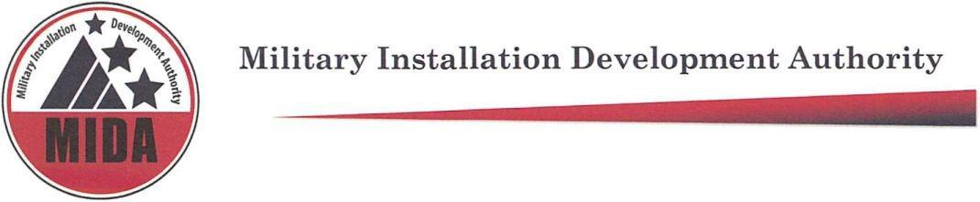

MIDA Board Meeting Pending Minutes April 5, 2022 @ 9:00 a.m.
Zoom Teleconference
To hear the audio recording of this meeting please go to: https://www.utah.gov/pmn/sitemap/notice/745495.html

Board Members Present: Jerry Stevenson, Gary Harter, Steve Farrell, Mark Shepherd, Gage Froerer, Ben Hart^

Board Members Excused: Mike Ostermiller, Stuart Adams,

^Non-voting board member

Agenda item (1) Welcome: Mark Shepherd

Agenda item (4)a Military Recreation Facility Project Area Update

Kurt Krieg: Extell update (3:02 – 14:40)

Agenda item (2) Approval of Minutes for January 11, 2022.

Steve Farrell: Motion to Approve January 11, 2022 minutes

Gage Froerer: Second

Jerry Stevenson, Gary Harter, Steve Farrell, Mark Shepherd, Gage Froerer vote “aye” in favor of approving minutes from January 11, 2022. None are opposed. The motion passes.

Agenda item (3) Consideration of Resolution 2022-04 Approving a Ground Lease Agreement with BLX Warehouse LLC for Lot 20 in the Military Recreation Facility Project Area

Paul Morris and Kurt Krieg: Explanation of Ground Lease (16:12 – 21:02)

Kurt Krieg, Paul Morris, Gary Hater, Steve Farrell: Further discussion regarding warehouse and its use (21:28 – 24:59)

Mark Shepherd: If there are no further questions, I will take a motion.

Gage Froerer: Motion to Approve Resolution 2022-04 Approving a Ground Lease Agreement with BLX Warehouse LLC for Lot 20 in the Military Recreation Facility Project Area

Steve Farrell: Second

Jerry Stevenson, Gary Harter, Steve Farrell, Mark Shepherd, Gage Froerer vote “aye” in favor of approving Resolution 2022-04 Approving a Ground Lease Agreement with BLX Warehouse LLC for Lot 20 in the Military Recreation Facility Project Area. None are opposed. The motion passes.

Agenda item (4)b Military Recreation Facility Project Area Update

Tyler Aldous: SkyRidge update (26:27 - 30:13)

Jack Johnson: Golf and Equestrian centers update (30:16 – 34:03)

Tyler Aldous: Trails and Lodge updates (34:05 – 37:27)

Mike Kosakowski, Paul Morris, Kurt Krieg: Discussion regarding north portal construction timeline, and traffic impact. (37:50 - 42:51)

Gary Harter, Kurt Krieg: Discussion regarding apartments, parking, traffic impacts, and housing affordability (42:57 – 46:21)

Agenda item (5) Falcon Hill Project Area Update

Taylor Woodbury, SRDP: Updates regarding north gate timeline, UDOT design build for 5600 S interchange and 1800 N traffic studies, RIC Campus update, building 4, and Jack in the Box opening. (46:33 – 50:28)

Agenda Item (6) Executive Director / CFO Report

Paul Morris: Legislative session and funding updates (50:47 – 1:08:05)

Paula Eldredge: 2022 Quarter 2 Finance Report (1:08:12 - 1:12:19)

Paul Morris: Further explanation of budget, spending, and income (1:12:20 - 1:16:34)

Agenda Item (7) Other Business

Agenda Item (8) Adjourn Meeting

Steve Farrell: Motion to Adjourn Meeting

Mark Shepherd: Second.

Steve Farrell, Mark Shepherd, Gage Froerer vote “aye” in favor of adjourning meeting. None are opposed. The motion passes.

Meeting adjourned at: 10:17

Meeting Attendees: Sara Turner, Derek Brenchley, Paula Eldredge, Ariana Farber, Kurt Krieg, Michelle Jensen, Rob Donigan, Jack Johnson, Paul Morris, Taylor Woodbury, Tyler Aldous, Ashley Burr, Michael Wagstaff, Heather Kruse, Dave Williamsen, Kristin Williams, Cory Shupe, Richard Catten, Chandler Beutler, Michael Kosakowski, Troy McChesney, Jack Walkenhorst, Bill Coleman, Brett Christensen, Mike Davis, Allison Aafedt, Abraham Van Der Spek, Roger Henriksen, Brent Hall, Ben Lasseter, Paul Persell, Val Oveson, Brian Garrett.

