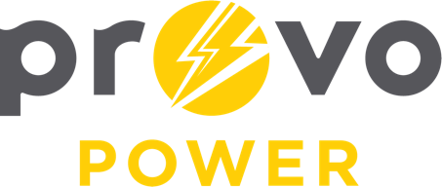
AGENDA
ENERGY BOARD MEETING PROVO POWER
Monday, April 4, 2022
4:00 P.M.

- Welcome & Introductions - Chairman Ned Hill
- Review & Approval of Minutes – March 7, 2022
- Financial Report – Charlie Fuller
- KPI Report – Charlie Fuller
- Budget Review – Travis Ball
- Calendar & Scheduling
  - Next board meeting: May 2, 2022

A copy of the agenda was posted in the Civic Center, and the Provo City Library, on March 30, 2022, and also delivered to the Mayor,
City Council Members, required news media, and adjacent cities in
compliance with the Utah Code 52-4-202

