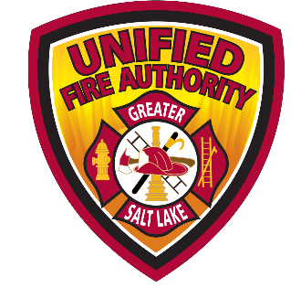
UFA
UNIFIED FIRE AUTHORITY

UFA Liaison Report for March

- UFA Budget update: UFA Divisions are hard at work developing their individual budgets to be included in the overall UFA budget proposal. Meetings with the Budget Committee and Fire Chief will happen over the next few months with a presentation to the Board Finance Committee on April 15. The full Board reviews the budget on May 17 with final approval scheduled for June 21.

- New Fire Chief: Dom Burchett has been chosen to be the new Fire Chief of UFA. With the retirement of Chief Dan Petersen on April 1, The UFA Board of Directors formed an AdHoc committee last September made up of several Mayors. The Board decided to initially recruit from within the organization and received three strong candidates who are Chief Officers in the UFA today. That process will was held on March 9 and 10 with the full Board discussing the potential selection at the March 15 Board of Directors meeting. A “Change in Command” ceremony will be held April 2 at the Jordan Academy for Technology (JATC) building in Riverton.
- Construction Update: Midvale Station 125: Construction is about half way through. Exterior walls are complete and this week, steel beams for the roof structure, interior framing and roof decking are being installed. We are still anticipating substantial completion of the station in August.
Magna Station 102: Geotech study findings indicated that Station 102 is in a liquefaction zone. Installation of aggregate piers is required to mitigate this issue. This has created some delay in construction, but the project is expected to get underway soon.
Eagle Mountain (251&253): The city approved the site plan last month for 251 and a construction bid closes in late February with selection expected soon. After awarding the contract, construction should begin soon. Station 253 will be located on Mid-Valley Road and the site plan application will be presented to the planning commission this week, hoping to get an approved proposal in front of City Council in March. Once approved, a bid process will begin to select a contractor.
- Firefighter Recruitment efforts: Recruit class 55 has 23 recruits that have been engaged in actively learning fire dynamics, tactical ventilation, saw safety and maintenance. Their physical fitness and fire ground capability has really improved along with their team cohesion. They are currently in week four, the class will come back together in week six with all 23 recruits being on the same schedule. Graduation for our recruits will be on May 19 at the JATC in Riverton.

- Legislative Session: As the 2022 Legislative session concluded, Assistant Chief Riley Pilgrim along with UFA’s lobbyists monitored several bills. We are worked closely with the State Chiefs, Utah Association of Special Districts and other special interest groups to ensure our concerns and/or support were heard.

- Retires: Captain Jim Johnson, Hazmat Tech Peter Gordon have both retired from the department.

Respectfully submitted,

Captain Michael Conn
Emigration Canyon Liaison
Cell 801.809.2210
Email mconn@unifiedfire.org

