Kanosh Town Corporation held a Public Hearing Wednesday, February 9, 2022, in the Town office at 7:00 p.m.
Members present Mayor Scott McDonald, Council members: Neil Shumway, Brandon Stephenson, Hayden George, and David Whitaker. Kanosh Town Clerk, Cindy Turner.
Others in attendance: Town Employee Lorin Shumway, CentraCom Representatives, Dixie Power representatives Colin Jack and Brandon Cummings, Stan Koyle, Beaver Lawnscape Bob Davidson, Ranae Davidson, Steve Crabb, Dan Neville, Star Cummings, Val Nafus, CERT Captain Geri Minton, John Pratt, Jared Blad, Shannon Blad, and Bart Whatcott.
Mayor McDonald welcomed all in attendance to the Public Hearing. The purpose of the public meeting is to discuss a change to our ordinance regarding the delivery of power and water.
Councilmember Neil Shumway explained that the topic of discussion in the public hearing tonight would be to discuss change of our ordinance regarding power and water: 001072, An ordinance establishing and adopting impact fees on development activities within the service area of Kanosh Town, Utah.
The ordinance has multiple references to service areas. In Section 1-3 A. It defines the service area as "Within the Town Boundaries". The proposal to discuss tonight is about the connection on the north end of town as well as others that have happened around town. At one point, providing electrical services outside of the town boundaries posed a concern due to our voltages and the way the infrastructure was set up. With various upgrades, this is no longer a concern for the Town of Kanosh.
The proposal tonight is to leave:
1-3 Services Areas Established
A. Within the Town Boundaries.
ADD:
B. Kanosh Town may provide Electrical Service outside of Town Boundaries when agreed upon by Kanosh Town and Dixie Power in writing.
We would not be changing anything on the other services we provide, only the electrical as stated in the one sentence.
Councilmember Shumway did speak with the Kanosh Town attorney and he stated that this should address the issue, but he emphasized that we do need to have the agreement with Dixie Power in writing. He also recommended we move quicker on something that we could to do a temp service and have the permanent service be pending written approval.

It was also noted that on page 21 of the Kanosh Town Plan it states:
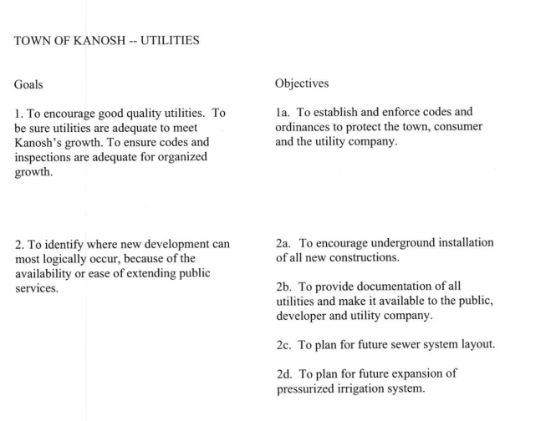

This Public Hearing concluded at 7:35 PM
Kanosh Town Corporation held the regular council meeting on Wednesday, February 9, 2022, electronically and in the town office at 7:35 p.m.

Members present:
Mayor Scott McDonald, Councilmember: Brandon Stephenson, David Whitaker, Neil Shumway, and Hayden George, and Kanosh Town Treasurer Karen Crook, Kanosh Town Clerk: Cindy Turner.

Others in attendance: Town Employee Lorin Shumway, CentraCom Representatives, Dixie Power representatives Colin Jack and Brandon Cummings, Stan Koyle, Beaver Lawnscape Bob Davidson, ReNae Davidson, Steve Crabb, Dan Neville, Star Cummings, Val Nafus, CERT Captain Geri Minton, John Pratt, Jared Blad, Shannon Blad, and Bart Whatcott.
Mayor Scott McDonald welcomed everyone in attendance and opened the regular Kanosh Town Council meeting.
Mayor McDonald offered the opening ceremonies through an invocation.
Councilmember Hayden George led everyone in attendance in the Pledge of allegiance.
Minutes of the January 12, 2022 meeting were read and were approved as amended through motion by Councilmember Hayden George, Councilmember Brandon Stephenson provided a second to the motion, all Council members voted in favor as noted below:
Mayor Scott McDonald: Aye
Council members
David Whitaker: Aye
Brandon Stephenson: Aye
Neil Shumway: Aye
Hayden George - Aye

Warrants for February 2022 were read discussed and approved to be paid through a motion by Councilmember Neil Shumway, Councilmember David Whitaker seconded the motion, all Council members voted in favor as noted below:
Mayor Scott McDonald: Aye
Council members
David Whitaker: Aye
Brandon Stephenson: Aye
Neil Shumway: Aye
Hayden George: Aye

CERT:
CERT Captain Geri Minton stated CERT has nothing new to report at this time.

Kanosh Town Fire Department: Fire Chief Shumway:
Chief Shumway addressed the Council reporting that our volunteer Firefighters responded to an accident involving one of our community members, the firefighters pulled together and worked together well, delivering our best in the accident.

Planning and Zoning Commission:
Planning and Zoning member Geri Minton stated the Planning Commission has nothing new to report or to present to the council at this time.

Mayor McDonald appointed Mr. Steve Crabb to fulfill the remainder of Blaine Blad’s term on the Planning and Zoning Commission Board.

Dixie Power Representatives Colin Jack and Brandon Cummings
Colin Jack addressed the Council members stating that the Town of Kanosh feeds their electricity over a line that used to feed out of Meadow and came to Kanosh. A few years ago Kanosh sold the first three miles of the line to Dixie Power. Dixie Power built a step-down sub because Dixie Power uses 25 KV in this area and Kanosh uses 12.5 KV, after the purchase of the first 3 miles Dixie Power reinsulated the line 25 KV and then just right outside of Town, they step it down to the 12.5KV. Between where Dixie Power purchased the first three miles, there is another mile and a half of line that they have already reinsulated and have energized at 25 KV, now it is apparent that they should have bought 4 and 1/2 miles of the line rather than just the 3 miles of line. With the purchase of the last mile and a half, they could help improve their service to the Paiute Indian Reservation. When they purchased the first 3 miles they paid around $100,000.00 and with that proposed purchasing the other 1 1/2 mile for $50,000.00. Verbally Dixie Power agreed to the purchase of 60,000.00

Following an in-depth discussion Dixie Power agreed to draft a proposal in time for next month's meeting, however before anything is agreed upon, our attorney Justin Wayment will go over it.

Discussion using money as a credit towards projects in town.
Centracom Representatives
Centracom Representatives announced their intent to bring fiber home service to Kanosh. The Tower north of Kanosh is providing service to the Reservation through a radio link, there is a fiber line that goes from the tower out to the reservation. Centracom presented the following map:
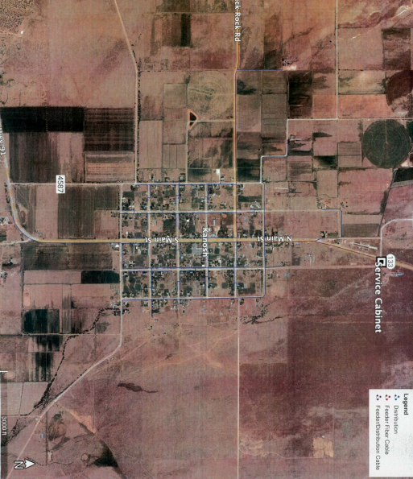

Councilmember Brandon Stephenson motioned to adopt the possible amendment to section 1-3 b of Ordinance 071002, Councilmember Hayden George provided a second to the motion, all Council members voted in favor as noted below through a roll call vote:
Mayor Scott McDonald: Aye
Council members
David Whitaker: Aye
Brandon Stephenson: Aye
Neil Shumway: Aye
Hayden George: Aye

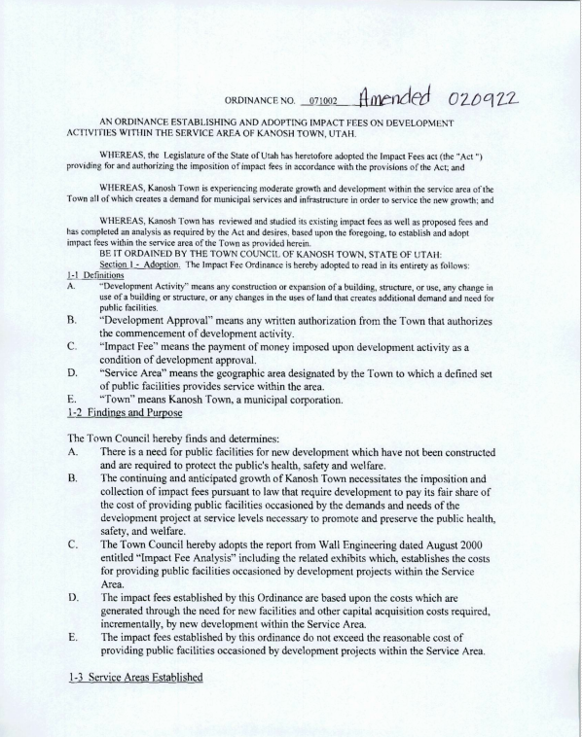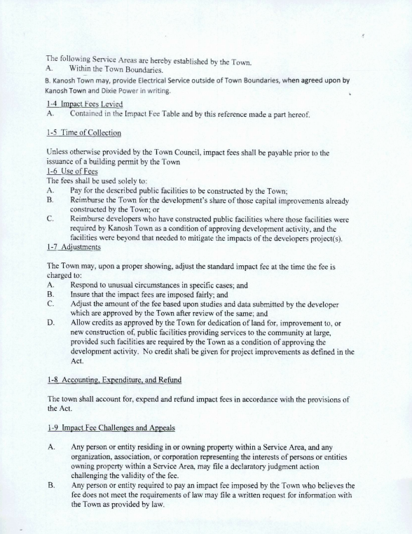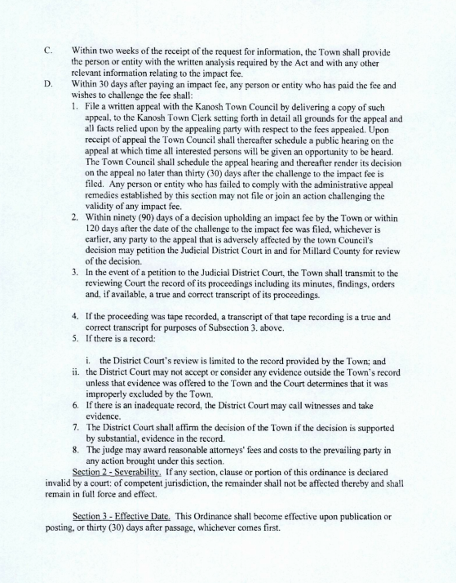
Councilmember Hayden George motioned to provide temporary service to CentraCom, through a verbal agreement with Dixie Power. Permanent power for CentraCom will be pending a written agreement with Dixie Power. Councilmember Neil Shumway provided a second to the motion, all Council members voted in favor as noted below:
Mayor Scott McDonald: Aye
Council members
David Whitaker: Aye
Brandon Stephenson: Aye
Neil Shumway: Aye
Hayden George: Aye
Note: This action will be ratified in March 2022.

Bob Davidson of Beaver Lawnscape.
Mr. Davidson provided cost estimates for continued services. To include the number of applications needed.
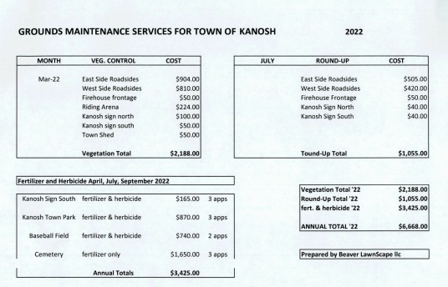

The cost of fertilizers has "doubled", the cost of "Roundup" has also doubled. Beaver Lawnscape was able to purchase their product before the "cost went through the roof".
Kanosh has a very definite Goat Head problem. Goat heads come out in July, so spraying the pre-emergent must take place before the goat heads flower out. Currently, our roads are being sprayed 8 feet on the roadsides. A discussion of spraying 15 feet on each side of the road and then spot spray. The tree roots in private residents could be adversely affected with that broad of a path on the roadsides. This service has to go out to bid as this is an annual contract.
Beaver Lawnscape is going to prepare his bid to include the goat head control, a herbicide for the cemetery, in addition to the grounds maintenance.
Councilmember Brandon Stephenson will put it out to bid tomorrow, then award the contract in the March meeting.
F450 bid award:
John Pratt 2555.00 had the highest bid.
Mel Gamble 300.00
Earl Gardner: 1252.00
Steve Crab: 555.55
Richard Penney 2150.00

Councilmember Brandon Stephenson motioned to accept John Pratt's bid of $2,555.00 on the F450. Councilmember Hayden George seconded the motion all Council members voted in favor as noted below:
Mayor Scott McDonald: Aye
Council members
David Whitaker: Aye
Brandon Stephenson: Aye
Neil Shumway: Aye
Hayden George: Aye

Resolution of UAMPS representative
Councilmember David Whitaker motioned to appoint Councilmember Neil Shumway as the UAMPS representative, Councilmember Hayden George seconded the motion, all Council members voted in favor as noted below:
Mayor Scott McDonald: Aye
Council members
David Whitaker: Aye
Brandon Stephenson: Aye
Hayden George: Aye
Councilmember Neil Shumway abstained from the vote.
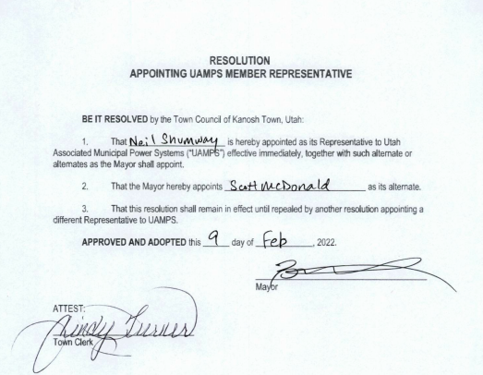

Review of Letter to be sent to the county in reference to the dumpsters.
Council members reviewed the draft of the letter prepared by Councilmember David Whitaker. Councilmember Whitaker read the letter and agreed to redraft it implementing suggestions rendered in this meeting.

Councilmember Whitaker called the people in charge of the landfill and learned that the county is working on ways to amend the problem.

Councilmember Brandon Stephenson motioned to approve and send the redraft of the letter with the changes discussed, Councilmember David Whitaker provided a second all Council members voted in favor as noted below:
Mayor Scott McDonald: Aye
Council members
David Whitaker: Aye
Brandon Stephenson: Aye
Neil Shumway: Aye
Hayden George: Aye

Below is the redraft of the letter:
To whom it may concern,
We have a concern with regards to the dumpsters that are used by Kanosh town citizens that we would like to pass on to those who manage the Millard County Landfill. Some of our elderly citizens are not able to lift garbage bags high enough to deposit them in the dumpsters up on the platform. Also due to the dumpster’s height, it can also be a challenge for them to open the lids. As a corollary to this problem, we are seeing increased household garbage that should have been loaded into the dumpsters being deposited elsewhere in town.
To resolve these issues, we request that adjustments be made at the platform of the transfer site to reduce the height that trash has to be lifted into the dumpsters in order to allow our elderly citizens to dispose of their garbage bags without assistance. We would be happy to discuss potential solutions that the Millard County Landfill may have to address this issue.
Thank you for your attention to this matter,
Kanosh Town Council

Moving the meeting to Tuesdays
Following the discussion, it was noted that there will be a problem or a conflict no matter the dates. No action will be taken at this time.

General Government:
The Kanosh Town Treasurer, Karen Crook has notified the Council she is going to be stepping down from this appointment.

The following will be posted throughout Town and on the Kanosh Town Facebook page.
NOTICE: Kanosh Town Corporation will be taking applications for the following position:
Position: Kanosh Town Treasurer
Salary: D.O.E.
Open: 2.10.22
Closes: 3.5.22

Utah Code: 10-6-141. City Treasurer -- Duties generally.
(1) The city treasurer is the custodian of all money, bonds, or other securities of the city.
(2) The city treasurer shall:
(a) determine the cash requirements of the city and provide for the investment of all money by following the procedures and requirements of Title 51, Chapter 7, State Money Management Act;
(b) receive all public funds and money payable to the city, within three business days after collection, including all taxes, licenses, fines, and intergovernmental revenue;
(c) keep an accurate detailed account of all money received under Subsection (2)(b) in the manner provided in this chapter and as directed by the legislative body of the city by ordinance or resolution; and
(d) collect all special taxes and assessments as provided by law and ordinance.
Responsibilities include but are not limited to:
* Attendance at monthly meetings
* Ability to communicate effectively verbally and in writing; ability to coordinate multiple tasks efficiently; and knowledge of computer applications and software
* Deposit money 3 -4 times per week
* Various quarterly and annual reports
* Monthly Utility Billings
* Be at the Town Hall at least 2 times per month to receive payments
* Business licenses, Animal Licenses, etc.
Qualifications:
* Must be a responsible employee
* Must be able to develop and maintain cooperative working relationships with Council members, Town employees, public agencies, and the public.
* Must be Kind and Courteous
Applicants may be expected to perform job-related duties other than those contained in this document.
Contact Cindy Turner for an application!
435-253-0151
Please submit a brief résumé and job application to
Cindy Turner
Box 9
Kanosh, Utah 84637

Utah Code:
10-3-916. Appointment of recorder and treasurer in a city of third, fourth, or fifth class or a town -- Vacancies in office.
(1)
(a) In each city of the third, fourth, or fifth class and in each town, the mayor, with the advice and consent of the city council, shall appoint a qualified person to the office of city recorder and a qualified person to the office of city treasurer.
(b) The mayor and city council shall use best efforts to ensure the office of city recorder or office of city treasurer is not vacant.
(2) The city recorder is ex officio the city auditor and shall perform the duties of that office.
(3) The mayor, with the advice and consent of the council, may also appoint and fill vacancies in all offices provided for by law or ordinance.
(4) All appointed officers shall continue in office until their successors are appointed and qualified.

This is a Mayor's appointment with the consent of council requirement. However, how the Mayor gets to that appointment is not defined so if he wishes to seek applicants.

Park:
Councilmember George reported that everything is good in the Park, nothing new to report.

Cemetery:
Nothing new to report at this time. Note: Councilmember Hayden George will post the Cemetery maintenance position.

Roads:
Going to solicit price estimates for spraying the weeds on the roadsides. Councilmember Brandon Stephenson will post the ad for this position.

Water:
*Councilmember David Whitaker thanked our Town employees, Lorin and Stephen for the emergency water repair we had on Saturday, it was a gusher. Their personal plans were canceled to provide this service for the Town, their willingness to help was appreciated.

*Mayor Scott McDonald reported that Kanosh now has a certified water operator!! Town Employee Lorin Shumway passed all the qualifications and testing to achieve this certification. Councilmembers noted that for this certification the town employee receives he should receive monetary compensation.

*It was pointed out that there is a family in Hatton whose well has gone dry. Various townspeople are trying to help them as they fill a barrel of water in Town. It was pointed out that other wells are experiencing the same problem who live outside of our city limits. A local townsperson, Mr. Dan Neville offered help by allowing those in need to get water from his extra water connection. Other options were also reviewed.

Electrical Department:
Councilmember Neil Shumway noted we have a few street lights out, he would like to replace them with a brighter cleaner light. At a distance, the ones on main street look like they are off until you are right up by them.

Review of Utility Delinquencies:
Councilmember's reviewed the monthly delinquency list. It was determined, again, to handle those accounts in arrears according to established Town policy.

Old Business:
*Corn Creek Project update:
Councilmember Brandon Stephenson reported the project is going forward. We are still in the design phase. Monthly meetings are being held. Councilmember Hayden George stated that the Irrigation board is trying to iron some things out, however, this action requires a majority vote of 66% of the shareholders. There have now been two meetings held where 66% of the shareholders were not even in attendance.

*Culinary Well Project update:
Councilmember Brandon Stephenson stated that the source protection plan is now complete. The Preferred Procedure establishes thresholds for four zones:
Zone One is the area within a 100-foot radius from the wellhead or margin of the collection area.
Zone Two is the area within a 250-day ground-water time of travel to the wellhead or margin of the collection area, the boundary of the aquifer(s) which supplies water to the ground-water source, or the ground-water divide, whichever is closer.
Zone Three (waiver criteria zone) is the area within a 3-year ground-water time of travel to the wellhead or margin of the collection area, the boundary of the aquifer(s) which supplies water to the ground-water source, or the ground-water divide, whichever is closer.
Zone Four is the area within a 15-year ground-water time of travel to the wellhead or margin of the collection area, the boundary of the aquifer(s) which supplies water to the ground-water source, or the ground-water divide, whichever is closer.

Councilmember Hayden George suggested considering doing 4" test holes, it may cost a little more money. Pinpoint where we want it, best case scenario we spend a little more money and we hit a good pocket of water, worst case scenario we spend a little extra money and drill and we hit a dry hole but at least we didn't dump a million dollars down a dry hole. Councilmember Stephenson will check into this option.

*24 of July
Mayor Scott McDonald appointed Councilmember Hayden George to be the July 24th celebration liaison, Councilmember George has accepted the appointment.
These were the costs associated with last year's celebration:
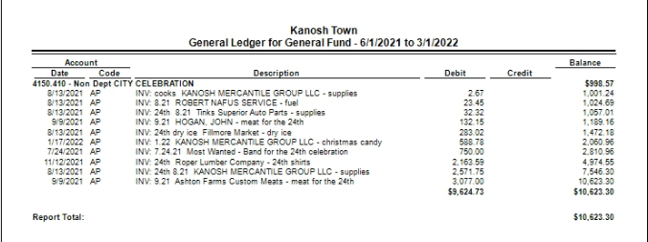

There has been a request for about 10 more great big Dutch ovens. Councilmember Neil Shumway has already requested cost estimates.

Public comments: limit of 3 minutes each
*Mr. Bart Whatcott questioned when his son will be able to receive a water utility connection, it was paid for in June of 2021.

Town employee Lorin Shumway stated he will ensure this is taken care of.

*Stan Koyle has volunteered to mow the streets again this year. We have the information required to allow him to do this.

*Dan Neville requested a copy of the annexation map, Councilmember Shumway supplied the request.

There being no further business to come before the board, the meeting adjourned.

Scott McDonald Cindy Turner,
Kanosh Town Mayor Kanosh Town Clerk

Open bids for weed maint. in March
Centracom's temporary power was ratified in March 2022.
Ratify Amendment to ordinance 071002
Dixie Power contract
Resolution appointing UAMPS member representative
Appointment of Kanosh Town Treasurer
Jessica Whitaker Heidi McFarlane Easter
Cemetery Maintenance
Town employee monetary wage increase

