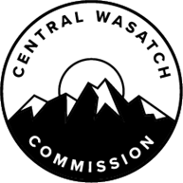
The Central Wasatch Commission Board met on Monday, March 7, 2022 to deliberate over the outcomes of the situational assessment, performed by Common Ground Institute. Through that discussion, the Board of Commissioners determined that the Central Wasatch Commission would further solicit public comment on the Draft Restatement and Recommitment of the Values and Principles of the Mountain Accord document now through Tuesday, March 22nd at 5:00 p.m.
You may provide comments the following ways: by emailing your comment to comments@cwc.utah.gov, by submitting a comment via comment form below, or by mailing a written comment.
Postmark your written comments no later than March 22, 2022 to:
Central Wasatch Commission
41 N. Rio Grande Street
Suite 102
Salt Lake City, UT 84101
There are two documents for your review, and comment. They are below:
The draft Restatement and Recommitment of the Values and Principles of the Mountain Accord document

The Comparison of Restatement and Recommitment of Values, Mtn Restatement, February 11 sent to Commissioners & Restatement and Recommitment of Values, Mtn Acd March 2, 2022

