Kanosh Town Corporation held the regular council meeting on Wednesday, January 12, 2022, electronically and in the town office at 7:00 p.m.
Members present:
Mayor Scott McDonald, Councilmember: Brandon Stephenson, David Whitaker, Neil Shumway, and Hayden George, and Kanosh Town Treasurer Karen Crook, Kanosh Town Clerk: Cindy Turner,

Others in attendance: CERT Captain Geri Minton, Planning and Zoning Chairman Ed Phillips, Bart Whatcott, David Hatton, Ilene Hatton, TJ Lavoto, Star Cummings, Brian Batt, Josh Whitaker, Geri Minton, Lorin Shumway, Stan Koyle, Heidi McDonald, Justin Wayment Attorney, Ben Coray, Jerry Vandussen

Mayor Scott McDonald welcomed everyone in attendance.

Councilmember David Whitaker offered the invocation.

Councilmember Neil Shumway led everyone in the Pledge of Allegiance

Mayor Scott McDonald also made the following Council department appointments:
Neil Shumway - electrical department
Brandon Stephenson - Roads and continue to be the liaison for the well project.
Hayden George - Parks and Cemetery
David Whitaker - Water Department

Mayor Scott McDonald conducted the following re-appointments:
Karen Crook to continue to serve as the Kanosh Town Treasurer
Cindy Turner to continue to serve as the Kanosh Town Clerk

Disclosure Statements:
This Disclosure Statement provides information regarding conflicts of interest and legal or disciplinary events of Municipal Advisor required to be disclosed to Client pursuant to MSRB Rule G-42(b) and (c)(ii). PART A – Disclosures of Conflicts of Interest. There were no disclosure statements needed at this time.

Minutes of the December 8, 2021 meeting were read and were approved as amended through motion by Councilmember Neil Shumway, Councilmember David Whitaker provided a second to the motion, all Council members voted in favor as noted below:
Mayor Scott McDonald: Aye
Council members
David Whitaker: Aye
Brandon Stephenson: Aye
Neil Shumway: Aye
Hayden George - Aye

Warrants for January 2022 were read discussed and approved to be paid through a motion by Councilmember Brandon Stephenson, Councilmember Hayden George seconded the motion, all Council members voted in favor as noted below:
Mayor Scott McDonald: Aye
Council members
David Whitaker: Aye
Brandon Stephenson: Aye
Neil Shumway: Aye
Hayden George: Aye

CERT:
Cert Commander Geri Minton stated that there is supposed to be a mini-conference in March, but because of COVID, it may not happen.

Kanosh Fire Chief:
Fire Chief Lorin Shumway reported that everything with the department is going fairly well. The assistant Chief, Travis Taylor, and Chief Shumway have been putting together a schedule for training. The radios have not yet been received.

Planning and Zoning:
*Chairman Ed Phillips reported that the monthly planning and zoning meeting was held, there were no applications for permits submitted.
A topic of discussion at the meeting was the need to replace Blaine Blad on the Planning and Zoning Commission.
As per letter from a family member, Mr. Blad will no longer be residing in Kanosh. Mr. Phillips expressed the appreciation of the Planning Commission to Mr. Blad for his service, stating he has been stalwart on the commission.
* The other topic of discussion at the meeting was a telephone call Mr. Phillips received. The individual introduced himself as a realtor from Alpine, representing a client who was looking at property in Kanosh to build a multi-unit housing facility.
He questioned the procedure for applying for a zoning change. The "realtor" never followed up. The bottom line is that there is no zoning for a multi-unit housing facility in Kanosh. Representing the Planning and Zoning Mr. Phillips was asked to make the council aware of this. Mr.
Phillips questioned if the Kanosh Council members want the Planning Commission to take this on as an assignment, looking at communities of similar size as Kanosh and developing something, turn it over the council as a review. They did not want to start down that road if there was no interest.

Attorney Justin Wayment:
Mr. Wayment provided the
Open Meeting Training:
What is a meeting:
“Meeting” means the convening of a public body, with a quorum present, including a workshop or an executive session whether the meeting is held in person or by means of electronic communications, for the purpose of discussing, receiving comments from the public about, or acting upon a matter over which the public body has jurisdiction or advisory power, about, or acting upon a matter over which the public has jurisdiction or advisory power.
*“MEETING” DOES NOT MEAN?
– A chance meeting. – A social meeting. – Meeting of a legislative body with both legislative and executive responsibilities. • No public funds are appropriated. • Meeting solely for discussion or to implement administrative/operational matters.
*ELECTRONIC MEETINGS –
Can meet by phone, computer or other electronic means. • Notice requirements still apply. • Public must have a means to attend or participate. • Must have adopted an existing rule, resolution, or ordinance.
*A “MEETING” CAN BE CLOSED TO:
Discuss an individual’s character, professional competence, or physical or mental health. – Discuss collective bargaining. – Discuss pending or reasonably imminent litigation. – Discuss the purchase, exchange, lease, or sale of real property. • Public notice of the terms and public approval of sale required. Discuss deployment of security personnel, devices, or systems. – For investigative proceedings regarding allegations of criminal misconduct. – Discuss commercial information, if a County legislative body.
*PROCESS TO CLOSE MEETINGS
A Quorum must be present. – Two-thirds of the body must vote to close the meeting. – The body must first hold a public meeting with proper notice before entering into the closed meeting. – The body must publicly disclose: • The vote by name of each member for or against entering into the closed meeting. • The reasons for holding the closed meeting. • Location of the closed meeting. Closed sessions recordings must be preserved forever.
You may not: – Approve any ordinance, resolution, rule, regulation, contract or appointment. – Interview a person to fill an elected position. – Take final action. • Final votes must be open and on the record.
*EMERGENCY MEETINGS –
The best notice practicable is given. – Must make an attempt to notify all of the members of the public body and a majority of them must approve the emergency meeting. – The minutes include a statement of the unforeseen circumstances that made the meeting necessary
*RECORDINGS
A recording must be kept of all open meetings. – A recording of an open meeting must be available to the public for listening within three business days after the meeting. – A recording is not required for site visits or traveling tours or for certain small local districts. • A recording must be kept of all closed meetings, except: – A meeting closed to discuss the character, professional competence, or physical or mental health of an individual does not need to be recorded, but the presiding person must sign a sworn statement. – A meeting closed to discuss deployment of security personnel, devices, or systems does not need to be recorded, but the presiding person must sign a sworn statement.
*MEETING MINUTES
Written minutes must be kept of all open meetings. – Written minutes shall be available to the public within a reasonable time. – A public body must establish and implement procedures for approval of written minutes. • Detailed written minutes may be kept of all closed meetings, except: – A meeting closed to discuss the character, professional competence, or physical or mental health of an individual does not need to be recorded or written minutes kept, but the presiding person must sign a sworn statement. – A meeting closed to discuss deployment of security personnel, devices, or systems does not need to be recorded or written minutes kept, but the presiding person must sign a sworn statement.
REQUIREMENTS FOR WRITTEN MINUTES •
All minutes must include: – Date/time; – Place of meeting; and – Names of all members present or absent. • Minutes of open meetings must include: – All matters proposed, discussed or decided; – All names and substance of information from individuals giving testimony; – Individual votes on each matter; and – Any additional information requested by a member.
*VIOLATIONS OF OPMA
“In addition to any other penalty under this chapter, a member of a public body who intentionally violates or intentionally abets or advises a violation of the closed meeting provisions of this chapter is guilty of a class B misdemeanor.” – A court can void any action in violation of the law. – Sometimes a violation can be “cured” by discussing an taking a public vote in a subsequent meeting. – May have to pay court costs and attorneys fees.
*LEGISLATIVE UPDATE • H.B. 189 – allows a closed meeting to be held to discuss the purchase, exchange, lease, or sale of a water right or water shares. • H.B. 315 – modifies the statutory requirements to publish or post notice to the Utah Public Notice Website by providing a temporary exemption (until December 31, 2012) for a municipality, local district, or a special service district, with an annual budget of less than $1,000,000. • S.B. 136 – authorizes the Independent Legislative Ethics Commission to convene a closed meeting without first convening an open meeting, if the closed meeting relates to the receipt or review of an ethics complaint, and the Commission provides advance public notice of the closed meeting. This bill also provides that an ethics committee of the Legislature may close a meeting by a majority vote for the purpose of conducting deliberations to reach a decision on an ethics complaint, or to seek legal advice on legal, evidentiary, or procedural matters.
*DELIBERATIONS
Normally, deliberations are conducted in the open. • Exception: Quasi-Judicial vs. Administrative or Legislative. – But, information gathering still conducted in the open
*WORK SESSIONS
Covered by the OPMA. • No decision can be made in work session, but must be made in an open session. • Do not use to circumvent the information gathering and deliberation process.
*CONFLICTS OF INTEREST
County Officers’ and Employees’ Disclosure Act (U.C.A. Sections 17-16a-1 et seq.). • Municipal Officers’ and Employees’ Ethics Act (U.C.A. Sections 10-3-1301 et seq.). • Utah Public Officers’ and Employees’ Ethics Act (U.C.A. Sections 67-16-1 et seq.
If you are an employee, elected or appointed officer: – “Elected officer” means any person elected or appointed to any office in the county. – “Appointed officer” means any person appointed to any statutory office or position or any other person appointed to any position of employment with a county, except special employees. Appointed officers include, but are not limited to persons serving on special, regular or full-time committees, agencies, or boards whether or not such persons are compensated for their services. The use of the word "officer" in this part is not intended to make appointed persons or employees "officers" of the county. You can vote as long as you don't have an interest.
Three Common Types of Conflicts of Interest
- Nepotism. Nepotism happens when an individual in charge of a hiring process chooses to award a job offer to someone in their own family or with whom they have a personal relationship. ...
- Self-Dealing. ...
- Business Relationships

*PROHIBITIONS
It is an offense for an elected or appointed officer to (similar provisions apply to employees): – Disclose confidential information acquired by reason of the officer’s official position or to use that information to secure special privileges or exemptions for himself or others; – Use or attempt to use the officer's official position to secure special privileges for the officer or for others; or – Knowingly receive, accept, take, seek or solicit, directly or indirectly, any gift or loan for the officer or for another, if the gift or loan tends to influence the officer in the discharge of the officer's official duties. • Exceptions: – An occasional no pecuniary gift having a value of less than $50; – An award publicly presented; – Any bona fide loan made in the ordinary course of business; or – Political campaign contributions actually used in a political campaign.
*INTERESTS CREATING A CONFLICT
Receives or agrees to receive compensation for assistance in a transaction involving the entity; • Have an interest in a business regulated by the entity; • Have an interest in a business doing business with the entity; or • Have an investment creating a conflict of interest with you duties.
I HAVE AN INTEREST, NOW WHAT? • Consult with the legal advisor. • File a sworn statement with entity’s governing body (for ongoing conflicts & for assistance in a transaction involving the entity). – Disclose the position held and the precise nature and value of the interest held. – File upon first becoming appointed or elected and each January thereafter. • Publicly disclose to the members of the body on which he is a member prior to discussion of the matter in an open meeting. • Disclosure needs to be entered into the minutes of the meeting.
*VIOLATIONS
Any Person who knowingly and intentionally violates, then Class A misdemeanor (more or less) and shall be dismissed from employment or removed from office. • If interest relates to business regulated by entity, then entity can rescind or void any contract without returning the consideration.
*GROUP TEXTS:
You can group texts for information purposes only.
TEXTS in a meeting:
Don't text each other or anyone else in a public meeting.
COMPUTERS:
If you have Town Computers, use them for Town business.
Use your home computers for home business. Those computers can be sequestered.

To view the code in its entirety please see:
https://le.utah.gov/xcode/Title52/Chapter4/C52-4_1800010118000101.pdf

Rule of thumb......"Believe in what you are doing. Be honest in your opinions.
Do what is right and move forward."

Mr. Wayment emphasized the importance of Avoiding litigation! Litigation is stressful!!!! Expensive and consumes a huge amount of time, distracting, etc.
- Document everything! Agreements need to be in writing. Incidents need to be in writing immediately! Detail everything. Discuss with another worker immediately. Give it 48 hours and then go back over it. Take pictures.
- Act quickly. Before you react, put yourself in their shoes.
- Keep ALL evidence.
- Plan ahead. People make mistakes, train, train, and retrain.

When you come to the meetings, be prepared. It is better to change an opinion than to persist in the wrong one.

Mr. Wayment also addressed Roberts Rule of Order:
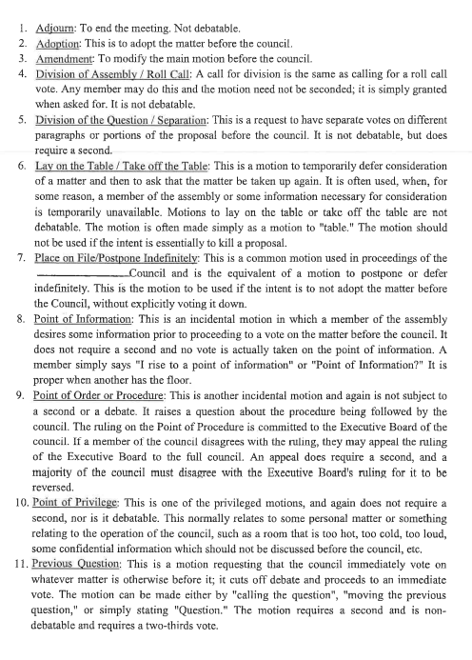
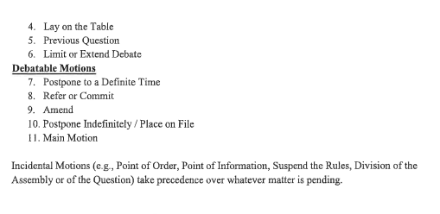
Rule of thumb: It never hurts to disclose, it may hurt not to disclose.
F450 Bid Opening:
The following notice was posted:
NOTICE:
Kanosh Town will be taking sealed bids on the pictured 2008 Ford F450 Super Duty 8 cylinder Diesel engine
Plow included Truck has a bad engine.
Bids can be submitted to:
Kanosh Town Corp.
P.O. Box 9
Kanosh, Utah 84637
Bid opening January 12th at the regular council meeting. All bids must be submitted prior to the 11th of January 2022.
Kanosh Town Reserves the right to reject any and all bids.
For additional information please contact Lorin Shumway.
Posted this 2nd day of December 2021.

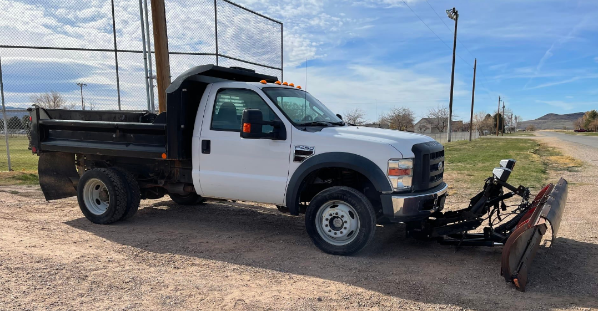
The following bid were received:
Jon Pratt: $2555.00
Mel Gamble: 300.00
Earl Gardner: 1252.00
Steve Crabb 555.55
Richard Penney 2150.00

Council member Neil Shumway motioned to table acceptance of the bids, Council member Hayden George provided a second to the motion, Council members voted in favor as noted below:
Mayor Scott McDonald: Aye
Council members
David Whitaker: Aye
Brandon Stephenson: Aye
Neil Shumway: Aye
Hayden George: Aye

Corn Creek Project:
Councilmember Brandon Stephenson Provided an update on the Project supplying the following FAQ sheets:
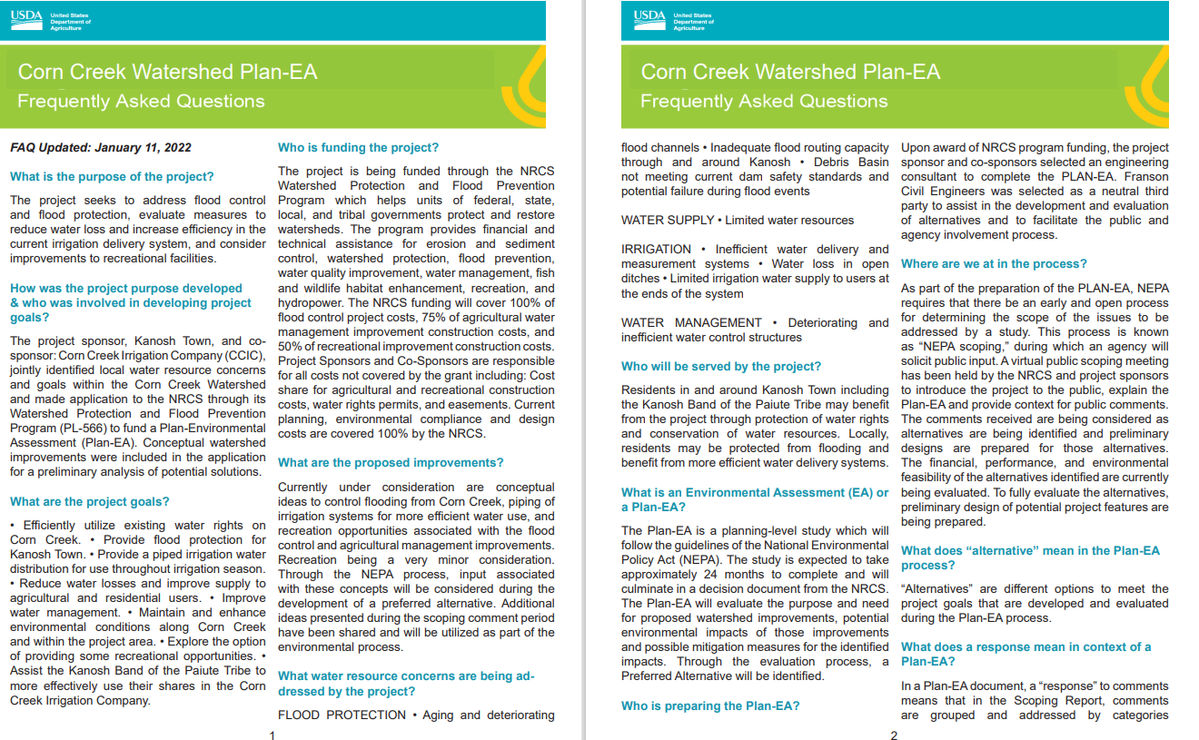

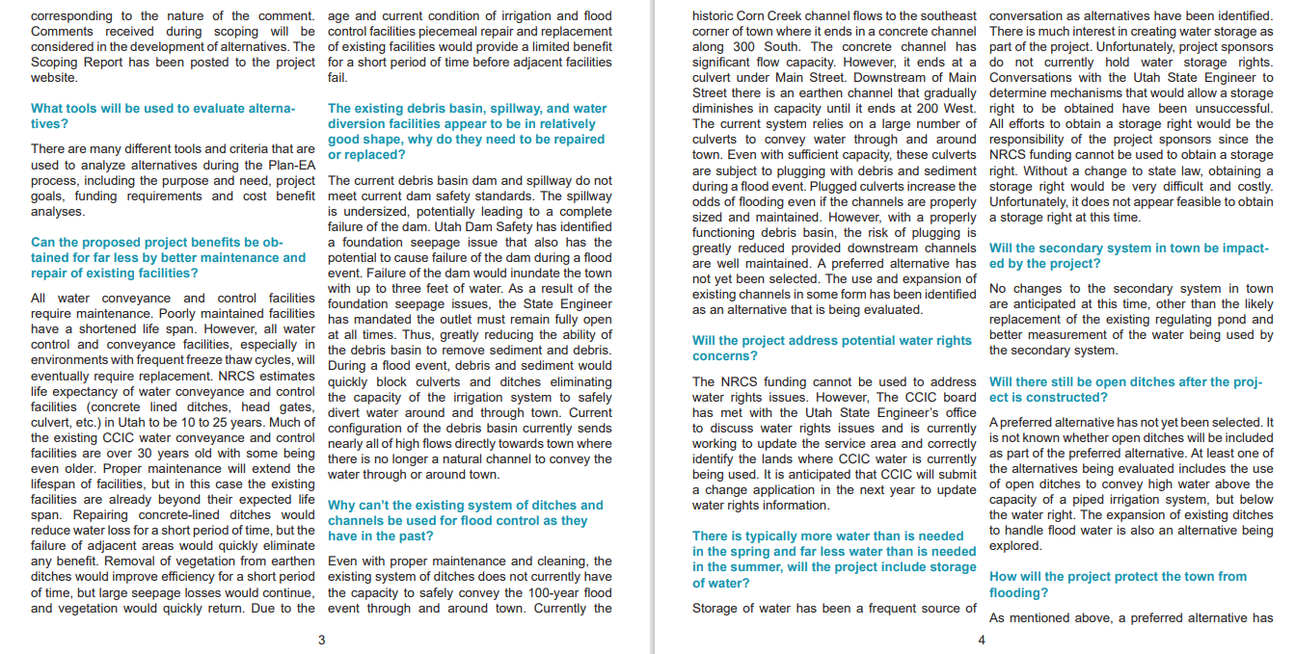
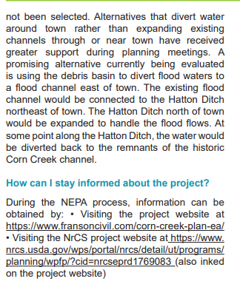

Culinary Well Project:
Councilmember Brandon Stephenson provided an update on the culinary well project. A company called Willow Sticks had been contacted and below is the study they provided: 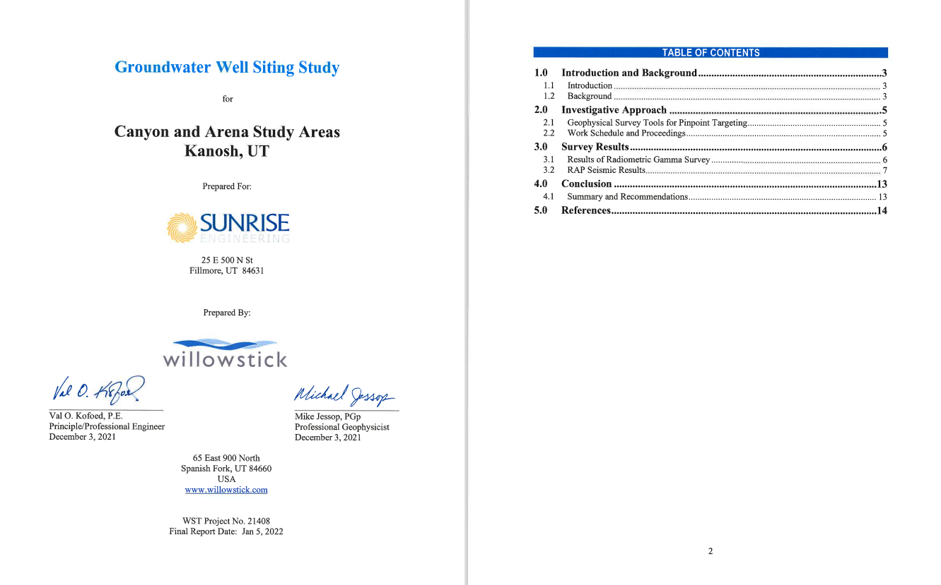

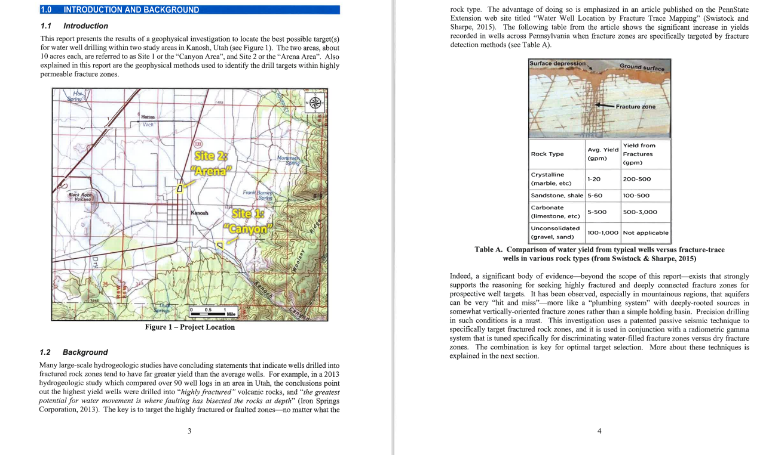
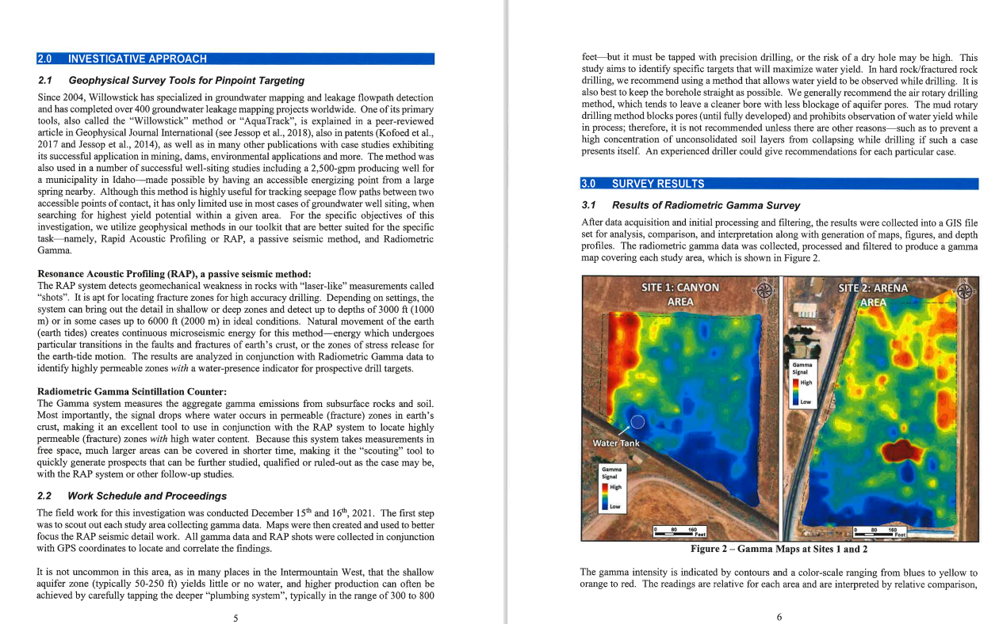
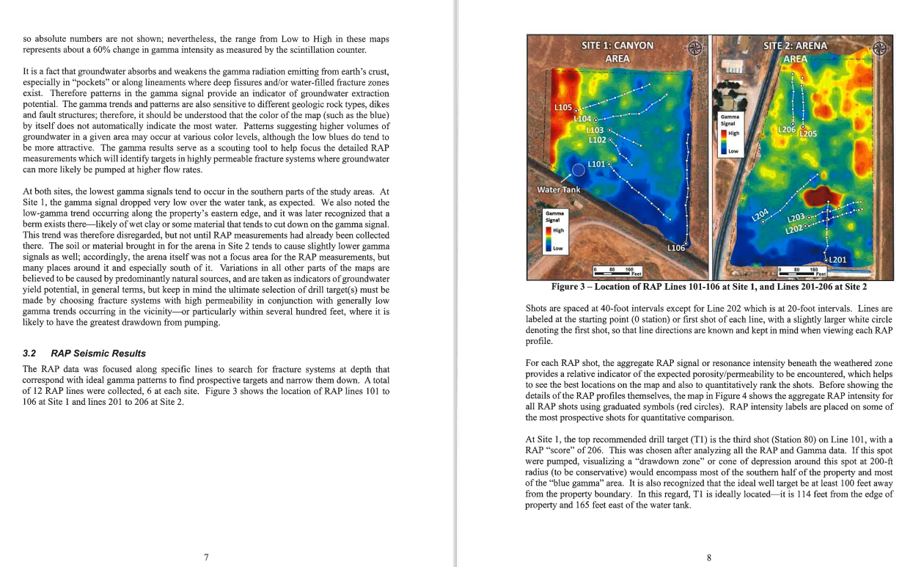
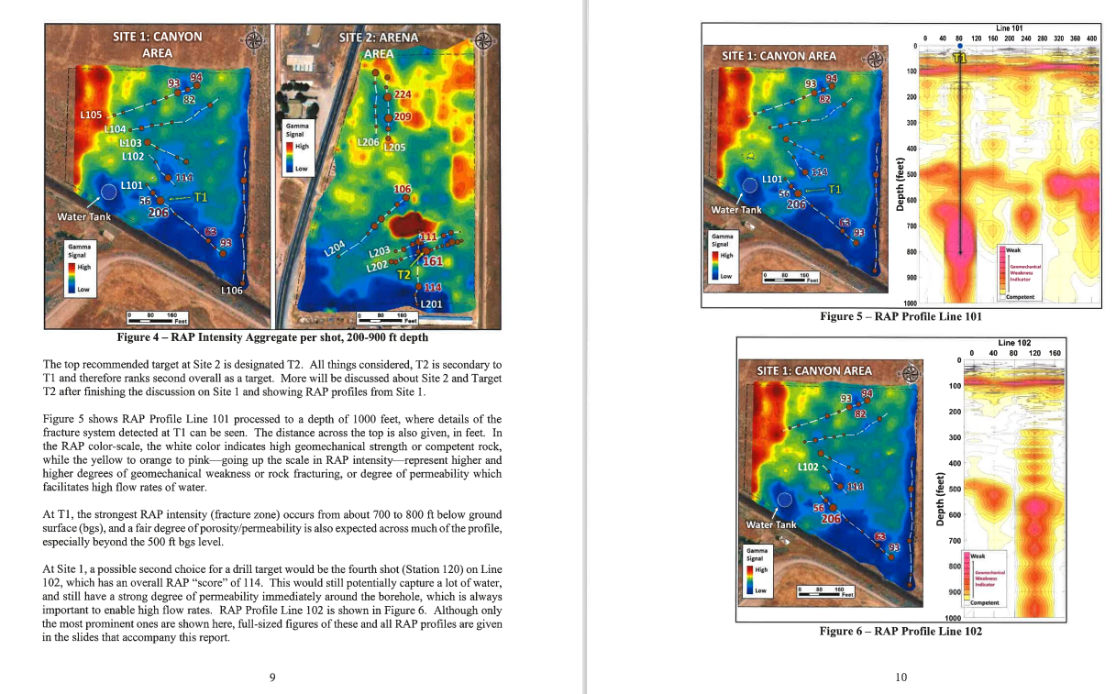
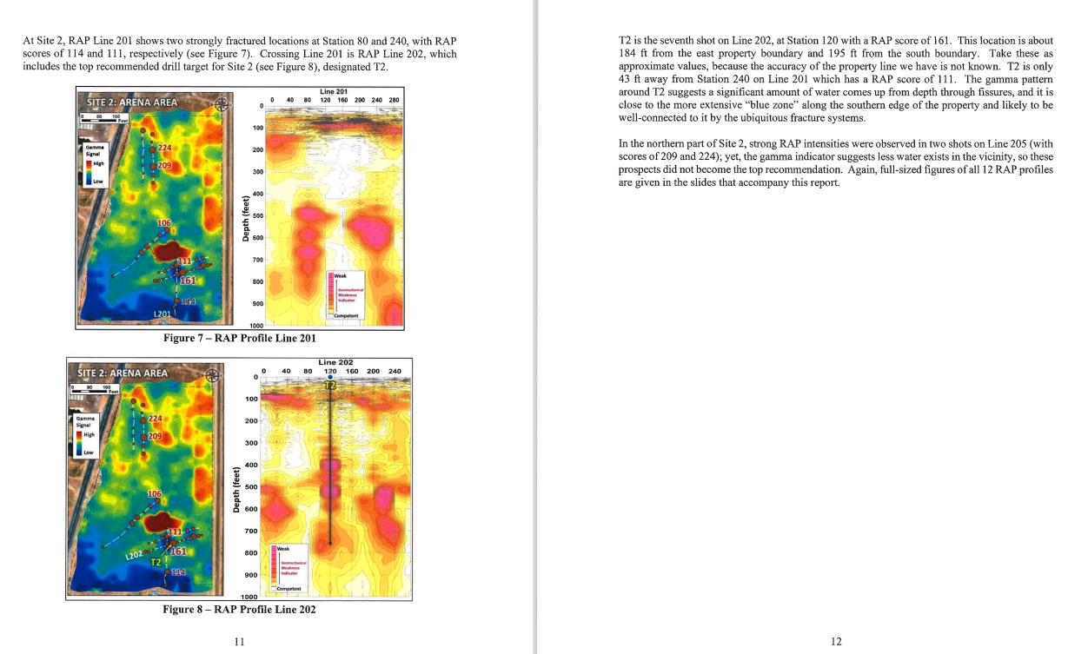
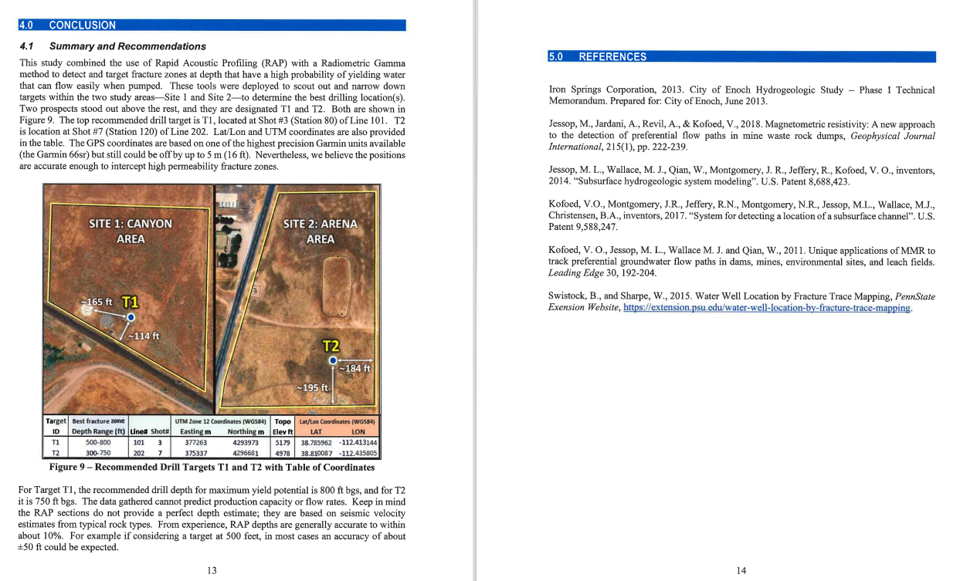
Council members discussed the information provided, and Council members requested a cost estimate for a smaller 10” diameter casing, including questions and clarifications. In light of the information presented, Councilmembers were more favorable toward the T1 site. Councilmember Stephenson will continue to provide additional information as it becomes available. Councilmember Brandon Stephenson verbally recognized past Councilmember Rodney Whatcott for all of his work on this project.

Council reports on departments:
Electrical Department
*Councilmember Neil Shumway noted that Flowell Electric / Dixie purchased our interest from the Meadow substation to the Hatton road and now has approached Kanosh with a request to purchase the line to the reservation road an additional mile and a half. It has all been upgraded recently no there is little if any maintenance. Their selling point to Kanosh is that we would never have to maintain it clear to our metering point. (Our metering point is right at the reservation road). They would like to meet with the council, preferably as an agenda item for the February meeting.

*The Centracom people have requested power at their new tower.
Councilmember Shumway noted the Kanosh Town Policy states that we currently do not allow power outside of the city limits. Dixie Power has given Kanosh permission to provide this power. Councilmember Shumway said that we may need to go back in and amend the policy, he will follow up with the Kanosh Town attorney.

Roads:
Councilmember Brandon Stephenson received a cost estimate for the city streets and the cemetery (to include a future expansion), resulting in an estimate of $350,397.50.

Park
Councilmember Hayden George commented that the signs have been put up in the park.

Cemetery
Discussion of if we need new asphalt in the cemetery, which will enable the expansion. Class B&C road money can be used for this project. If the project takes place the water lines will be taken under the roads first. Discussion also about fixing the one existing bad road.

Water:
Councilmember David Whitaker mentioned that if we could get the overflow that is just going into the
ditch into the settling pond could supplement our irrigation water. We would have to pump it up to the settling pond.

General Government:
*Dumpster: there has been concern over the height of the dumpsters.
Several of our citizens struggle to get the trash into the dumpster due to the height. It was questioned if we could get a shorter dumpster and or place the dumpster below the platform to help with this struggle. The dumpster is county-operated and any change would have to be the decision of the County. We will draft a letter to the County with our request.
*Meeting Schedule: Councilmember David Whitaker questioned if the Town meeting could be moved to the second Tuesday of the month rather than the second Wednesday of the month due to conflicting schedules. We will look into what it would take to change the meeting date.

Review of Utility Delinquencies:
Councilmember's reviewed the monthly delinquency list. It was determined, again, to handle those accounts in arrears according to established Town policy.

Public comments: limit of 3 minutes each
Stan Koyle commented that the burn pit is a mess. It is being used for more trash than it is limbs and is quite a mess.

There being no further business to come before the board, the meeting adjourned.

Scott McDonald Cindy Turner,
Kanosh Town Mayor Kanosh Town Clerk
Agenda Feb
F450 Bid Opening:
Dixie Power potential purchase of distribution line between the Hatton road to the reservation road
Public hearing??
Road Improvements

