Executive Director Update
January 27, 2022

SCHOOL WIDE - Mrs. Herring
Welcome to National School Choice Week in which all campuses are fully invested. We kicked off this celebration by co-sponsoring the School Choice Expo at the Provo Convention Center on Jan.22. This effort was successfully chaired by Hilary Cramer and hosted by student leaders of Freedom Prep. The National School Choice organization donated $5,00 for this event and it will likely continue to be an annual event in Utah Valley each year. Charters on Capitol Hill year was cancelled due to ongoing Omicron concerns.

At schools this week, parents are invited to tour and learn the outstanding educational opportunities offered in our K-12 classes. Yellow scarves are visible on employees and used by students during the annual school choice dances. Faculty and Staff photos are traditionally taken again this year. School Choice is the ultimate foundation behind everything we do at Freedom Prep.

Teachers at Freedom Prep are busy taking advantage of $1,000 funding available through USBE’s generous legislative efforts last week. Through the DonorsChoose organization, which has been a source of prolific funding over many years, $12 million is currently available for Utah teachers to access in best efforts to benefit K-12 students. Happily, several dozen of our faculty have already been awarded these funds thus far. A well needed windfall for Utah education this year.

In early February, Freedom Prep is sending a select team of people to participate in PowerSchool University. We will be transitioning to this new technology platform for student information and enrollment, by next fall within our organization. After exploring and discussion this need for several years, the time is now to make this change. The team will return to train the campuses in PowerSchool in preparation for the change. This is a win-win as our organization increases in size and proficiency is needed more than ever before.

The long-awaited bus barn at the secondary campus is finally off to a smooth start. Heavy equipment began working in mid-January, and we look forward to housing our several buses off site and in a facility suited to the maintenance and upkeep of these vehicles. Mike Cutler is overseeing this project with the Executive Administration.

As we move into second semester, things are as busy as usual at our four campuses. We welcome our new secondary Assistant Principal, Brandon Waite, who has stepped right onboard at the highest level of involvement. He is our third assistant currently.

Please enjoy the campus Principal updates and photos included below. Newsflashes also contain weekly campus information regarding activities and all things parents need to be aware of to support their successful students.

As always, we are keeping a close eye on the legislative session and bills that would impact education. Hoping for a healthy WPU, some licensing changes for SPED and other funding areas. Our UAPCS team and Senator Fillmore stand firmly in the charter arena on our behalf.

The annual schoolwide Spelling Bee for 4-8 grades took place on Jan. 19 at FPA I. The winners were Nygel Pectol in 8th grade, and the runner-up was Lyvian Zheng in 5th grade from the Vineyard campus. Congratulations to these students who will represent Freedom Prep at the regionals. See last photo.

PROVO ELEMENTARY CAMPUS
Mrs. Wolf
Upcoming Events
- This week is National School of Choice Week! Our students have written and drawn pictures about how much the love our school, danced along with the school choice dance, and are wearing all yellow to school this Friday to “Shine for School Choice.”
- Parent/Teacher conferences are just around the corner at the end of February. This is a great time of year to rally students and parents as we enter the home stretch. Prior to these conferences, we assess the students that have the greatest need and work with those students and parents to create a plan for success so they can finish the year strong.
Student Achievement
- We have completed our middle of the year testing in Acadience Reading (K-5) and Acadience Math (1st-3rd). We have immediate reactions to the data and are meeting to discuss this in more depth. With our recent addition of Karla Kay Snow as Curriculum Director, we have a great team to internalize, evaluate, and create action steps using the data. Here is what stands out so far:
- Our first-grade students need the most support in reading. Debby Moon, our literacy coach, has already met with the first-grade team to problem solve and provide additional training. Debby, Cherlynn, and I will be going into their team meetings and in their literacy time as well to observe and help work with the students. We are fortunate to have instructional paraprofessionals working with first grade and those services will continue.
- For reading, the rest of our grades progressed very well, and some classes have all students on or above grade level. Our teachers’ progress monitor weekly and keep accurate track of student data.
- In Acadience math, we saw great growth from BOY to MOY. In first grade, we have about 31 students who will qualify for Title 1 Math tutoring services. In second grade, 32 students who qualify. This is 63 students' total. In comparison to the fall testing, we had 149 who qualified for Title 1 math in first and second grade. What is exciting is that the students that have graduated out of Title 1 Math, did not test back in. The students who will qualify for Title 1 Math services are students we have not pulled or worked with yet. The graduates of the Title 1 Math program scored blue, with a few green on the scale. This shows the intervention works and has lasting success.
Teacher Training
- Veronica Sundell, our SPED trainer, has been doing a series of trainings with our faculty on interventions for students and how to properly execute tier 1, 2, and 3 instruction. These sessions have been very helpful for teachers learning to implement progress monitoring systems and how to implement effective RTI (response to intervention). This week our teachers learned next steps for what to do when their interventions don’t seem to be working.
- We are gearing up for several job fairs in the coming weeks. We always look to hire the best and brightest that will contribute positively to our school. As of right now (I don’t want to jinx it!) we will have very little teacher turnover at FPA1.
VINEYARD ELEMENTARY CAMPUS
Mrs. Banfield
Recent Events: We finished term two in December with a lively spirit week. Students and staff dressed up throughout the week in various holiday attire. Then culminated the festivities with a school assembly where each grade level sang a holiday song and then the 4th grade participated in “slime the principal” for donating the most to our Penny Wars fundraiser. Altogether we raised $715.00 which was used to purchase new uniforms and gift cards for some of our student families in need. We also enjoyed a Mexican Fiesta Breakfast with all FPA3 staff.
Students in grades 1-5 participated in class, grade-level, and school wide Spelling Bees over the past few weeks. Three students in each grade level were awarded a 1st, 2nd, and 3rd place winner. All three of our 5th grade finalists made it to the top ten in school wide bee with Lyvian Zheng coming in 2nd place overall and will now participate in the regional Spelling Bee competition in February.
Mr. Penate and his after-school drama class performed the play Frozen 2 Junior for our school community last week and it was a big hit with three shows.
Upcoming Events: This week we are focused on celebrating National School of Choice week where we have planned activities for the students each day. Administrators will participate in the Utah School Expo event. We are looking forward to hosting an open house on the 26th and hope to capture the interest of prospective students.
We will celebrate 100 days of learning on the 28th. WIDA testing, informal teacher observations, parent teacher conferences, and the Scholastic Book Fair will occur during the month of February.
Intent to return forms have been emailed to FPA families for 2022-2023 enrollment.

Student Achievement:
MOY Acadience Math & Reading has been ongoing throughout January. We have a few more students to test, but here are some preliminary results.
Acadience Reading:

Grade | BOY Proficiency Composite | MOY Proficiency Composite
Kindergarten | 69% | 81%
1st Grade | 65% | 74%
2nd Grade | 82% | 76%
3rd Grade | 75% | 73%
4th Grade | 68% | 75%
5th Grade | 61% | 67%

Acadience Math:

Grade | BOY proficiency composite | MOY proficiency composite
1st grade | 59% | 56%
2nd grade | 74% | 54%
3rd grade | 64% | 68%

Teachers and Academic paraprofessionals are using this MOY data to form new grade-level groups for intervention. Grade level teams are in the process of analyzing the results from both Reading and Math data to inform and improve instruction.
Americorps tutoring after school has been extended to four days a week. This tutoring focuses on Math and Reading.
Teacher Training:
Teachers will participate in an Anti-Bullying training on February 1st from our social worker Mike Sherman. Ongoing training for Love & Logic occurs once a month along with regular Mentor and Mentee trainings.
We have increased the number of teachers participating in our PCBL cohort, so we have representation for each grade level. This has been a rewarding and collaborative effort as teachers work together with Provo campus teachers in identifying essential standards to prepare for competency-based learning and assessments. Administrators will visit Quest Academy next week to observe PCBL in action.
We are in the process of collecting teacher intent to return forms and looking at staffing needs for next school year. We have already begun receiving resumes for teaching positions and will start interviewing in February.
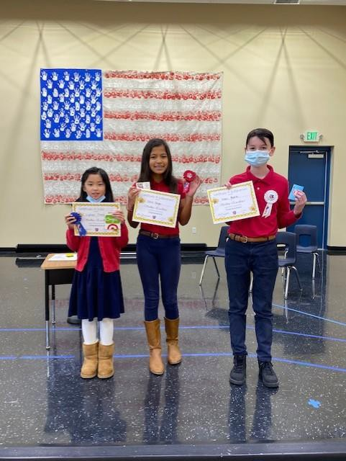
USBE LETRS training continues for those teachers and administrators who are participating.
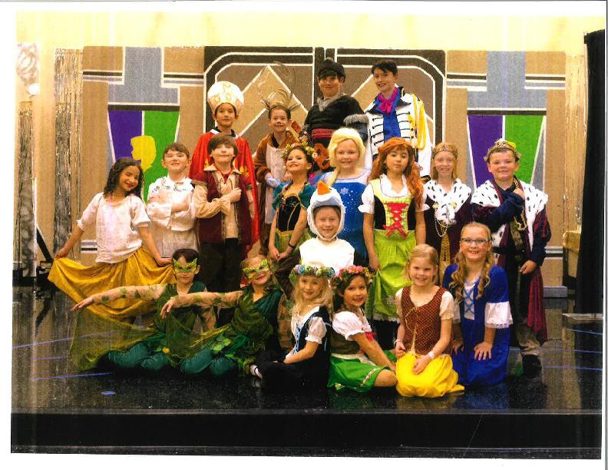

Spelling Bee/5th Grade Finalists Frozen 2 Jr. Cast

PROVO SECONDARY CAMPUS/Middle School and High School
Mr. Fullmer

Recent Events
- 12.4.21 - Saturday with Santa
- 12.6.21 - LIA Toy Drive
- 12.7.21 to 12.9.21 - Data Days with Math, Language Arts, and Science teams
- 12.11.21 - Robotics State Qualifier Competition hosted by FPA2
- 12.11.21 - Winter Ballroom Concert from 2-8pm in Auditorium
- 12.13.21 - Spirit Week and Holiday Choir Concert
- 12.15.21 - Winter Band/Orchestra Concert @ 5:30, 6:45, 7:30
- 12.17.21 - End of Term 2
- 1.1.22 to 1.31.22 - 10 min. Play festival all month
- 1.7.22 - Honor Roll Breakfast Term 2
- 1.10.22 to 1.14.22 - Spelling Bee
- 1.12 & 13.22 - College and Career Parent Night (8th-11th graders) 6pm-8pm
- 1.19.22 - LIA visit to UVU
- 1.22.22 - Utah School Choice Expo - @ Provo Convention Center
- 1.24.22 - National Charter School Choice week
- 1.27.22 - Fight the New drug Assembly and Parent Night
- There are currently 4 sport teams participating right now in the Winter.
- High School: Bball (boys and girls)
- Middle School: Bball (girls)
- Cheer
- There are many other activities after school for our students to be involved in at this time:
- Writer’s Guild, Robotics (high school and middle school), Choir, Orchestra/Band, Theatre, Ballroom
Upcoming Events (launch of the year, sports, extracurricular, COVID, etc.)
- 2.2.22 - NAEP Test
- 2.7.22 - Data Days with Math, Language Arts, and Science teams Round 3
- 2.7.22 - Success Week/Eagle Time/Mid-term Q3
- 2.16.22 - 5th Grade Tours
- 2.18 & 19.22 - LIA Thrift Shop Fundraiser
- 2.23 & 24.22 - Parent Teacher Conferences
- 2.26.22 - School Dance
- 2.28.22 - Chopped Competition Begins
- 2.28.22 - Spring RISE Interim
- 3.1.22 - Spring Choir Concert
- 3.2.22 - Spring Band/Orchestra Concert
- 3.9.22 - End of Term 3
- 3.11.22 - Professional Development Day
- 3.18.22 - Honor Roll Breakfast Term 3
- 3.21.22 - Student Council Elections Begins
- 3.22.22 - ACT and Utah Aspire PlusTesting
- 3.24-26.22 - Non-musical plays
- 3.28.22 - Data Days with Math, Language Arts, and Science teams Round 4
- 4.1.22 - Student Council Elections Announced
- 4.4.22 - Spring Break
- 4.16.22 - Lego League State Competition
- 4.18.22 - Success Week/Eagle Time/Mid-term Q4
- 4.18.22 - State Testing Begins
- 4.23.22 - Prom
- 4.25.22 - High School Student Council Cabinet Elections
- 4.28.22 - Middle School Student Council Cabinet Elections
- 4.29.22 - Carnival
- 5.2.22 - Teacher appreciation Week
- 5.6.22 - State Testing Ends
- 5.18.22 - Choir Pop concert
- 5.19.22 - End of year Band/Orchestra Concert
- 5.20.22 - Last Day of School for Seniors
- 5.23.22 - Last Week of School
- 5.25.22 - Senior Graduation
- 5.26.22 - Last Day of School
- 5.28.22 - Humanitarian Trip
Student Achievement
- Success Week and Eagle Time: Mid-term is always a good time to celebrate with students who are passing all of their classes and provide extra support to students who may be failing one or more of their classes. Success Week is the week of mid-term. Grade level teams strategically reached out to and provided extra support to their students last week. Many students who were failing one or more classes were able to bring their grade(s) up and qualify for Eagle Time (fun activities for students who are passing all of their classes on Friday of mid-term). Students who did not qualify for Eagle Time are put into study halls at the end of the day on Friday to receive the extra support they needed to bring their grades up.
- Early College Opportunities: In fulling our vision of being a preparatory school and with the assistance of a grant we won last spring we have been working diligently to expand our concurrent enrollment classes that allow students to earn UVU college credit while in high school. Currently, Freedom Prep offers seven classes that students can take through UVU. There are 124 students enrolled in these classes. Some students taking more than 1 class. In addition, students can take AP classes in world history, physics, and calculus. We have also taken our juniors and seniors on college tours to Weber State, now College, and MTech as part of College Awareness month in November.
- Data Days: Our English, Math and Science teachers spent a day together this past term looking at data, identifying essential standards, and making plan to fill gaps in learning for their students. It was a highly effective meeting for each team and provided some much needed time to be able to dig deep and collaborate on what is important.
- Math Lab: To help support our SPED middle school students with their math, we have a designated math lab throughout the day where students are provided one-on-one instructions as needed.
- Americorp Tutors: To better support our middle school students with math and literacy, there are two Americorp tutors on-site part time to provide more one-on-one target instruction. They will use last year’s RISE scores, the Fall Interim scores, and teacher referrals to know which students to work with.
- Success Team and Tutoring: Starting Aug. 31st until the end of the year, Clair Miranda is running “Success Team” every Mon-Thur from 2:45-3:30pm after school for students. Success Team is a place where students can go after school to receive tutoring. Mr. Peavler and Mr. Bethke are also providing after school tutoring in conjunction with success team.
- 8th Grade NAEP Test: All 8th graders will take this test.
- We had 6 students who auditioned for the Utah Music Educator Association's All-State ensembles and 4 of those students were ACCEPTED! 2 years ago, we had 1 student audition and he didn't make it. Last year that same student (Gabriel Coletti) auditioned and was accepted. This year, thanks to Gabriel's leadership, 5 others joined him in the audition process. (By the way, Gabriel placed 3rd chair French Horn this year overall and is principal horn in one of the All-State Orchestras.)
- This year Kristen Lafave was accepted on clarinet in the Junior High Band
- Also, Emily Metzger was accepted on violin and will be playing 1st violin in the Junior High All-State Orchestra. Giselle Fernandez was accepted on flute and is playing in the same orchestra as Gabriel.
- A Body Image workshop, run by our social worker Lainy Barrick, will run for 6 weeks beginning February 6th after school on Mondays in room 235. This is for high schoolers only.
- A Self-Esteem and Confidence workshop, run by our social worker Lainy Barrick, will run for 6 weeks beginning February 10th after school on Thursdays in room 204. This is for middle schoolers only.
Teacher Training
- Mar. PD Day:
- SPED Training: All teachers had the opportunity to be trained by our in-house Sped department. We focused on accommodations and modifications.
- Ellevation Software Training: This is a program that provides data regarding second language learners in reading, speaking, listening, and writing. It also connects teachers with strategies and activities that integrate language and content instruction into a mainstream classroom.
- Content Team Collaboration (HIT Teams): Teachers worked collaboratively as HIT teams to apply the ELL and Sped training they received, as well as work on identifying and breaking down essential standards individually and as teams.
- Teacher Academy: As part of a continued focus for building teacher capacity, this year we are holding Teacher Academy Wednesdays after school. The content is now targeted towards helping all teachers. For this past month, the class has focused on training teachers on foundational best practices for effective teachers. Joseph Ponczoch and Alvin Echeverria are the teachers leading our Teacher Academy.

FPVA CAMPUS
Kim Flewallen – Academic Dean
Enrollment for semester 2:
- 89 students total in fulltime FPVA
- Elementary K-5 has 33 students
- Secondary 6-12 has 56 students
- Hybrid students at FPA2 are at 30 students
- Total for both full-time and hybrid students is 119
FPVA's enrollment has 14 new students total, 11 of these added after semester 2 started.
At the end of semester 1 we lost 12 students from FPVA, and all went back to FPA onsite schools except 1.
Both elementary teachers K-5 teach part-time, and our two secondary teachers are full-time.
One of our elementary teachers, Hilary Cramer, just completed organizing and running an event for the National School Choice Week this past Saturday. It was a big success!
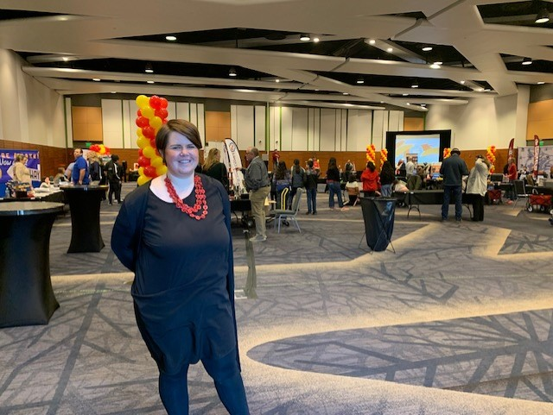

Acadience Testing is well underway with the virtual elementary and almost complete. We will be doing Wida testing with our 10 virtual EL students at the end of February. All virtual 8th graders recently ts took the Civics test and passed. We are preparing for the upcoming RISE, Utah ACT Aspire Plus, ACT, and we have one virtual student who will take the DLM (Dynamic Learning Maps) alternate assessment.

Things are going well in all aspects of FPVA. We are looking forward to how many will return to FPA onsite next year once the intent to return forms are in.

ST. GEORGE CAMPUS
Brandon Winn

Student Achievement
- Middle of year Acadience testing for reading and math has been completed. We have seen a lot of hard work from our students, teachers, and paraprofessionals. Our students were making great progress throughout quarter 2; however, we did see a sizeable regression coming back from the winter break. After discussion with the other FPA elementary principals, we have decided to do our middle of year (MOY) testing before the winter break instead of after the break. Hopefully, this gives us more accurate data about our students and their growth before the long break. A couple of highlights from our MOY data, our 3rd grade teacher, Ms. Pahl, saw tremendous growth from her 3rd grade students. She is part of our Personalized Competency-Based Learning (PCBL) team and has implemented a basic PCBL framework in her classroom for math. Her students came into the school year at 38% proficiency and have grown by 22% over the year up to 58% proficiency!
- FPA4 held its first ever spelling bee, and it was a great success. I was very impressed with the level of commitment by our students. We held a final round for the 3rd-5th grade students where the top 3 in each grade-level competed. It was quite the competitive bee, but our top 3 winners all were 4th graders.
- Kindergarten, 1st, and 2nd grade went on an exciting field trip to the St. George Children’s Museum. St. George Children's Museum is a nonprofit children's museum. The mission statement of the museum is to provide vibrant and engaging interactive activities that invite children and families to discover, imagine and create.
Teacher Training
- On our first faculty meeting back from the winter break, we had Emily Sagendorf from SEDC (Southwest Educational Development Center) provide an amazing classroom management and behavior intervention training for the teachers. Classroom management is the foundation for a classroom environment that is so vital to creating a highly effective learning environment. Teachers were able to see some new ideas and strategies to add to their “tool bag” to better support their students. They were also able to see the research and data that supports creating positive behavior interventions and supports (PBIS) in the classroom.
- I am meeting with a representative from SEDC (Southwest Educational Development Center) to organize more teacher trainings. These trainings opportunities will range from teaching STEM, coding for students, Canvas training (along with other technology programs), and behavior management support. These professional development opportunities will continue to happen throughout the remainder of the school year. I am also working with the Director of SEDC to create a cohort of FPA4 teachers that can pursue their STEM endorsement at SUU through SEDC at no cost of their own.

