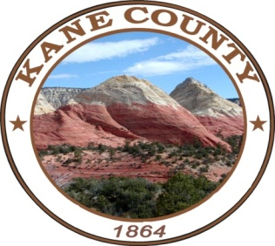
NOTICE AND AGENDA OF A MEETING OF THE KANE COUNTY COMMISSION
***************************************

PUBLIC NOTICE IS HEREBY GIVEN that the Commissioners of Kane County, State of Utah, will hold a TOWN HALL Meeting at the Kanab Center, 20 N. 100 E. Kanab, Utah on Tuesday February 8, 2022 at the hour of 6:00 p.m.

*The Commission Chair, in his discretion, may accept public comment on any listed agenda item unless more notice is required by the Open and Public Meetings Act.

CALL MEETING TO ORDER
WELCOME

Here are the agenda items for the town hall meeting on Tuesday night.

1. Information on Transient Room Tax (TRT) - Camille Taylor
- Video presentation
- Additional Information
- 15 - 20 minute Q & A regarding TRT

2. Information on Local and Special Service Districts (LSD, SSD) - Commissioner Heaton
- Summary of handout - What is a Local or Special Service District?
- 15 - 20 minute Q & A regarding LSDs and SSDs

3. Local Service District's request to expand service capabilities - Commissioner Chamberlain

NOTICE OF SPECIAL ACCOMMODATION DURING PUBLIC MEETINGS:
In compliance with the Americans with Disabilities Act, individuals needing special accommodations (including auxiliary communicative aids and services) during this meeting should notify Karla Johnson at (435) 644-2458. Agenda items may be accelerated or taken out of order without notice as the Administration deems appropriate. All items to be placed on the agenda must be submitted to the Clerk’s office by noon Thursday, prior to the meeting.

