


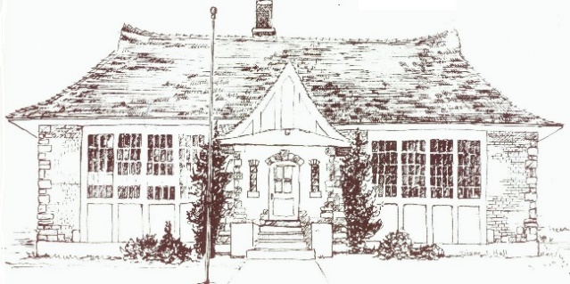
Town of Mantua

Newsletter February 2022
409 N. Main, Mantua Utah 435-723-7054
Office Hours 9 am-1 pm Monday-Friday
townofmantua@gmail.com
www.townofmantua.com

Happy
Vallentine’s Day!
New Council sworn in January 6th
Mayor Terry Nelson mayor@mantuautah.org
Council
Matt Jeppsen mcjeppsen@mantuautah.org
Jared Jeppsen jjeppsen@mantuautah.org
Justin Brown jbrown@mantuautah.org
Karen Nelson knelson@mantuautah.org
~~~~~~~~~~~~~~~~~~~~~~~~~~~~~~~~~~~
Mantua will be holding Town Council meeting on February 3rd and 17th at 6:30 p.m. at Town Hall. Mantua Planning and Zoning will be held on February 10th 6:30 p.m. at Town Hall. Call 723-7054 to be put on the agenda for Town Council or Planning & Zoning Comm. no later than 48 hrs. prior to the meeting. Town Hall closes at 1 pm so plan accordingly. A Mantua Budget Work Meeting will follow the February 3rd Town Council Meeting.
~~~~~~~~~~~~~~~~~~~~~~~~~~~~~~~~~~~~
Sheena Zook. Mantua’s part- time court clerk, has taken a full-time job close to her home. We want to thank her for all the service she provided our town. Her experience and work ethic were an asset and she will be missed.
~~~~~~~~~~~~~~~~~~~~~~~~~~~~~~~~~~~~
Mantua Police Department would like all residents in need to call this number for
Dispatch-Non Emergency Assistance Number-435-723-5227,
For an Emergency always call 911.
~~~~~~~~~~~~~~~~~~~~~~~~~~~~~
Keep our children safe! Don’t speed! Come to a full stop at stop signs!
~~~~~~~~~~~~~~~~~~~~~~~~~~~~~
Calendar of Important Town Dates
Town Clean Up Day TBA
Easter Egg Hunt-April 16th, 10 am
Heidi Reddington, Heidi Roper
Dog Clinic-May 14th, 9 am-noon
At the Bowery.
Little Valley Days-July 11-16th
Chairmen for LVD
Spencer & Cassandra Jeppsen,
Ted & Amber Jeppsen,
Bryce & Tonya Jeppsen,
If you want to volunteer call- 435-723-8727
Santa Coming to Town proposed to be
Monday, Nov 28th time – TBA.
~~~~~~~~~~~~~~~~~~~~~~~~~~~~~~~~~~~~~
The green oval 2021 dog tags bought for the year are good through May 31, 2022. The new blue biscuit 2022 dog tags and licenses will be available the beginning of April. Watch for more information on our dog clinic, May 14th.
~~~~~~~~~~~~~~~~~~~~~~~~~~~~~~~~~~~~~~
Remember to remove all cars, trailers, farm equipment, recreational vehicles, etc. from the Town rights-of-way and road shoulders. There is one-hour limited parking on the Town rights-of-way, or road shoulders 6 am to 12 midnight from Nov.1st - April 1st. The Town will not be responsible for damage caused to vehicles by snow plowing when vehicles are parked on the right-of-ways or road shoulders. No parking overnight from midnight to 6 am on Town rights-of-way or road shoulders, from Nov.1st - April 1st.
~~~~~~~~~~~~~~~~~~~~~~~~~~~~~~~~~~~~~~

Recycling pick up days 2022

January 10 & 24
February 7 & 21
March 7 & 21
April 4 & 18
May 2, 16 & 31
June 13 & 27
July 11 & 25
August 8 & 22
September 6 & 19
October 3, 17 & 31
November 14 & 28
December 12 & 26
To ensure pickup please put your garbage and recycling cans out on Sunday night, pickup can be as early as 6 am on Monday.
~~~~~~~~~~~~~~~~~~~~~~~~~~~~~~~~~
The Town had a donation of 25 Veteran’s crosses that need refurbishing. If you can help with this project or know a veteran that needs a Veteran’s cross on their grave in the Mantua cemetery call- Councilmen Jared Jeppsen, jjeppsen@mantuautah.org
~~~~~~~~~~~~~~~~~~~~~~~~~~~~~~~~~~~~~
Since Matt Jeppsen cannot be both on the Town Council and Planning and Zoning, Pam Eaves was named to replace him on Planning and Zoning. Congratulations, Pam! Thanks for your service, Matt! Matt, Mantua benefits from you on Town Council.
~~~~~~~~~~~~~~~~~~~~~~~~~~~~~~~~~~~~~
Recently there was an accident at the lake,
involving children from a local school.
The school had taken every precaution, but accidents happen. Their foresight in having so many adults there made a swift and safe rescue of all the children.
Mantua residents, as the water continues to fill the reservoir from North Dam and Maple Springs the ice rises. That leaves a small area by the shore which may have thinner ice while the rest of the body has very thick ice. Also with the ice fishermen, the holes they make can have thin ice as well and be difficult to detect. Ice near where water is coming into the reservoir can also be dangerous. Be Careful! Never go alone or without someone knowing where you are!
MORE ACCESS TO TOWN
AGENDAS, MINUTES & INFO
To have better access to Mantua’s agendas,
Planning and Zoning info and to the Town newsletter please go to Utah Public Notice Website at https://www.utah.gov/pmn/
Under Government mark Cities
Under Entity mark Mantua
Under Body you can choose
Mantua Town Council,
Town of Mantua
Town of Mantua Planning and Zoning
Any or all!
The website will send the info to your email!
Under Town Council you can see the agenda for each Town Council meeting.
Under Town of Mantua we will send the monthly newsletter and any notices on emergency meetings or emergency news.
Under Planning and Zoning you can receive the minutes of each monthly meeting.
Complete the Subscription Options area with your contact information. Send!
Make sure you get a confirmation email.
We are urging residents to sign up and opt to receive these digitally so Mantua can save money on mailing the newsletter and residents can keep more up to date.
~~~~~~~~~~~~~~~~~~~~~~~~~~~~~~~~~~~~~
TURKEYS, TURKEYS, TURKEYS
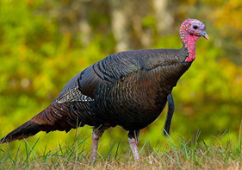
You should be seeing fewer. The Town Council initiated Turkey trapping with the DWR who then takes the turkeys out near Pilot Mountain to release the birds. There have been about 150 turkeys trapped & relocated. Thank you to the DWR & the residents who have helped.
~~~~~~~~~~~~~~~~~~~~~~~~~~~~~~~~~~~~~
Mantua welcomed Dakota Midkift to our police department. We have Chief Hamer and three deputies on our force.
~~~~~~~~~~~~~~~~~~~~~~~~~~~~~~~~~~~~~

