Kanosh Town Corporation held the regular council meeting on Wednesday, December 8, 2021, electronically and in the town office at 7:00 p.m.
Members present:
Mayor Frank Paxton, Councilmember's: Brandon Stephenson, Rodney Whatcott, Neil Shumway, and Hayden George, and Kanosh Town Treasurer Karen Crook, Kanosh Town Clerk: Cindy Turner

Others in attendance: CERT Chairman Ed Phillips, Bart Whatcott, Jim Kooyey, Fransen Engineering Layne Jensen, Josh Whitaker, Chad Whitaker, Mayor elect Scott McDonald, Stan Koyle, Brandon George, Steve Crab, Kanosh Town attorney Justin Wayment, Star Cummings, Councilmember elect David Whitaker

Councilmember Rodney Whatcott offered the invocation.

Councilmember Neil Shumway led everyone in the Pledge of Allegiance.

Minutes of the November 10, 2021 meeting were read and were approved as amended through motion by Councilmember Rodney Whatcott, Councilmember provided a second to the motion, all Council members voted in favor as noted below:
Mayor Frank Paxton: Aye
Council members
Rodney Whatcott: Aye
Brandon Stephenson: Aye
Neil Shumway: Aye
Hayden George - Aye

Warrants for December 2021 were read discussed and approved to be paid through a motion by Councilmember Hayden George, Councilmember Brandon Stephenson seconded the motion, all Council members voted in favor as noted below:
Mayor Frank Paxton: Aye
Council members
Rodney Whatcott: Aye
Brandon Stephenson: Aye
Neil Shumway: Aye
Hayden George: Aye

CERT:
Nothing to report at this time.

Fire Department:
Fire Chief Lorin Shumway reported the radios have been ordered, however not yet received.

Chief Shumway noted nothing additional to report at this time.

Planning and Zoning:
Planning and Zoning Chairman Ed Phillips reported the building permits for Jim Kooy have been finalized. The permit has now been presented to the council for approval, with a favorable recommendation of approval from the Planning Commission.

The Property on 200 N 200 E purchased by Fernando Gutierrez. Payment for water and power of this parcel has been submitted.

Councilmember Hayden George motioned in approval of the permits as presented. Council member Neil Shumway provided a second to the motion, all Council members voted in favor as noted below:
Mayor Frank Paxton: Aye
Council members
Rodney Whatcott: Aye
Brandon Stephenson: Aye
Neil Shumway: Aye
Hayden George: Aye

Fransen Engineering: Layne Jensen:
Mr. Jensen addressed the council members providing an update of the CCI project. Mr. Jensen presented and addressed the following handouts:

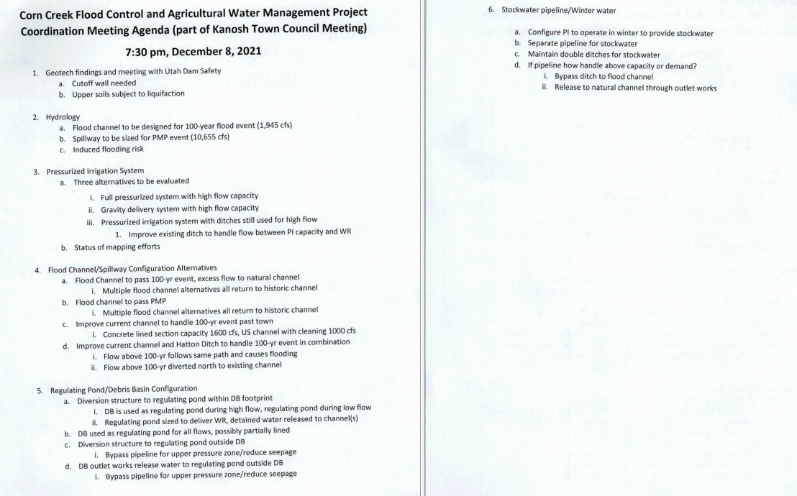

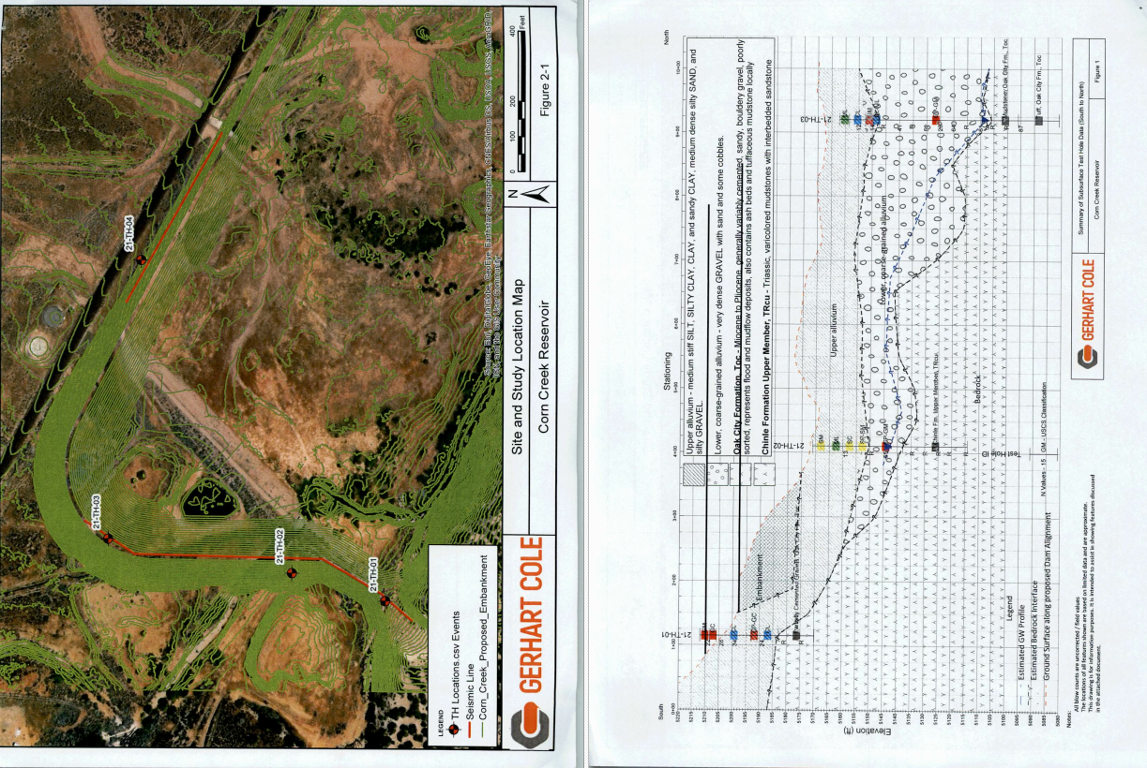
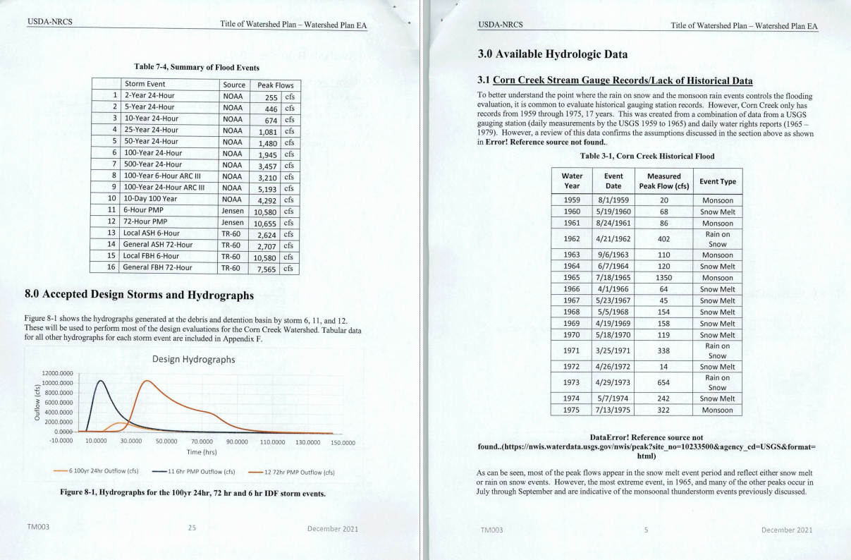

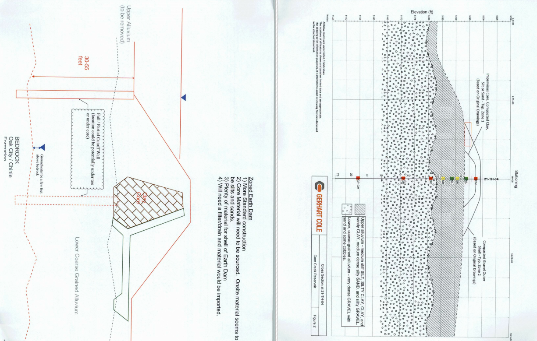

At 8:45 p.m. Councilmember Brandon Stephenson motioned to move into a closed session for the purpose of discuss the Corn Creek Irrigation project acquisition of easements of property. Councilmember Rodney Whatcott seconded the motion, all Council members voted in favor through a role call vote as noted below:
Mayor Frank Paxton: Aye
Council members
Rodney Whatcott: Aye
Brandon Stephenson: Aye
Neil Shumway: Aye
Hayden George: Aye

At 10:30 p.m. the regular council meeting resumed.

No action to be taken on the closed session.

Culinary well siting
Willow Sticks is lined up to come down next week to do a well siting evaluation. In order to move our change of application for our water, we need to have a site specified. We will have them look at the site next to the well and also the one north of town. After their evaluation they will make a recommendation where we should drill. Mr. Ben Coray is researching to see if this can be funded through the project, the town will have to pay either way, it will either be out of our initial 200,000.00 or we will just pay for it up front. It costs $5500.00 to do both sites. Councilmember Rodney Whatcott motioned to have Willow Sticks to come and do a well siting evaluation on both sites, Councilmember Brandon Stephenson seconded the motion, all Council members voted in favor as noted below:

Mayor Frank Paxton: Aye
Council members
Rodney Whatcott: Aye
Brandon Stephenson: Aye
Neil Shumway: Aye
Hayden George: Aye

Christmas Celebration:
Councilmember's agreed to meet on 12/21 at the fire station at 7:00 p.m. for the official sacking of the Christmas candy for the town celebration.

Review of Utility Delinquencies:
Council members reviewed the monthly delinquency list. It was determined, again, to handle those accounts in arrears according to established Town policy overlay existing and improvements at the cemetery

Review of Utility Delinquencies:
Council members reviewed the monthly delinquency list. It was determined, again, to handle those accounts in arrears according to established Town policy

Old business
Note on the F450 that it has a bad engine. The bid opening will take place in the January meeting.

It should be noted that "Bill Pay" is proving to be of benefit to the Town!

Public comment:
Mayor elect Scott McDonald verbalized his appreciation to the outgoing mayor and council, recognizing the countless hours they have rendered on behalf of the Town of Kanosh.

There being no further business to come before the board, the meeting adjourned.

Frank Paxton, Cindy Turner,
Kanosh Town Mayor Kanosh Town Clerk

