10-10A-4-1: R-1-10 DISTRICT (10,000 SQUARE FEET):

Minimum lot area | 10,000 square feet
Minimum frontage | 80 feet (except corner lots 90 feet). Minimum frontage may be reduced by 30% on a cul-de-sac lot, as measured along the line that follows the minimum front setback for the lot and as long as the total lot area exceeds 10,000 square feet
Minimum setbacks | Front: 25 feet  Side: 10 feet  Rear: 10 feet
Setback exception | Driveway, walkway
Maximum height | 35 feet (see definition of building height, section 10-2-1 of this title) (exception - church steeples)
Parking | In accordance with section 10-21-13 of this title
Minimum road setback | 25 feet from any dedicated street or highway
Secondary structure height | Up to 18 feet - permitted  18 feet to 35 feet - conditional  Above 35 feet - not allowed
Secondary structure setback | Front: 25 feet  Side: 5 feet  Rear: 5 feet

(Ord. 2018.08, 12-13-2018)
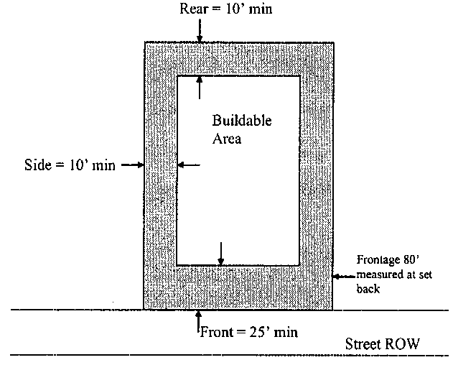

(Ord. 2012.04, 1-18-2012)

