
December 8, 2021
DETERMINATION REGARDING CONDUCTING TOWN OF HIDEOUT PUBLIC MEETINGS
WITHOUT AN ANCHOR LOCATION

The Planning Commission Chair of the Town of Hideout hereby determines that conducting a meeting with an anchor location presents a substantial risk to the health and safety of those who may be present at the anchor location pursuant to Utah Code section 52-4-207(5) and Hideout Town Ordinance 2020-03. The facts upon which this determination is based include: The seven-day rolling percent and number of positive COVID-19 cases in Utah has been over 15.72% of those tested since December 2, 2021. The seven-day average number of positive cases has been, on average, 1415 per day since December 7, 2021.
This meeting will not have a physical anchor location. All participants will connect remotely. All public meetings are available via YouTube Live Stream on the Hideout, Utah YouTube channel at: https://www.youtube.com/channel/UCKdWnJad-WwvcAK75QjRb1w/
Interested parties may join by dialing in as follows:
Meeting URL: https://zoom.us/j/4356594739
To join by telephone dial: US: +1 408-638-0986
Meeting ID: 435 659 4739
Additionally, comments may be emailed to hideoututah@hideoututah.gov. Emailed comments received prior to the scheduled meeting will be entered into public record.
This determination will expire in 30 days on January 7, 2022.
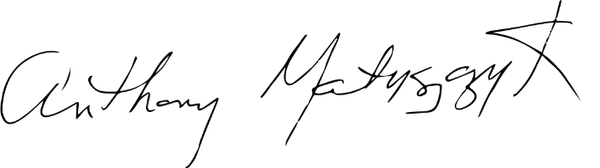
BY:
____________________________
Tony Matyszczyk,
Planning Commission Chair


ATTEST:

______________________
Kathleen Hopkins, Deputy Town Clerk

